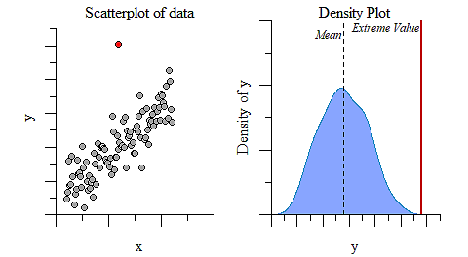

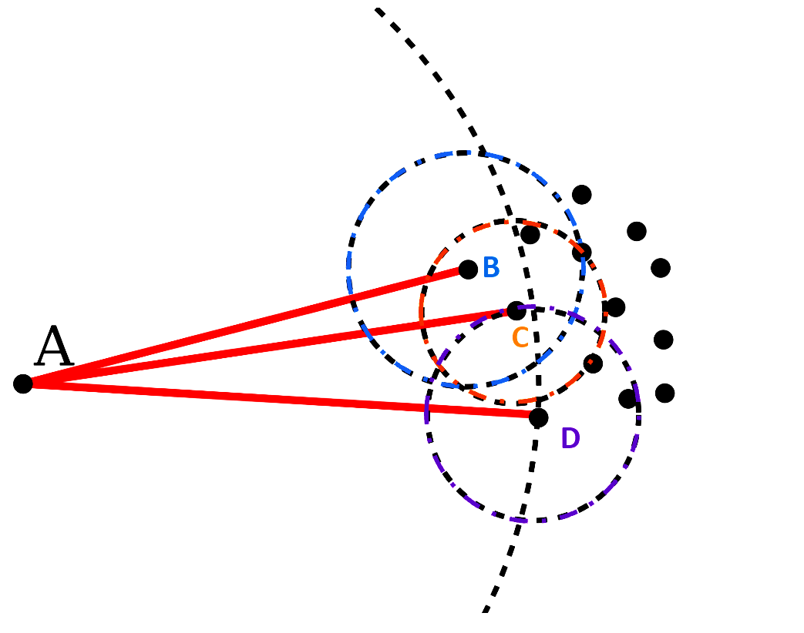

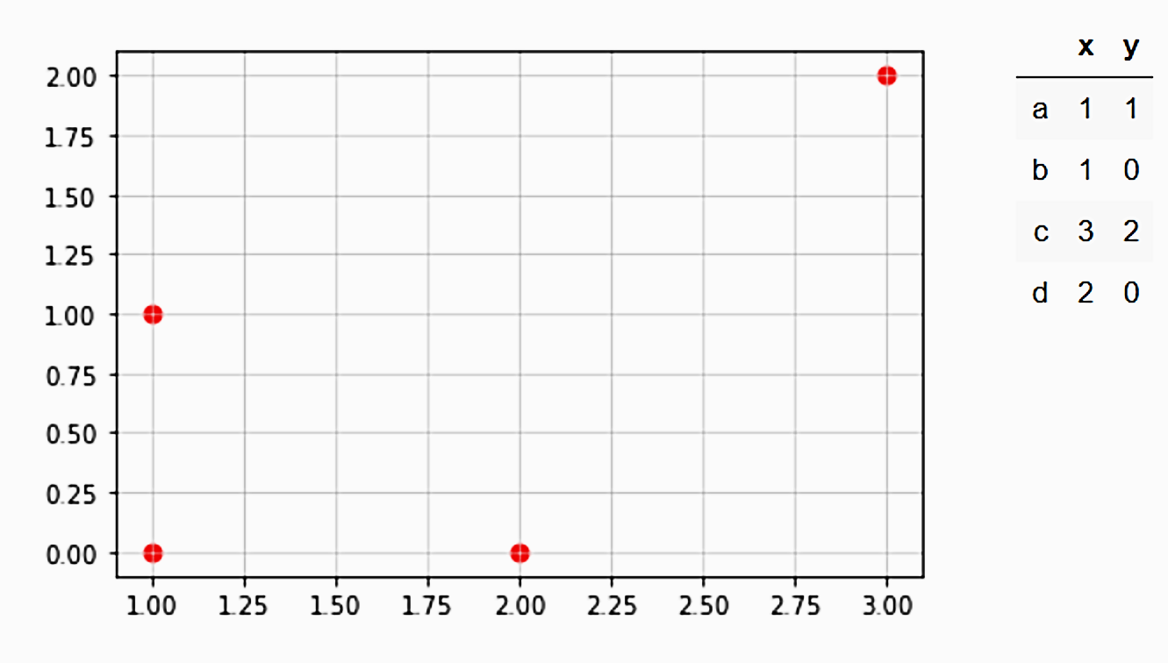

**c (3,2)**

**d (2,0)**

**b (1,0)**

**a (1,1)**

**Normal Distance (Manhattan) (NDM)**

NDM (a, b) = 1

NDM (a, d) = 2

NDM (b, d) = 1

NDM (a, c) = 3

NDM (b, c) = 4

NDM (c, d) = 3

**k-Distance (k = 2)**

kD2 (a) = 2

kD2 (b) = 1

kD2 (c) = 3

kD2 (d) = 2

**Neighborhood with k = 2**

N2(a) = {b, d}

N2(b) = {a, d}

N2(c) = {a, d}

N2(d) = {a, b}

**Reachability Distance**

**RD (a, b)** = max {kD2 (b), ND (a, b)} = max {1,1} = 1

**RD (a, d)** = max {kD2 (d), ND (a, d)} = max {2,1} = 2

**RD (b, a)** = max {kD2 (a), ND (b, a)} = max {2,1} = 2

**RD (b, d)** = max {kD2 (d), ND (b, d)} =max {2,1} = 2

**RD (c, a)** = max {kD2 (a), ND (C, a)} = max {2,3} = 3

**RD (c, d)** = max {kD2 (d), ND (C, d)} = max {2,3} = 3

**RD (d, a)** = max {kD2 (a), ND (d, a)} = max {2,2} = 2

**RD (d, b)** = max {kD2 (b), ND (d, b)} = max {1,1} = 1

**Local Reachability Density**

**LRD(a)** = 1 / (RD (a, b) + RD (a, d)) / 2) = 2/3

**LRD(b)** = 1 / (RD (b, a) + RD (b, d)) / 2) = 1/2

**LRD(c)** = 1 / (RD (c, a) + RD (c, d)) / 2) = 1/3

**LRD(d)** = 1 / (RD (d, a) + RD (d, b)) / 2) = 2/3

**Local Outlier Factor Score**

**LOF(a)**= ((LRD(b) + LRD(d)) / LRD(a)) / 2 = [(1/2 + 2/3) / (2/3)] / 2 = 7/8 = 0.875

**LOF(b)** = ((LRD(a) + LRD(d)) / LRD(b)) / 2 = [(2/3 + 2/3) / (1/2)] / 2 = 4/3 = 1.333

**LOF(c)** = ((LRD(a) + LRD(d)) / LRD(c)) / 2 = [(2/3 + 2/3) / (1/3)] / 2 = 4/2 = 2

**LOF(d)** = ((LRD(a) + LRD(b)) / LRD(d)) / 2 = [(2/3 + 1/2) / (2/3)] / 2 = 7/8 = 0.875

