STA553 Data Visualization
Focusing on effective design and creation of visual represention of information

Visualization
Via web tools
Dynamic Visualization
Static Visualization

RPubs & GitHub
Webpage and CV
Reactive Visualization
Interactive Visualization
Ggplot and extension
Base R Plot functions

Statistical Methods and Real-world Applications
Using cutting-edge technologies
- Linear Regression Models
- Generalized Linear Models
- Time Series Models

To be Covered in
STA 490
Covered in STA 319, 320, and 321
- Sampling Techniques Survey
- Survey Design and Analysis
- PCA (CFA) in Survey Analysis

Website Directory (GitHub Repository)


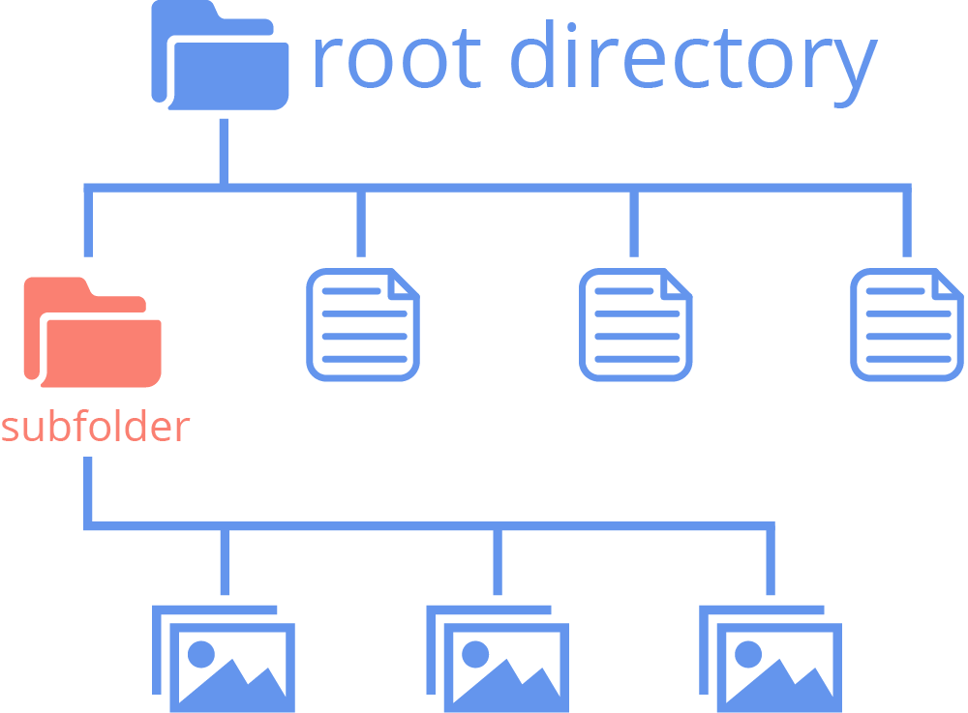
img
Index.html







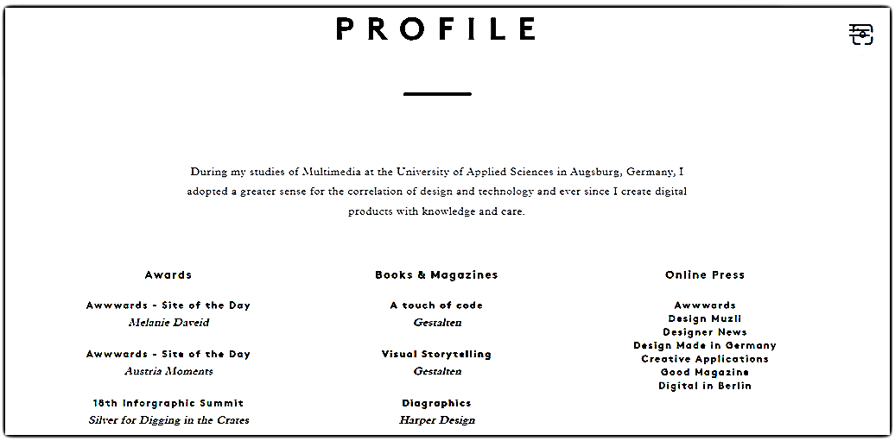
Short bio
Contact information
Your Name
Contact information
URL link of Your CV (could be more than on page)
Technical Skills (programming and other analytic Skills)
Projects reports (with links to some representative project reports)
Professional Preparation



Name
Contact Information

