STA490 Statistics Capstone
Effective Written and Oral Communication with Technologies

Effective Oral Communication
Effective Written Communication

Consulting and Job Interviews
Oral Presentation
Analytics Reports
CV & Personal Web Site

Statistical Methods and Real-world Applications
Using cutting-edge technologies
SS
To be Covered in
STA 490
Covered in STA 319, 320, and 321
- Sampling Techniques Survey
- Survey Design and Analysis
- PCA (CFA) in Survey Analysis
- Linear Regression Models
- Generalized Linear Models
- Time Series Models

Website Directory (GitHub Repository)


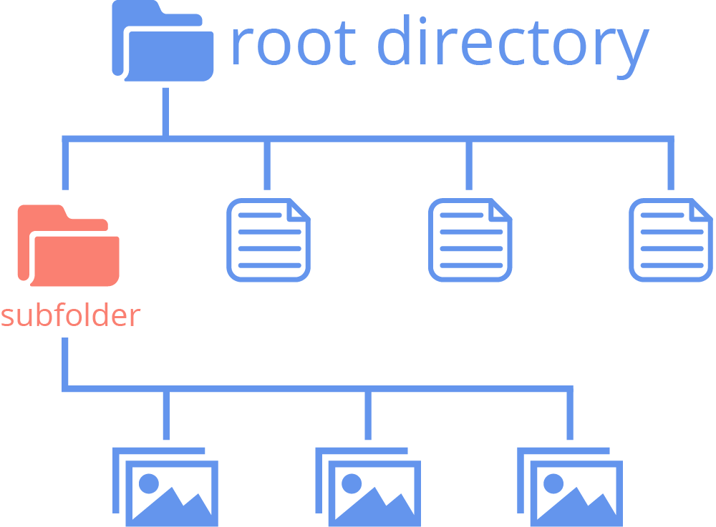
img
Index.html







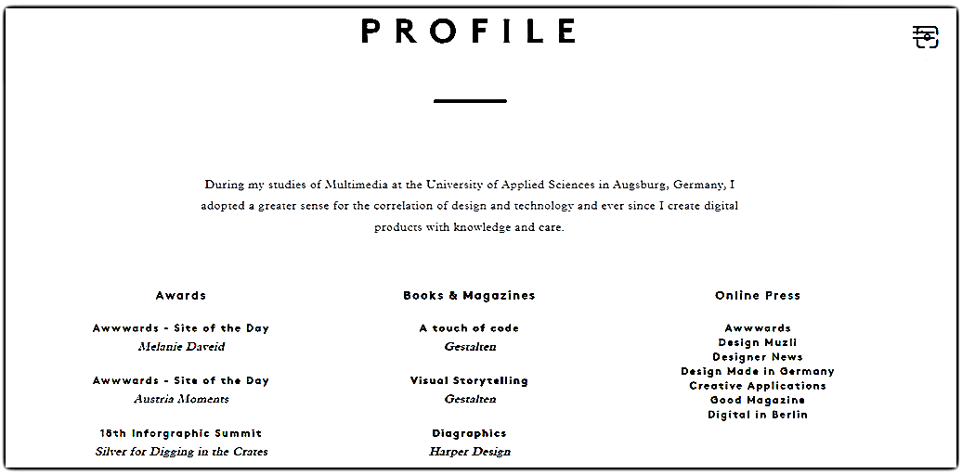
Short bio
Contact information
Your Name
Contact information
URL link of Your CV (could be more than on page)
Technical Skills (programming and other analytic Skills)
Projects reports (with links to some representative project reports)
Professional Preparation



Name
Contact Information

