**Analysis Report on**

## **Acculturation Pattern of Asian Indian and Hmong Women**

1. **Introduction**

We use ARIS instrument to gather information from Asian Indian and Hmong women on language use, acculturation and perceived prejudice. The primary interest in this study focuses on the association between the acculturation and social and family life. Various regression models are used to extract the information that addresses the research questions and visualization is used to present the findings.

1. **Data Management**

Three records were deleted due to significant missing values in ARIS questions; the total number of observations is 94 (one respondent is from China). There about 3% missing values in ARIS. We perform simple imputation using the frequency distribution of individual items in ARIS. Several variables were redefined. We did not impute demographic variables. Therefore, the actual effective sample sizes in the different models are slightly different. Due to relatively small sample size, we can only perform univariate analysis. All demographic related variables are treated as categorical variables.

1. **Statistical Methods**

Several statistical methods are used in this study. We use the PCA as a dimension reduction tool to extract information from the subscale of acculturation in the form of unitless indices. The score of these indices reflects the level of acculturation. Both simple and multiple linear regression models are used to examine the association between the process of acculturation and the covariates. We also use multi-category logit model to the data using variable acculturation and two employment related variables to see how the level of acculturation affects the employment.

1. **Results**

Numerous models were built in this study. We summarize the results in following several subsections. Our research questions focus on acculturation.

* 1. *PCA and intra-class correlation*

We performed principal component procedure to define multivariate indices to capture the information from ARIS questionnaires for the three subscales (language use, acculturation and perceived prejudice). The first three principal components of each subscale are used to define the multivariate indices account about 70% of variation of the scale. Since all principal components are mutually independent, we can use ordinary regression models to examine the association between the principal components and potential predictor variables. In this study, we focus on the analysis of the process of acculturation and potential factors. The variance explained by each individual principal component is shown in Fig. 1. *The higher the principal component score, the higher the level of acculturation*.

Among the first three major principal components, only two variables, age and country of birth, are statistically associated with the second and the third PC and the direction of the association is the same as that in with the first PC. Therefore, we only use first principal component in the analysis.

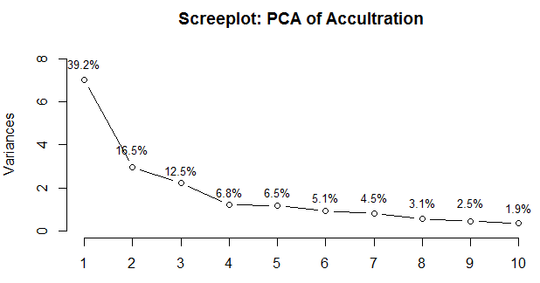

Figure 1. Screeplot of the principal component of acculturation

|  |  |  |  |  |  |
| --- | --- | --- | --- | --- | --- |
| Predictor Variables | | Multiple Linear Regression | | Simple Linear Regression | |
| Slope (std.err) | P value | Slope (Sdt.err) | P-value |
| Occupation  Ref: employed | Self-employed | 1.49888(0.60139) | 0.0156* | 3.2951(0.5834) | <0.0001* |
| Un-employed | 1.55628(0.58653) | 0.0103* | 2.2512(0.5407) | <0.0001* |
| Age  Ref: < 30 | Between 30 and 50 | 0.91525(0.48754) | 0.0656* | 2.0078(0.5085) | 0.0002* |
| 50 or above | 2.32765(0.72578) | 0.0022* | 3.9012(0.6268) | <0.0001* |
| Use Commu Service  Ref: Never | Occasionally | 1.00976(0.53178) | 0.0627* | 1.2424(0.6582) | 0.0627* |
| Regularly | -0.07311 (0.67425) | 0.9140 | 0.1692(0.8553) | 0.8437 |
| Country of Birth  Ref: India | Laos-Thailand | -0.91821 (0.62740) | 0.1488 | -0.287(0.4915) | 0.5606 |
| USA | -3.50943 (0.88523) | 0.0002* | -4.652( 0.7424) | <0.0001* |
| Education Level  Ref: HS- below | Baccalaureate | -0.52825 (0.58771) | 0.3725 | 0.5337(0.6431) | 0.409 |
| Post- Baccalaureate | -1.44594 (0.64858) | 0.0297* | -0.3014(0.7748) | 0.698 |
| Work Status  Ref: Full Time | Part-time |  |  | 0.9679 (0.6541) | 0.143 |
| Home-maker |  |  | 3.4329 (0.5170) | <0.0001* |
| Ethnics Ref: Indian | Hoong/Mein |  |  | -1.1319(0.5564) | 0.0447* |

Table 1. PCA 1 Principal component regression models: PCA score versus predictor variables

Table 2 Baseline logit models on the employment v.s. acculturation

|  |  |  |  |  |  |  |  |  |  |
| --- | --- | --- | --- | --- | --- | --- | --- | --- | --- |
| Employment Status Ref: full-time | | | | | Employment Types Ref: employed | | | | |
| level | parameter | ln OR | OR | p-val | level | parameter | ln OR | OR | p-val |
| Part  time | intercept | -0.145 | 0.865 | 0.692 | Self-employd | intercept | -0.559 | 0.572 | 0.118 |
| slope | 0.172 | 1.187 | 0.217 | slope | 0.791 | 2.206 | <0.001 |
| Home  maker | intercept | 0.566 | 1.761 | 0.085 | Un- employd | intercept | 0.064 | 1.066 | 0.819 |
| slope | 0.852 | 2.343 | <0.001 | slope | 0.462 | 1.587 | 0.001 |

* 1. *Factors Associated with the Acculturation Process*

We select a select a set of demographic variables in regression models. Due to missing values in some occurred in some of the variables, some of the variables were excluded from the multiple linear regression models. We also fit simple linear regression models using all selected predictor variables. The results of these regression models are summarized in Table 1.

In the multiple linear regression model, those who are self-employed (p=0.0156) or unemployed (p = 0.0103) have higher acculturation levels than those who are unemployed. For age variable, older people (age 30-50 with p = 0.0656 and age 50+ with p=0.0022) have higher level of acculturation than that of people younger than 30 years old. The model also indicates that those who use community services occasionally have higher level of acculturation than that of those who never used the services. Interestingly, there is no significant difference in terms of acculturation between those who never used the service and those who use the service regularly (p = 0.914). Those who were born in USA have a lower level of acculturation (p = 0.0002). There is no significant difference between those were born in India, Thailand and Laos (p = 0.1488). In terms of educational background, those who received post-baccalaureate degree have a lower level acculturation (p = 0.0297) but no significant difference was found between the group with baccalaureate and the group with a pre-baccalaureate education.

From simple linear regression models, comparisons of the level of acculturation among groups defined by covariates are unconditional. The results obtained from these simple linear regression models are almost identical to those obtained from the multiple linear regression model except the variable of educational background which does not show an association with the level of acculturation. In addition, two other simple linear regression models were also built. With respect to the employment status, there is no significant difference in terms of level acculturation between full-timers and part-timers ( p =0.143) but the difference between homemakers and full timer is statistically significant (p < 0.001). Within the self-reported ethnical group, Asian Indian women have a higher level acculturation than Hoong/Mein women.

* 1. *The relationship between probability of employment types/types and the level of acculturation*

To have a closer look at how the level of acculturation impacts the employment, we fit multi-category baseline logit models to the data. Two models were built using the two employment variables as responses. The results are summarized in Table 2.

From the left half of Tables 2, we can see that, as the score of the level of acculturation increases by one unit, the odds of being a part-timer is about the same as being a full-timer ( p =0.217). However, with unit increase of the score of acculturation level, the odds of being a home-maker is 2.343 time the odds of being a full-timer (p < 0.0001). This result is consistent with the simple linear regression model given in the table 1. From the left half of Table 2, we can see that, with one unit increase of the acculturation score, the odds of being self-employed is 2.206 times the odds of being employed (p < 0.001). Similarly, the odds of being unployed is 1.587 times the odds of being employed. This is also consistent with the result obtained from the multiple linear regression model in Table 1.

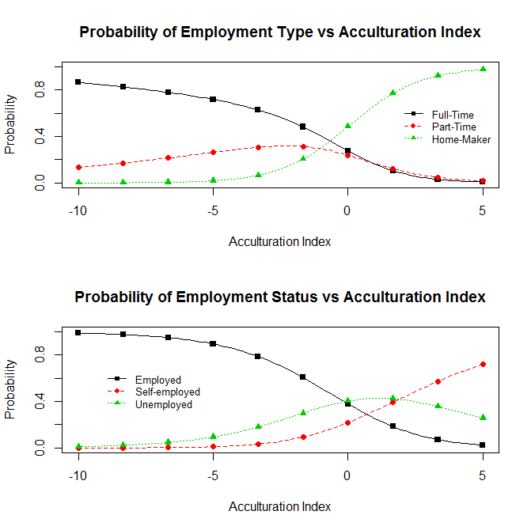

*Figure 2. Probability curves of employment versus acculturation index based on baseline logit models.*

The baseline logit model is a nonlinear regression model which links the probability of being a category of the response variable to a nonlinear function of the predictor variable. As an example, we look at the baseline logit model with employment type. Let x = acculturation. Using the information in the left half of Table 2, we can write explicitly the probabilities of being in three employment categories in the following system,



The above three probability functions are plotted in the top panel of the Figure 2. We can see that as the acculturation level increases, the probability of being a full-timer decreases; the probability of being a part-timer initially increases and then decreases; the probability of being a homemaker increases monotonically. The bottom panel of the probability curves can be similarly interpreted.