Q1:

Biological robustness is one of the overall characteristics of a biological system, which refers to a trait of a biological system to maintain its structural and functional stability when disturbed by uncertainties such as external perturbations or internal parameter uptake.

Biological vulnerability refers to the degree or possibility of damage to an organism that arises from the non-stimulation of the external environment.

In the case of living organisms, their robustness and vulnerability are expressed differently at different stages. Taking the case fatality rate of epidemic cases in Hong Kong at the time of new coronavirus infestation as an example, it can be found that the older the age, especially, the higher the case fatality rate of its infection with the new pavilion, especially in the group over 80 years old, the mortality rate is as high as 7.91%, which indicates that the life robustness of the older group is low and the vulnerability is relatively high. In contrast, the case fatality rate of the group under 49 years of age was less than 0.02%, which indicates that the group has a higher life robustness and a relatively lower vulnerability.

Since an organism is always in a changing environment, but it can maintain a relatively stable internal environment. that allows it to survive in a variety of environments. In this sense, such as accomplices are essential for the individual organism to maintain its life characteristics.

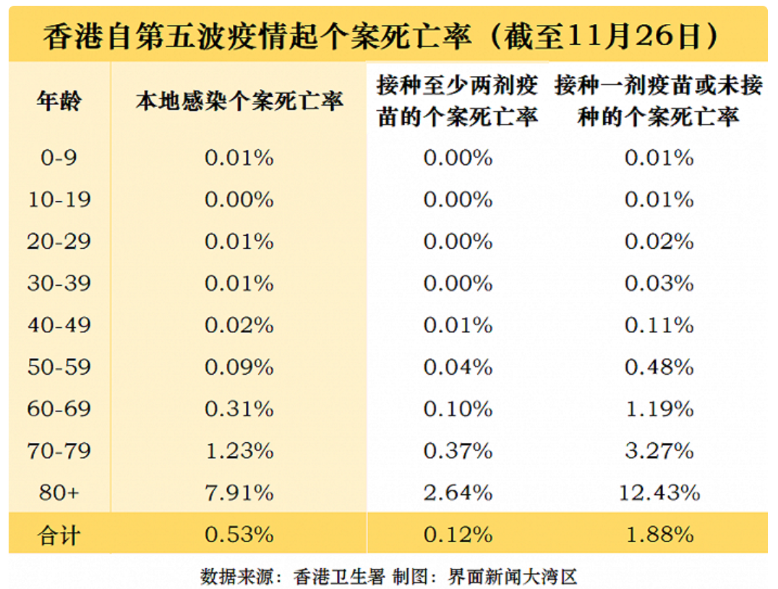

Q2:

8.1 $v_{\left(production\right)}=k_{1}\left[E\right]\left[S\right]$

$v_{\left(consumption\right)}=(k_{2}+k_{3})\left[ES\right]$

At steady state, $v_{\left(production\right)}=v_{\left(consumption\right)}$

$\left(k_{2}+k_{3}\right)\left[ES\right]=k_{1}\left[E\right]\left[S\right]$ $\frac{k_{2}+k_{3}}{k_{1}}=\frac{\left[E\right]\left[S\right]}{\left[ES\right]}=K_{m}$ $\frac{\left[ES\right]K_{m}}{\left[S\right]}=\left[E\right]$ $\frac{\left[E][I\right]}{K_{i}}=\left[EI\right]$

$\frac{\frac{K_{m}}{\left[S\right]}\left[ES][I\right]}{K_{i}}=\left[EI\right]$ $\frac{\left[E\right]+\left[ES\right]+[EI]}{\left[ES\right]}=\frac{V_{max}}{v}$ $\frac{1}{v}=\frac{K_{m}}{V_{max}}\left(\frac{\left[I\right]}{K_{i}}+1\right)·\frac{1}{[S]}+\frac{1}{V_{max}}$

#include<stdio.h>

#include<math.h>

#define f(x,y) (-1\*(x)\*(y)\*(y))

void main(void)

{

double a,b,x0,y0,k1,k2,k3,k4,h;

int n,i;

printf("input a,b,x0,y0,n:");

scanf("%lf%lf%lf%lf%d",&a,&b,&x0,&y0,&n);

printf("x0\ty0\tk1\tk2\tk3\tk4\n");

for(h=(b-a)/n,i=0;i!=n;i++)

{

k1=f(x0,y0);

k2=f(x0+h/2,y0+k1\*h/2);

k3=f(x0+h/2,y0+k2\*h/2);

k4=f(x0+h,y0+h\*k3);

printf("%lf\t%lf\t",x0,y0);

printf("%lf\t%lf\t",k1,k2);

printf("%lf\t%lf\n",k3,k4);

y0+=h\*(k1+2\*k2+2\*k3+k4)/6;

x0+=h;

}

printf("xn=%lf\tyn=%lf\n",x0,y0);

}

Q3

The possible reason for this situation is that the model used has been trained many times prior to this, resulting in the model having developed a weighting where the model produces a strong accuracy judgment for a certain type of data, i.e., the underlying module, leading to a high prediction of the model even when training the model with brand new data, resulting in a high accuracy result with only a few short rounds of real training.

This situation is a feature of machine learning these days, and in my experience, these kinds of problems can occur not only in bioinformatics processing, but also in electronic information.

A typical example that I have experienced is that we once trained a model through machine learning to identify the gender of people coming out of a building, and after a period of training, we found that the model was far more accurate in identifying women than men. When the model was later applied to other situations, it was found that the reason for this was that the vast majority of women would habitually look in the mirror at the glass when they came out of the building, and the model learned this feature as representative of women, but when this feature was placed in other situations, it obviously might not apply.

It is also clear that this type of situation is not a feature unique to biological information, and that it occurs when it comes to feature learning for conscious energetic subjects.