Supplementary Materials for:
Frequency Band Personalization for Seizure Network Analysis in
Multifocal Patients

Genchang Pengª, Mehrdad Nourani^{a,*}, Omar Nofal^{b} and Jay Harvey^{b}
ª Department of Electrical and Computer Engineering, The University of Texas at Dallas, TX 75080, USA (email: {Genchang.Peng, nourani}@utdallas.edu).
^{b} Department of Neurology, The University of Texas Southwestern Medical Center, Dallas, TX 75390, USA (email: {Omar.Nofal, Jay.Harvey}@UTSouthwestern.edu).
*Corresponding author.

Statement:
This work involved human subjects or animals in its research. Approval of all ethical and experimental procedures and protocols was granted by the Institutional Review Boards of The University of Texas at Dallas and the University of Texas Southwestern Medical Center, under No. IRB-21-198.
Any inquiry about research data on studied subjects in this work is upon rational request, and should contact the corresponding author: Dr. Mehrdad Nourani (nourani@utdallas.edu).

Overview:
This document contains the supplementary materials for our second-round submitted manuscript, “Frequency Band Personalization for Seizure Network Analysis in
Multifocal Patients”. This document is organized as follows:
- Section S1: Visualization of DTF-based seizure network
- Section S2: Curves of density differences (ΔD) across frequency bands for all patients

S1. Visualization of DTF-based seizure network
In this part, we show the procedure of visualizing the DTF connectivity matrix into a graph. Using the β band (13-30) for illustration, as with our earlier works [1], we build the band-specific DTF matrix in Figure S1-1(a). Then, we discard the diagonal elements, i.e., self-correlations, and keep only top-15% strongest edges (i.e., sparsification). The seizure network is visualized in Figure S1-1(c), where edges are differentiated by colors to indicate the direction between L (left) and R (right).

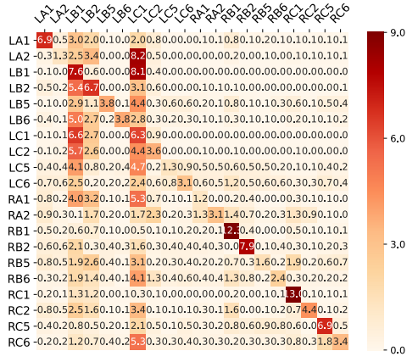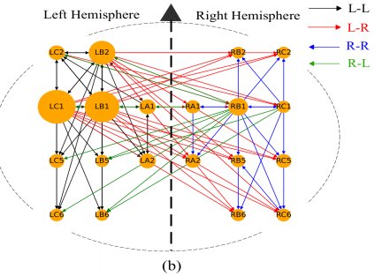
- (b)
Fig. S1-1 From DTF matrix to visualized seizure network, extracted from left-onset events in Patient 2000. (a) β band matrix. (b) Visualization of the seizure network by keeping top-15% edges.

References:
[1] G. Peng, M. Nourani and J. Harvey, "SEEG-Based bilateral seizure network analysis for neurostimulation treatment”, IEEE Transactions on Neural Systems and Rehabilitation Engineering, vol. 33, pp 664-674, 2025.

S2. Curves of density differences across frequency bands
In this section, for all eight patients, we show the curves of density differences (ΔD) over frequency bands. As demonstrated in the manuscript, this curve is used for optimal band selection, where the 95% quantile is the threshold.
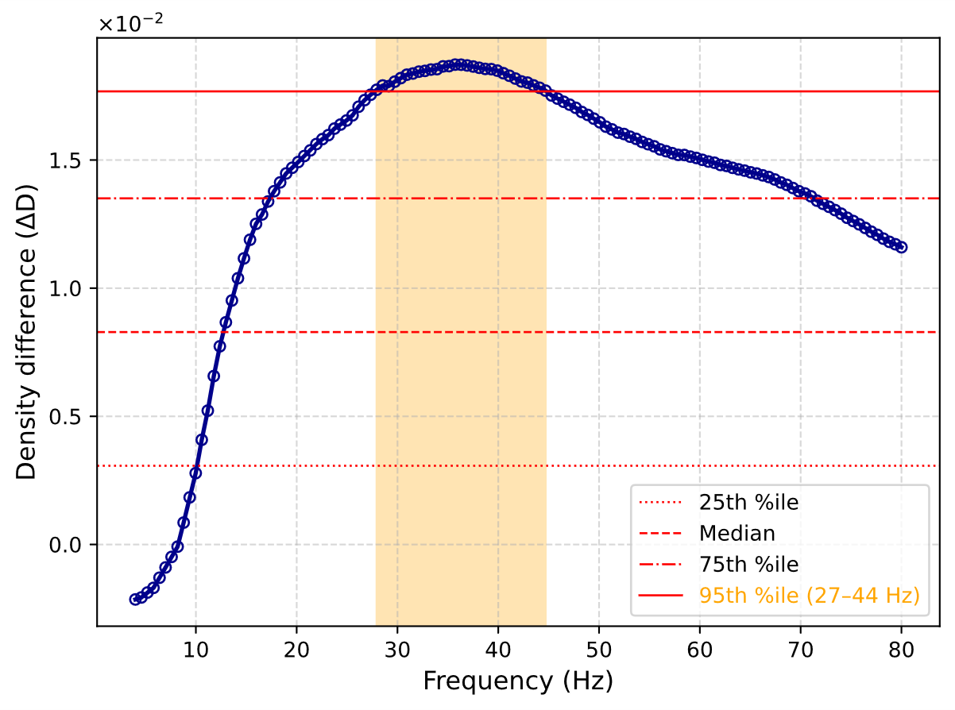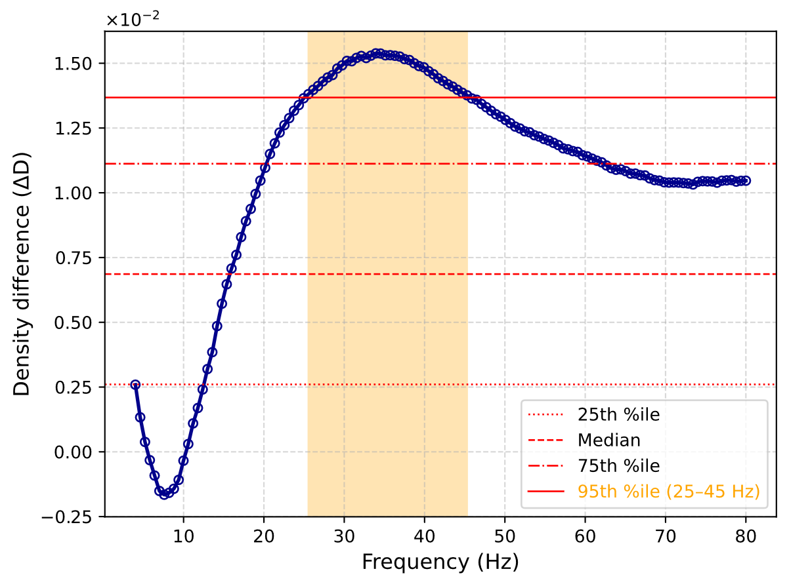
Fig. S2-1 ΔD across frequency ranges for left and right hemisphere seizures in Patient 2000.

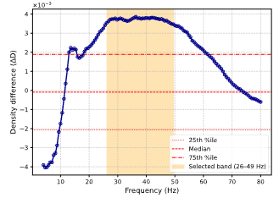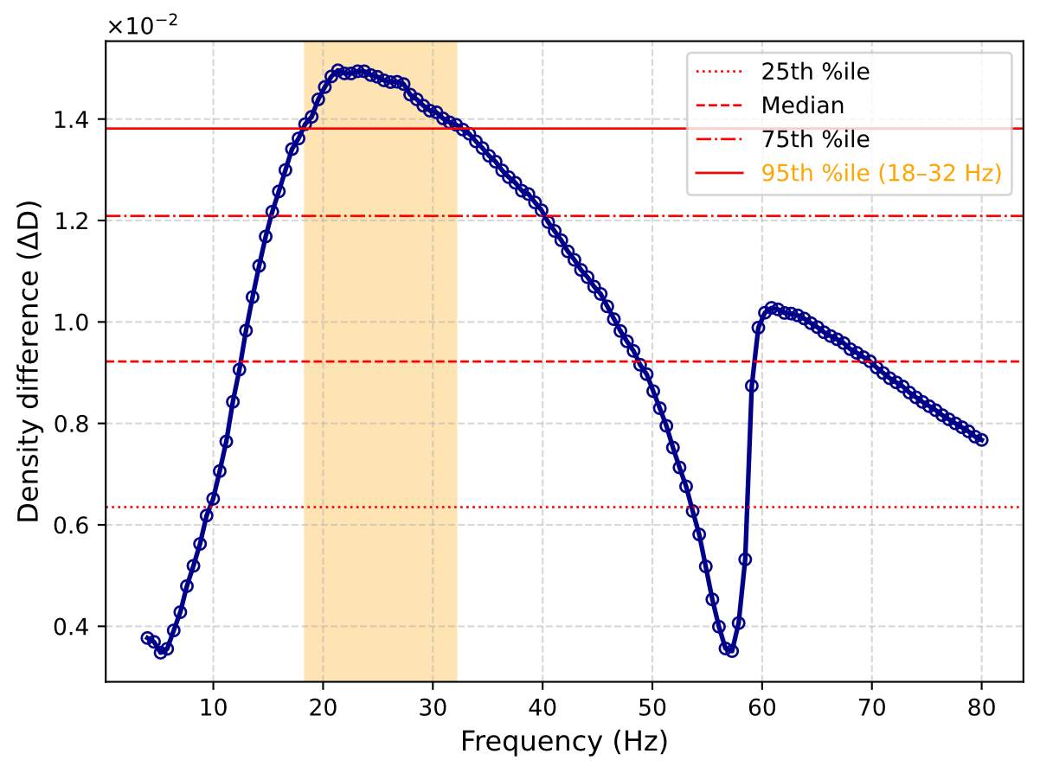

Fig. S2-2 ΔD across frequency ranges for left and right hemisphere seizures in Patient 2100.
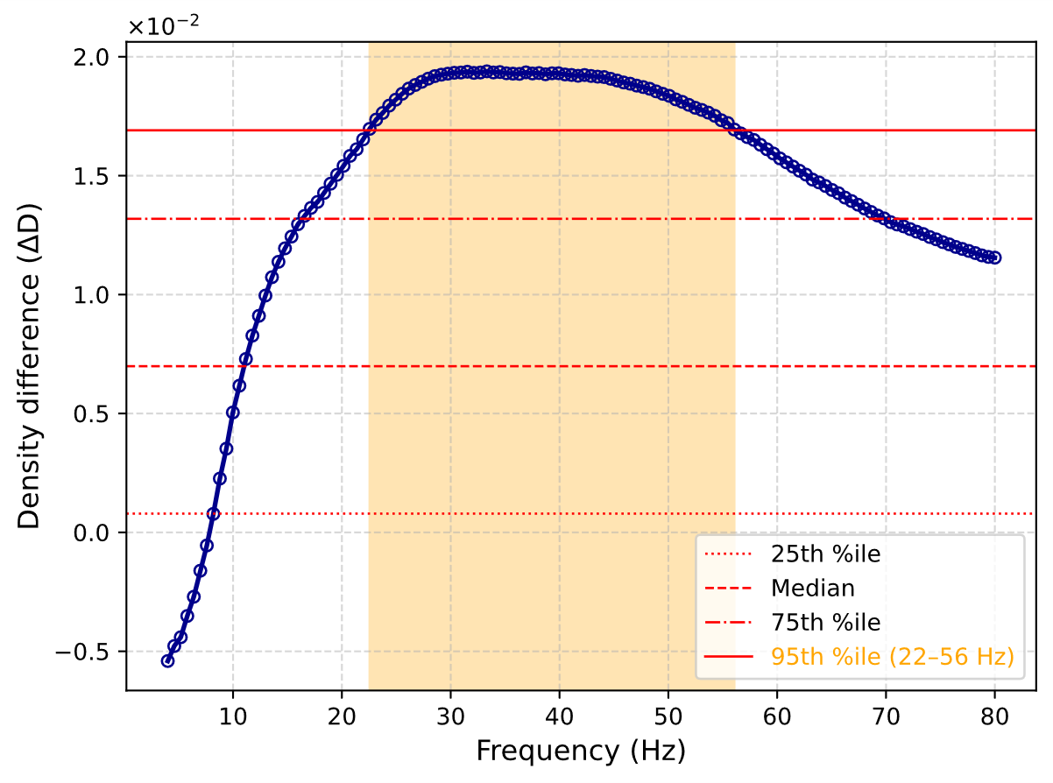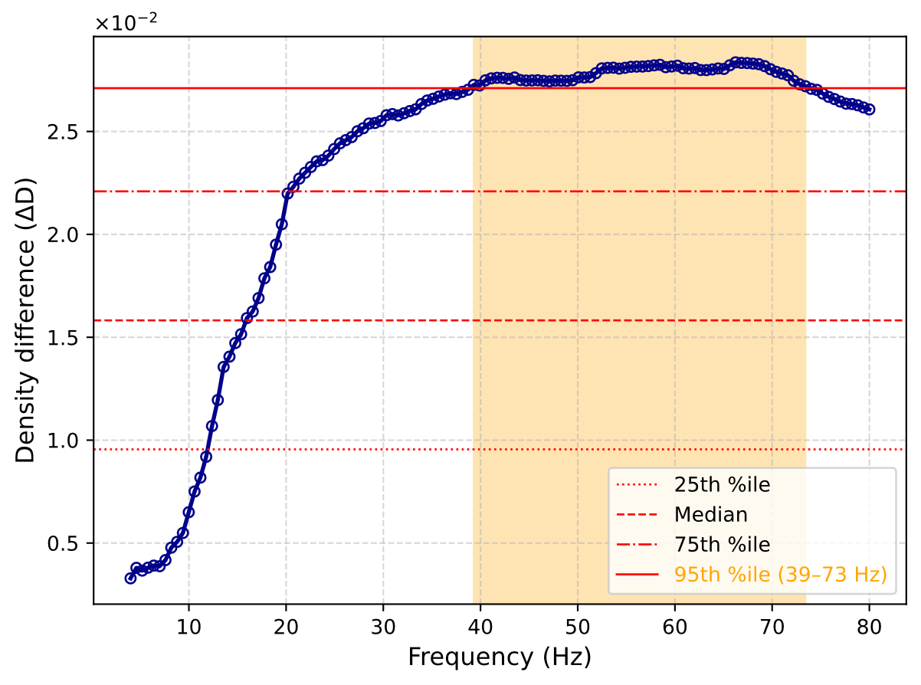
Fig. S2-3 ΔD across frequency ranges for left and right hemisphere seizures in Patient 2200.

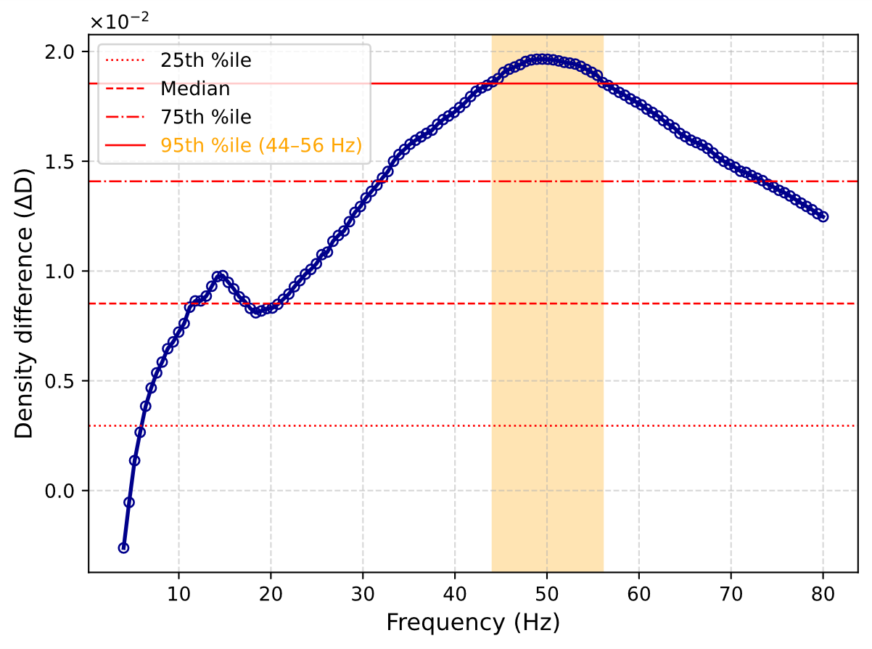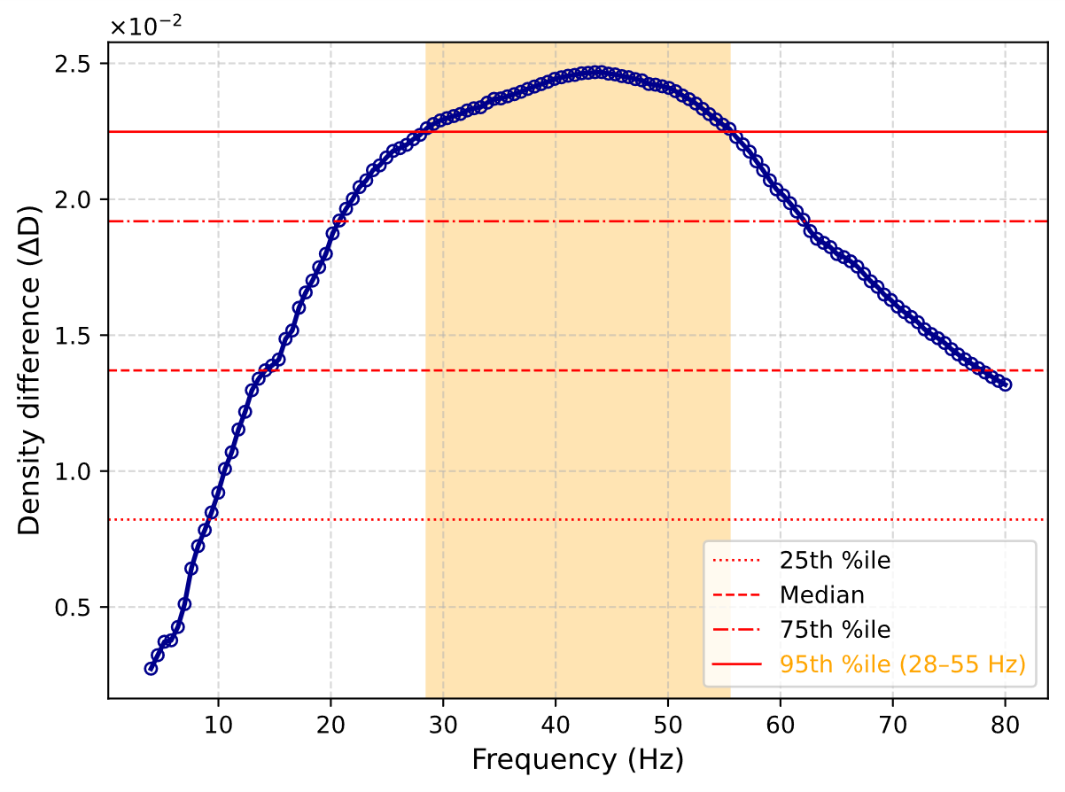
Fig. S2-4 ΔD across frequency ranges for left and right hemisphere seizures in Patient 2300.

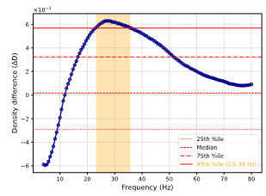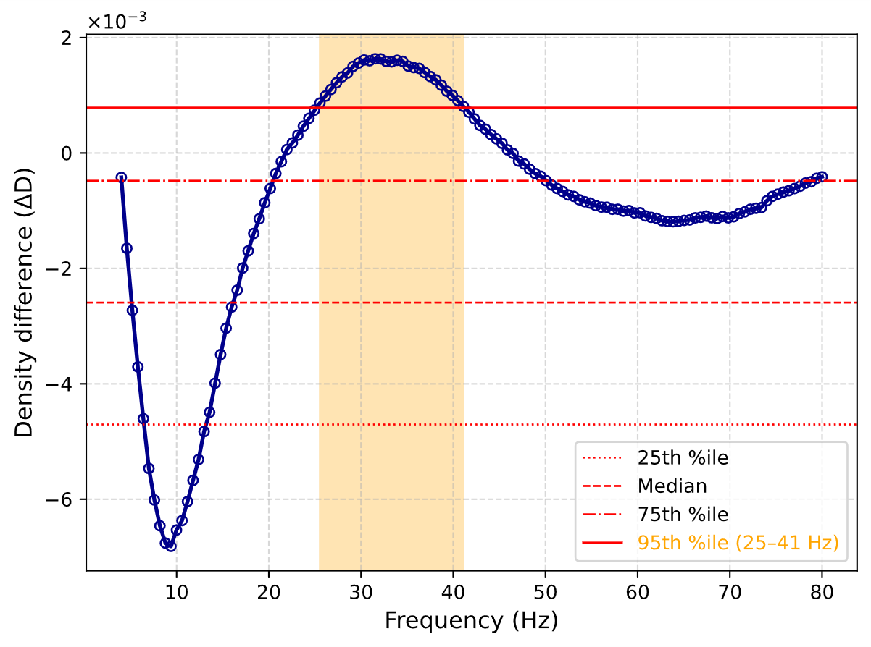
Fig. S2-5 ΔD across frequency ranges for left and right hemisphere seizures in Patient 2400.

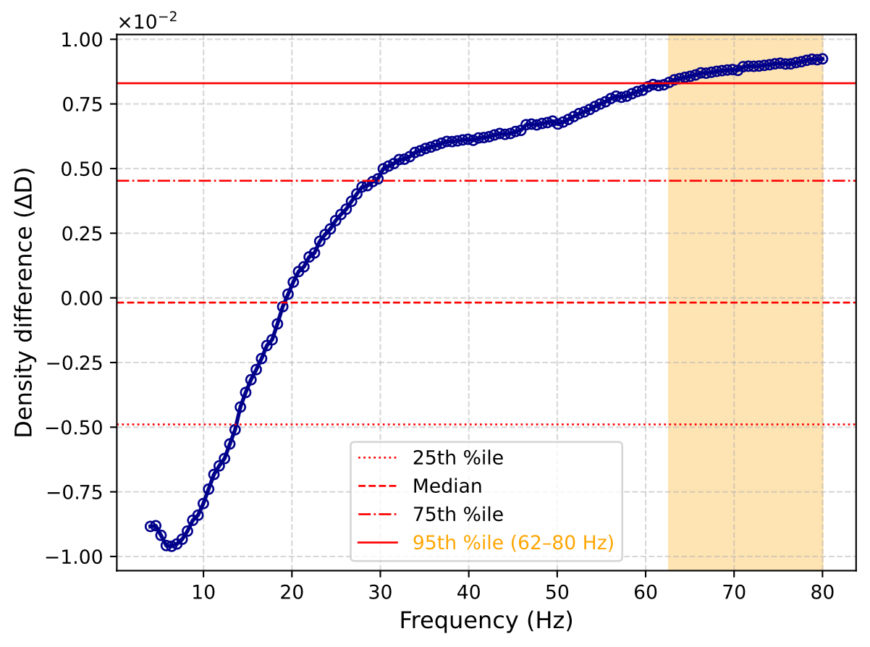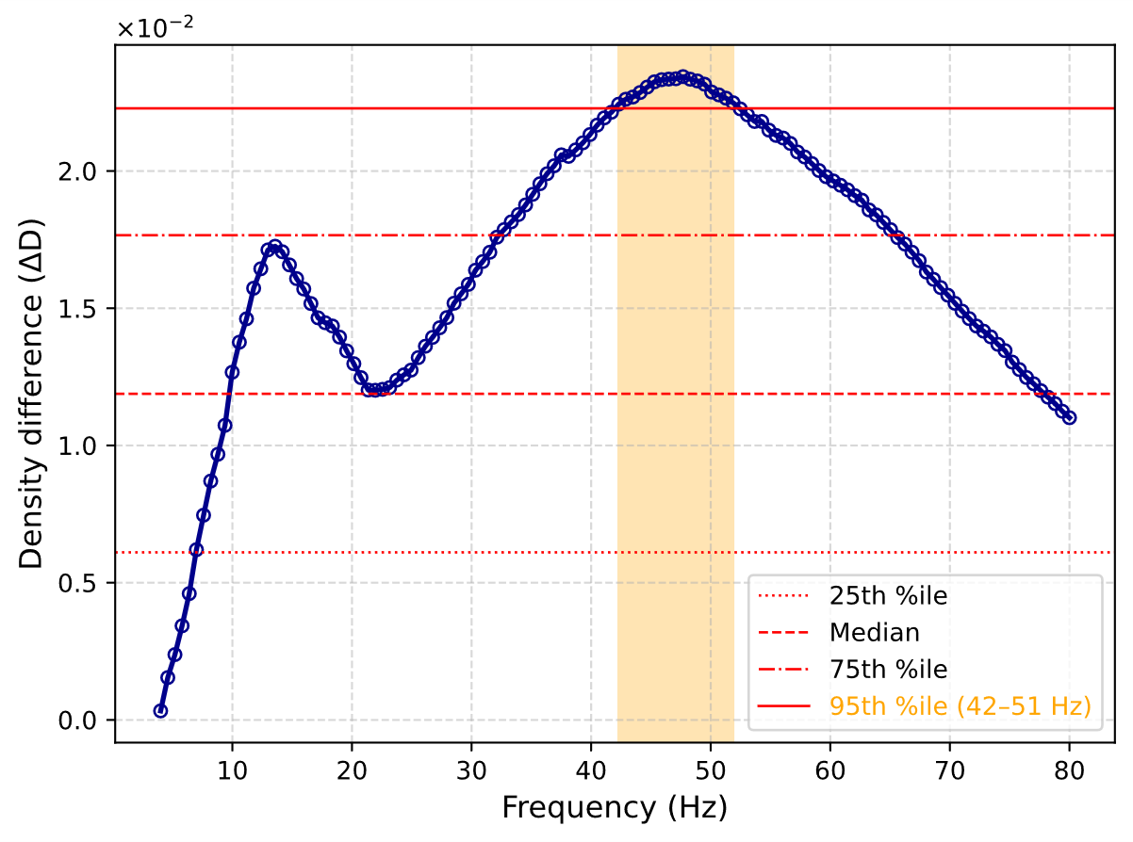
Fig. S2-6 ΔD across frequency ranges for left and right hemisphere seizures in Patient 2500.

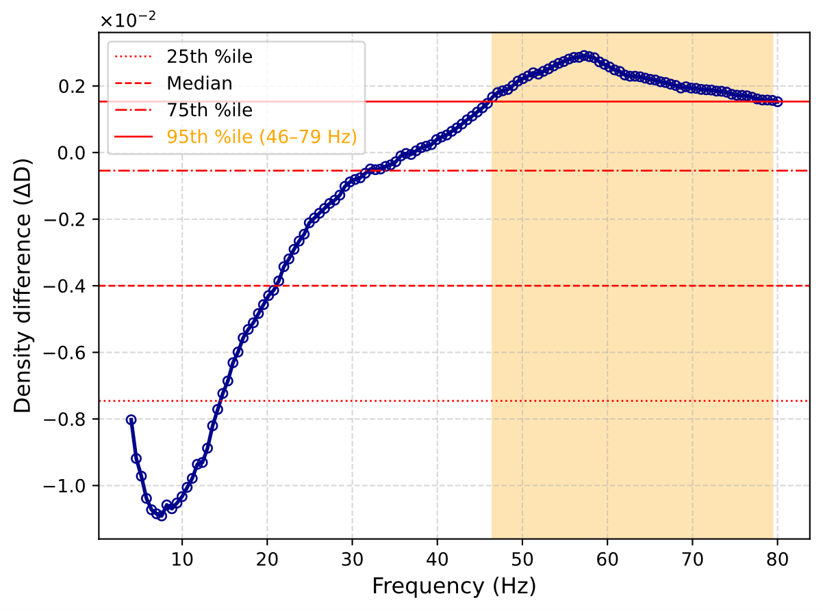
Fig. S2-7 ΔD across frequency ranges for left and right hemisphere seizures in Patient 2600.

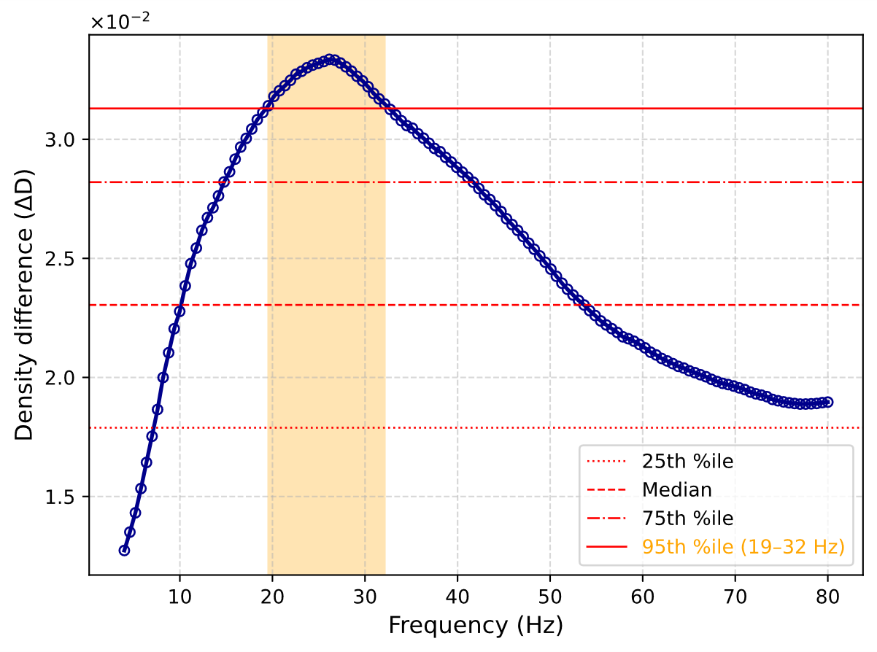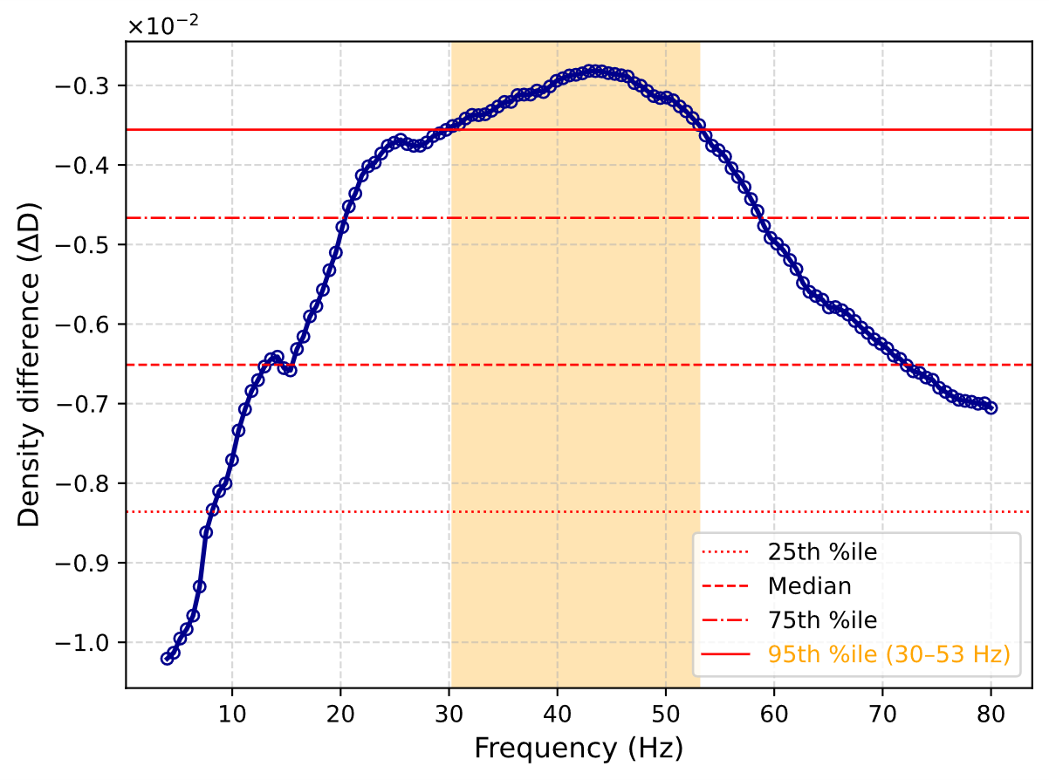
Fig. S2-8 ΔD across frequency ranges for left and right hemisphere seizures in Patient 2700.

