Codebook for Data

Autogenerated data summary from dataMaid

2020-02-03 07:46:13

# Data report overview

The dataset examined has the following dimensions:

|  |  |
| --- | --- |
| Feature | Result |
| Number of observations | 30897 |
| Number of variables | 68 |

# Codebook summary table

|  |  |  |  |  |  |
| --- | --- | --- | --- | --- | --- |
| Label | Variable | Class | # unique values | Missing | Description |
|  | **timeBodyAccelerometer-mean()-X** | numeric | 10293 | 66.67 % |  |
|  | **timeBodyAccelerometer-mean()-Y** | numeric | 10300 | 66.67 % |  |
|  | **timeBodyAccelerometer-mean()-Z** | numeric | 10294 | 66.67 % |  |
|  | **timeBodyAccelerometer-std()-X** | numeric | 10296 | 66.67 % |  |
|  | **timeBodyAccelerometer-std()-Y** | numeric | 10298 | 66.67 % |  |
|  | **timeBodyAccelerometer-std()-Z** | numeric | 10298 | 66.67 % |  |
|  | **timeGravityAccelerometer-mean()-X** | numeric | 10297 | 66.67 % |  |
|  | **timeGravityAccelerometer-mean()-Y** | numeric | 10299 | 66.67 % |  |
|  | **timeGravityAccelerometer-mean()-Z** | numeric | 10300 | 66.67 % |  |
|  | **timeGravityAccelerometer-std()-X** | numeric | 10289 | 66.67 % |  |
|  | **timeGravityAccelerometer-std()-Y** | numeric | 10294 | 66.67 % |  |
|  | **timeGravityAccelerometer-std()-Z** | numeric | 10297 | 66.67 % |  |
|  | **timeBodyAccelerometerJerk-mean()-X** | numeric | 10300 | 66.67 % |  |
|  | **timeBodyAccelerometerJerk-mean()-Y** | numeric | 10300 | 66.67 % |  |
|  | **timeBodyAccelerometerJerk-mean()-Z** | numeric | 10300 | 66.67 % |  |
|  | **timeBodyAccelerometerJerk-std()-X** | numeric | 10291 | 66.67 % |  |
|  | **timeBodyAccelerometerJerk-std()-Y** | numeric | 10297 | 66.67 % |  |
|  | **timeBodyAccelerometerJerk-std()-Z** | numeric | 10294 | 66.67 % |  |
|  | **timeBodyGyroscope-mean()-X** | numeric | 10299 | 66.67 % |  |
|  | **timeBodyGyroscope-mean()-Y** | numeric | 10300 | 66.67 % |  |
|  | **timeBodyGyroscope-mean()-Z** | numeric | 10298 | 66.67 % |  |
|  | **timeBodyGyroscope-std()-X** | numeric | 10293 | 66.67 % |  |
|  | **timeBodyGyroscope-std()-Y** | numeric | 10297 | 66.67 % |  |
|  | **timeBodyGyroscope-std()-Z** | numeric | 10297 | 66.67 % |  |
|  | **timeBodyGyroscopeJerk-mean()-X** | numeric | 10296 | 66.67 % |  |
|  | **timeBodyGyroscopeJerk-mean()-Y** | numeric | 10300 | 66.67 % |  |
|  | **timeBodyGyroscopeJerk-mean()-Z** | numeric | 10299 | 66.67 % |  |
|  | **timeBodyGyroscopeJerk-std()-X** | numeric | 10293 | 66.67 % |  |
|  | **timeBodyGyroscopeJerk-std()-Y** | numeric | 10296 | 66.67 % |  |
|  | **timeBodyGyroscopeJerk-std()-Z** | numeric | 10292 | 66.67 % |  |
|  | **timeBodyAccelerometerMagnitude-mean()** | numeric | 10297 | 66.67 % |  |
|  | **timeBodyAccelerometerMagnitude-std()** | numeric | 10295 | 66.67 % |  |
|  | **timeGravityAccelerometerMagnitude-mean()** | numeric | 10297 | 66.67 % |  |
|  | **timeGravityAccelerometerMagnitude-std()** | numeric | 10295 | 66.67 % |  |
|  | **timeBodyAccelerometerJerkMagnitude-mean()** | numeric | 10293 | 66.67 % |  |
|  | **timeBodyAccelerometerJerkMagnitude-std()** | numeric | 10295 | 66.67 % |  |
|  | **timeBodyGyroscopeMagnitude-mean()** | numeric | 10299 | 66.67 % |  |
|  | **timeBodyGyroscopeMagnitude-std()** | numeric | 10299 | 66.67 % |  |
|  | **timeBodyGyroscopeJerkMagnitude-mean()** | numeric | 10294 | 66.67 % |  |
|  | **timeBodyGyroscopeJerkMagnitude-std()** | numeric | 10298 | 66.67 % |  |
|  | **frequencyBodyAccelerometer-mean()-X** | numeric | 10296 | 66.67 % |  |
|  | **frequencyBodyAccelerometer-mean()-Y** | numeric | 10293 | 66.67 % |  |
|  | **frequencyBodyAccelerometer-mean()-Z** | numeric | 10296 | 66.67 % |  |
|  | **frequencyBodyAccelerometer-std()-X** | numeric | 10295 | 66.67 % |  |
|  | **frequencyBodyAccelerometer-std()-Y** | numeric | 10298 | 66.67 % |  |
|  | **frequencyBodyAccelerometer-std()-Z** | numeric | 10297 | 66.67 % |  |
|  | **frequencyBodyAccelerometerJerk-mean()-X** | numeric | 10294 | 66.67 % |  |
|  | **frequencyBodyAccelerometerJerk-mean()-Y** | numeric | 10297 | 66.67 % |  |
|  | **frequencyBodyAccelerometerJerk-mean()-Z** | numeric | 10295 | 66.67 % |  |
|  | **frequencyBodyAccelerometerJerk-std()-X** | numeric | 10292 | 66.67 % |  |
|  | **frequencyBodyAccelerometerJerk-std()-Y** | numeric | 10295 | 66.67 % |  |
|  | **frequencyBodyAccelerometerJerk-std()-Z** | numeric | 10291 | 66.67 % |  |
|  | **frequencyBodyGyroscope-mean()-X** | numeric | 10298 | 66.67 % |  |
|  | **frequencyBodyGyroscope-mean()-Y** | numeric | 10297 | 66.67 % |  |
|  | **frequencyBodyGyroscope-mean()-Z** | numeric | 10298 | 66.67 % |  |
|  | **frequencyBodyGyroscope-std()-X** | numeric | 10298 | 66.67 % |  |
|  | **frequencyBodyGyroscope-std()-Y** | numeric | 10294 | 66.67 % |  |
|  | **frequencyBodyGyroscope-std()-Z** | numeric | 10296 | 66.67 % |  |
|  | **frequencyBodyAccelerometerMagnitude-mean()** | numeric | 10297 | 66.67 % |  |
|  | **frequencyBodyAccelerometerMagnitude-std()** | numeric | 10299 | 66.67 % |  |
|  | **frequencyBodyAccelerometerJerkMagnitude-mean()** | numeric | 10291 | 66.67 % |  |
|  | **frequencyBodyAccelerometerJerkMagnitude-std()** | numeric | 10297 | 66.67 % |  |
|  | **frequencyBodyGyroscopeMagnitude-mean()** | numeric | 10298 | 66.67 % |  |
|  | **frequencyBodyGyroscopeMagnitude-std()** | numeric | 10297 | 66.67 % |  |
|  | **frequencyBodyGyroscopeJerkMagnitude-mean()** | numeric | 10294 | 66.67 % |  |
|  | **frequencyBodyGyroscopeJerkMagnitude-std()** | numeric | 10293 | 66.67 % |  |
|  | **subject** | integer | 31 | 66.67 % |  |
|  | **activity** | integer | 7 | 66.67 % |  |

# Variable list

## timeBodyAccelerometer-mean()-X

|  |  |
| --- | --- |
| Feature | Result |
| Variable type | numeric |
| Number of missing obs. | 20598 (66.67 %) |
| Number of unique values | 10292 |
| Median | 0.28 |
| 1st and 3rd quartiles | 0.26; 0.29 |
| Min. and max. | -1; 1 |

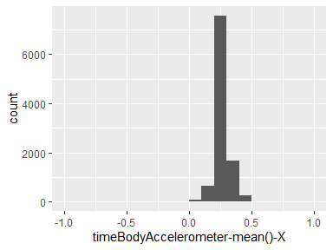

## timeBodyAccelerometer-mean()-Y

|  |  |
| --- | --- |
| Feature | Result |
| Variable type | numeric |
| Number of missing obs. | 20598 (66.67 %) |
| Number of unique values | 10299 |
| Median | -0.02 |
| 1st and 3rd quartiles | -0.02; -0.01 |
| Min. and max. | -1; 1 |

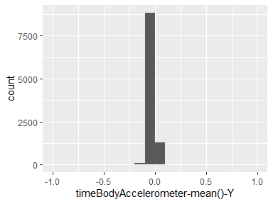

## timeBodyAccelerometer-mean()-Z

|  |  |
| --- | --- |
| Feature | Result |
| Variable type | numeric |
| Number of missing obs. | 20598 (66.67 %) |
| Number of unique values | 10293 |
| Median | -0.11 |
| 1st and 3rd quartiles | -0.12; -0.1 |
| Min. and max. | -1; 1 |

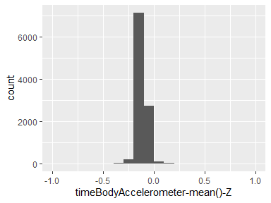

## timeBodyAccelerometer-std()-X

|  |  |
| --- | --- |
| Feature | Result |
| Variable type | numeric |
| Number of missing obs. | 20598 (66.67 %) |
| Number of unique values | 10295 |
| Median | -0.94 |
| 1st and 3rd quartiles | -0.99; -0.25 |
| Min. and max. | -1; 1 |

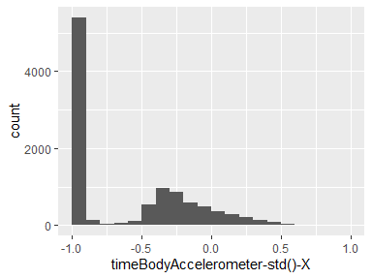

## timeBodyAccelerometer-std()-Y

|  |  |
| --- | --- |
| Feature | Result |
| Variable type | numeric |
| Number of missing obs. | 20598 (66.67 %) |
| Number of unique values | 10297 |
| Median | -0.84 |
| 1st and 3rd quartiles | -0.98; -0.06 |
| Min. and max. | -1; 1 |

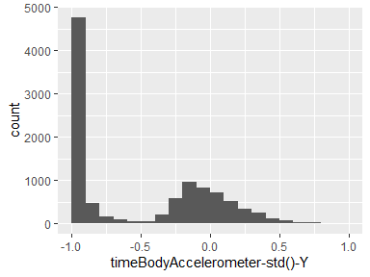

## timeBodyAccelerometer-std()-Z

|  |  |
| --- | --- |
| Feature | Result |
| Variable type | numeric |
| Number of missing obs. | 20598 (66.67 %) |
| Number of unique values | 10297 |
| Median | -0.85 |
| 1st and 3rd quartiles | -0.98; -0.28 |
| Min. and max. | -1; 1 |

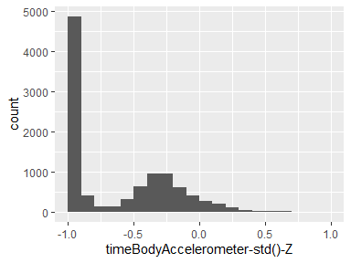

## timeGravityAccelerometer-mean()-X

|  |  |
| --- | --- |
| Feature | Result |
| Variable type | numeric |
| Number of missing obs. | 20598 (66.67 %) |
| Number of unique values | 10296 |
| Median | 0.92 |
| 1st and 3rd quartiles | 0.81; 0.95 |
| Min. and max. | -1; 1 |

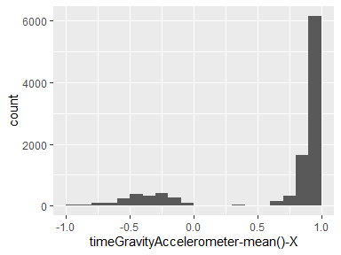

## timeGravityAccelerometer-mean()-Y

|  |  |
| --- | --- |
| Feature | Result |
| Variable type | numeric |
| Number of missing obs. | 20598 (66.67 %) |
| Number of unique values | 10298 |
| Median | -0.14 |
| 1st and 3rd quartiles | -0.24; 0.12 |
| Min. and max. | -1; 1 |

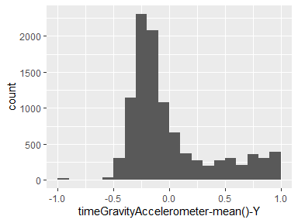

## timeGravityAccelerometer-mean()-Z

|  |  |
| --- | --- |
| Feature | Result |
| Variable type | numeric |
| Number of missing obs. | 20598 (66.67 %) |
| Number of unique values | 10299 |
| Median | 0.04 |
| 1st and 3rd quartiles | -0.12; 0.22 |
| Min. and max. | -1; 1 |

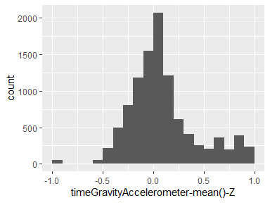

## timeGravityAccelerometer-std()-X

|  |  |
| --- | --- |
| Feature | Result |
| Variable type | numeric |
| Number of missing obs. | 20598 (66.67 %) |
| Number of unique values | 10288 |
| Median | -0.98 |
| 1st and 3rd quartiles | -0.99; -0.96 |
| Min. and max. | -1; 1 |

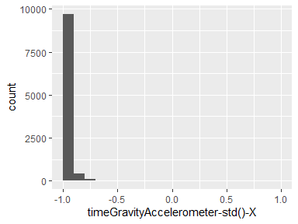

## timeGravityAccelerometer-std()-Y

|  |  |
| --- | --- |
| Feature | Result |
| Variable type | numeric |
| Number of missing obs. | 20598 (66.67 %) |
| Number of unique values | 10293 |
| Median | -0.98 |
| 1st and 3rd quartiles | -0.99; -0.95 |
| Min. and max. | -1; 1 |

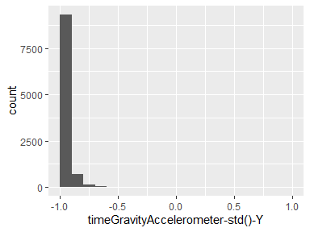

## timeGravityAccelerometer-std()-Z

|  |  |
| --- | --- |
| Feature | Result |
| Variable type | numeric |
| Number of missing obs. | 20598 (66.67 %) |
| Number of unique values | 10296 |
| Median | -0.97 |
| 1st and 3rd quartiles | -0.99; -0.93 |
| Min. and max. | -1; 1 |

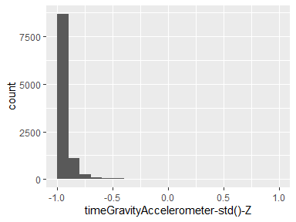

## timeBodyAccelerometerJerk-mean()-X

|  |  |
| --- | --- |
| Feature | Result |
| Variable type | numeric |
| Number of missing obs. | 20598 (66.67 %) |
| Number of unique values | 10299 |
| Median | 0.08 |
| 1st and 3rd quartiles | 0.06; 0.09 |
| Min. and max. | -1; 1 |

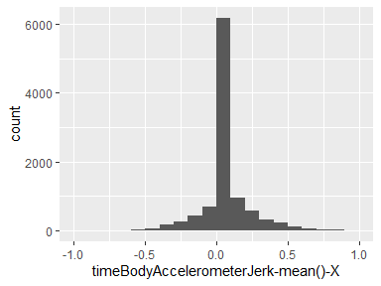

## timeBodyAccelerometerJerk-mean()-Y

|  |  |
| --- | --- |
| Feature | Result |
| Variable type | numeric |
| Number of missing obs. | 20598 (66.67 %) |
| Number of unique values | 10299 |
| Median | 0.01 |
| 1st and 3rd quartiles | -0.02; 0.03 |
| Min. and max. | -1; 1 |

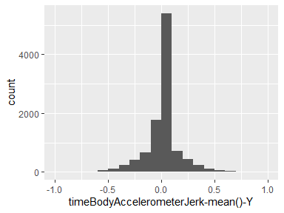

## timeBodyAccelerometerJerk-mean()-Z

|  |  |
| --- | --- |
| Feature | Result |
| Variable type | numeric |
| Number of missing obs. | 20598 (66.67 %) |
| Number of unique values | 10299 |
| Median | 0 |
| 1st and 3rd quartiles | -0.03; 0.02 |
| Min. and max. | -1; 1 |

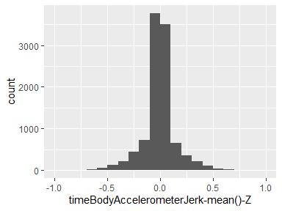

## timeBodyAccelerometerJerk-std()-X

|  |  |
| --- | --- |
| Feature | Result |
| Variable type | numeric |
| Number of missing obs. | 20598 (66.67 %) |
| Number of unique values | 10290 |
| Median | -0.95 |
| 1st and 3rd quartiles | -0.99; -0.29 |
| Min. and max. | -1; 1 |

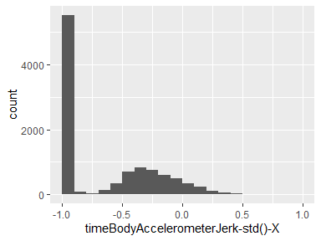

## timeBodyAccelerometerJerk-std()-Y

|  |  |
| --- | --- |
| Feature | Result |
| Variable type | numeric |
| Number of missing obs. | 20598 (66.67 %) |
| Number of unique values | 10296 |
| Median | -0.93 |
| 1st and 3rd quartiles | -0.99; -0.22 |
| Min. and max. | -1; 1 |

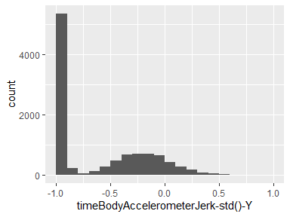

## timeBodyAccelerometerJerk-std()-Z

|  |  |
| --- | --- |
| Feature | Result |
| Variable type | numeric |
| Number of missing obs. | 20598 (66.67 %) |
| Number of unique values | 10293 |
| Median | -0.95 |
| 1st and 3rd quartiles | -0.99; -0.55 |
| Min. and max. | -1; 1 |

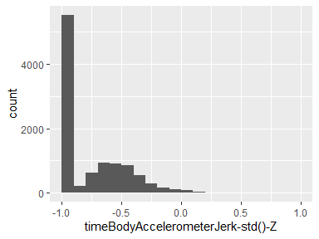

## timeBodyGyroscope-mean()-X

|  |  |
| --- | --- |
| Feature | Result |
| Variable type | numeric |
| Number of missing obs. | 20598 (66.67 %) |
| Number of unique values | 10298 |
| Median | -0.03 |
| 1st and 3rd quartiles | -0.05; -0.01 |
| Min. and max. | -1; 1 |

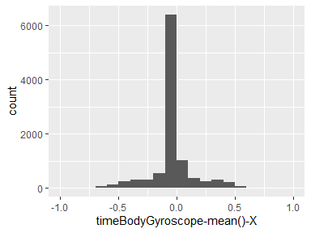

## timeBodyGyroscope-mean()-Y

|  |  |
| --- | --- |
| Feature | Result |
| Variable type | numeric |
| Number of missing obs. | 20598 (66.67 %) |
| Number of unique values | 10299 |
| Median | -0.07 |
| 1st and 3rd quartiles | -0.1; -0.05 |
| Min. and max. | -1; 1 |

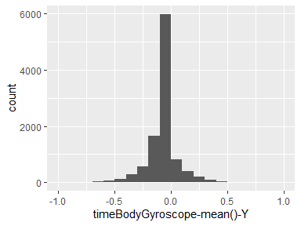

## timeBodyGyroscope-mean()-Z

|  |  |
| --- | --- |
| Feature | Result |
| Variable type | numeric |
| Number of missing obs. | 20598 (66.67 %) |
| Number of unique values | 10297 |
| Median | 0.09 |
| 1st and 3rd quartiles | 0.06; 0.11 |
| Min. and max. | -1; 1 |

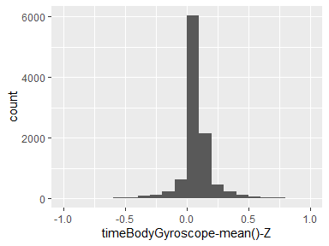

## timeBodyGyroscope-std()-X

|  |  |
| --- | --- |
| Feature | Result |
| Variable type | numeric |
| Number of missing obs. | 20598 (66.67 %) |
| Number of unique values | 10292 |
| Median | -0.9 |
| 1st and 3rd quartiles | -0.99; -0.48 |
| Min. and max. | -1; 1 |

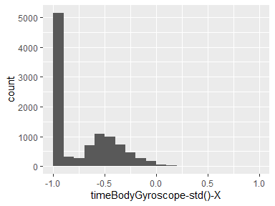

## timeBodyGyroscope-std()-Y

|  |  |
| --- | --- |
| Feature | Result |
| Variable type | numeric |
| Number of missing obs. | 20598 (66.67 %) |
| Number of unique values | 10296 |
| Median | -0.91 |
| 1st and 3rd quartiles | -0.98; -0.45 |
| Min. and max. | -1; 1 |

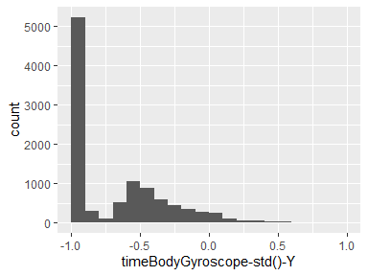

## timeBodyGyroscope-std()-Z

|  |  |
| --- | --- |
| Feature | Result |
| Variable type | numeric |
| Number of missing obs. | 20598 (66.67 %) |
| Number of unique values | 10296 |
| Median | -0.88 |
| 1st and 3rd quartiles | -0.99; -0.34 |
| Min. and max. | -1; 1 |

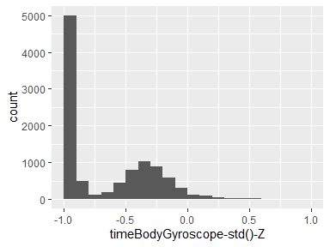

## timeBodyGyroscopeJerk-mean()-X

|  |  |
| --- | --- |
| Feature | Result |
| Variable type | numeric |
| Number of missing obs. | 20598 (66.67 %) |
| Number of unique values | 10295 |
| Median | -0.1 |
| 1st and 3rd quartiles | -0.12; -0.08 |
| Min. and max. | -1; 1 |

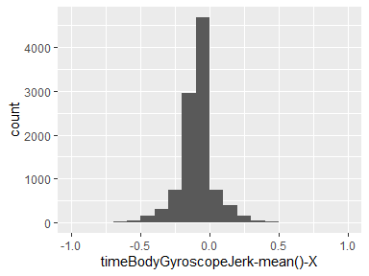

## timeBodyGyroscopeJerk-mean()-Y

|  |  |
| --- | --- |
| Feature | Result |
| Variable type | numeric |
| Number of missing obs. | 20598 (66.67 %) |
| Number of unique values | 10299 |
| Median | -0.04 |
| 1st and 3rd quartiles | -0.06; -0.03 |
| Min. and max. | -1; 1 |

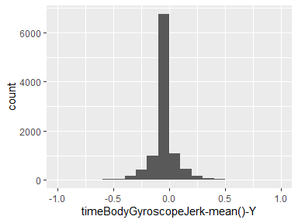

## timeBodyGyroscopeJerk-mean()-Z

|  |  |
| --- | --- |
| Feature | Result |
| Variable type | numeric |
| Number of missing obs. | 20598 (66.67 %) |
| Number of unique values | 10298 |
| Median | -0.05 |
| 1st and 3rd quartiles | -0.08; -0.03 |
| Min. and max. | -1; 1 |

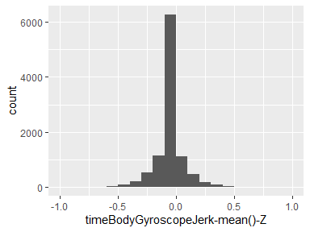

## timeBodyGyroscopeJerk-std()-X

|  |  |
| --- | --- |
| Feature | Result |
| Variable type | numeric |
| Number of missing obs. | 20598 (66.67 %) |
| Number of unique values | 10292 |
| Median | -0.93 |
| 1st and 3rd quartiles | -0.99; -0.49 |
| Min. and max. | -1; 1 |

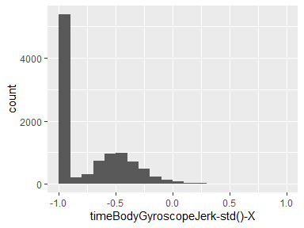

## timeBodyGyroscopeJerk-std()-Y

|  |  |
| --- | --- |
| Feature | Result |
| Variable type | numeric |
| Number of missing obs. | 20598 (66.67 %) |
| Number of unique values | 10295 |
| Median | -0.95 |
| 1st and 3rd quartiles | -0.99; -0.63 |
| Min. and max. | -1; 1 |

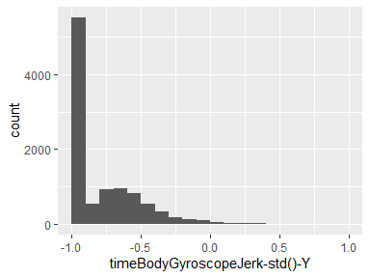

## timeBodyGyroscopeJerk-std()-Z

|  |  |
| --- | --- |
| Feature | Result |
| Variable type | numeric |
| Number of missing obs. | 20598 (66.67 %) |
| Number of unique values | 10291 |
| Median | -0.95 |
| 1st and 3rd quartiles | -0.99; -0.51 |
| Min. and max. | -1; 1 |

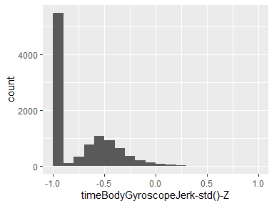

## timeBodyAccelerometerMagnitude-mean()

|  |  |
| --- | --- |
| Feature | Result |
| Variable type | numeric |
| Number of missing obs. | 20598 (66.67 %) |
| Number of unique values | 10296 |
| Median | -0.87 |
| 1st and 3rd quartiles | -0.98; -0.12 |
| Min. and max. | -1; 1 |

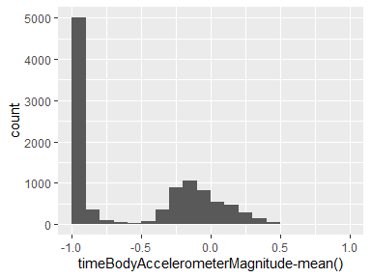

## timeBodyAccelerometerMagnitude-std()

|  |  |
| --- | --- |
| Feature | Result |
| Variable type | numeric |
| Number of missing obs. | 20598 (66.67 %) |
| Number of unique values | 10294 |
| Median | -0.84 |
| 1st and 3rd quartiles | -0.98; -0.24 |
| Min. and max. | -1; 1 |

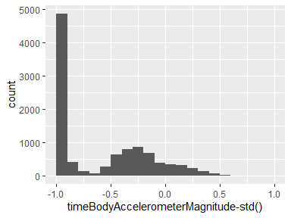

## timeGravityAccelerometerMagnitude-mean()

|  |  |
| --- | --- |
| Feature | Result |
| Variable type | numeric |
| Number of missing obs. | 20598 (66.67 %) |
| Number of unique values | 10296 |
| Median | -0.87 |
| 1st and 3rd quartiles | -0.98; -0.12 |
| Min. and max. | -1; 1 |

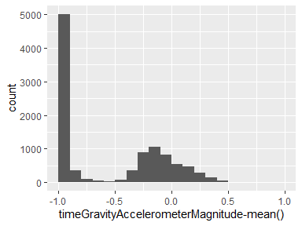

## timeGravityAccelerometerMagnitude-std()

|  |  |
| --- | --- |
| Feature | Result |
| Variable type | numeric |
| Number of missing obs. | 20598 (66.67 %) |
| Number of unique values | 10294 |
| Median | -0.84 |
| 1st and 3rd quartiles | -0.98; -0.24 |
| Min. and max. | -1; 1 |

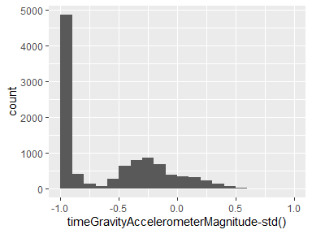

## timeBodyAccelerometerJerkMagnitude-mean()

|  |  |
| --- | --- |
| Feature | Result |
| Variable type | numeric |
| Number of missing obs. | 20598 (66.67 %) |
| Number of unique values | 10292 |
| Median | -0.95 |
| 1st and 3rd quartiles | -0.99; -0.3 |
| Min. and max. | -1; 1 |

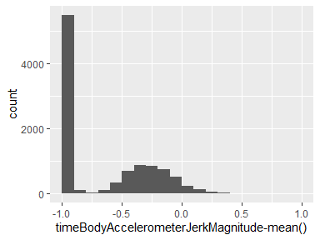

## timeBodyAccelerometerJerkMagnitude-std()

|  |  |
| --- | --- |
| Feature | Result |
| Variable type | numeric |
| Number of missing obs. | 20598 (66.67 %) |
| Number of unique values | 10294 |
| Median | -0.93 |
| 1st and 3rd quartiles | -0.99; -0.27 |
| Min. and max. | -1; 1 |

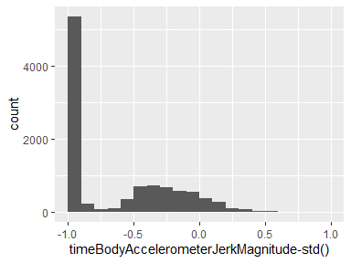

## timeBodyGyroscopeMagnitude-mean()

|  |  |
| --- | --- |
| Feature | Result |
| Variable type | numeric |
| Number of missing obs. | 20598 (66.67 %) |
| Number of unique values | 10298 |
| Median | -0.82 |
| 1st and 3rd quartiles | -0.98; -0.25 |
| Min. and max. | -1; 1 |

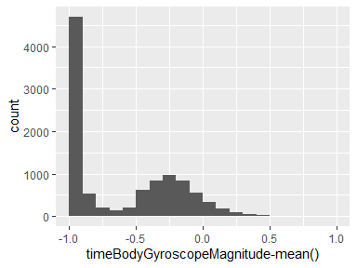

## timeBodyGyroscopeMagnitude-std()

|  |  |
| --- | --- |
| Feature | Result |
| Variable type | numeric |
| Number of missing obs. | 20598 (66.67 %) |
| Number of unique values | 10298 |
| Median | -0.83 |
| 1st and 3rd quartiles | -0.98; -0.39 |
| Min. and max. | -1; 1 |

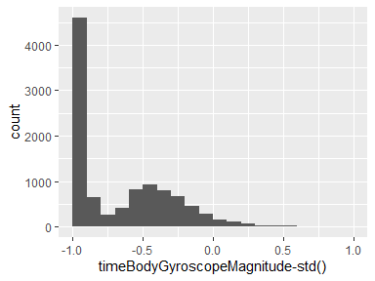

## timeBodyGyroscopeJerkMagnitude-mean()

|  |  |
| --- | --- |
| Feature | Result |
| Variable type | numeric |
| Number of missing obs. | 20598 (66.67 %) |
| Number of unique values | 10293 |
| Median | -0.96 |
| 1st and 3rd quartiles | -0.99; -0.55 |
| Min. and max. | -1; 1 |

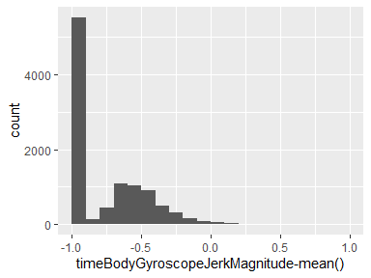

## timeBodyGyroscopeJerkMagnitude-std()

|  |  |
| --- | --- |
| Feature | Result |
| Variable type | numeric |
| Number of missing obs. | 20598 (66.67 %) |
| Number of unique values | 10297 |
| Median | -0.94 |
| 1st and 3rd quartiles | -0.99; -0.61 |
| Min. and max. | -1; 1 |

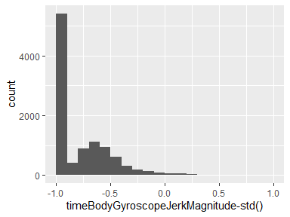

## frequencyBodyAccelerometer-mean()-X

|  |  |
| --- | --- |
| Feature | Result |
| Variable type | numeric |
| Number of missing obs. | 20598 (66.67 %) |
| Number of unique values | 10295 |
| Median | -0.95 |
| 1st and 3rd quartiles | -0.99; -0.26 |
| Min. and max. | -1; 1 |

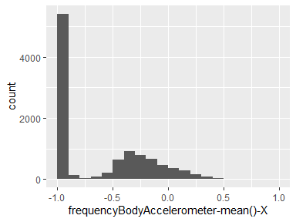

## frequencyBodyAccelerometer-mean()-Y

|  |  |
| --- | --- |
| Feature | Result |
| Variable type | numeric |
| Number of missing obs. | 20598 (66.67 %) |
| Number of unique values | 10292 |
| Median | -0.86 |
| 1st and 3rd quartiles | -0.98; -0.1 |
| Min. and max. | -1; 1 |

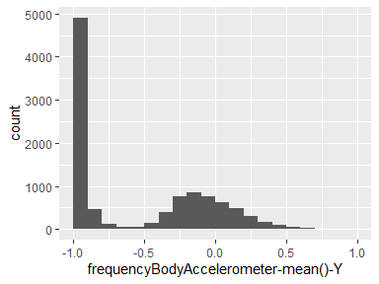

## frequencyBodyAccelerometer-mean()-Z

|  |  |
| --- | --- |
| Feature | Result |
| Variable type | numeric |
| Number of missing obs. | 20598 (66.67 %) |
| Number of unique values | 10295 |
| Median | -0.9 |
| 1st and 3rd quartiles | -0.98; -0.37 |
| Min. and max. | -1; 1 |

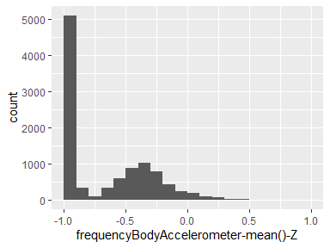

## frequencyBodyAccelerometer-std()-X

|  |  |
| --- | --- |
| Feature | Result |
| Variable type | numeric |
| Number of missing obs. | 20598 (66.67 %) |
| Number of unique values | 10294 |
| Median | -0.94 |
| 1st and 3rd quartiles | -0.99; -0.25 |
| Min. and max. | -1; 1 |

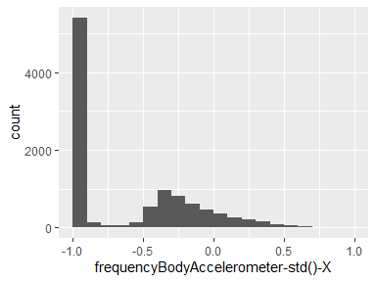

## frequencyBodyAccelerometer-std()-Y

|  |  |
| --- | --- |
| Feature | Result |
| Variable type | numeric |
| Number of missing obs. | 20598 (66.67 %) |
| Number of unique values | 10297 |
| Median | -0.83 |
| 1st and 3rd quartiles | -0.98; -0.09 |
| Min. and max. | -1; 1 |

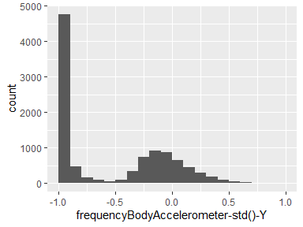

## frequencyBodyAccelerometer-std()-Z

|  |  |
| --- | --- |
| Feature | Result |
| Variable type | numeric |
| Number of missing obs. | 20598 (66.67 %) |
| Number of unique values | 10296 |
| Median | -0.84 |
| 1st and 3rd quartiles | -0.98; -0.3 |
| Min. and max. | -1; 1 |

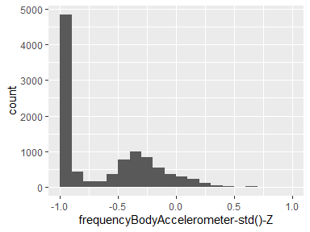

## frequencyBodyAccelerometerJerk-mean()-X

|  |  |
| --- | --- |
| Feature | Result |
| Variable type | numeric |
| Number of missing obs. | 20598 (66.67 %) |
| Number of unique values | 10293 |
| Median | -0.95 |
| 1st and 3rd quartiles | -0.99; -0.33 |
| Min. and max. | -1; 1 |

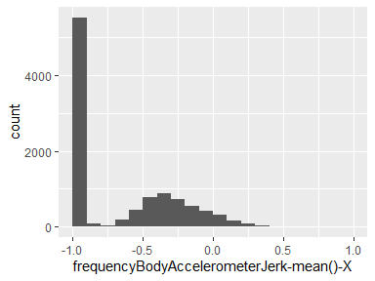

## frequencyBodyAccelerometerJerk-mean()-Y

|  |  |
| --- | --- |
| Feature | Result |
| Variable type | numeric |
| Number of missing obs. | 20598 (66.67 %) |
| Number of unique values | 10296 |
| Median | -0.93 |
| 1st and 3rd quartiles | -0.98; -0.26 |
| Min. and max. | -1; 1 |

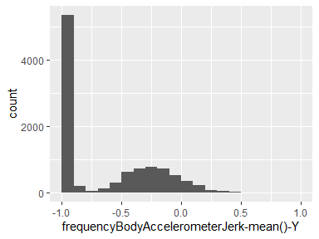

## frequencyBodyAccelerometerJerk-mean()-Z

|  |  |
| --- | --- |
| Feature | Result |
| Variable type | numeric |
| Number of missing obs. | 20598 (66.67 %) |
| Number of unique values | 10294 |
| Median | -0.95 |
| 1st and 3rd quartiles | -0.99; -0.51 |
| Min. and max. | -1; 1 |

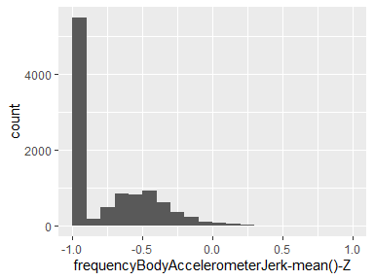

## frequencyBodyAccelerometerJerk-std()-X

|  |  |
| --- | --- |
| Feature | Result |
| Variable type | numeric |
| Number of missing obs. | 20598 (66.67 %) |
| Number of unique values | 10291 |
| Median | -0.96 |
| 1st and 3rd quartiles | -0.99; -0.32 |
| Min. and max. | -1; 1 |

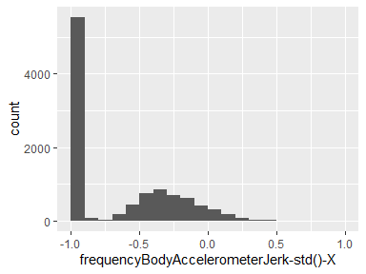

## frequencyBodyAccelerometerJerk-std()-Y

|  |  |
| --- | --- |
| Feature | Result |
| Variable type | numeric |
| Number of missing obs. | 20598 (66.67 %) |
| Number of unique values | 10294 |
| Median | -0.93 |
| 1st and 3rd quartiles | -0.99; -0.24 |
| Min. and max. | -1; 1 |

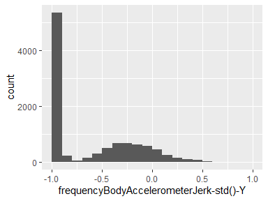

## frequencyBodyAccelerometerJerk-std()-Z

|  |  |
| --- | --- |
| Feature | Result |
| Variable type | numeric |
| Number of missing obs. | 20598 (66.67 %) |
| Number of unique values | 10290 |
| Median | -0.96 |
| 1st and 3rd quartiles | -0.99; -0.59 |
| Min. and max. | -1; 1 |

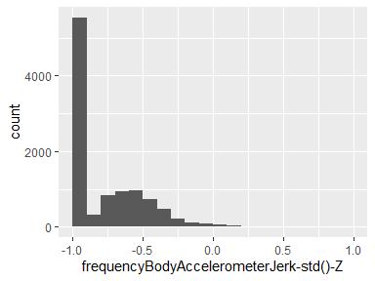

## frequencyBodyGyroscope-mean()-X

|  |  |
| --- | --- |
| Feature | Result |
| Variable type | numeric |
| Number of missing obs. | 20598 (66.67 %) |
| Number of unique values | 10297 |
| Median | -0.89 |
| 1st and 3rd quartiles | -0.99; -0.38 |
| Min. and max. | -1; 1 |

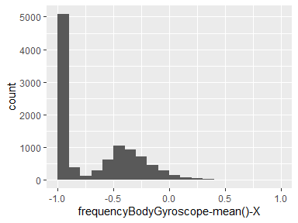

## frequencyBodyGyroscope-mean()-Y

|  |  |
| --- | --- |
| Feature | Result |
| Variable type | numeric |
| Number of missing obs. | 20598 (66.67 %) |
| Number of unique values | 10296 |
| Median | -0.92 |
| 1st and 3rd quartiles | -0.98; -0.47 |
| Min. and max. | -1; 1 |

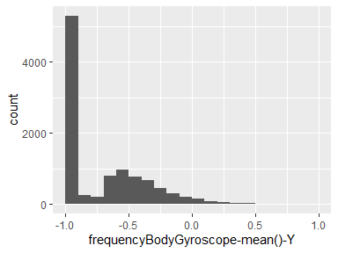

## frequencyBodyGyroscope-mean()-Z

|  |  |
| --- | --- |
| Feature | Result |
| Variable type | numeric |
| Number of missing obs. | 20598 (66.67 %) |
| Number of unique values | 10297 |
| Median | -0.89 |
| 1st and 3rd quartiles | -0.99; -0.32 |
| Min. and max. | -1; 1 |

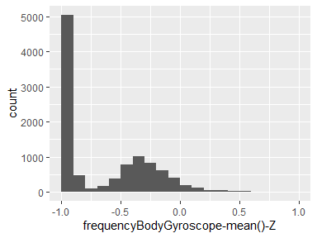

## frequencyBodyGyroscope-std()-X

|  |  |
| --- | --- |
| Feature | Result |
| Variable type | numeric |
| Number of missing obs. | 20598 (66.67 %) |
| Number of unique values | 10297 |
| Median | -0.91 |
| 1st and 3rd quartiles | -0.99; -0.52 |
| Min. and max. | -1; 1 |

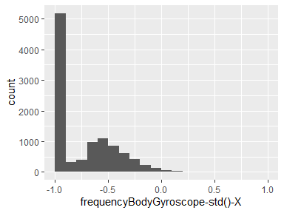

## frequencyBodyGyroscope-std()-Y

|  |  |
| --- | --- |
| Feature | Result |
| Variable type | numeric |
| Number of missing obs. | 20598 (66.67 %) |
| Number of unique values | 10293 |
| Median | -0.91 |
| 1st and 3rd quartiles | -0.98; -0.44 |
| Min. and max. | -1; 1 |

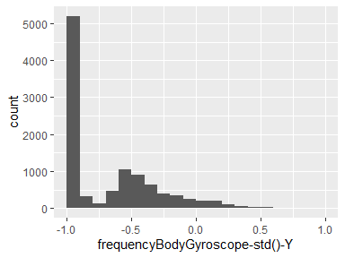

## frequencyBodyGyroscope-std()-Z

|  |  |
| --- | --- |
| Feature | Result |
| Variable type | numeric |
| Number of missing obs. | 20598 (66.67 %) |
| Number of unique values | 10295 |
| Median | -0.89 |
| 1st and 3rd quartiles | -0.99; -0.42 |
| Min. and max. | -1; 1 |

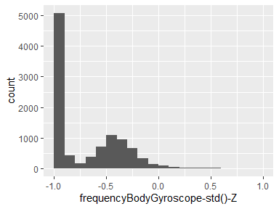

## frequencyBodyAccelerometerMagnitude-mean()

|  |  |
| --- | --- |
| Feature | Result |
| Variable type | numeric |
| Number of missing obs. | 20598 (66.67 %) |
| Number of unique values | 10296 |
| Median | -0.88 |
| 1st and 3rd quartiles | -0.98; -0.22 |
| Min. and max. | -1; 1 |

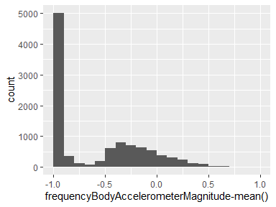

## frequencyBodyAccelerometerMagnitude-std()

|  |  |
| --- | --- |
| Feature | Result |
| Variable type | numeric |
| Number of missing obs. | 20598 (66.67 %) |
| Number of unique values | 10298 |
| Median | -0.85 |
| 1st and 3rd quartiles | -0.98; -0.38 |
| Min. and max. | -1; 1 |

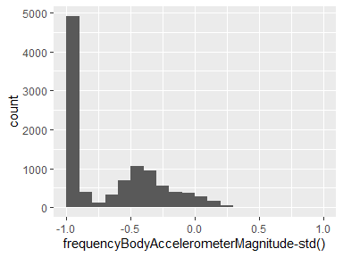

## frequencyBodyAccelerometerJerkMagnitude-mean()

|  |  |
| --- | --- |
| Feature | Result |
| Variable type | numeric |
| Number of missing obs. | 20598 (66.67 %) |
| Number of unique values | 10290 |
| Median | -0.93 |
| 1st and 3rd quartiles | -0.99; -0.26 |
| Min. and max. | -1; 1 |

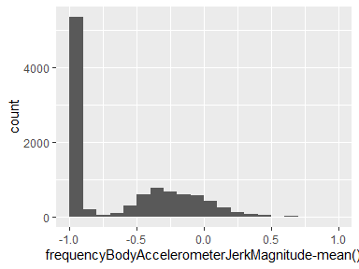

## frequencyBodyAccelerometerJerkMagnitude-std()

|  |  |
| --- | --- |
| Feature | Result |
| Variable type | numeric |
| Number of missing obs. | 20598 (66.67 %) |
| Number of unique values | 10296 |
| Median | -0.93 |
| 1st and 3rd quartiles | -0.99; -0.31 |
| Min. and max. | -1; 1 |

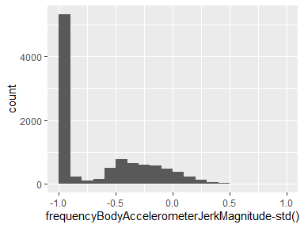

## frequencyBodyGyroscopeMagnitude-mean()

|  |  |
| --- | --- |
| Feature | Result |
| Variable type | numeric |
| Number of missing obs. | 20598 (66.67 %) |
| Number of unique values | 10297 |
| Median | -0.88 |
| 1st and 3rd quartiles | -0.98; -0.45 |
| Min. and max. | -1; 1 |

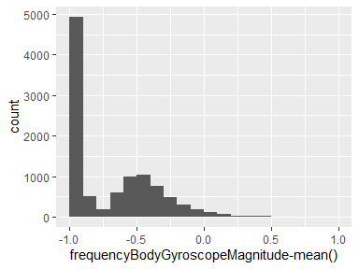

## frequencyBodyGyroscopeMagnitude-std()

|  |  |
| --- | --- |
| Feature | Result |
| Variable type | numeric |
| Number of missing obs. | 20598 (66.67 %) |
| Number of unique values | 10296 |
| Median | -0.83 |
| 1st and 3rd quartiles | -0.98; -0.47 |
| Min. and max. | -1; 1 |

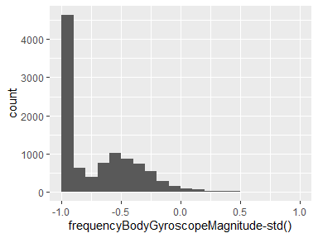

## frequencyBodyGyroscopeJerkMagnitude-mean()

|  |  |
| --- | --- |
| Feature | Result |
| Variable type | numeric |
| Number of missing obs. | 20598 (66.67 %) |
| Number of unique values | 10293 |
| Median | -0.95 |
| 1st and 3rd quartiles | -0.99; -0.61 |
| Min. and max. | -1; 1 |

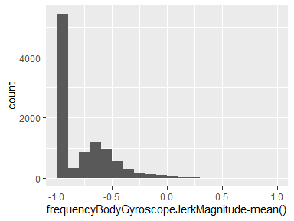

## frequencyBodyGyroscopeJerkMagnitude-std()

|  |  |
| --- | --- |
| Feature | Result |
| Variable type | numeric |
| Number of missing obs. | 20598 (66.67 %) |
| Number of unique values | 10292 |
| Median | -0.94 |
| 1st and 3rd quartiles | -0.99; -0.64 |
| Min. and max. | -1; 1 |

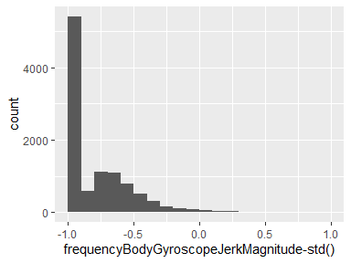

## subject

|  |  |
| --- | --- |
| Feature | Result |
| Variable type | integer |
| Number of missing obs. | 20598 (66.67 %) |
| Number of unique values | 30 |
| Median | 17 |
| 1st and 3rd quartiles | 9; 24 |
| Min. and max. | 1; 30 |

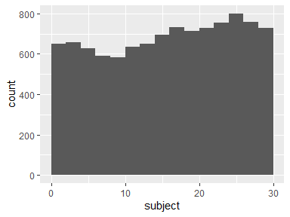

## activity

|  |  |
| --- | --- |
| Feature | Result |
| Variable type | integer |
| Number of missing obs. | 20598 (66.67 %) |
| Number of unique values | 6 |
| Median | 4 |
| 1st and 3rd quartiles | 2; 5 |
| Min. and max. | 1; 6 |

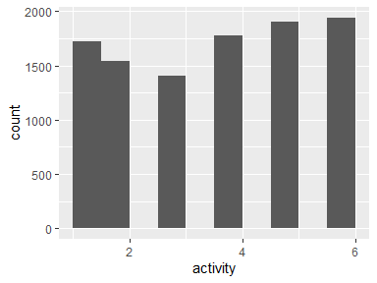

Report generation information:

* Created by: pengguo-01 (username: pg000).
* Report creation time: Mon Feb 03 2020 07:46:16
* Report was run from directory: c:/Users/pg000/Desktop
* dataMaid v1.4.0 [Pkg: 2019-12-10 from CRAN (R 3.6.2)]
* R version 3.6.2 (2019-12-12).
* Platform: x86_64-w64-mingw32/x64 (64-bit)(Windows 10 x64 (build 18362)).
* Function call: dataMaid::makeDataReport(data = Data, mode = c("summarize", "visualize", "check"), smartNum = FALSE, file = "codebook_Data.Rmd", checks = list( character = "showAllFactorLevels", factor = "showAllFactorLevels", labelled = "showAllFactorLevels", haven_labelled = "showAllFactorLevels", numeric = NULL, integer = NULL, logical = NULL, Date = NULL), listChecks = FALSE, maxProbVals = Inf, codebook = TRUE, reportTitle = "Codebook for Data")