Codebook for data_mean_std

Autogenerated data summary from dataMaid

2020-02-06 11:51:00

# Data report overview

The dataset examined has the following dimensions:

|  |  |
| --- | --- |
| Feature | Result |
| Number of observations | 10299 |
| Number of variables | 68 |

# Codebook summary table

|  |  |  |  |  |  |
| --- | --- | --- | --- | --- | --- |
| Label | Variable | Class | # unique values | Missing | Description |
|  | **subject_Id** | integer | 30 | 0.00 % |  |
|  | **TimeDomain.BodyAcceleration-mean-X** | numeric | 10292 | 0.00 % |  |
|  | **TimeDomain.BodyAcceleration-mean-Y** | numeric | 10299 | 0.00 % |  |
|  | **TimeDomain.BodyAcceleration-mean-Z** | numeric | 10293 | 0.00 % |  |
|  | **TimeDomain.BodyAcceleration-std-X** | numeric | 10295 | 0.00 % |  |
|  | **TimeDomain.BodyAcceleration-std-Y** | numeric | 10297 | 0.00 % |  |
|  | **TimeDomain.BodyAcceleration-std-Z** | numeric | 10297 | 0.00 % |  |
|  | **TimeDomain.GravityAcceleration-mean-X** | numeric | 10296 | 0.00 % |  |
|  | **TimeDomain.GravityAcceleration-mean-Y** | numeric | 10298 | 0.00 % |  |
|  | **TimeDomain.GravityAcceleration-mean-Z** | numeric | 10299 | 0.00 % |  |
|  | **TimeDomain.GravityAcceleration-std-X** | numeric | 10288 | 0.00 % |  |
|  | **TimeDomain.GravityAcceleration-std-Y** | numeric | 10293 | 0.00 % |  |
|  | **TimeDomain.GravityAcceleration-std-Z** | numeric | 10296 | 0.00 % |  |
|  | **TimeDomain.BodyAccelerationJerk-mean-X** | numeric | 10299 | 0.00 % |  |
|  | **TimeDomain.BodyAccelerationJerk-mean-Y** | numeric | 10299 | 0.00 % |  |
|  | **TimeDomain.BodyAccelerationJerk-mean-Z** | numeric | 10299 | 0.00 % |  |
|  | **TimeDomain.BodyAccelerationJerk-std-X** | numeric | 10290 | 0.00 % |  |
|  | **TimeDomain.BodyAccelerationJerk-std-Y** | numeric | 10296 | 0.00 % |  |
|  | **TimeDomain.BodyAccelerationJerk-std-Z** | numeric | 10293 | 0.00 % |  |
|  | **TimeDomain.BodyAngularSpeed-mean-X** | numeric | 10298 | 0.00 % |  |
|  | **TimeDomain.BodyAngularSpeed-mean-Y** | numeric | 10299 | 0.00 % |  |
|  | **TimeDomain.BodyAngularSpeed-mean-Z** | numeric | 10297 | 0.00 % |  |
|  | **TimeDomain.BodyAngularSpeed-std-X** | numeric | 10292 | 0.00 % |  |
|  | **TimeDomain.BodyAngularSpeed-std-Y** | numeric | 10296 | 0.00 % |  |
|  | **TimeDomain.BodyAngularSpeed-std-Z** | numeric | 10296 | 0.00 % |  |
|  | **TimeDomain.BodyAngularAcceleration-mean-X** | numeric | 10295 | 0.00 % |  |
|  | **TimeDomain.BodyAngularAcceleration-mean-Y** | numeric | 10299 | 0.00 % |  |
|  | **TimeDomain.BodyAngularAcceleration-mean-Z** | numeric | 10298 | 0.00 % |  |
|  | **TimeDomain.BodyAngularAcceleration-std-X** | numeric | 10292 | 0.00 % |  |
|  | **TimeDomain.BodyAngularAcceleration-std-Y** | numeric | 10295 | 0.00 % |  |
|  | **TimeDomain.BodyAngularAcceleration-std-Z** | numeric | 10291 | 0.00 % |  |
|  | **TimeDomain.BodyAccelerationMagnitude-mean** | numeric | 10296 | 0.00 % |  |
|  | **TimeDomain.BodyAccelerationMagnitude-std** | numeric | 10294 | 0.00 % |  |
|  | **TimeDomain.GravityAccelerationMagnitude-mean** | numeric | 10296 | 0.00 % |  |
|  | **TimeDomain.GravityAccelerationMagnitude-std** | numeric | 10294 | 0.00 % |  |
|  | **TimeDomain.BodyAccelerationJerkMagnitude-mean** | numeric | 10292 | 0.00 % |  |
|  | **TimeDomain.BodyAccelerationJerkMagnitude-std** | numeric | 10294 | 0.00 % |  |
|  | **TimeDomain.BodyAngularSpeedMagnitude-mean** | numeric | 10298 | 0.00 % |  |
|  | **TimeDomain.BodyAngularSpeedMagnitude-std** | numeric | 10298 | 0.00 % |  |
|  | **TimeDomain.BodyAngularAccelerationMagnitude-mean** | numeric | 10293 | 0.00 % |  |
|  | **TimeDomain.BodyAngularAccelerationMagnitude-std** | numeric | 10297 | 0.00 % |  |
|  | **FrequencyDomain.BodyAcceleration-mean-X** | numeric | 10295 | 0.00 % |  |
|  | **FrequencyDomain.BodyAcceleration-mean-Y** | numeric | 10292 | 0.00 % |  |
|  | **FrequencyDomain.BodyAcceleration-mean-Z** | numeric | 10295 | 0.00 % |  |
|  | **FrequencyDomain.BodyAcceleration-std-X** | numeric | 10294 | 0.00 % |  |
|  | **FrequencyDomain.BodyAcceleration-std-Y** | numeric | 10297 | 0.00 % |  |
|  | **FrequencyDomain.BodyAcceleration-std-Z** | numeric | 10296 | 0.00 % |  |
|  | **FrequencyDomain.BodyAccelerationJerk-mean-X** | numeric | 10293 | 0.00 % |  |
|  | **FrequencyDomain.BodyAccelerationJerk-mean-Y** | numeric | 10296 | 0.00 % |  |
|  | **FrequencyDomain.BodyAccelerationJerk-mean-Z** | numeric | 10294 | 0.00 % |  |
|  | **FrequencyDomain.BodyAccelerationJerk-std-X** | numeric | 10291 | 0.00 % |  |
|  | **FrequencyDomain.BodyAccelerationJerk-std-Y** | numeric | 10294 | 0.00 % |  |
|  | **FrequencyDomain.BodyAccelerationJerk-std-Z** | numeric | 10290 | 0.00 % |  |
|  | **FrequencyDomain.BodyAngularSpeed-mean-X** | numeric | 10297 | 0.00 % |  |
|  | **FrequencyDomain.BodyAngularSpeed-mean-Y** | numeric | 10296 | 0.00 % |  |
|  | **FrequencyDomain.BodyAngularSpeed-mean-Z** | numeric | 10297 | 0.00 % |  |
|  | **FrequencyDomain.BodyAngularSpeed-std-X** | numeric | 10297 | 0.00 % |  |
|  | **FrequencyDomain.BodyAngularSpeed-std-Y** | numeric | 10293 | 0.00 % |  |
|  | **FrequencyDomain.BodyAngularSpeed-std-Z** | numeric | 10295 | 0.00 % |  |
|  | **FrequencyDomain.BodyAccelerationMagnitude-mean** | numeric | 10296 | 0.00 % |  |
|  | **FrequencyDomain.BodyAccelerationMagnitude-std** | numeric | 10298 | 0.00 % |  |
|  | **FrequencyDomain.BodyBodyAccelerationJerkMagnitude-mean** | numeric | 10290 | 0.00 % |  |
|  | **FrequencyDomain.BodyBodyAccelerationJerkMagnitude-std** | numeric | 10296 | 0.00 % |  |
|  | **FrequencyDomain.BodyBodyAngularSpeedMagnitude-mean** | numeric | 10297 | 0.00 % |  |
|  | **FrequencyDomain.BodyBodyAngularSpeedMagnitude-std** | numeric | 10296 | 0.00 % |  |
|  | **FrequencyDomain.BodyBodyAngularAccelerationMagnitude-mean** | numeric | 10293 | 0.00 % |  |
|  | **FrequencyDomain.BodyBodyAngularAccelerationMagnitude-std** | numeric | 10292 | 0.00 % |  |
|  | **activity_type** | factor | 6 | 0.00 % |  |

# Variable list

## subject_Id

|  |  |
| --- | --- |
| Feature | Result |
| Variable type | integer |
| Number of missing obs. | 0 (0 %) |
| Number of unique values | 30 |
| Median | 17 |
| 1st and 3rd quartiles | 9; 24 |
| Min. and max. | 1; 30 |

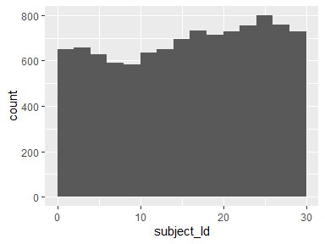

## TimeDomain.BodyAcceleration-mean-X

|  |  |
| --- | --- |
| Feature | Result |
| Variable type | numeric |
| Number of missing obs. | 0 (0 %) |
| Number of unique values | 10292 |
| Median | 0.28 |
| 1st and 3rd quartiles | 0.26; 0.29 |
| Min. and max. | -1; 1 |

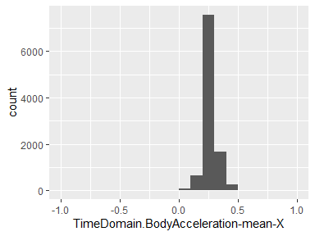

## TimeDomain.BodyAcceleration-mean-Y

|  |  |
| --- | --- |
| Feature | Result |
| Variable type | numeric |
| Number of missing obs. | 0 (0 %) |
| Number of unique values | 10299 |
| Median | -0.02 |
| 1st and 3rd quartiles | -0.02; -0.01 |
| Min. and max. | -1; 1 |

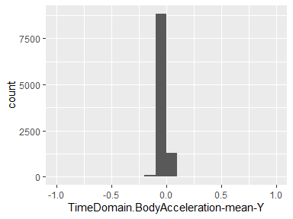

## TimeDomain.BodyAcceleration-mean-Z

|  |  |
| --- | --- |
| Feature | Result |
| Variable type | numeric |
| Number of missing obs. | 0 (0 %) |
| Number of unique values | 10293 |
| Median | -0.11 |
| 1st and 3rd quartiles | -0.12; -0.1 |
| Min. and max. | -1; 1 |

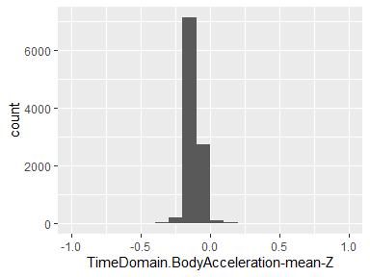

## TimeDomain.BodyAcceleration-std-X

|  |  |
| --- | --- |
| Feature | Result |
| Variable type | numeric |
| Number of missing obs. | 0 (0 %) |
| Number of unique values | 10295 |
| Median | -0.94 |
| 1st and 3rd quartiles | -0.99; -0.25 |
| Min. and max. | -1; 1 |

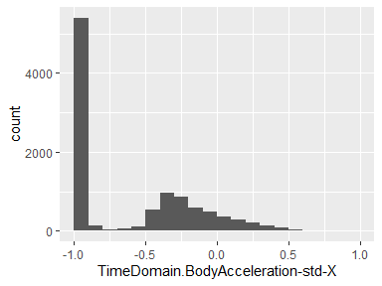

## TimeDomain.BodyAcceleration-std-Y

|  |  |
| --- | --- |
| Feature | Result |
| Variable type | numeric |
| Number of missing obs. | 0 (0 %) |
| Number of unique values | 10297 |
| Median | -0.84 |
| 1st and 3rd quartiles | -0.98; -0.06 |
| Min. and max. | -1; 1 |

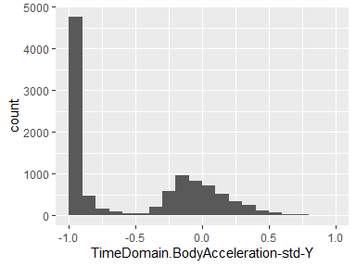

## TimeDomain.BodyAcceleration-std-Z

|  |  |
| --- | --- |
| Feature | Result |
| Variable type | numeric |
| Number of missing obs. | 0 (0 %) |
| Number of unique values | 10297 |
| Median | -0.85 |
| 1st and 3rd quartiles | -0.98; -0.28 |
| Min. and max. | -1; 1 |

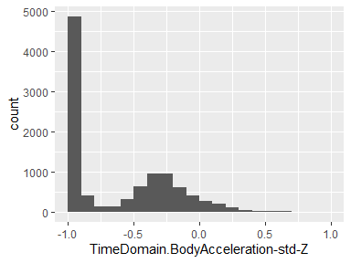

## TimeDomain.GravityAcceleration-mean-X

|  |  |
| --- | --- |
| Feature | Result |
| Variable type | numeric |
| Number of missing obs. | 0 (0 %) |
| Number of unique values | 10296 |
| Median | 0.92 |
| 1st and 3rd quartiles | 0.81; 0.95 |
| Min. and max. | -1; 1 |

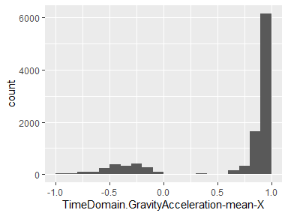

## TimeDomain.GravityAcceleration-mean-Y

|  |  |
| --- | --- |
| Feature | Result |
| Variable type | numeric |
| Number of missing obs. | 0 (0 %) |
| Number of unique values | 10298 |
| Median | -0.14 |
| 1st and 3rd quartiles | -0.24; 0.12 |
| Min. and max. | -1; 1 |

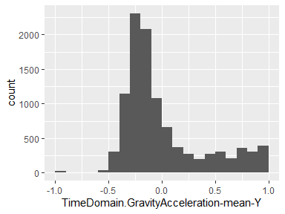

## TimeDomain.GravityAcceleration-mean-Z

|  |  |
| --- | --- |
| Feature | Result |
| Variable type | numeric |
| Number of missing obs. | 0 (0 %) |
| Number of unique values | 10299 |
| Median | 0.04 |
| 1st and 3rd quartiles | -0.12; 0.22 |
| Min. and max. | -1; 1 |

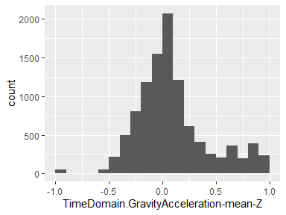

## TimeDomain.GravityAcceleration-std-X

|  |  |
| --- | --- |
| Feature | Result |
| Variable type | numeric |
| Number of missing obs. | 0 (0 %) |
| Number of unique values | 10288 |
| Median | -0.98 |
| 1st and 3rd quartiles | -0.99; -0.96 |
| Min. and max. | -1; 1 |

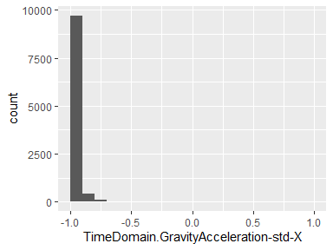

## TimeDomain.GravityAcceleration-std-Y

|  |  |
| --- | --- |
| Feature | Result |
| Variable type | numeric |
| Number of missing obs. | 0 (0 %) |
| Number of unique values | 10293 |
| Median | -0.98 |
| 1st and 3rd quartiles | -0.99; -0.95 |
| Min. and max. | -1; 1 |

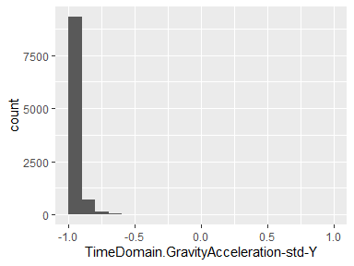

## TimeDomain.GravityAcceleration-std-Z

|  |  |
| --- | --- |
| Feature | Result |
| Variable type | numeric |
| Number of missing obs. | 0 (0 %) |
| Number of unique values | 10296 |
| Median | -0.97 |
| 1st and 3rd quartiles | -0.99; -0.93 |
| Min. and max. | -1; 1 |

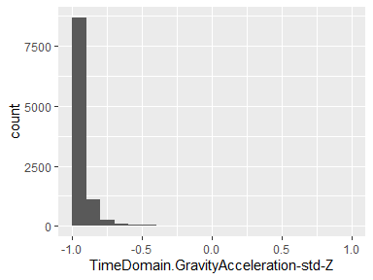

## TimeDomain.BodyAccelerationJerk-mean-X

|  |  |
| --- | --- |
| Feature | Result |
| Variable type | numeric |
| Number of missing obs. | 0 (0 %) |
| Number of unique values | 10299 |
| Median | 0.08 |
| 1st and 3rd quartiles | 0.06; 0.09 |
| Min. and max. | -1; 1 |

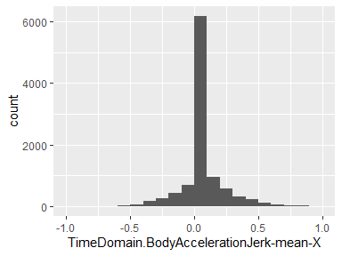

## TimeDomain.BodyAccelerationJerk-mean-Y

|  |  |
| --- | --- |
| Feature | Result |
| Variable type | numeric |
| Number of missing obs. | 0 (0 %) |
| Number of unique values | 10299 |
| Median | 0.01 |
| 1st and 3rd quartiles | -0.02; 0.03 |
| Min. and max. | -1; 1 |

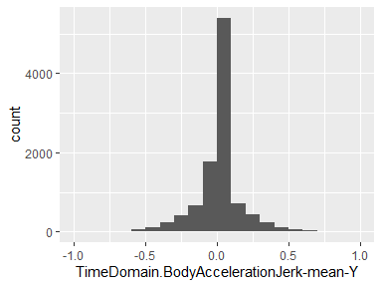

## TimeDomain.BodyAccelerationJerk-mean-Z

|  |  |
| --- | --- |
| Feature | Result |
| Variable type | numeric |
| Number of missing obs. | 0 (0 %) |
| Number of unique values | 10299 |
| Median | 0 |
| 1st and 3rd quartiles | -0.03; 0.02 |
| Min. and max. | -1; 1 |

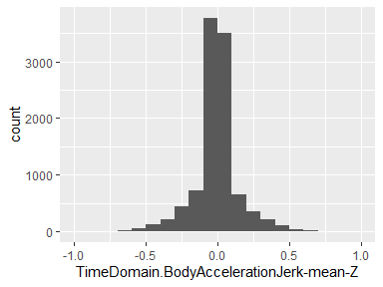

## TimeDomain.BodyAccelerationJerk-std-X

|  |  |
| --- | --- |
| Feature | Result |
| Variable type | numeric |
| Number of missing obs. | 0 (0 %) |
| Number of unique values | 10290 |
| Median | -0.95 |
| 1st and 3rd quartiles | -0.99; -0.29 |
| Min. and max. | -1; 1 |

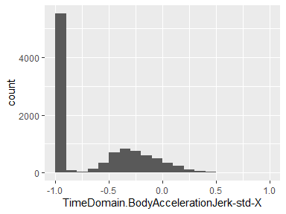

## TimeDomain.BodyAccelerationJerk-std-Y

|  |  |
| --- | --- |
| Feature | Result |
| Variable type | numeric |
| Number of missing obs. | 0 (0 %) |
| Number of unique values | 10296 |
| Median | -0.93 |
| 1st and 3rd quartiles | -0.99; -0.22 |
| Min. and max. | -1; 1 |

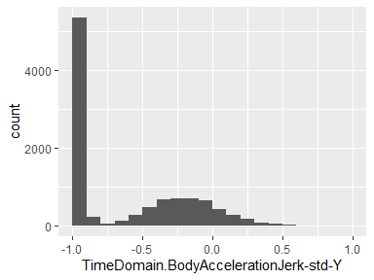

## TimeDomain.BodyAccelerationJerk-std-Z

|  |  |
| --- | --- |
| Feature | Result |
| Variable type | numeric |
| Number of missing obs. | 0 (0 %) |
| Number of unique values | 10293 |
| Median | -0.95 |
| 1st and 3rd quartiles | -0.99; -0.55 |
| Min. and max. | -1; 1 |

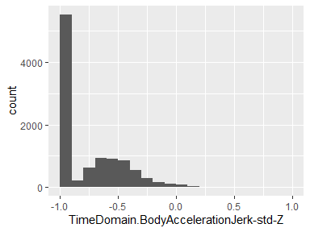

## TimeDomain.BodyAngularSpeed-mean-X

|  |  |
| --- | --- |
| Feature | Result |
| Variable type | numeric |
| Number of missing obs. | 0 (0 %) |
| Number of unique values | 10298 |
| Median | -0.03 |
| 1st and 3rd quartiles | -0.05; -0.01 |
| Min. and max. | -1; 1 |

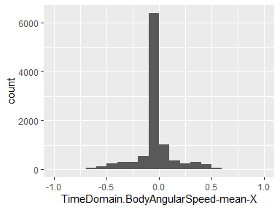

## TimeDomain.BodyAngularSpeed-mean-Y

|  |  |
| --- | --- |
| Feature | Result |
| Variable type | numeric |
| Number of missing obs. | 0 (0 %) |
| Number of unique values | 10299 |
| Median | -0.07 |
| 1st and 3rd quartiles | -0.1; -0.05 |
| Min. and max. | -1; 1 |

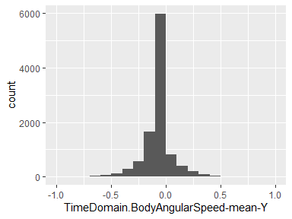

## TimeDomain.BodyAngularSpeed-mean-Z

|  |  |
| --- | --- |
| Feature | Result |
| Variable type | numeric |
| Number of missing obs. | 0 (0 %) |
| Number of unique values | 10297 |
| Median | 0.09 |
| 1st and 3rd quartiles | 0.06; 0.11 |
| Min. and max. | -1; 1 |

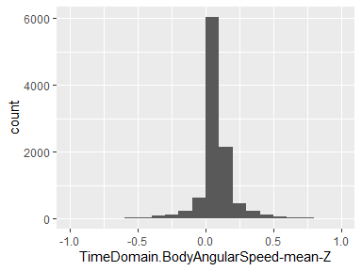

## TimeDomain.BodyAngularSpeed-std-X

|  |  |
| --- | --- |
| Feature | Result |
| Variable type | numeric |
| Number of missing obs. | 0 (0 %) |
| Number of unique values | 10292 |
| Median | -0.9 |
| 1st and 3rd quartiles | -0.99; -0.48 |
| Min. and max. | -1; 1 |

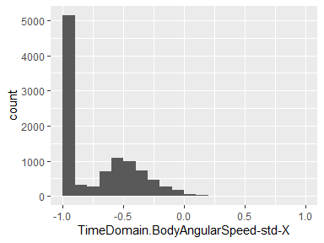

## TimeDomain.BodyAngularSpeed-std-Y

|  |  |
| --- | --- |
| Feature | Result |
| Variable type | numeric |
| Number of missing obs. | 0 (0 %) |
| Number of unique values | 10296 |
| Median | -0.91 |
| 1st and 3rd quartiles | -0.98; -0.45 |
| Min. and max. | -1; 1 |

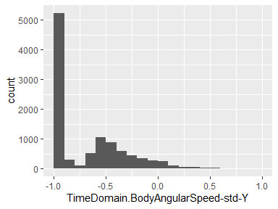

## TimeDomain.BodyAngularSpeed-std-Z

|  |  |
| --- | --- |
| Feature | Result |
| Variable type | numeric |
| Number of missing obs. | 0 (0 %) |
| Number of unique values | 10296 |
| Median | -0.88 |
| 1st and 3rd quartiles | -0.99; -0.34 |
| Min. and max. | -1; 1 |

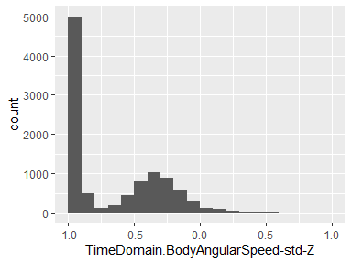

## TimeDomain.BodyAngularAcceleration-mean-X

|  |  |
| --- | --- |
| Feature | Result |
| Variable type | numeric |
| Number of missing obs. | 0 (0 %) |
| Number of unique values | 10295 |
| Median | -0.1 |
| 1st and 3rd quartiles | -0.12; -0.08 |
| Min. and max. | -1; 1 |

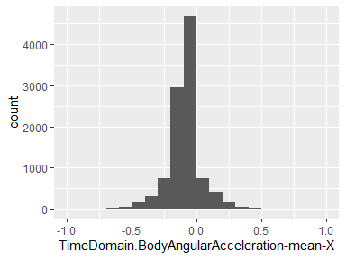

## TimeDomain.BodyAngularAcceleration-mean-Y

|  |  |
| --- | --- |
| Feature | Result |
| Variable type | numeric |
| Number of missing obs. | 0 (0 %) |
| Number of unique values | 10299 |
| Median | -0.04 |
| 1st and 3rd quartiles | -0.06; -0.03 |
| Min. and max. | -1; 1 |

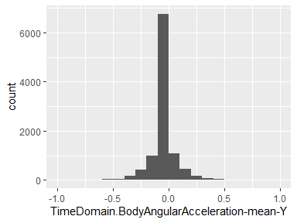

## TimeDomain.BodyAngularAcceleration-mean-Z

|  |  |
| --- | --- |
| Feature | Result |
| Variable type | numeric |
| Number of missing obs. | 0 (0 %) |
| Number of unique values | 10298 |
| Median | -0.05 |
| 1st and 3rd quartiles | -0.08; -0.03 |
| Min. and max. | -1; 1 |

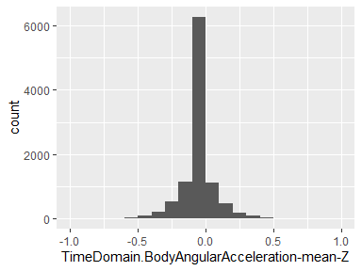

## TimeDomain.BodyAngularAcceleration-std-X

|  |  |
| --- | --- |
| Feature | Result |
| Variable type | numeric |
| Number of missing obs. | 0 (0 %) |
| Number of unique values | 10292 |
| Median | -0.93 |
| 1st and 3rd quartiles | -0.99; -0.49 |
| Min. and max. | -1; 1 |

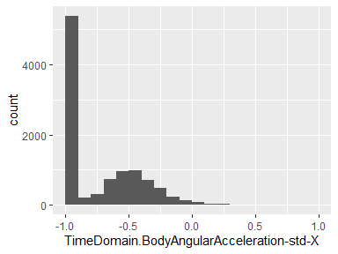

## TimeDomain.BodyAngularAcceleration-std-Y

|  |  |
| --- | --- |
| Feature | Result |
| Variable type | numeric |
| Number of missing obs. | 0 (0 %) |
| Number of unique values | 10295 |
| Median | -0.95 |
| 1st and 3rd quartiles | -0.99; -0.63 |
| Min. and max. | -1; 1 |

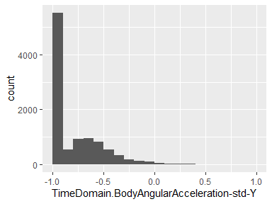

## TimeDomain.BodyAngularAcceleration-std-Z

|  |  |
| --- | --- |
| Feature | Result |
| Variable type | numeric |
| Number of missing obs. | 0 (0 %) |
| Number of unique values | 10291 |
| Median | -0.95 |
| 1st and 3rd quartiles | -0.99; -0.51 |
| Min. and max. | -1; 1 |

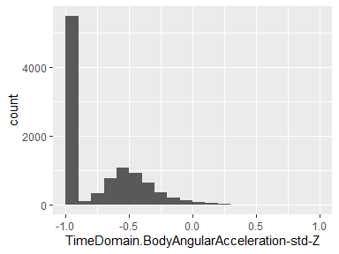

## TimeDomain.BodyAccelerationMagnitude-mean

|  |  |
| --- | --- |
| Feature | Result |
| Variable type | numeric |
| Number of missing obs. | 0 (0 %) |
| Number of unique values | 10296 |
| Median | -0.87 |
| 1st and 3rd quartiles | -0.98; -0.12 |
| Min. and max. | -1; 1 |

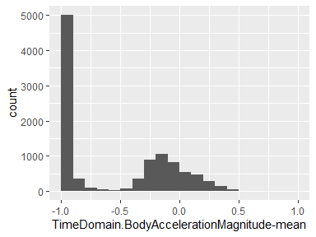

## TimeDomain.BodyAccelerationMagnitude-std

|  |  |
| --- | --- |
| Feature | Result |
| Variable type | numeric |
| Number of missing obs. | 0 (0 %) |
| Number of unique values | 10294 |
| Median | -0.84 |
| 1st and 3rd quartiles | -0.98; -0.24 |
| Min. and max. | -1; 1 |

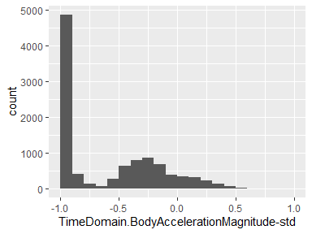

## TimeDomain.GravityAccelerationMagnitude-mean

|  |  |
| --- | --- |
| Feature | Result |
| Variable type | numeric |
| Number of missing obs. | 0 (0 %) |
| Number of unique values | 10296 |
| Median | -0.87 |
| 1st and 3rd quartiles | -0.98; -0.12 |
| Min. and max. | -1; 1 |

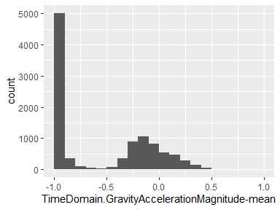

## TimeDomain.GravityAccelerationMagnitude-std

|  |  |
| --- | --- |
| Feature | Result |
| Variable type | numeric |
| Number of missing obs. | 0 (0 %) |
| Number of unique values | 10294 |
| Median | -0.84 |
| 1st and 3rd quartiles | -0.98; -0.24 |
| Min. and max. | -1; 1 |

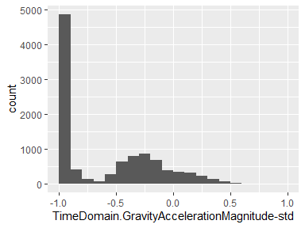

## TimeDomain.BodyAccelerationJerkMagnitude-mean

|  |  |
| --- | --- |
| Feature | Result |
| Variable type | numeric |
| Number of missing obs. | 0 (0 %) |
| Number of unique values | 10292 |
| Median | -0.95 |
| 1st and 3rd quartiles | -0.99; -0.3 |
| Min. and max. | -1; 1 |

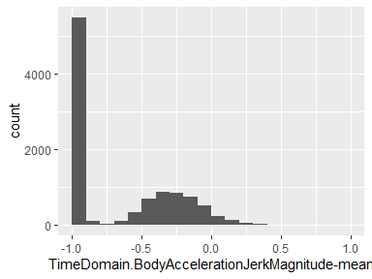

## TimeDomain.BodyAccelerationJerkMagnitude-std

|  |  |
| --- | --- |
| Feature | Result |
| Variable type | numeric |
| Number of missing obs. | 0 (0 %) |
| Number of unique values | 10294 |
| Median | -0.93 |
| 1st and 3rd quartiles | -0.99; -0.27 |
| Min. and max. | -1; 1 |

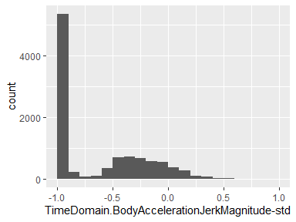

## TimeDomain.BodyAngularSpeedMagnitude-mean

|  |  |
| --- | --- |
| Feature | Result |
| Variable type | numeric |
| Number of missing obs. | 0 (0 %) |
| Number of unique values | 10298 |
| Median | -0.82 |
| 1st and 3rd quartiles | -0.98; -0.25 |
| Min. and max. | -1; 1 |

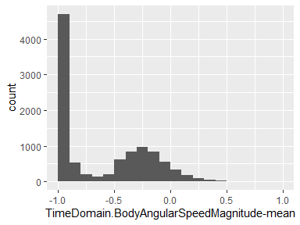

## TimeDomain.BodyAngularSpeedMagnitude-std

|  |  |
| --- | --- |
| Feature | Result |
| Variable type | numeric |
| Number of missing obs. | 0 (0 %) |
| Number of unique values | 10298 |
| Median | -0.83 |
| 1st and 3rd quartiles | -0.98; -0.39 |
| Min. and max. | -1; 1 |

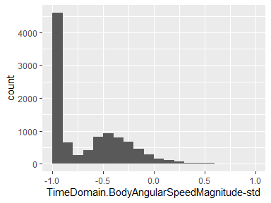

## TimeDomain.BodyAngularAccelerationMagnitude-mean

|  |  |
| --- | --- |
| Feature | Result |
| Variable type | numeric |
| Number of missing obs. | 0 (0 %) |
| Number of unique values | 10293 |
| Median | -0.96 |
| 1st and 3rd quartiles | -0.99; -0.55 |
| Min. and max. | -1; 1 |

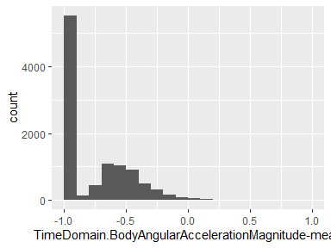

## TimeDomain.BodyAngularAccelerationMagnitude-std

|  |  |
| --- | --- |
| Feature | Result |
| Variable type | numeric |
| Number of missing obs. | 0 (0 %) |
| Number of unique values | 10297 |
| Median | -0.94 |
| 1st and 3rd quartiles | -0.99; -0.61 |
| Min. and max. | -1; 1 |

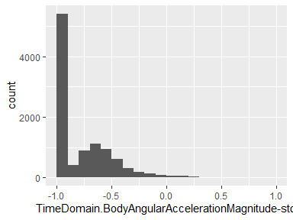

## FrequencyDomain.BodyAcceleration-mean-X

|  |  |
| --- | --- |
| Feature | Result |
| Variable type | numeric |
| Number of missing obs. | 0 (0 %) |
| Number of unique values | 10295 |
| Median | -0.95 |
| 1st and 3rd quartiles | -0.99; -0.26 |
| Min. and max. | -1; 1 |

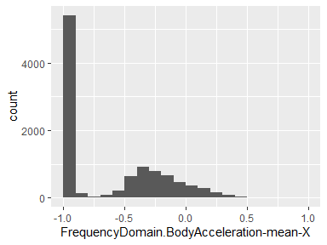

## FrequencyDomain.BodyAcceleration-mean-Y

|  |  |
| --- | --- |
| Feature | Result |
| Variable type | numeric |
| Number of missing obs. | 0 (0 %) |
| Number of unique values | 10292 |
| Median | -0.86 |
| 1st and 3rd quartiles | -0.98; -0.1 |
| Min. and max. | -1; 1 |

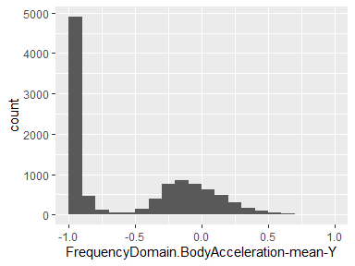

## FrequencyDomain.BodyAcceleration-mean-Z

|  |  |
| --- | --- |
| Feature | Result |
| Variable type | numeric |
| Number of missing obs. | 0 (0 %) |
| Number of unique values | 10295 |
| Median | -0.9 |
| 1st and 3rd quartiles | -0.98; -0.37 |
| Min. and max. | -1; 1 |

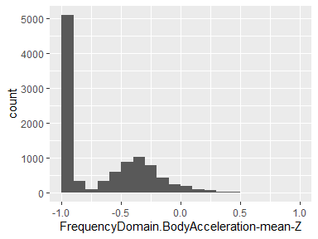

## FrequencyDomain.BodyAcceleration-std-X

|  |  |
| --- | --- |
| Feature | Result |
| Variable type | numeric |
| Number of missing obs. | 0 (0 %) |
| Number of unique values | 10294 |
| Median | -0.94 |
| 1st and 3rd quartiles | -0.99; -0.25 |
| Min. and max. | -1; 1 |

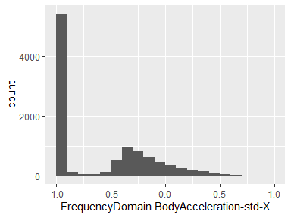

## FrequencyDomain.BodyAcceleration-std-Y

|  |  |
| --- | --- |
| Feature | Result |
| Variable type | numeric |
| Number of missing obs. | 0 (0 %) |
| Number of unique values | 10297 |
| Median | -0.83 |
| 1st and 3rd quartiles | -0.98; -0.09 |
| Min. and max. | -1; 1 |

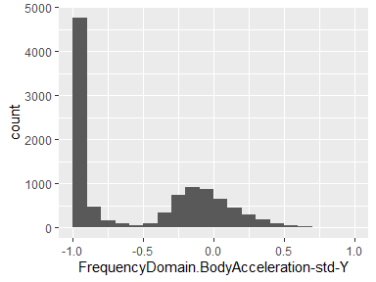

## FrequencyDomain.BodyAcceleration-std-Z

|  |  |
| --- | --- |
| Feature | Result |
| Variable type | numeric |
| Number of missing obs. | 0 (0 %) |
| Number of unique values | 10296 |
| Median | -0.84 |
| 1st and 3rd quartiles | -0.98; -0.3 |
| Min. and max. | -1; 1 |

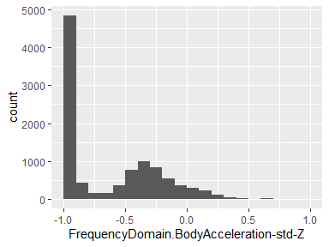

## FrequencyDomain.BodyAccelerationJerk-mean-X

|  |  |
| --- | --- |
| Feature | Result |
| Variable type | numeric |
| Number of missing obs. | 0 (0 %) |
| Number of unique values | 10293 |
| Median | -0.95 |
| 1st and 3rd quartiles | -0.99; -0.33 |
| Min. and max. | -1; 1 |

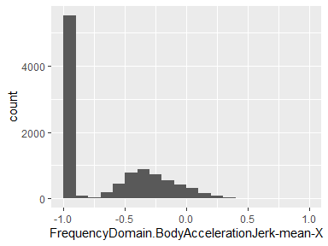

## FrequencyDomain.BodyAccelerationJerk-mean-Y

|  |  |
| --- | --- |
| Feature | Result |
| Variable type | numeric |
| Number of missing obs. | 0 (0 %) |
| Number of unique values | 10296 |
| Median | -0.93 |
| 1st and 3rd quartiles | -0.98; -0.26 |
| Min. and max. | -1; 1 |

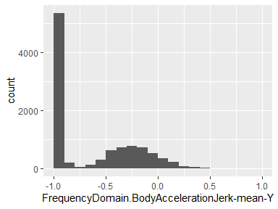

## FrequencyDomain.BodyAccelerationJerk-mean-Z

|  |  |
| --- | --- |
| Feature | Result |
| Variable type | numeric |
| Number of missing obs. | 0 (0 %) |
| Number of unique values | 10294 |
| Median | -0.95 |
| 1st and 3rd quartiles | -0.99; -0.51 |
| Min. and max. | -1; 1 |

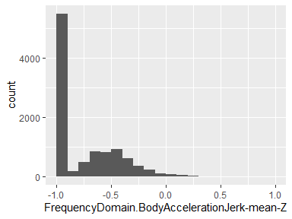

## FrequencyDomain.BodyAccelerationJerk-std-X

|  |  |
| --- | --- |
| Feature | Result |
| Variable type | numeric |
| Number of missing obs. | 0 (0 %) |
| Number of unique values | 10291 |
| Median | -0.96 |
| 1st and 3rd quartiles | -0.99; -0.32 |
| Min. and max. | -1; 1 |

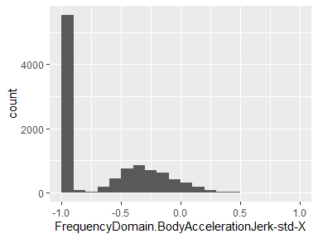

## FrequencyDomain.BodyAccelerationJerk-std-Y

|  |  |
| --- | --- |
| Feature | Result |
| Variable type | numeric |
| Number of missing obs. | 0 (0 %) |
| Number of unique values | 10294 |
| Median | -0.93 |
| 1st and 3rd quartiles | -0.99; -0.24 |
| Min. and max. | -1; 1 |

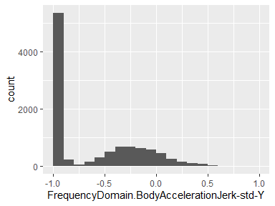

## FrequencyDomain.BodyAccelerationJerk-std-Z

|  |  |
| --- | --- |
| Feature | Result |
| Variable type | numeric |
| Number of missing obs. | 0 (0 %) |
| Number of unique values | 10290 |
| Median | -0.96 |
| 1st and 3rd quartiles | -0.99; -0.59 |
| Min. and max. | -1; 1 |

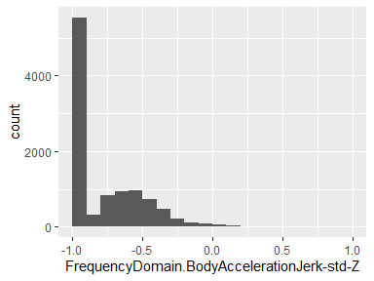

## FrequencyDomain.BodyAngularSpeed-mean-X

|  |  |
| --- | --- |
| Feature | Result |
| Variable type | numeric |
| Number of missing obs. | 0 (0 %) |
| Number of unique values | 10297 |
| Median | -0.89 |
| 1st and 3rd quartiles | -0.99; -0.38 |
| Min. and max. | -1; 1 |

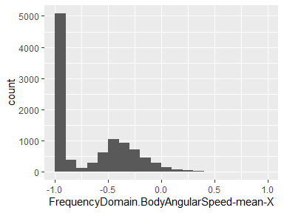

## FrequencyDomain.BodyAngularSpeed-mean-Y

|  |  |
| --- | --- |
| Feature | Result |
| Variable type | numeric |
| Number of missing obs. | 0 (0 %) |
| Number of unique values | 10296 |
| Median | -0.92 |
| 1st and 3rd quartiles | -0.98; -0.47 |
| Min. and max. | -1; 1 |

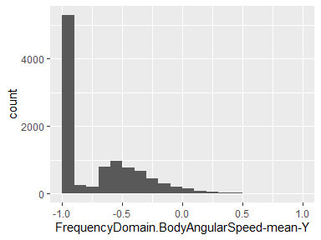

## FrequencyDomain.BodyAngularSpeed-mean-Z

|  |  |
| --- | --- |
| Feature | Result |
| Variable type | numeric |
| Number of missing obs. | 0 (0 %) |
| Number of unique values | 10297 |
| Median | -0.89 |
| 1st and 3rd quartiles | -0.99; -0.32 |
| Min. and max. | -1; 1 |

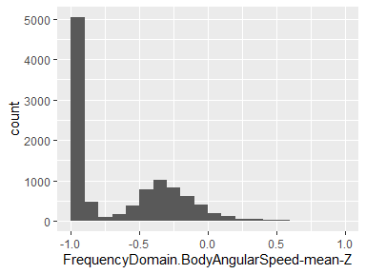

## FrequencyDomain.BodyAngularSpeed-std-X

|  |  |
| --- | --- |
| Feature | Result |
| Variable type | numeric |
| Number of missing obs. | 0 (0 %) |
| Number of unique values | 10297 |
| Median | -0.91 |
| 1st and 3rd quartiles | -0.99; -0.52 |
| Min. and max. | -1; 1 |

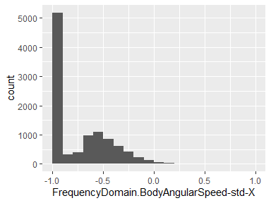

## FrequencyDomain.BodyAngularSpeed-std-Y

|  |  |
| --- | --- |
| Feature | Result |
| Variable type | numeric |
| Number of missing obs. | 0 (0 %) |
| Number of unique values | 10293 |
| Median | -0.91 |
| 1st and 3rd quartiles | -0.98; -0.44 |
| Min. and max. | -1; 1 |

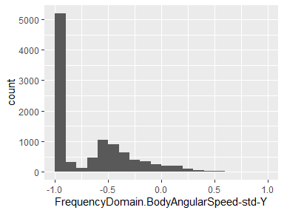

## FrequencyDomain.BodyAngularSpeed-std-Z

|  |  |
| --- | --- |
| Feature | Result |
| Variable type | numeric |
| Number of missing obs. | 0 (0 %) |
| Number of unique values | 10295 |
| Median | -0.89 |
| 1st and 3rd quartiles | -0.99; -0.42 |
| Min. and max. | -1; 1 |

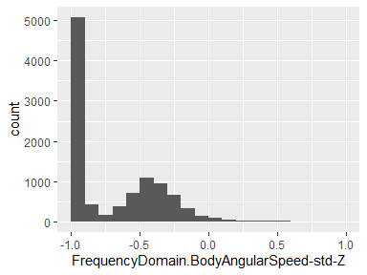

## FrequencyDomain.BodyAccelerationMagnitude-mean

|  |  |
| --- | --- |
| Feature | Result |
| Variable type | numeric |
| Number of missing obs. | 0 (0 %) |
| Number of unique values | 10296 |
| Median | -0.88 |
| 1st and 3rd quartiles | -0.98; -0.22 |
| Min. and max. | -1; 1 |

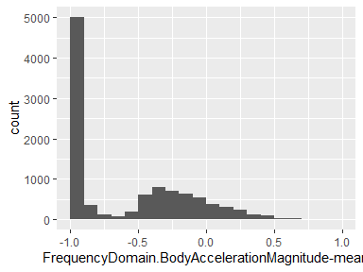

## FrequencyDomain.BodyAccelerationMagnitude-std

|  |  |
| --- | --- |
| Feature | Result |
| Variable type | numeric |
| Number of missing obs. | 0 (0 %) |
| Number of unique values | 10298 |
| Median | -0.85 |
| 1st and 3rd quartiles | -0.98; -0.38 |
| Min. and max. | -1; 1 |

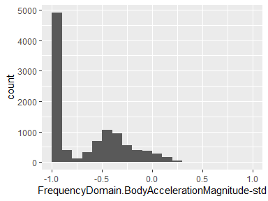

## FrequencyDomain.BodyBodyAccelerationJerkMagnitude-mean

|  |  |
| --- | --- |
| Feature | Result |
| Variable type | numeric |
| Number of missing obs. | 0 (0 %) |
| Number of unique values | 10290 |
| Median | -0.93 |
| 1st and 3rd quartiles | -0.99; -0.26 |
| Min. and max. | -1; 1 |

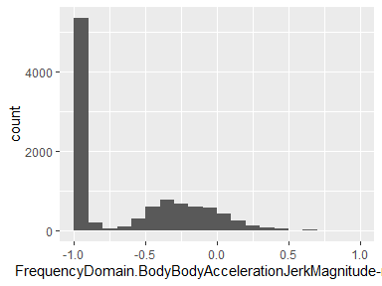

## FrequencyDomain.BodyBodyAccelerationJerkMagnitude-std

|  |  |
| --- | --- |
| Feature | Result |
| Variable type | numeric |
| Number of missing obs. | 0 (0 %) |
| Number of unique values | 10296 |
| Median | -0.93 |
| 1st and 3rd quartiles | -0.99; -0.31 |
| Min. and max. | -1; 1 |

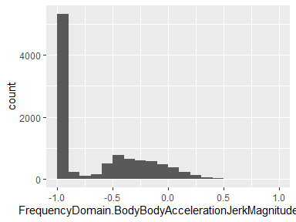

## FrequencyDomain.BodyBodyAngularSpeedMagnitude-mean

|  |  |
| --- | --- |
| Feature | Result |
| Variable type | numeric |
| Number of missing obs. | 0 (0 %) |
| Number of unique values | 10297 |
| Median | -0.88 |
| 1st and 3rd quartiles | -0.98; -0.45 |
| Min. and max. | -1; 1 |

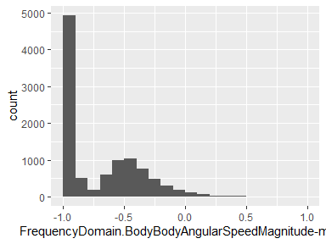

## FrequencyDomain.BodyBodyAngularSpeedMagnitude-std

|  |  |
| --- | --- |
| Feature | Result |
| Variable type | numeric |
| Number of missing obs. | 0 (0 %) |
| Number of unique values | 10296 |
| Median | -0.83 |
| 1st and 3rd quartiles | -0.98; -0.47 |
| Min. and max. | -1; 1 |

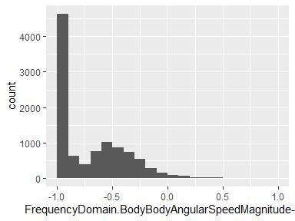

## FrequencyDomain.BodyBodyAngularAccelerationMagnitude-mean

|  |  |
| --- | --- |
| Feature | Result |
| Variable type | numeric |
| Number of missing obs. | 0 (0 %) |
| Number of unique values | 10293 |
| Median | -0.95 |
| 1st and 3rd quartiles | -0.99; -0.61 |
| Min. and max. | -1; 1 |

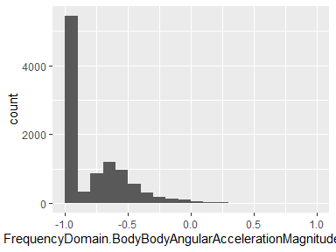

## FrequencyDomain.BodyBodyAngularAccelerationMagnitude-std

|  |  |
| --- | --- |
| Feature | Result |
| Variable type | numeric |
| Number of missing obs. | 0 (0 %) |
| Number of unique values | 10292 |
| Median | -0.94 |
| 1st and 3rd quartiles | -0.99; -0.64 |
| Min. and max. | -1; 1 |

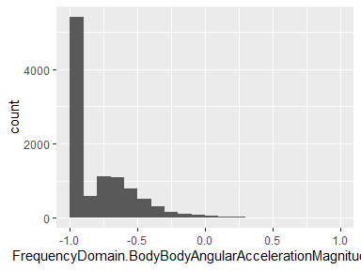

## activity_type

|  |  |
| --- | --- |
| Feature | Result |
| Variable type | factor |
| Number of missing obs. | 0 (0 %) |
| Number of unique values | 6 |
| Mode | “LAYING” |
| Reference category | LAYING |

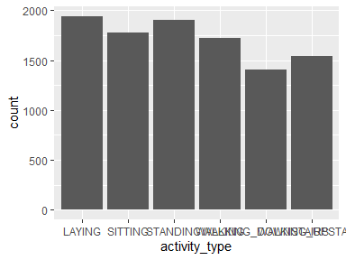

* Observed factor levels: "LAYING", "SITTING", "STANDING", "WALKING", "WALKING_DOWNSTAIRS", "WALKING_UPSTAIRS".

Report generation information:

* Created by: pengguo-01 (username: pg000).
* Report creation time: Thu Feb 06 2020 11:51:01
* Report was run from directory: C:/Users/pg000/Desktop
* dataMaid v1.4.0 [Pkg: 2019-12-10 from CRAN (R 3.6.2)]
* R version 3.6.2 (2019-12-12).
* Platform: x86_64-w64-mingw32/x64 (64-bit)(Windows 10 x64 (build 18362)).
* Function call: dataMaid::makeDataReport(data = data_mean_std, mode = c("summarize", "visualize", "check"), smartNum = FALSE, file = "codebook_data_mean_std.Rmd", checks = list(character = "showAllFactorLevels", factor = "showAllFactorLevels", labelled = "showAllFactorLevels", haven_labelled = "showAllFactorLevels", numeric = NULL, integer = NULL, logical = NULL, Date = NULL), listChecks = FALSE, maxProbVals = Inf, codebook = TRUE, reportTitle = "Codebook for data_mean_std")