rtb系统架构设计
一， 简介
RTB（RealTime Bidding）实时竞价，是一种利用第三方技术在数以百万计的网站上针对每一个用户展示行为进行评估以及出价的竞价技术。与大量购买投放频次不同，实时竞价规避了无效的受众到达，针对有意义的用户进行购买。它的核心是DSP平台（需求方平台），RTB对于媒体来说，可以带来更多的广告销量、实现销售过程自动化及减低各项费用的支出。而对于广告商和代理公司来说，最直接的好处就是提高了效果与投资回报率。
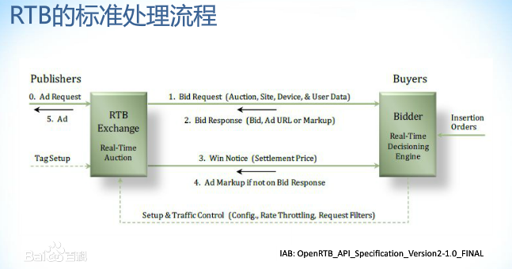
二，原理
RTB并不是新鲜事物，Real Time Bidding（即时竞价）在广告行业中早已耳熟能详。传统的互联网广告生态链一般最多只有三方，分别是广告主、广告代理商(即广告公司)以及互联网媒体。而在RTB广告交易模式中，原有的广告生态链发生了变化，整个生态链包括广告主、DSP、广告交易平台以及互联网媒体四个主体。广告主将自己的广告需求放到DSP平台上，互联网媒体将自己的广告流量资源放到广告交易平台，DSP通过与广告交易平台的技术对接完成竞价购买。
因此，当用户访问一个网站时，SSP即向Ad Exchange广告交易平台发送用户访问讯号，随后广告位的具体信息则会经过DMP的分析匹配后发送给DSP，DSP将对此进行竞价，价高者会获得这个广告展现机会，并被目标用户看到——从开始竞价到完成投放，这一系列的过程仅需100毫秒，全部依托机器完成。

RTB是一种技术为王的精准营销手段，当一个用户在全网浏览过某种商品，或点击过特殊类目的广告后，其浏览痕迹都会通过cookie记录在案，而通过广告交易平台，你在下一次浏览网页的时候，将被推送符合偏好的广告。RTB相关技术的不断发展使得系统侧自身便能实现更好的精准营销，让投放的广告更精准更有价值。
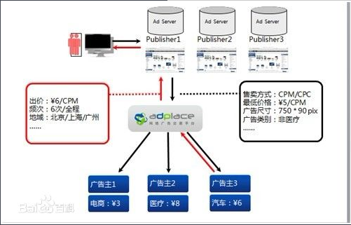

三， 架构
这里把RTB分为4种节点，throttle，bidder，connector，bidderConnector
，4种节点的架构如下
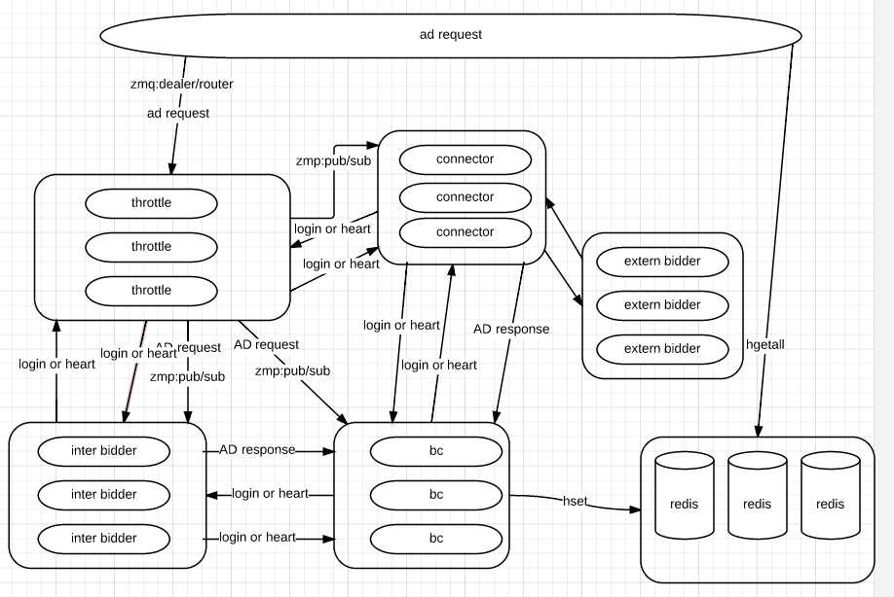

Rtb系统被设计成多对多的分布式系统，数据在throttle就知道发往哪个bidder，connector，bidderCollector。这是由publish key决定的。

Rtb系统分布式设计的关键在于设备的管理以及数据的通道。
设备管理：设备管理在于登录和心跳，相关协议见managerProto.proto

数据通道：数据通道在于publish key。只有得到publish key，解析publish key得到bidder或者connector的信息和bidderCollector的信息。数据到BC的所有通道就都确定了。

四，节点介绍
Rtb系统有4种节点，bidder和connector作用相似，只是bidder是内部广告竞价，connector是从外部bidder竞价。Throttle publish ad request给指定的bidder和connector，bidder得到内部的ad response发送给BC，connector得到外部的 ad response发送给BC。
节点与节点之间的数据通道
4.1 throttle
4.1.1 throttle的模块
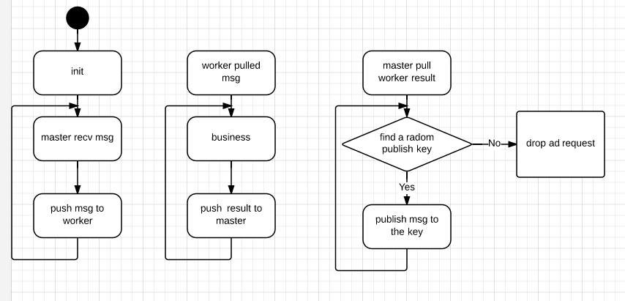
Throttle：数据分发以及负载均衡管理模块
Throttle主要分为业务模块和管理模块
业务模块：
数据的传输用的是zeromq的libevent异步模式
这个模块是throttle，bidder，connector，bidderCollector这4个模块中最上层的一个模块，负责管理下面bidder， connector， bidderCollector这3个节点。
这个模块与上层的数据通信方式是zeromq的dealer/router模式中的router端（服务端），上层是dealer（客户端），所以如果增加throttle节点，需要告知上层接收上层数据的ip与端口，与下层的数据通信方式是zeromq的publish/subscribe模式中的publish端（服务端），
下层是zeromq的publish/subscribe模式中的subscribe端（客户端）
数据根据ad request中的uuid得到的随机索引来得到publish的通道，把数据publish到这个通道

管理模块：
这个模块包括：管理bidder节点的模块，管理connector节点的模块，管理bidderCollector节点的模块，管理publish key的模块

Publish key 格式(由下面字段组成的字符串)：
bidderCollector manager ip | ： | bidderCollector manager port | ： | bidderCollector data port | - | bidder ip | ： | bidder manager port

4.1.2 bidder的模块
业务模块：
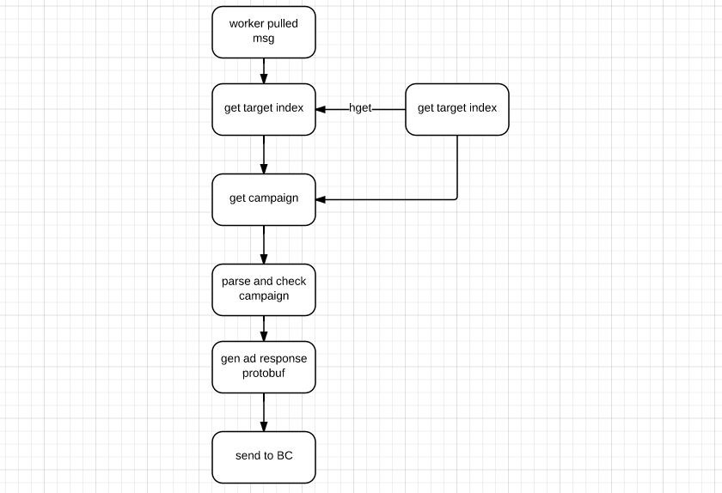
参与计算的target项：

Geographic
"country"
"region"
"city"

OS Families
"family"
"version"

Device Models
"vendor"
"model"

Languages
"lang"

Carriers
"carrier"

Connection Types
"conn.type"

Day Part
“day.part"

参与校验的target
target_verify_set.set_devphone(phone);
target_verify_set.set_devtablet(tablet);
target_verify_set.set_supmapp(app);
target_verify_set.set_supmweb(web);
target_verify_set.set_inventory(mobile_request.inventoryquality());
target_verify_set.set_traffic(mobile_request.trafficquality());
target_verify_set.set_appid(mobile_request.appid());
target_verify_set.set_appcategory(mobile_request.appcategory());

Targeting Index result data in redis

Introduction
We save all targeting info into redis through the hash, you can use hget to get all campaign ids.The value returned
is bytes which is a int array.So when you has got the bytes ,you must
convert the bytes to int array.

Geographic
The geographic has three layer : country,region,city.A country has many region, and a region has cities.
Country: key=country ,field = ${country_id}
Region: key=region, field = ${region_id}
City: key=city, field = ${city_id}
The geographic index save all 'include' campaign is ,so when you want to get the campaigns of one city ,
you must also get region and country campaigns,then obtain their union set.
the result campaign ids = (COUNTRY U REGION U CITY).
The COUNTRY,REGION,CITY are sorted set and (COUNTRY ∩ REGION ∩ CITY)=Ø null set.

OS Families
Like geographic,the os family has two layer.The Os.Family has just Android and IOS of which Os.Family.Version is the detail version.
Os.Family: key=family , field =${os_family_id}
Os.Family.Version: key=version, field=${os_version_id}
the result campaign ids = (OS.FAMILY U OS.FAMILY.VERSION ).
The OS.FAMILY,OS.FAMILY.VERSION are sorted set and (OS.FAMILY ∩ OS.FAMILY.VERSION )=Ø.

Device Models
Like geographic,the device models has two layer.Every Device.Vendor has many Device.Model.
Device.Vendor:key= vendor, field =${device_vendor_id}
Device.Model: key= model, field =${device_model_id}
the result campaign ids = (VENDOR U MODEL ) .
The Device.Vendor,Device.Model are sorted set and (VENDOR ∩ MODEL ) = Ø.

Languages
key=lang, field=${language_id}

Carriers
key=carrier, field=${carrier_id}

Connection Types
key=conn.type, field=${connection_type_id}

Day Part
key=day. part, field=${the value between [1,7*24]}
Daypart is used to tell the system when it can play the ads.The time slot is one hour and one week is divided into total 7*24 hours,so the advertiser can select which hours in [1,7*24] to play his ads.

Frequency
Note:the frequency are used to filter the campaign after the uion/insert operations.
Frequency data in the targeting:
"frequency" : {
"no_track" : 0,
"five_minutes" : 22,
"day" : 22,
"week" : 22,
"month" : 22,
"lifetime" : 22
}
"no_track" means show to users enable be tracked .And other five fields mean showing how many impressions during the time slot(five_minutes,day,week,month or liftetime).

Supply Type
There are two types,Mobile App/Web.
Mobile App: key=sup.m.app, field=0 or 1, (1 means true and 0 means false)
Mobile Web: key=sup.m.web, field=0 or 1, (1 means true and 0 means false)

For example
Get campaign ids,first reid-cli to the redis server,and input the command
redis> hget carrier 2
"\x00\x00\x00\x00\x00\x00\x00\x01\x00\x00\x00\x02\x00\x00\x00\x03"
Get Campaign Info,when you have got the campaign ids,then you can continue to get campaign info from the redis.
key=camp,field = ${campaign_id}
redis-cli to the redis server,then input the command.
redis>hget camp 75
will return a protobuf data,format as follow:
message CampaignProtoEntity{
optional string id = 1;
optional string currency = 2;
optional string state = 3;
optional string biddingType = 4;
optional string biddingValue = 5;
optional string advertiserId = 6;
optional double pacingRate = 7;
optional Action action = 8;
repeated Creatives creatives = 9;
optional Targeting targeting = 10;
optional bool externalBuying = 11;
optional string expectCpm = 12;
optional string thirdPartyExpectCpm = 13;
optional string thirdPartyBiddingType = 14;
optional string thirdPartyBiddingValue = 15;
optional uint32 networkId = 16;
optional string publisherSource= 17;
message Action {
optional string actionTypeName = 1;
optional string inApp = 2;
optional string content = 3;
}
message Creatives {
optional string size = 1;
repeated Datas datas = 2;
message Datas {
optional string id = 1;
optional string categoryId = 2;
optional string channel = 3;
optional string mediaTypeId = 4;
optional string mediaSubTypeId = 5;
}
}
message Targeting {
optional string supplyTypeMobileWeb = 1;
optional string supplyTypeMobileApp = 2;
optional string deviceTypeTablet = 3;
optional string deviceTypePhone = 4;
optional uint32 trafficQuality = 5;
optional string inventoryQuality = 6;
optional Frequency frequency = 7;
optional AppCriteria appId = 8;
optional AppCriteria appCategory = 9;
optional uint32 session = 10;
message Frequency {
optional uint32 no_track = 1;
optional uint32 five_minutes = 2;
optional uint32 day = 3;
optional uint32 week = 4;
optional uint32 month = 5;
optional uint32 lifetime = 6;
}
message AppCriteria{
optional bool in = 1;
repeated uint32 ids = 2;
}
}
}
与throttle通信的模块
管理throttle节点的模块
管理bidderCollector节点的模块

4.1.3 connector的模块
4.1.4 bidderCollector的模块

业务模块
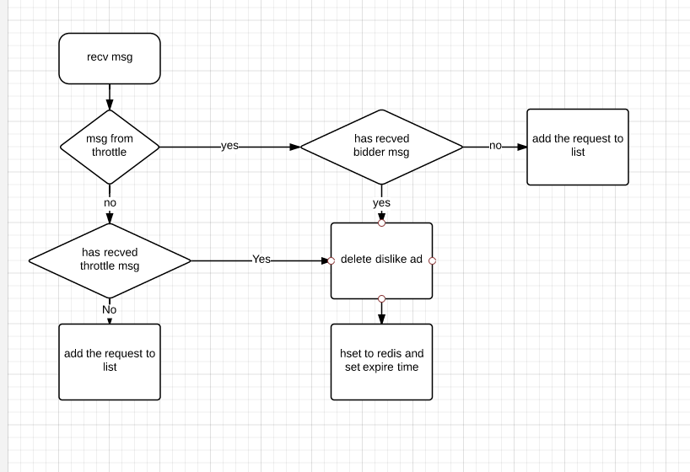

bidderCollector的业务主要业务是把AD response中dislike的ad删除，并且把删除后的结果插入到指定的redis。
bidderCollector接收到throttle的ad request信息和bidder的ad response信息后根据AdInsight列表去掉不能展示的ad，然后把剩余的ad response插入redis，并且设置这个ad response在redis中的生存期

设备管理模块：
管理throttle设备
管理bidder设备
管理connector设备

