Descriptors are used by USB devices to report their attributes.

**bTerminalID**

A non-zero constant that uniquely identifies the Terminal within the video function. This value is used in all requests to address this Terminal.

增加扩展协议时要用到。

Extension Unit descriptor

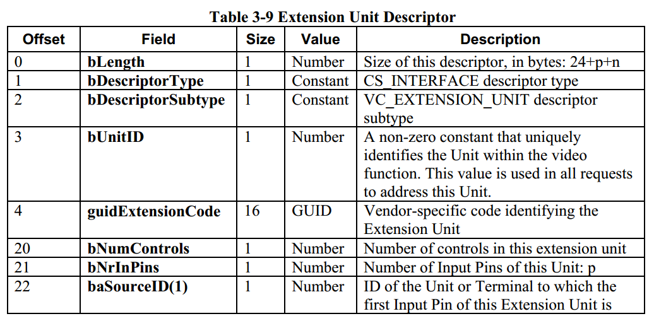

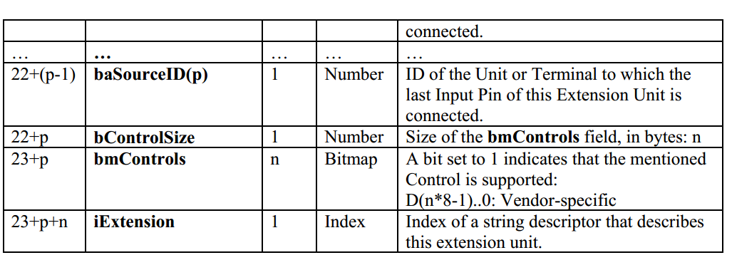

Payload 传输类型与文档对应关系

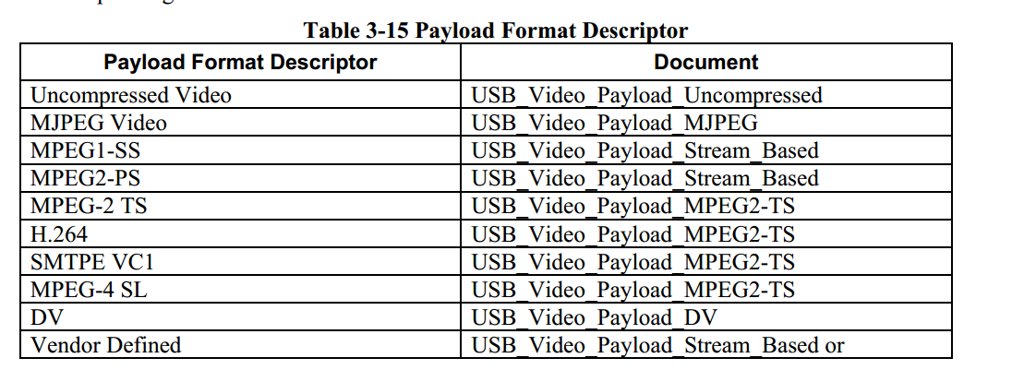

**Color Matching Descriptor**

**描述传送的数据颜色构成标准。**

**Request：**

**分为两类：**VideoControl Requests，VideoStreaming Requests

寻址：Unit ID, Control Selector

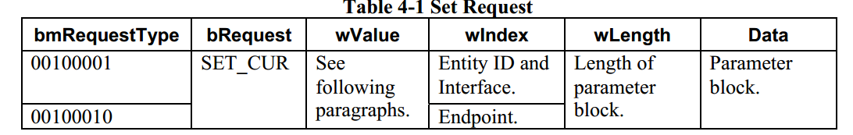

**bmRequestType 表示类型，共有两类 Get Request** Set requests

**bRequest 表示属性，属性共有七种**

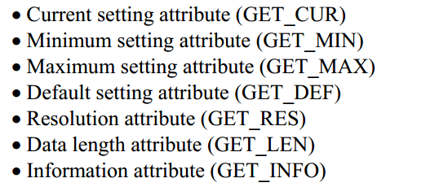

Wvalue 表示某种unit下各个命令的编码。

Windex 表示各个unit的编码。