FIT5216: Modelling Discrete Optimization Problems

Assignment 4: Cargo Handling

**Part G:**

**Experiment 1: Increase the number of loaders**

|  |  |
| --- | --- |
| NL | Obj |
| 2 | 205 |
| 3 | 183 |
| 4 | 183 |
| 5 | 183 |

The number of CARGOs that need to be loaded at the same time is limited. If the number of loaders is greater than the number of CARGOs waiting to be loaded, then efficiency will not increase.

**Experiment 2: reduce build_time**

|  |  |
| --- | --- |
| build_time | Obj |
| 4 | 205 |
| 3 | 181 |
| 2 | 152 |
| 1 | 124 |

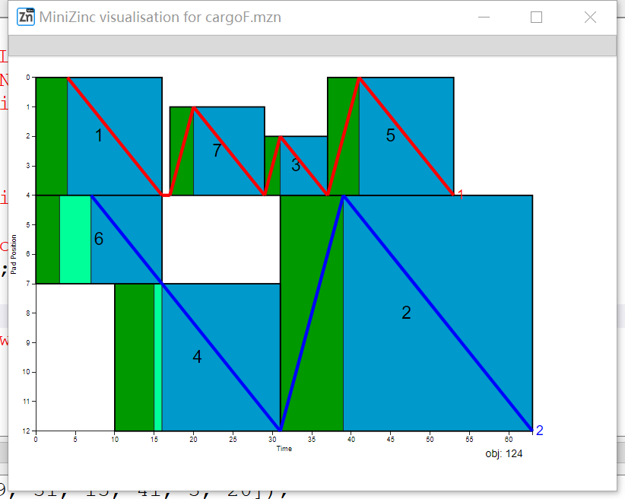 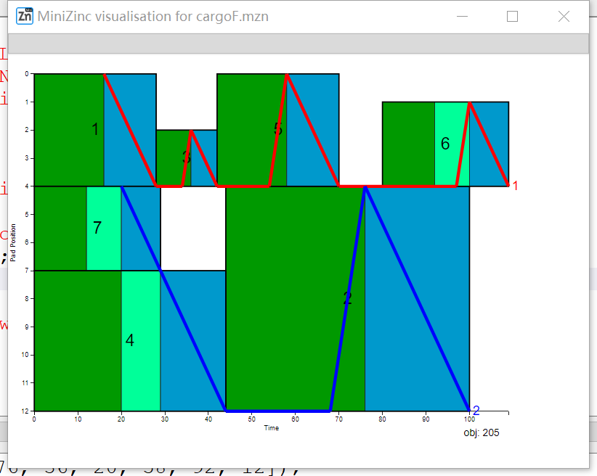

build_time = 1 build_time = 4

The figure indicates that the smaller the build time, the smaller the time square occupied by CARGO's build (the green area in the figure).

**Experiment 3：load_speed(time for loader to move 1 unit)**

|  |  |
| --- | --- |
| Load_speed | Obj |
| 1 | 205 |
| 2 | 205 |
| 3 | 205 |
| 4 | 205 |
| 5 | 198 |

Load_speed is the slope of the broken line with positive slope in the figure.

 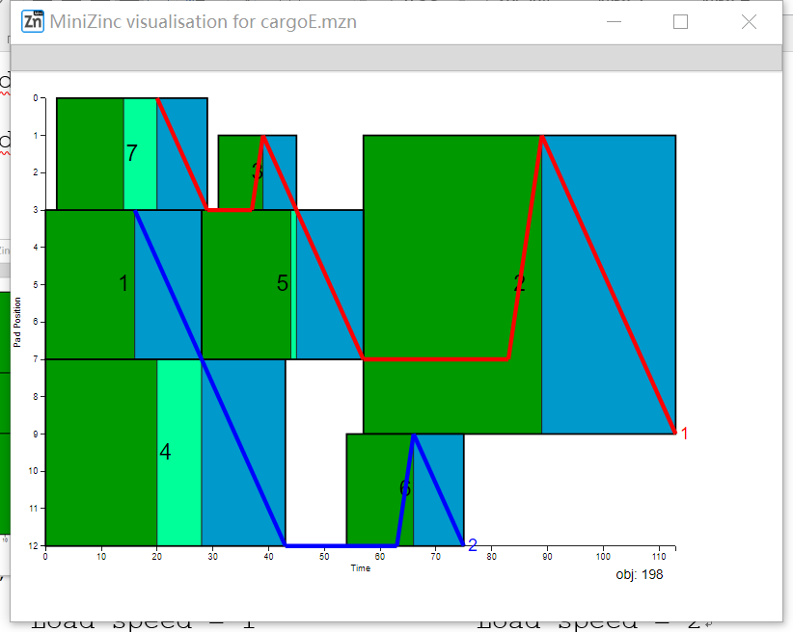

Load_speed = 1 Load_speed = 5

Experimental results show that increasing load speed does not decrease obj significantly. This is because when the optimal solution is obtained, usually the loader spends much less time moving from cargoA to cargoB than the build time of cargoB, which means during the build time of the cargoB, the loader always is able to reach the designated location.

**Experiment 4: Reduce load_time (time to load 1 unit)**

|  |  |
| --- | --- |
| load_time | Obj |
| 3 | 205 |
| 2 | 162 |
| 1 | 116 |

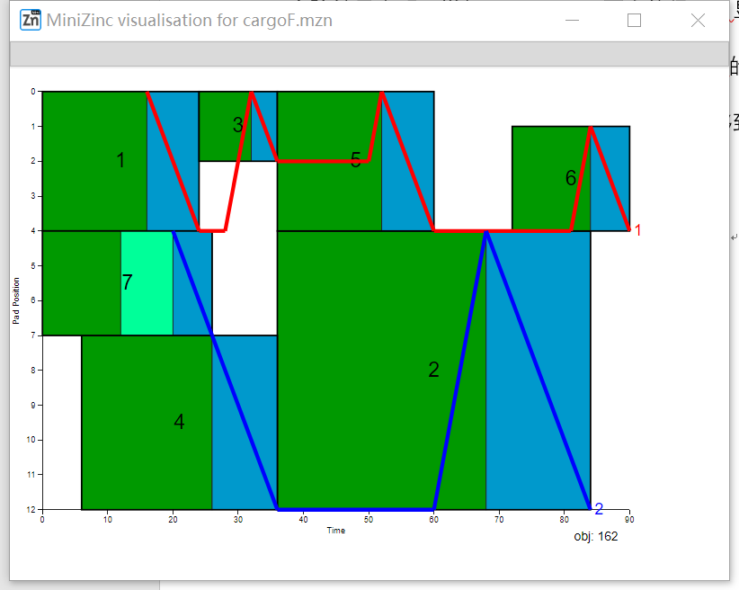 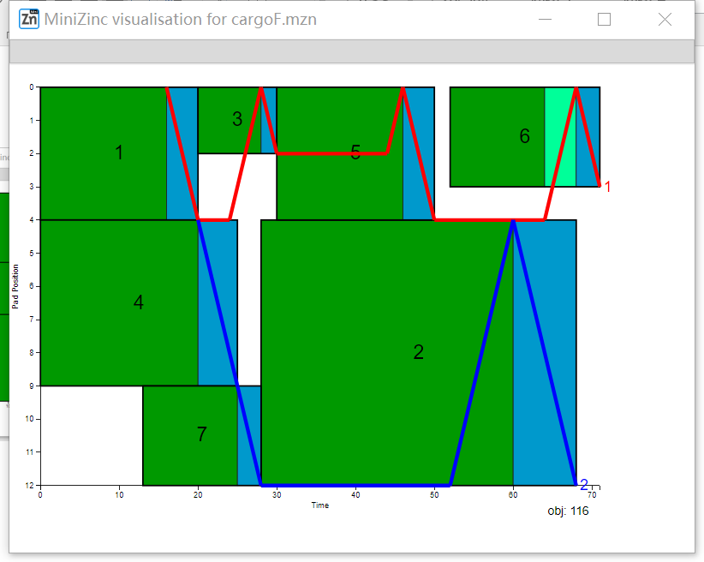

load_time = 2 load_time = 1

The smaller the load time, the smaller the load time block (blue square in the figure) occupied by each CARGO.

**Experiment 5：three loaders in one rail**

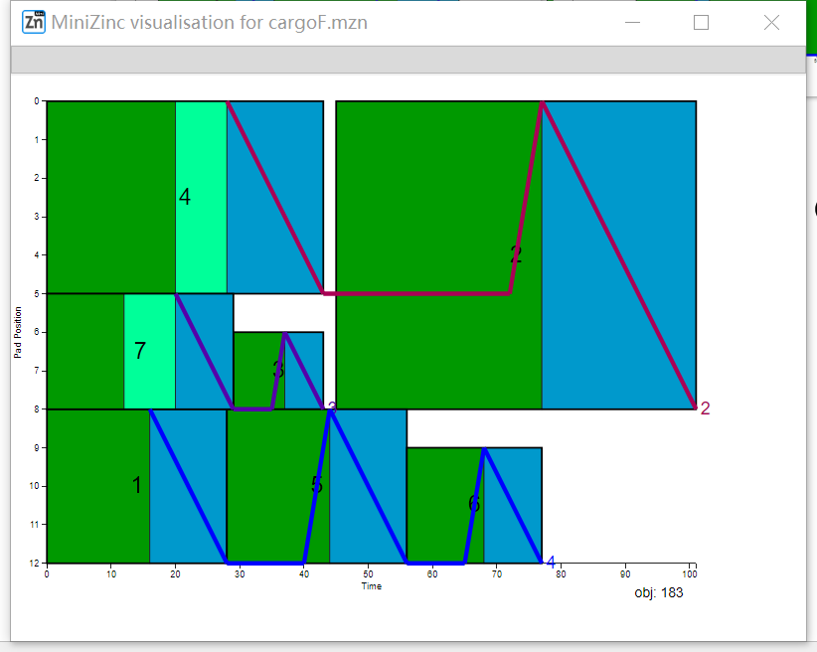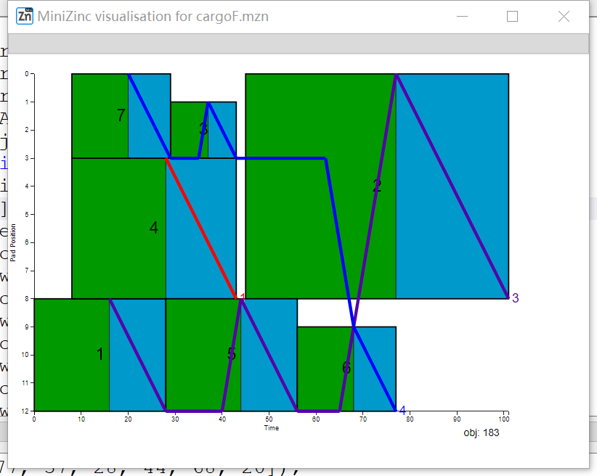

NL=4,two loader per rail NL=4,three loader per rail

having three loaders on a rail is similar to Experiment 1 and does not significantly improve the throughput of the port.

**Conclusion:**

According to the results, reduce build time, reduce load time, add more rails are the three most worthwhile upgrades to the port