**Query Refinement Techniques**

Our query refinement techniques can be seen in the ranked_retrieval.py document.

We implemented two different query refinement techniques:

1. Relevant Feedback

Relevant feedback was implemented using Rocchio formula.

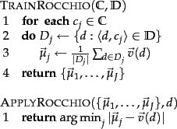

We applied Rocchio’s algorithm to expand the results based on the list of documents returned as relevant feedback in the query.

We were unable to tune the parameters in the Rocchio algorithm as the leaderboard was down.

1. Query Expansion

We also implemented query expansion using the wordnet of the nltk.corpus module.

We find synonyms of the word, and then we augment the original query vector by adding a value proportional to the factor of similarity between the original word and the synonym.

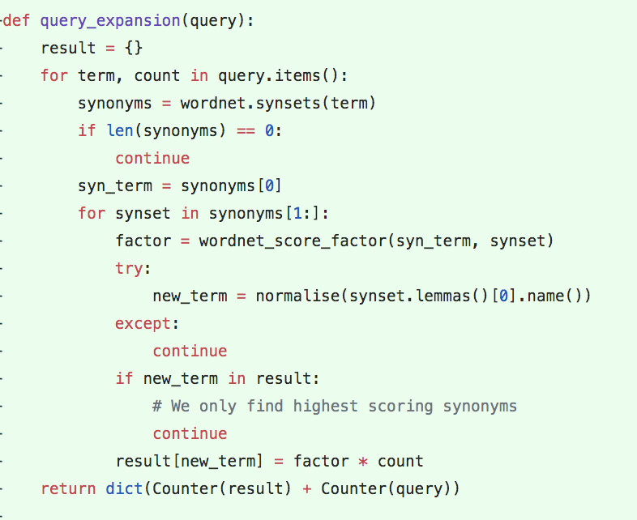

**Integration with ranked retrieval**

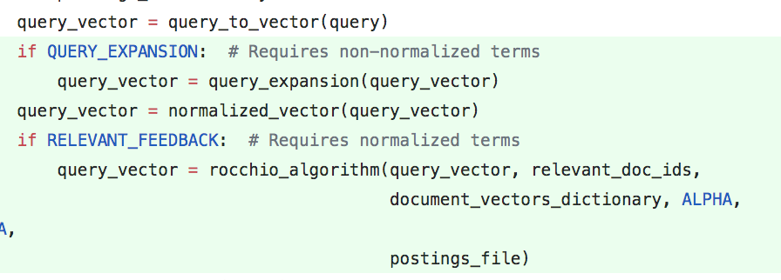

**Figure: get_relevant_docs function in ranked_retrieval.py**

We first applied query expansion before applying relevant feedback so as to reduce the number of extra queries that would be generated. We also felt that semantically, applying query expansion before relevant feedback was more appropriate.