这个版本的API比较简陋，请谅解，这个版本经常变动，如碰上更新不能访问，请和我联系，抱歉

测试账号 admin/passw0rd
CONTEXTPATH=http://115.28.41.123:8080/web 或 http://115.28.41.123:8080/apk

接口一：登录接口
{CONTEXTPATH}/api/auth
POST
username=admin
password=passw0rd

成功 需要把返回的token放在其他API的请求头里

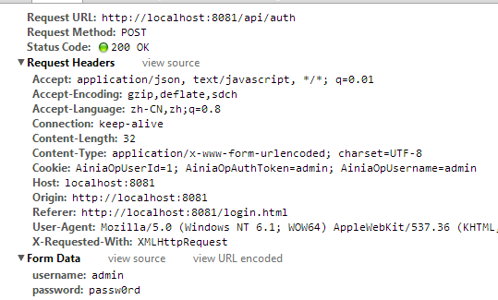

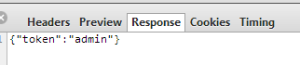

失败
状态码 401

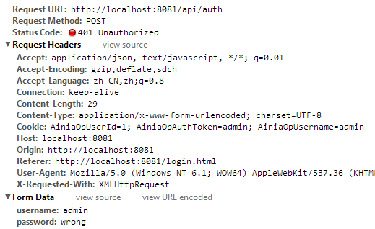

以下接口header都得带认证信息

Authorization:{token}

接口二：任务接口 (这个接口我刚才没说，这个接口主要是用来存工作流的信息，得通过这个接口获得检测请求及其回复)

{contextpath}/api/task

目前状态有三种
pending 尚未处理
proceeding 等待专家处理
completed 已回复

仅支持GET请求，如果用POST请求返回405 method not allowed

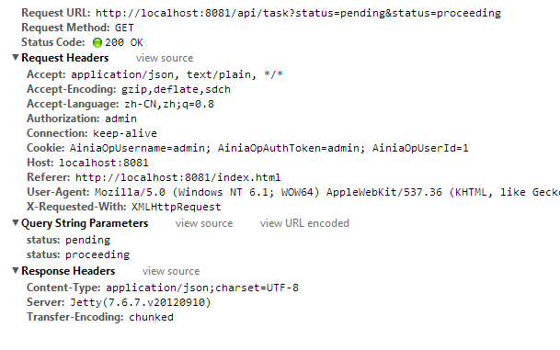
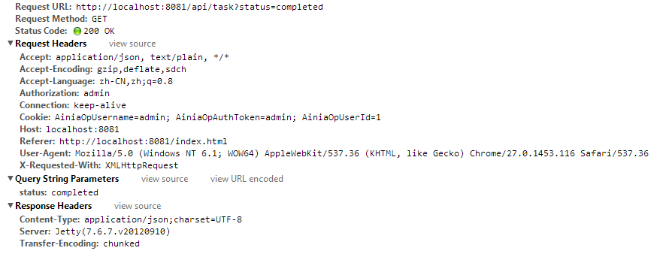
{"total":4,"max":15,"curPage":1,"pageCount":1,"pageable":true,"datas":[{"id":2,"status":"pending","expertId":null,"operatorId":8,"auto":false,"createdDate":"2013-07-04 01:00:00","completedDate":null,"version":1,"examinationId":2,"level":"outside","userName":"测试用户1","userId":1,"complete":false},{"id":3,"status":"pending","expertId":null,"operatorId":8,"auto":false,"createdDate":"2013-07-04 01:00:00","completedDate":null,"version":1,"examinationId":3,"level":"outside","userName":"测试用户2","userId":2,"complete":false},{"id":4,"status":"pending","expertId":null,"operatorId":8,"auto":false,"createdDate":"2013-07-04 01:00:00","completedDate":null,"version":1,"examinationId":4,"level":"warning","userName":"测试用户2","userId":2,"complete":false},{"id":5,"status":"pending","expertId":null,"operatorId":8,"auto":false,"createdDate":"2013-07-04 01:00:00","completedDate":null,"version":1,"examinationId":5,"level":"danger","userName":"测试用户2","userId":2,"complete":false}],"offset":0}

接口三：检测请求的医疗数据

{contextpath}/api/examination/{examinationId}

仅支持GET请求，如果用POST请求返回405 method not allowed

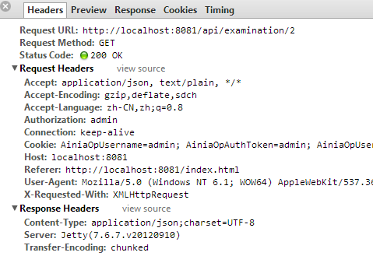

{"id":2,"userId":1,"userName":"测试用户1","testItem":"PHONE","userType":"VIP","level":"outside","bloodPressureLow":80,"bloodPressureHigh":120,"heartRhythm":-100,"bloodOxygen":null,"breath":80,"bodyTemp":37.5,"pulserate":60,"heartData":"","temp":37.6,"chargeType":"YEAR","createdDate":"2013-07-04 01:00:00","version":1}

接口四：检测请求的相关回复列表

{contextpath}/api/examination/{examinationId}/reply

通过GET请求获得数据列表，POST是运营平台使用

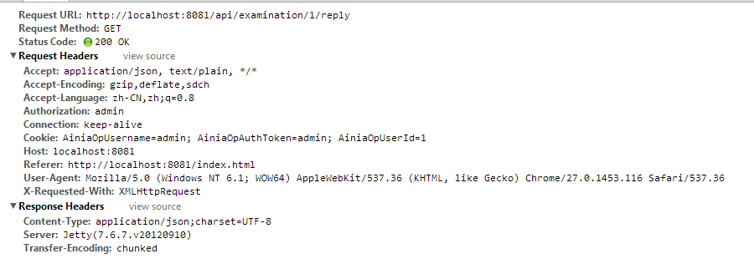
不带分页信息

[{"id":1,"type":null,"title":"标题","result":"呼吸正常","content":"呼吸正常的个性建议","employeeId":1,"examinationId":1,"createdDate":null,"lastUpdated":"2013-07-11 10:15:38","version":null}, {"id":2,"type":null,"title":"标题","result":"呼吸正常","content":"呼吸正常的个性建议","employeeId":1,"examinationId":1,"createdDate":null,"lastUpdated":"2013-07-11 10:15:38","version":null}]

接口五

不确定带不带认证信息

{contextpath}/api/examination/upload

成功 201

