STAT0030_ICA2

Hongwei Peng

10/02/2019

# R Question 1

## Question 1a read the data

setwd('/Users/hongwei/Documents/GitHub/STAT/STAT0030_ICA2')  
rawdata <- read.table("cars.dat", #input data  
 header=TRUE) #the first line as the names of the variables

## Question 1b

summary(rawdata)

## tr hp wt mpg   
## Min. :0.0000 Min. : 52.0 Min. :1513 Min. :10.40   
## 1st Qu.:0.0000 1st Qu.: 96.5 1st Qu.:2581 1st Qu.:15.43   
## Median :0.0000 Median :123.0 Median :3325 Median :19.20   
## Mean :0.4062 Mean :146.7 Mean :3217 Mean :20.09   
## 3rd Qu.:1.0000 3rd Qu.:180.0 3rd Qu.:3610 3rd Qu.:22.80   
## Max. :1.0000 Max. :335.0 Max. :5425 Max. :33.90

table(rawdata$tr)

##   
## 0 1   
## 19 13

plot(rawdata,main="Plot Between all Variables") #overlook

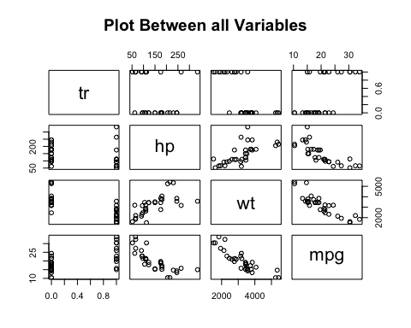

pairs(rawdata[,2:4], # plot hp, wt, mpg   
 main = "Plot Between all Variables -- 3 species", #add the main title  
 pch = c(21,24)[unclass(rawdata$tr)+1], #different tr shows different shape  
 bg = c("red", "green3")[unclass(rawdata$tr)+1]) #different tr shows different colour

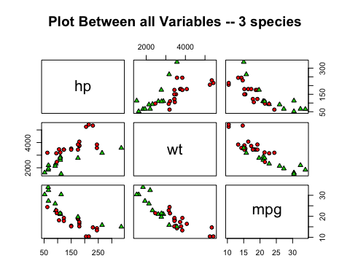

logdata <- cbind(rawdata[,1],log(rawdata[,c(2,3,4)])) #log the data  
names(logdata) <- c("tr","hp","wt","mpg")#rename the names of the variables   
plot(logdata,main="Plot Between log Variables") #overlook

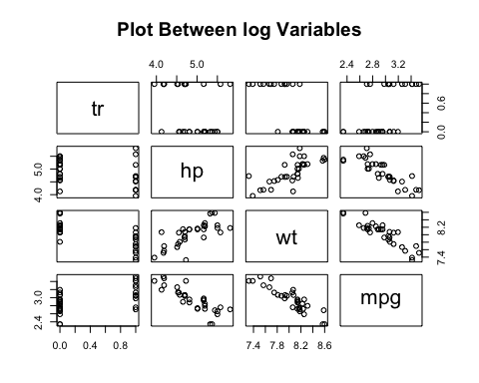

pairs(logdata[,2:4], # plot log(hp), log(wt), log(mpg)  
 main = "Plot Between log Variables -- 3 species", #add the main title  
 pch = c(21,24)[unclass(logdata$tr)+1], #different tr shows different shape  
 bg = c("red", "green3")[unclass(logdata$tr)+1]) #different tr shows different colour

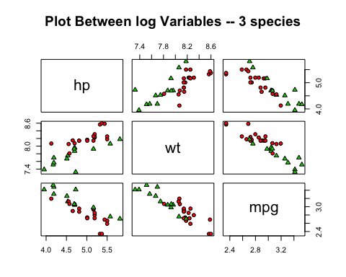

## question 1c

boxplot(mpg~tr, #MPG by TR  
 data=rawdata, #set the dataset  
 xlab="Gear Transmission Type" , #add the xlab title  
 ylab="Miles Per Gallon", #add the ylab title  
 main="MPG by Gear Transmission Type", #add the main title  
 names=c("Automatic","Manual")) #change xlab value to character

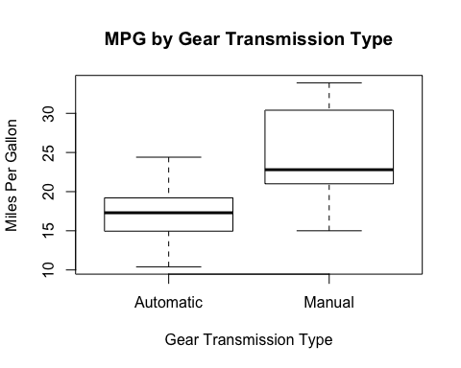

t.test(mpg~tr, data=logdata)

##   
## Welch Two Sample t-test  
##   
## data: mpg by tr  
## t = -3.8257, df = 23.958, p-value = 0.0008194  
## alternative hypothesis: true difference in means is not equal to 0  
## 95 percent confidence interval:  
## -0.5336626 -0.1596180  
## sample estimates:  
## mean in group 0 mean in group 1   
## 2.816692 3.163332

model<-lm(mpg~tr+hp+wt, data=logdata); # i.e, full without qsec and gears  
summary(model)

##   
## Call:  
## lm(formula = mpg ~ tr + hp + wt, data = logdata)  
##   
## Residuals:  
## Min 1Q Median 3Q Max   
## -0.204243 -0.081099 -0.003198 0.080083 0.197919   
##   
## Coefficients:  
## Estimate Std. Error t value Pr(>|t|)   
## (Intercept) 8.59990 0.86159 9.981 1e-10 ***  
## tr 0.01069 0.06040 0.177 0.860813   
## hp -0.25971 0.06438 -4.034 0.000384 ***  
## wt -0.54535 0.13062 -4.175 0.000262 ***  
## ---  
## Signif. codes: 0 '***' 0.001 '**' 0.01 '*' 0.05 '.' 0.1 ' ' 1  
##   
## Residual standard error: 0.1072 on 28 degrees of freedom  
## Multiple R-squared: 0.883, Adjusted R-squared: 0.8705   
## F-statistic: 70.44 on 3 and 28 DF, p-value: 3.686e-13

summary(model$residuals)

## Min. 1st Qu. Median Mean 3rd Qu. Max.   
## -0.204243 -0.081099 -0.003198 0.000000 0.080083 0.197919

par(mfrow=c(2,2)) #put 4 graphes together  
plot(model) #plot 4 graphes as following

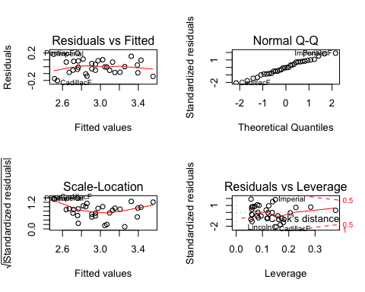

best<-step(model, direction="both")

## Start: AIC=-139.2  
## mpg ~ tr + hp + wt  
##   
## Df Sum of Sq RSS AIC  
## - tr 1 0.00036 0.32197 -141.17  
## <none> 0.32161 -139.21  
## - hp 1 0.18691 0.50852 -126.54  
## - wt 1 0.20023 0.52184 -125.72  
##   
## Step: AIC=-141.17  
## mpg ~ hp + wt  
##   
## Df Sum of Sq RSS AIC  
## <none> 0.32197 -141.17  
## + tr 1 0.00036 0.32161 -139.21  
## - hp 1 0.21221 0.53418 -126.97  
## - wt 1 0.45943 0.78140 -114.80

summary(best)

##   
## Call:  
## lm(formula = mpg ~ hp + wt, data = logdata)  
##   
## Residuals:  
## Min 1Q Median 3Q Max   
## -0.201439 -0.079566 0.002144 0.078778 0.196144   
##   
## Coefficients:  
## Estimate Std. Error t value Pr(>|t|)   
## (Intercept) 8.71876 0.53056 16.433 3.12e-16 ***  
## hp -0.25531 0.05840 -4.372 0.000145 ***  
## wt -0.56228 0.08741 -6.433 4.89e-07 ***  
## ---  
## Signif. codes: 0 '***' 0.001 '**' 0.01 '*' 0.05 '.' 0.1 ' ' 1  
##   
## Residual standard error: 0.1054 on 29 degrees of freedom  
## Multiple R-squared: 0.8829, Adjusted R-squared: 0.8748   
## F-statistic: 109.3 on 2 and 29 DF, p-value: 3.133e-14

summary(best$residuals)

## Min. 1st Qu. Median Mean 3rd Qu. Max.   
## -0.201439 -0.079566 0.002144 0.000000 0.078778 0.196144

par(mfrow=c(2,2)) #put 4 graphes together  
plot(best)#plot 4 graphes as following

