Reviewer 1 Comments to the Author

The manuscript aims to show a new way to make predictions in unmeasured locations named Feature-Free Regression Kriging (FFRK), having as competitors OK, RK, ML models, SML.
Despite of subject being interesting, I have found some issues:
1) The authors are using 9 covariates to help predict in the competitor's model. Have they checked if all of them are improving the explanation? Did they check significance?【准确】

Response:

We sincerely appreciate the reviewer's insightful suggestion. Validating the effectiveness of the selected environmental covariates is indeed crucial for ensuring a fair and rigorous comparison between the benchmark models (RK and ML) and our proposed FFRK.

To address this, we have implemented a multi-dimensional statistical framework to systematically analyze the 9 covariates across three heavy metal elements (Cu, Pb, and Zn). Specifically:

- Multicollinearity Check: We calculated the Variance Inflation Factor (VIF) to ensure that the input features are independent and do not contain redundant information.
- Linear Significance Testing: We employed Linear Models (LM) to assess the statistical significance (P-value) and weight coefficients of each covariate.
- Non-linear Importance Evaluation: Using Random Forest (RF), we calculated the Increase in Mean Squared Error (IncMSE) to identify covariates that might exhibit complex non-linear explanatory power even when linear significance is low.

As shown in the newly added Table S1 and the corresponding analysis in Section Appendix 3, all VIF values are below the threshold of 4, and the majority of variables show significant linear or non-linear contributions. This evidence ensures that our benchmark models are optimized with high-quality features, further strengthening our conclusion that FFRK achieves superior performance without relying on these external variables.

Please refer to our new added Appendix 3:

To ensure the fairness and rigor of the comparative experiments, a systematic validity analysis was conducted on the nine selected external covariates. This analysis aims to verify whether these environmental factors provide substantial explanatory power for the benchmark models—such as Regression Kriging and Machine Learning—rather than introducing redundant information.
A multi-dimensional statistical testing framework was employed for this evaluation. First, the Variance Inflation Factor (VIF) was utilized to assess multicollinearity, ensuring the independence of the input features. Second, the contribution of each feature was quantified using both Linear Model and Random Forest: the LM estimates weight coefficients via ordinary least squares and tests statistical significance through P-values; meanwhile, the RF employs an ensemble learning mechanism to measure feature importance by calculating the Increase in Mean Squared Error (IncMSE) after permuting specific features, thereby capturing their roles in complex non-linear relationships.
The results, as summarized in Table S3, demonstrate that all selected external covariates performed robustly across the prediction tasks for the three elements. First, the VIF values for all variables ranged from 1.07 to 3.78, remaining well below the conservative threshold of 4. This indicates the absence of severe multicollinearity and confirms the independence and non-redundancy of the selected environmental features. Regarding statistical significance, the majority of variables exhibited high explanatory power within the linear framework ($P < 0.05$). For instance, in Cu prediction, Dlith ($P < 0.001$) and NDVI ($P < 0.001$) showed highly significant linear correlations. Similarly, for Pb and Zn, factors such as SOC and pH maintained consistently high significance across all tests. Notably, for the few variables that did not reach statistical significance in the linear models—such as Road density in Cu prediction ($P = 0.1679$) or Dfault in Zn prediction ($P = 0.2348$)—they nonetheless displayed substantial contributions in the Random Forest model, with IncMSE values of 15.27 and 30.86, respectively. This disparity suggests that these factors may influence heavy metal distribution through complex non-linear mechanisms that LM fails to capture, yet RF effectively utilizes.In conclusion, this multi-dimensional analysis confirms that the benchmark models (RK and ML) are operating under high-quality, high-relevance feature inputs. This evidence provides a rigorous baseline for comparison, further highlighting the architectural advantage of the proposed FFRK, which achieves superior accuracy without relying on these external environmental covariates.

2) Why is Universal Kriging (UK) not a competitor?
感觉这个也没有什么细节，也就是：构建二次多项式公式→拟合变差函数→克里格插值
# Formula: Target ~ x + y + x^2 + y^2 + x*y
# 构建二次多项式公式
uk_formula_str <- paste(target_var, "~",
x_field, "+", y_field, "+",
"I(", x_field, "^2) +",
"I(", y_field, "^2) +",
"I(", x_field, "*", y_field, ")")
var_formula <- stats::as.formula(uk_formula_str)

# 拟合变差函数
res_auto <- fit_variogram_robust(train_sp, var_formula)

if(!is.null(res_auto)) {
# 记录变差函数参数
vario_model_str <- paste(res_auto$model, collapse=";")
vario_psill_str <- paste(round(res_auto$psill,4), collapse=";")
vario_range_str <- paste(round(res_auto$range,4), collapse=";")
vario_kappa_str <- paste(round(res_auto$kappa,4), collapse=";")

# 克里格插值
pred.krig <- krige(var_formula, train_sp, test_sp, model=res_auto)
p <- pred.krig$var1.pred
p_var <- pred.krig$var1.var

Response:

We thank the reviewer for this constructive suggestion. UK is indeed a classic geostatistical method for addressing spatial non-stationarity by assuming that the mean of the process follows a deterministic trend. To ensure a more comprehensive model comparison, we have added UK as a baseline competitor in the revised manuscript.
Following standard practice, we implemented a UK model utilizing a quadratic polynomial trend surface defined by the coordinates (Formula: Target~ x + y + x^2 + y^2 + x*y). The experimental results across the three heavy metals (Cu, Zn, and Pb) consistently demonstrate that FFRK (LM) significantly outperforms the supplemental UK model.
Taking the FFRK (LM) results as a representative example, the performance comparison is as follows:
- Cu Prediction: UK achieved an $R^2$ of 0.2646, while FFRK (LM) reached 0.443, representing a performance improvement of approximately 67.4%.
- Pb Prediction: The $R^2$ for UK was 0.1786, whereas FFRK (LM) achieved 0.397. This indicates that FFRK (LM) provides more than double the predictive explanatory power of the UK model.
- Zn Prediction: UK performed relatively poorly with an $R^2$ of only 0.0794. In contrast, FFRK (LM) showed high robustness with an $R^2$ of 0.375, which is nearly a fivefold increase compared to UK.
The traditional UK approach relies on absolute coordinates to fit a global, smooth polynomial trend. However, such deterministic functions often struggle to capture complex, small-scale spatial non-stationarity and local variations inherent in geographic data.

Table. Results of UK
Element | R2 | MAE | RMSE
Cu | 0.2646 | 0.7526 | 0.9810
Zn | 0.0794 | 0.6115 | 0.7716
Pb | 0.1786 | 0.5445 | 0.6738

3) What kind of models have been used in semivariogram models? Gaussian, exponential, Mattern etc? And how about the parameters? Is it possible to show the semivariogram curves? Or has the author used the ML method to estimate the parameters?
Response:
我们使用 automap 包中的 autofitVariogram() 函数对经验半变异函数进行拟合，并选择相应的理论模型。候选模型限定为球状模型（Spherical, Sph）和指数模型（Exponential, Exp）。最优拟合模型的参数（Variogram model、Nugget、Partial sill、Sill、Range、Nugget-to-sill ratio）从返回的 vgm 对象中直接提取。预测值及克里金方差通过 gstat包的krige()函数计算得到。

Table. Results of UK
Element | Method | Variogram model | Nugget | Partial sill | Sill | Range | Nugget-to-sill ratio
Cu | FFRK-RF | Spherical | 0.15993 | 0 | 0.15993 | 0.1698 | 1
 | OK | Spherical | 1.31563 | 0.40342 | 1.71906 | 2.582 | 0.7653
 | RK-RF | Spherical | 0.29009 | 0.07687 | 0.36695 | 1.1572 | 0.7905
Pb | FFRK-RF | Spherical | 0.10424 | 0.02615 | 0.13038 | 1.0817 | 0.7995
 | OK | Spherical | 0.76237 | 0.05628 | 0.81865 | 1.1699 | 0.9313
 | RK-RF | Spherical | 0.16593 | 0.06416 | 0.23009 | 1.1205 | 0.7212
Zn | FFRK-RF | Spherical | 0.09037 | 0 | 0.09037 | 0.1698 | 1
 | OK | Spherical | 0.6441 | 0.12049 | 0.76459 | 0.6064 | 0.8424
 | RK-RF | Spherical | 0.11424 | 0.02115 | 0.13538 | 1.109 | 0.8438

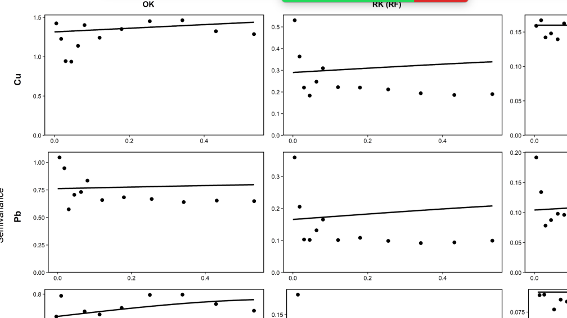

4) The main feature of the Kriging technique is also an error prediction, in comparison to the other interpolation methods, such as the IDW, for instance. I would like to see the errors of the proposed model in comparison to those of its competitors.
Response:

error prediction是由 gstat包krige()函数 在求解克里金方程组时直接计算提取得到的克里金预测方差（pred.krig$var1.var ），其数值完全由已拟合的半变异函数模型以及样点的空间配置决定，而非通过与观测值比较事后计算得到。

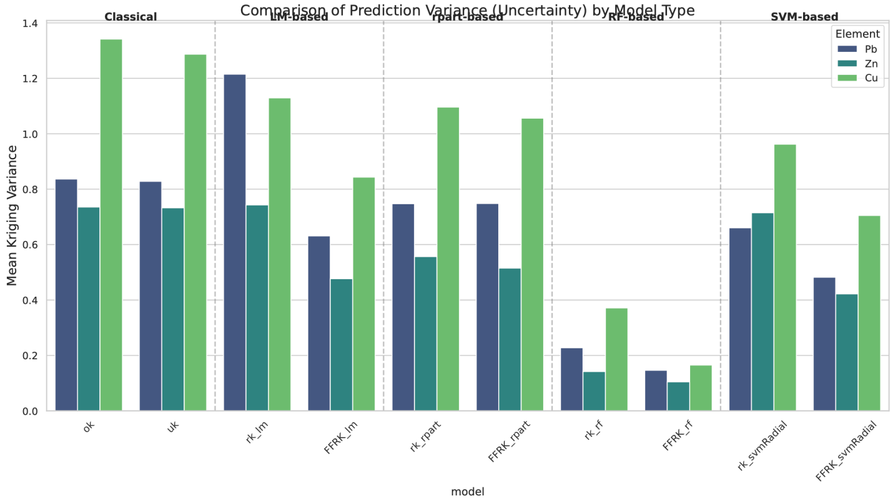
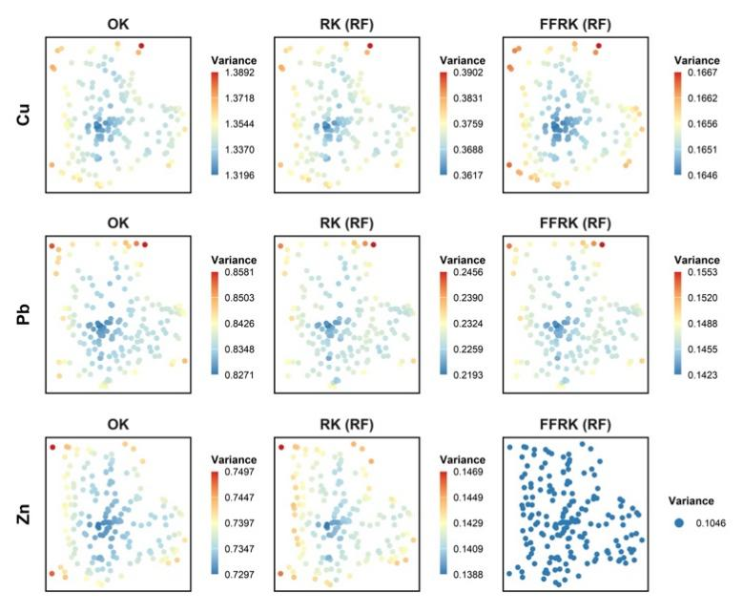

5) In Figure 6, the authors show the superiority of the proposed model in relation to R2, but it was the worst when RMSE and MAE were used. Is there some explanation for that? What is the impact? Based on Figure 5, the prediction of FFRK looks better. Is it possible to add the prediction of OK and UK, for comparison purposes?

Response:
解释一下。。。。
做一个OK和UK的空间图，只放在response letter就好。OK的图应该之前都做过了
做出图

6) It is not clear how the dimensions FSVD and FGOS were calculated from the example. Is it possible to give more details?
Response:
解释一下。。。。
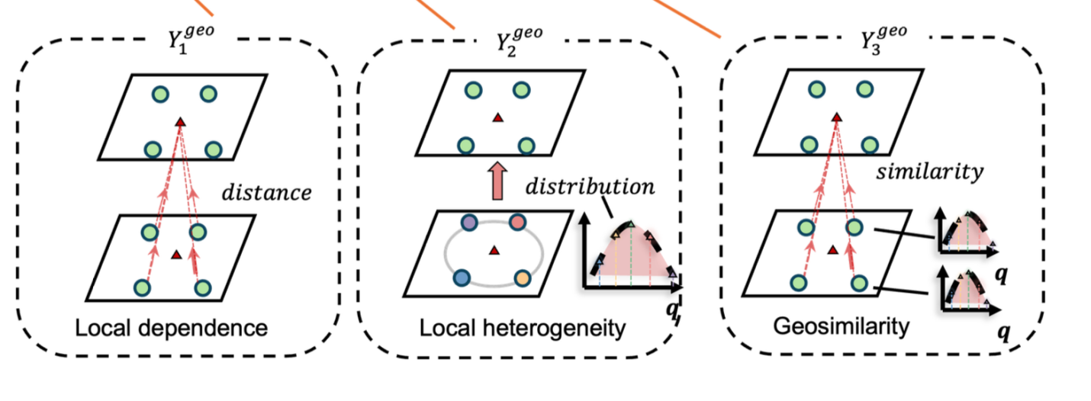
7) From Section 2, apparently, the prediction of the spatial features was a simple task. But during the case study, the authors said that they have used machine learning techniques for that: See page 13, "For the target variable, we computed its three-dimensional geofeatures, including dependence, heterogeneity, and similarity. Subsequently, we selected four types of machine learn
ing models—linear model (LM), decision tree (DT), random forest (RF), and support vector machine (SVM)—to predict the trend of the target variable. After obtaining the residuals by comparing the predicted trend with observations, we applied ordinary kriging for spatial interpolation of the residuals. Finally, the predicted trend and interpolated residuals were combined to produce the prediction." Why? Or did I misunderstand? For me, the inclusion of this step increases the complexity of the prediction. Have the authors checked for overfitting?

Response:
回归kriging

Reviewer 2 Comments to the Author

This paper introduces a "feature-free" variant of regression kriging that aims to sidestep explicit covariate engineering by learning relationships directly from spatial data. The idea is appealing and relevant to Geographical Analysis. However, in its current form, the manuscript has several issues that prevent publication.
1. The term "feature-free" is misleading and doesn't make much sense in the context of regression kriging, which inherently relies on covariates (features) to model spatial variation. The method manually extracts features from spatial coordinates (e.g., distances, number of neighbors), and further discussion about the relationship to deep kernel learning, which uses neural networks to learn features from raw inputs, is needed.

Response:

感谢您的意见。我们确实认为FFRK有误导性。我们修改为了covariate free regression kriging (CFRK)
2. Code and data should be provided to ensure reproducibility

Response:
做成一个python package

