|  |  |  |  |  |
| --- | --- | --- | --- | --- |
| **Sklopljeno nihanje ista smer A = 14.6 cm** | | | | |
|
| **N** | **St. Nihajev** | **t [s]** | **t0 [s]** | **Δt0 [s]** |
| 1 | 30 | 54.81 | 1.827 | -0.0155 |
| 2 | 35 | 64.87 | 1.853 | 0.0105 |
| 3 | 35 | 64.58 | 1.845 | 0.0025 |
| 4 | 35 | 64.81 | 1.852 | 0.0095 |
| 5 | 35 | 64.31 | 1.837 | -0.0055 |
| 6 | 35 | 64.43 | 1.841 | -0.0015 |
| Average: | 1.8425 | Value: | 1.84 | ± 0.01 |

|  |  |  |  |  |
| --- | --- | --- | --- | --- |
| **Sklopljeno nihanje nasprotna smer A = 14.6 cm** | | | | |
|
| **N** | **St. Nihajev** | **t [s]** | **t0 [s]** | **Δt0 [s]** |
| 1 | 35 | 63.13 | 1.804 | 0.0056 |
| 2 | 35 | 62.94 | 1.798 | -0.0004 |
| 3 | 35 | 62.92 | 1.798 | -0.0004 |
| 4 | 35 | 62.84 | 1.795 | -0.0034 |
| 5 | 35 | 62.92 | 1.798 | -0.0004 |
| 6 | 35 | 63.00 | 1.800 | 0.0016 |
| 7 | 35 | 62.96 | 1.799 | 0.0006 |
| 8 | 35 | 62.84 | 1.795 | -0.0034 |
| Average: | 1.7984 | Value | 1.798 | ± 0.003 |

|  |  |  |  |  |  |
| --- | --- | --- | --- | --- | --- |
| **Utripanje A = 14.6 cm** | | | | | |
|
| **Nihalo** | **N** | **St. Nihajev** | **t [s]** | **t0 [s]** | **Δt0 [s]** |
| 1 | 1 | 15 | 27.21 | 1.814 | 0.005 |
| 2 | 15 | 27.25 | 1.817 | 0.002 |
| 3 | 15 | 27.42 | 1.828 | -0.009 |
| 2 | 1 | 15 | 27.26 | 1.817 | 0.002 |
| 2 | 15 | 27.19 | 1.813 | 0.006 |
| 3 | 15 | 27.41 | 1.827 | -0.008 |
|  | Average | 1.819 | Value | 1.82 | ± 0.01 |

|  |  |  |  |  |  |
| --- | --- | --- | --- | --- | --- |
| **Mirovanje** | | | | | |
|
| **Nihalo** | **N** | **St. Mirovanj** | **t [s]** | **t0 [s]** | **Δt0 [s]** |
| 1 | 1 | 4 | 282.38 | 70.60 | 0.71 |
| 2 | 4 | 281.96 | 70.49 | 0.60 |
| 3 | 4 | 279.46 | 69.87 | -0.02 |
| 4 | 4 | 279.72 | 69.93 | 0.04 |
| 2 | 1 | 4 | 278.25 | 69.56 | -0.33 |
| 2 | 4 | 277.94 | 69.49 | -0.40 |
| 3 | 4 | 278.61 | 69.65 | -0.24 |
| 4 | 4 | 278.25 | 69.56 | -0.33 |
|  | Average: | 69.89 | Value | 69.9 | ± 0.4 |

|  |  |  |  |
| --- | --- | --- | --- |
| **Vzmet** | | | |
|
| **x [cm]** | **m [g]** | **Δx [cm]** | **F [N]** |
| 72 | 0 | 0 | 0 |
| 74.5 | 50 | 2.5 | 0.4905 |
| 76.4 | 100 | 1.9 | 0.981 |
| 78.5 | 150 | 2.1 | 1.4715 |
| 80.5 | 200 | 2 | 1.962 |
| 82.4 | 250 | 1.9 | 2.4525 |

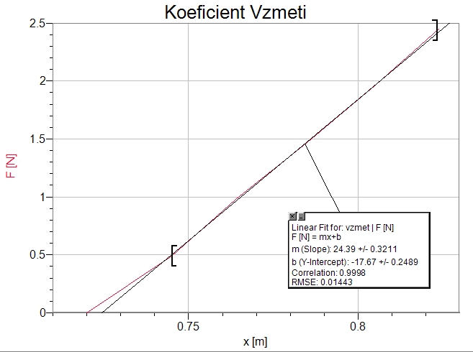



|  |  |  |
| --- | --- | --- |
| **Tabela podatkov** | | |
|
| **m [kg]** | 1.269 | ± 0.001 |
| **do [m]** | 0.79 | ± 0.01 |
| **d [m]** | 0.1 | ± 0.001 |
| **l [m]** | 0.98 | ± 0.01 |
| **k [N/m]** | 24.4 | ± 0.3 |
| **J [kg m2]** | 0.79 | ± 0.02 |
| **D [Nm]** | 9.8 | ± 0.1 |
| **D' [Nm]** | 0.244 | ± 0.005 |