|  |  |  |
| --- | --- | --- |
| **λ = 405 nm** | | |
|
| **U[V]** | **I[pA]** | **dI[pA]** |
| -0,50 | 110 | 5 |
| -0,60 | 95 | 5 |
| -0,70 | 75 | 4 |
| -0,80 | 60 | 3 |
| -0,90 | 45 | 2 |
| -1,00 | 35 | 2 |
| -1,10 | 25 | 1 |
| -1,20 | 14 | 1 |
| -1,30 | 6 | 1 |
| -1,40 | 1 | 1 |
| -1,43 | 0 | 0,5 |

|  |  |  |
| --- | --- | --- |
| **λ = 436 nm** | | |
|
| **U[V]** | **I[pA]** | **dI[pA]** |
| -0,50 | 115 | 5 |
| -0,60 | 93 | 4 |
| -0,70 | 73 | 3 |
| -0,80 | 55 | 3 |
| -0,90 | 39 | 2 |
| -1,00 | 24 | 2 |
| -1,10 | 11 | 1 |
| -1,20 | 2 | 1 |
| -1,25 | 0 | 1 |

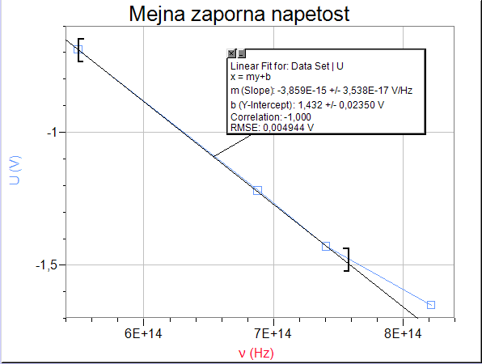

|  |  |  |
| --- | --- | --- |
| **λ = 546 nm** | | |
|
| **U[V]** | **I[pA]** | **dI[pA]** |
| -0,10 | 100 | 5 |
| -0,20 | 75 | 4 |
| -0,30 | 50 | 3 |
| -0,40 | 30 | 2 |
| -0,50 | 15 | 1 |
| -0,60 | 5 | 1 |
| -0,69 | 0 | 1 |

|  |  |  |
| --- | --- | --- |
| **Mejna zaporna napetost** | | |
|
| **U[V]** | **ν [Hz]** | **λ [nm]** |
| -1,60 | 8,21918E+14 | 365 |
| -1,40 | 7,40741E+14 | 405 |
| -1,20 | 6,88073E+14 | 436 |
| -0,70 | 5,49451E+14 | 546 |

|  |  |  |
| --- | --- | --- |
| **λ = 365 nm** | | |
|
| **U[V]** | **I[pA]** | **dI[pA]** |
| -0,60 | 270 | 10 |
| -0,70 | 230 | 9 |
| -0,80 | 190 | 7 |
| -0,90 | 170 | 6 |
| -1,00 | 140 | 5 |
| -1,10 | 115 | 5 |
| -1,20 | 90 | 5 |
| -1,30 | 70 | 4 |
| -1,40 | 45 | 2 |
| -1,50 | 25 | 1 |
| -1,60 | 10 | 1 |
| -1,70 | 3 | 1 |

