|  |  |  |  |
| --- | --- | --- | --- |
| **Meritev** | | | |
|
| **m [g]** | **U [V]** | **F [N]** | **U2 [V2]** |
| 0,50 | 1003 | 0,005 | 1006009 |
| 1,00 | 1667 | 0,010 | 2778889 |
| 1,50 | 1702 | 0,015 | 2896804 |
| 2,00 | 2119 | 0,020 | 4490161 |
| 2,50 | 2396 | 0,025 | 5740816 |
| 3,00 | 2582 | 0,030 | 6666724 |
| 3,50 | 2537 | 0,035 | 6436369 |

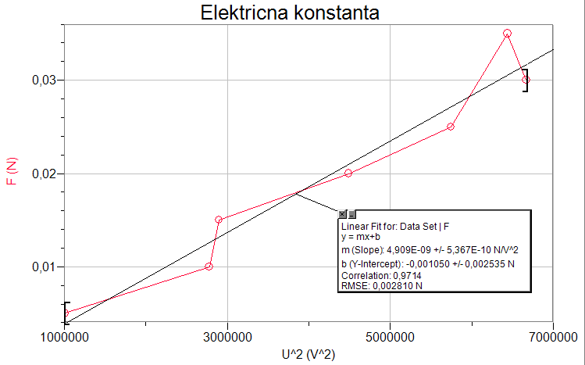

|  |  |
| --- | --- |
| **Dodatne Meritve** | |
|
| 2r [cm] | 19 |
| d [cm] | 0,51 |