|  |  |
| --- | --- |
| **Normalna smer toka** | |
|
| **I [A]** | **m [g]** |
| 0,000 | 0,000 |
| 0,145 | 0,040 |
| 0,245 | 0,120 |
| 0,346 | 0,190 |
| 0,443 | 0,270 |
| 0,547 | 0,350 |
| 0,644 | 0,450 |
| 0,738 | 0,540 |
| 0,834 | 0,630 |
| 0,948 | 0,730 |
| 1,041 | 0,820 |
| 1,150 | 0,930 |
| 1,249 | 1,020 |
| 1,354 | 1,120 |
| 1,443 | 1,220 |
| 1,545 | 1,330 |

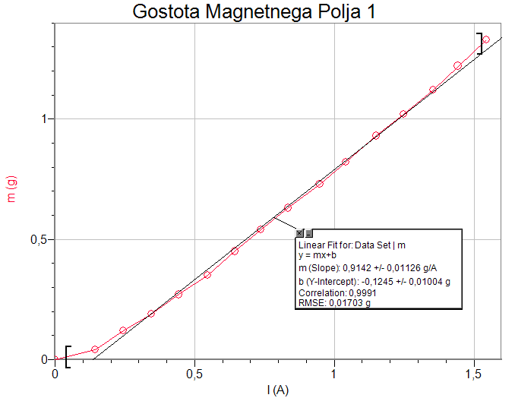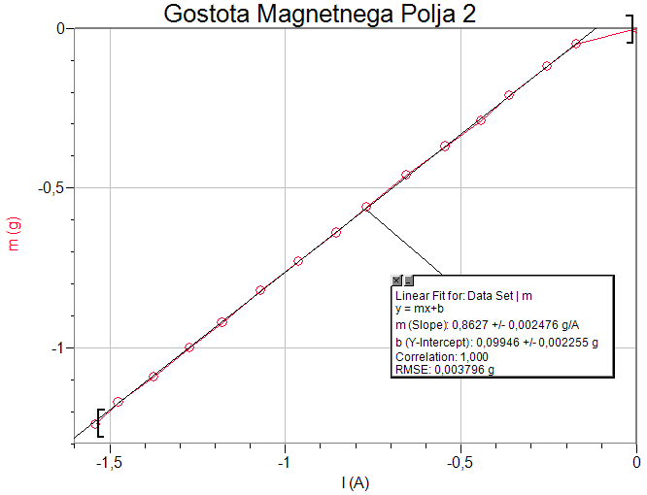

|  |  |
| --- | --- |
| **Obratna smer toka** | |
|
| **I [A]** | **m [g]** |
| 0,000 | 0,000 |
| -0,171 | -0,050 |
| -0,254 | -0,120 |
| -0,363 | -0,210 |
| -0,443 | -0,290 |
| -0,545 | -0,370 |
| -0,655 | -0,460 |
| -0,769 | -0,560 |
| -0,854 | -0,640 |
| -0,962 | -0,730 |
| -1,070 | -0,820 |
| -1,179 | -0,920 |
| -1,271 | -1,000 |
| -1,375 | -1,090 |
| -1,475 | -1,170 |
| -1,540 | -1,240 |

|  |  |
| --- | --- |
| **Dodatni podatki** | |
|
| l [cm] | 2 |
| h [cm] | 1,1 |