|  |  |
| --- | --- |
| **I = 4,0A** | |
|
| **I_H [A]** | **F [N]** |
| 0,38 | 0,00030 |
| 0,75 | 0,00058 |
| 1,12 | 0,00093 |
| 1,50 | 0,00116 |
| 1,88 | 0,00149 |
| 2,25 | 0,00179 |
| 2,62 | 0,00207 |

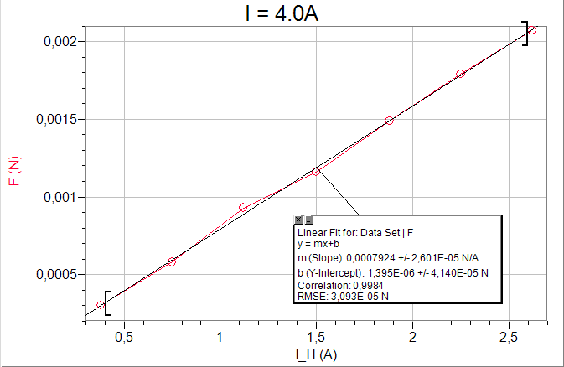

|  |  |
| --- | --- |
| **I_H = 3,0A** | |
|
| **I [A]** | **F [N]** |
| 0,50 | 0,00036 |
| 1,00 | 0,00077 |
| 1,50 | 0,00117 |
| 2,00 | 0,00158 |
| 2,50 | 0,00197 |
| 3,00 | 0,00235 |
| 3,50 | 0,00276 |
| 4,00 | 0,00311 |
| 4,50 | 0,00351 |

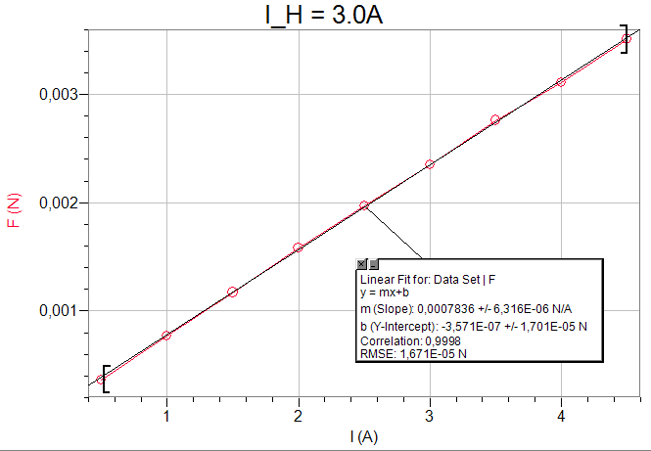

|  |  |
| --- | --- |
| **Dodatne meritve** | |
|
| **r [m]** | 0,06 |
| **N** | 2 |
| **l [m]** | 0,06 |
| **N_H** | 154 |
| **R_H [m]** | 0,20 |
| **S [m^2]** | 0,011309734 |
| **τ** | 0,004814411 |
| **I [A]** | 4,0 |
| **I_H [A]** | 3,0 |
| **μ0, ref [Vs/Am]** | 1,25664E-06 |