|  |  |  |  |  |  |
| --- | --- | --- | --- | --- | --- |
| **Izracunane in izmerjene  resonancne frekvence** | | | | | |
|
| **(nx, ny, nz)** | **νizr [Hz]** | **ν [Hz]** | **A** | **σA** | **Aν** |
| (1, 0, 0) | 299,8 | 308,5 | 0,41 | 0,25 | 0,35 |
| (2, 0, 0) | 599,6 | 615,0 | 0,82 | 0,55 | 0,78 |
| (3, 0, 0) | 899,5 | 930,5 | 0,48 | 0,3 | 0,42 |
| (0, 1, 0) | 441,6 | 455,5 | 0,5 | 0,31 | 0,44 |

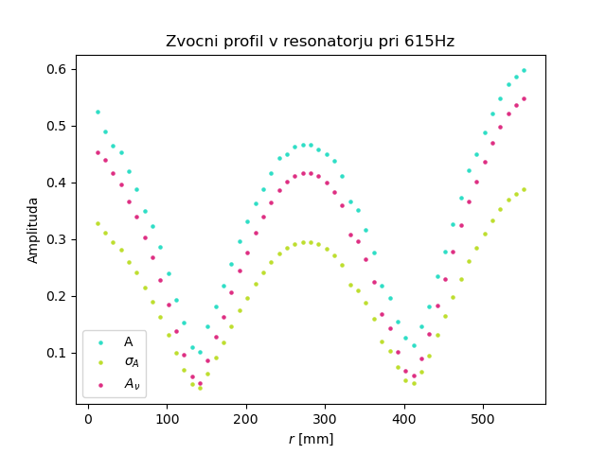

|  |  |  |
| --- | --- | --- |
| **Hitrost zvoka** | | |
|
| **ν [Hz]** | **c [m/s]** | **Δc [m/s]** |
| 308,50 | 349,84 | -0,19 |
| 615,00 | 348,71 | -1,32 |
| 930,00 | 351,54 | 1,51 |
| c = | 350 | ± 1 |

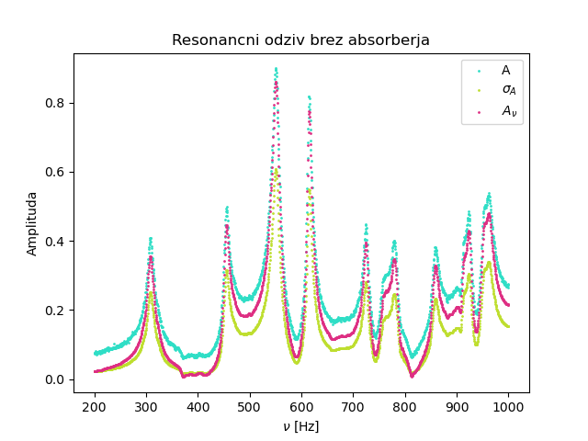

|  |  |
| --- | --- |
| **Ocena razpolovne  sirine** | |
|
| **ν [Hz]** | **Δν [Hz]** |
| 308,5 | 15 |
| 455,5 | 10 |
| 615,0 | 10 |
| 930,5 | 20 |

