|  |  |  |  |  |  |
| --- | --- | --- | --- | --- | --- |
| **Aktivnost v odvisnosti  od razdalje do vira** | | | | | |
|
| **Predal** | **d [cm]** | **N** | **t [s]** | **A [Bq]** | **1/√A** |
| 1 | 1,001333 | 10073 | 137 | 73,52555 | 0,116622 |
| 2 | 2,002667 | 10024 | 237 | 42,29536 | 0,153764 |
| 3 | 3,004 | 10032 | 378 | 26,53968 | 0,194112 |
| 4 | 4,005333 | 10789 | 596 | 18,10235 | 0,235035 |
| 5 | 5,006667 | 11940 | 900 | 13,26667 | 0,274549 |
| 6 | 6,008 | 9990 | 1000 | 9,99 | 0,316386 |
| 7 | 7,009333 | 10717 | 1382 | 7,754703 | 0,359102 |
| 8 | 8,010667 | 10788 | 1618 | 6,667491 | 0,387274 |
| 9 | 9,012 | 10012 | 1884 | 5,314225 | 0,43379 |
| 10 | 10,01333 | 11814 | 2653 | 4,453072 | 0,473882 |

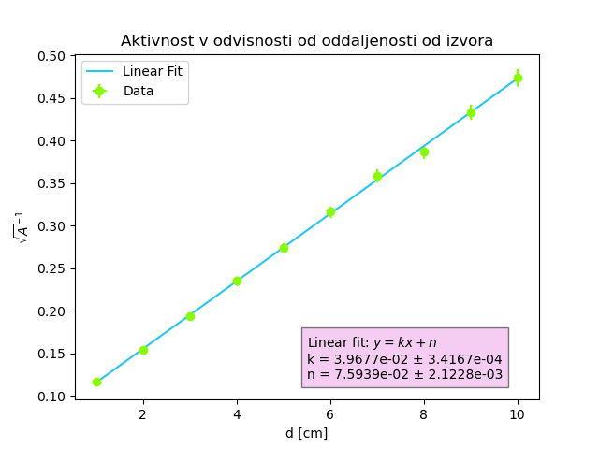

|  |  |
| --- | --- |
| **Additional Data** | |
|
| d9 [mm] | 90,12 |
| d1 [mm] | 10,01333 |

