|  |
| --- |
| **Premik na vijaku 1.** |
|
| **mm ± 0.01 mm** |
| 0.16 |
| 0.165 |
| 0.16 |

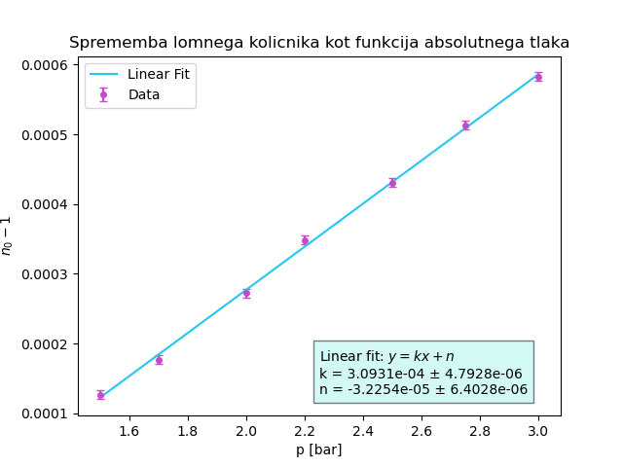

|  |
| --- |
| **Premik na vijaku 5.** |
|
| **mm ± 0.01 mm** |
| 0.15 |
| 0.145 |
| 0.15 |

|  |  |
| --- | --- |
| **Lomni kolicnik** | |
|
| **Δp [bar]** | **St. ponovitev** |
| 0.5 | 20 |
| 0.7 | 28 |
| 1.0 | 43 |
| 1.2 | 55 |
| 1.5 | 68 |
| 1.75 | 81 |
| 2.00 | 92 |