|  |  |  |
| --- | --- | --- |
| **Amplituda in faza  zvocnega polja** | | |
|
| **n** | **URMS [mV]** | **Δφ** |
| 1 | 724 | 0 |
| 2 | 730 | π |
| 3 | 654 | 0 |
| 4 | 674 | π |
| 5 | 614 | 0 |
| 6 | 580 | π |
| 7 | 560 | 0 |
| 8 | 540 | π |
| 9 | 485 | 0 |
| 10 | 500 | π |

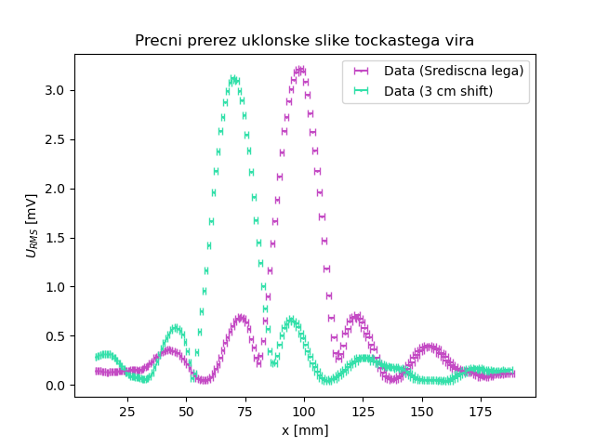

|  |  |
| --- | --- |
| **Amplituda in faza  zvocnega polja (kombinacije)** | |
|
| **n** | **URMS [mV]** |
| [1, 2] | 200 |
| [2, 4] | 1240 |
| [1, 3, 4] | 920 |
| [1, 2, 3, 4] | 250 |
| [6, 7 ,8] | 460 |
| [3, 5, 7] | 1860 |

