**MacOS Instructions for Installing and Running Jupyter Notebook**

**Installing Jupyter Notebook (do only once)**

1. In your browser, go to anaconda.com.

2. In the upper right, click the green download button.

1. Scroll down a little and click on macOS.
2. Click the green Download button under Python 3.7 version
3. After it downloads to your downloads folder, double click if it doesn’t open automatically.

**Finding the terminal app and getting it on your dock (do only once)**

1. Once it has installed, open your terminal. Do this by going typing “terminal” and selecting “Name” in the search button on your finder. Then scroll down to the app named “Terminal” which has an icon of a black screen with a prompt to the left (see the screen shot below).
2. Double click terminal.
3. On your dock, right click the icon and go to Options->keep in doc. You will need to use terminal every time you want to open a jupyter notebook.



**Running Jupyter Notebook (do these steps each time)**

1. Open terminal by double-clicking the icon on your dock
2. Type jupyter notebook in the terminal and hit return.
3. The Jupyter file browser will open in a web browser tab. It will look something like this:

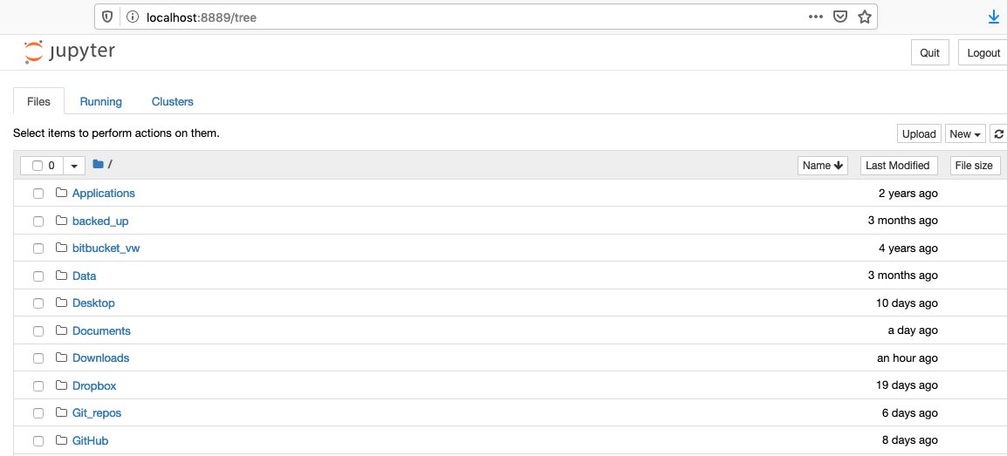

1. Next you have to navigate to the folder where your Jupyter Notebook is by clicking on each folder. For example, if your Jupyter Notebook is in /Documents/class_work/notebook/, you would click on the folder Documents, then class_work, and then notebook.
2. You would then see your Jupyter Notebooks and ancillary files. The Jupyter Notebooks end in “.ipynb” and have an icon of a book to the left. For example, in the view below, the Jupyter Notebooks are “Rovibrational_spectra_1_*.ipynb,” “Rovibrational_spectra_2_*.ipynb,” and “Rovibrational_spectra_3_*.ipynb,”  
     
   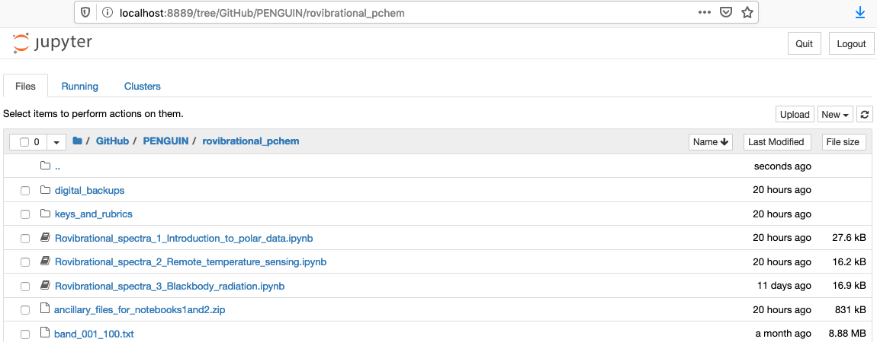
3. Expanded view:  
     
   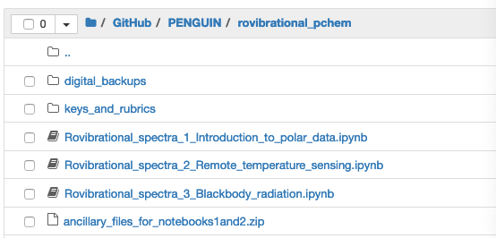
4. Double click the python notebook you want to run. E.g. “Introduction_to_python3.ipynb.” It will open in a new tab.
5. The notebook will periodically be saved automatically. You can save manually at any time by selecting “save and checkpoint” under “File” in the top menu.
6. Run the notebook by clicking each cell in turn and pressing shift+enter. The cells generally must be run in order.

**Quitting Jupyter Notebook (do these steps each time)**

1. When you are finished, save by selecting “save and checkpoint” under File.
2. Quit from the notebook by selecting “close and halt” also under File. You may need to click a button asking if you want to leave the page.
3. Repeat these steps for each notebook you have open, until all that is open is the home screen.
4. Click “Quit” in the upper right-hand corner.
5. Close the browser tab.