**Finding files on your Mac**

While downloading data from the Internet is fairly straightforward, finding files on your computer can be confusing. Also, to use Jupyter Notebook, you have to have all the files together in one directory. This means you need to know where files go when you download them and how to find and move around files on your computer.

**How to find files on a Mac:**

1. Open a finder window.
2. In the Search window in the upper right, type the beginning letters of the file you want to find. For example, if we want to find the file “” we type "smtaerich1", as shown in the circled region below.

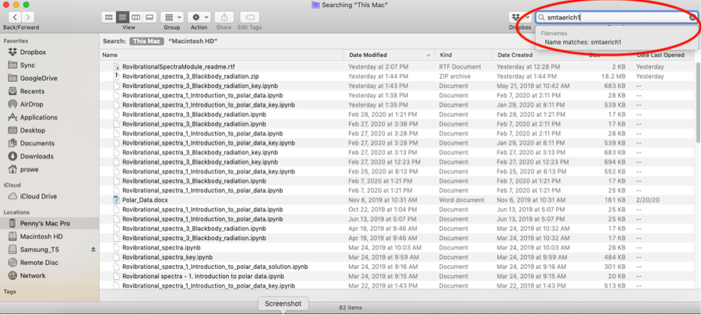

1. Click the pop-up box that appears below the search bar, that begins with "Name matches", as shown above.
2. A list of file appears. Above that, be sure "This Mac" is clicked, as shown near the upper left above.
3. Single-click the file name. Your finder may now display the file location at the bottom.

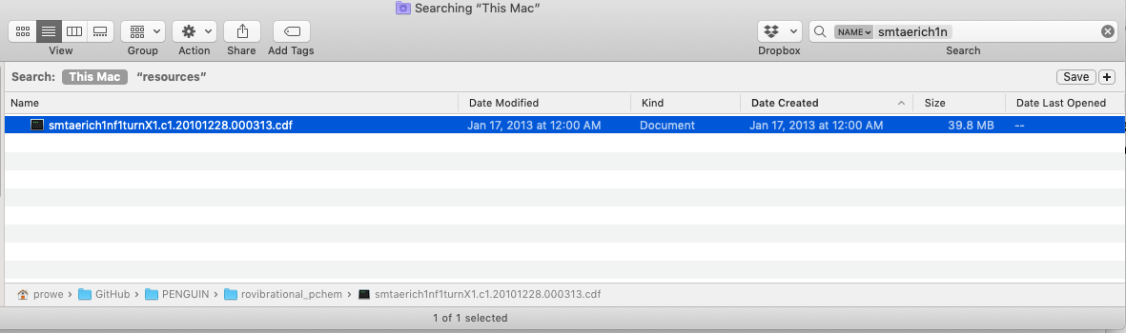

**Move downloaded file into the directory where your Jupyter Notebook is**

1. In a separate finder, navigate to the directory where you downloaded the module. If you don’t know where it is, repeat the above steps to find the file name of one of the Jupyter Notebooks you will be using, which end in .ipynb.
2. Drag and drop the file you downloaded from the Internet to the directory where your Jupyter Notebook is.