**Finding files on your PC**

While downloading data from the Internet is fairly straightforward, finding files on your computer can be confusing. Also, to use Jupyter Notebook, you have to have all the files together in one directory. This means you need to know where files go when you download them and how to find and move around files on your computer.

**How to find files on Windows:**

1. Open the file explorer.
2. In the search bar in the upper right, type the beginning letters of the file name. Here the user searched for “geek.”

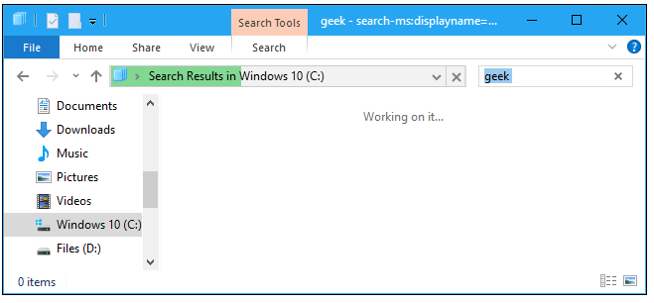

1. The file will display below.
2. Single click on the file. The location will show in the address bar to the left of the search bar.

**Move downloaded file into the directory where your Jupyter Notebook is**

1. In a separate file explorer window, navigate to the directory where you downloaded the module. If you don’t know where it is, repeat the above steps to find the file name of one of the Jupyter Notebooks you will be using, which end in .ipynb.
2. Drag and drop the file you downloaded from the Internet to the directory where your Jupyter Notebook is.