# **Ice Cores and Isotopes: Inferring Past Climate Conditions**

Overview

In Part 1, you will begin by using data from ice core/snow pit locations in Antarctica to determine how temperature changes with elevation and distance from the ocean (this is called the lapse rate). Then you will use the annual oxygen isotope data for the region and calculate the relationship between the isotopes and temperature. This present day relationship will provide the information we need to interpret past oxygen isotope data from the ice core in Part 2. In Part 2, you will use the isotope-temperature relationship to determine the temperature changes at Dome C over the past 800,000 years.

Background

Water molecules are made up of two hydrogen atoms and one oxygen atom. Hydrogen has two common isotopes, normal hydrogen (H) and the heavier deuterium (2H). Oxygen also has two common isotopes, the normal 16O and the heavier 18O. Water molecules can occur in a number of combinations of hydrogen and oxygen isotopes, like H216O, H218O, 2H216O or even 2H218O. For this exercise we are going to focus on the oxygen isotopes of the water molecule. Differences in the amount of these oxygen isotopes in a water molecule are measured by using the ratio of 18O/16O. The amount of 18O/16O in a water sample is compared to the known 18O/16O ratio of average ocean water (called VSMOW). This comparison is called *δ*18O (pronounced “delta-18-O”). Variations in the *δ*18O of the oxygen in the water molecule are useful in understanding the hydrological cycle. Average ocean water has a *δ*18O value of 0‰ (‰ is pronounced per mil and is the symbol for one-thousandth, just like %, or percent, which is the symbol for one-hundredth).

**Part 1: Determining the present day relationship between temperature, elevation, and oxygen isotopes in East Antarctica**

You will focus in on the latitudinal transect highlighted in the orange circle in East Antarctica, that goes from the coast at Dumont d’Urville to the interior at Dome C, the location where the ice core data in Part 2 was collected.

*Note: A second transect can be calculated from the coast near the Shackleton Ice Shelf to the interior at Vostok Station circled in red – if you have extra time you could compare values from the two transects.*

1) First, you will want to look at the Antarctic Elevation data (Map 1a).

Determine the elevation at the coast (Dumont d’Urville):

and the elevation Dome C:

The difference between these two values will be the elevation gradient (Dome C minus Dumont d’Urville).

The change in elevation (dh) in meters is:

2) Then look at the Annual Mean Temperature data (Map 1b.).

Determine the temperature at the coast (Dumont d’Urville):

and the temperature at Dome C:

The difference between the two temperature values will be the temperature gradient (Dome C minus Dumont d’Urville).

The change in temperature (dT) in ˚C is:

3) Now calculate the relationship between elevation and slope, or the *lapse rate*, for the Dumont d’Urville-Dome C transect. To do this you need to divide the change in temperature (dT) by the change in elevation (dh). This allows you to determine how much the temperature decreases for every 1 km increase in elevation. *\*Remember to convert meters to km\**

East Antarctic Lapse Rate:

4) Next, you will continue with a map of real ice core and snow pit data collected from Antarctica at the same locations as the temperature data (Map 2) to calculate the change in isotopes (dI)/change in elevation (dh).

Determine the oxygen isotope value at the coast (Dumont d’Urville), in per mil (‰):

and the oxygen isotope value at Dome C, in per mil (‰):

The difference between the two oxygen isotope values is the isotope gradient (Dome C minus Dumont d’Urville).

The change in isotopes (dI) in per mil (‰) is:

5) Now calculate the *isotope slope* for the Dumont d’Urville-Dome C transect. To do this you need to divide the change in isotopes (dI) by the change in elevation (dh).

East Antarctic Isotope Gradient (per mil/km):

*\*Remember to convert m to km\**

6) Once you have determined the present day isotope gradient, you now have enough information to calculate the oxygen isotope-temperature relationship that we have been trying to find, using your answers from questions 3 and 5:

A more precise way to determine this relationship is to follow the same procedure you used above to interpret the data plotted on the maps, but this time using a table of all of the data collected along the Dumont d’Urville-Dome C transect, which are in the Excel spreadsheet LapseRate Isotope Temp Part1.xlsx. This will ask you to make graphs in Excel – if you have not done this before, ask me (or a peer) for help and I can walk you through it!

7) Plot Temperature *vs*. Elevation. Then add a linear trend line to determine the slope (dT/dh). At the bottom of the traverse data (C52), enter the slope for dT/dh. *Remember to convert meters to km.*

Record your value here as well – how does this compare with your answer from #3 above?

8) Plot *δ*18O *vs*. Elevation. Then add a linear trend line to determine the slope (dI/dh). At the bottom of the traverse data (E52), enter the slope for dI/dh. *Remember to convert meters to km.* Record your value here as well – how does this compare with your answer from #5 above?

9) Use the two slopes from above to determine the isotope/temperature relationship for Dome C. Remember the units for the gradient are (per mil/˚C) as elevation cancels out!!! Record your value here as well – how does this compare with your answer from #6 above?

10) You now have a relationship between temperature and expected oxygen isotope values for the H2O in the ice/snow of East Antarctica! Explain why this relationship exists based on the concept of isotopic *fractionation* and the path these water molecules followed on their way to being precipitated in Antarctica.

**Map 1a.**

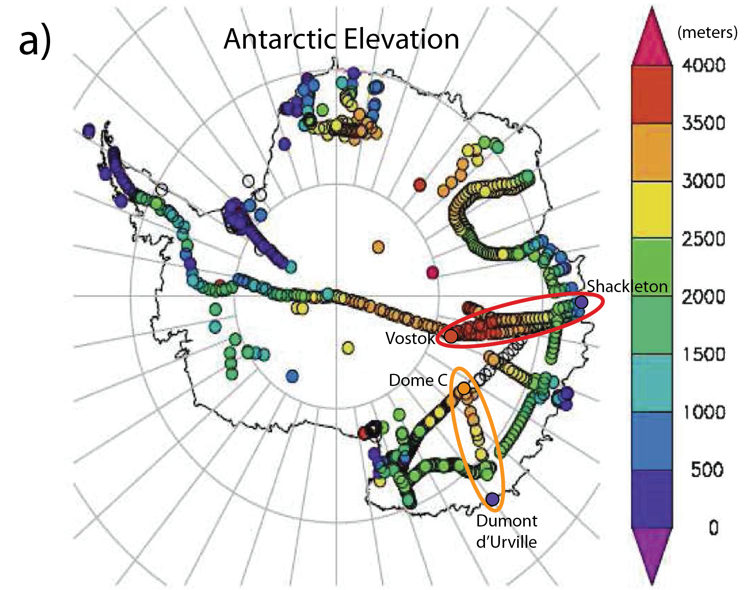

**Important:** When reading the color bar values, make sure you consistently read the numbers from the same location on the color box. For example, 0 m would be the BOTTOM of the dark purple, so the value of the next dark blue box would be 500 m, NOT 1000 m. For neg. values in Map 1b, you would read the # from the BOTTOM of the box, so the red box would be –10˚C.

**Map 1b.**

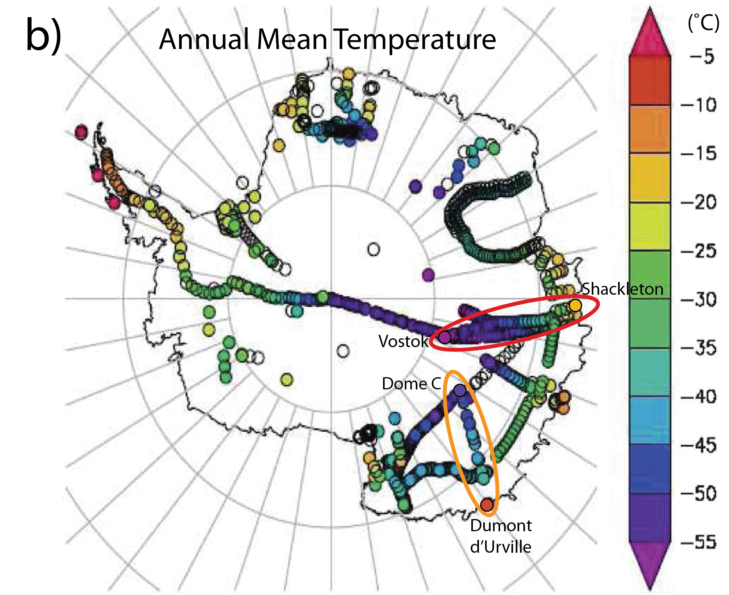

**Important:** When reading the color bar values, make sure you consistently read the numbers from the same location on the color box. For negative values on this map, you would read the # from the BOTTOM of the box, so the red box would be –10˚C.

**Map 2**.

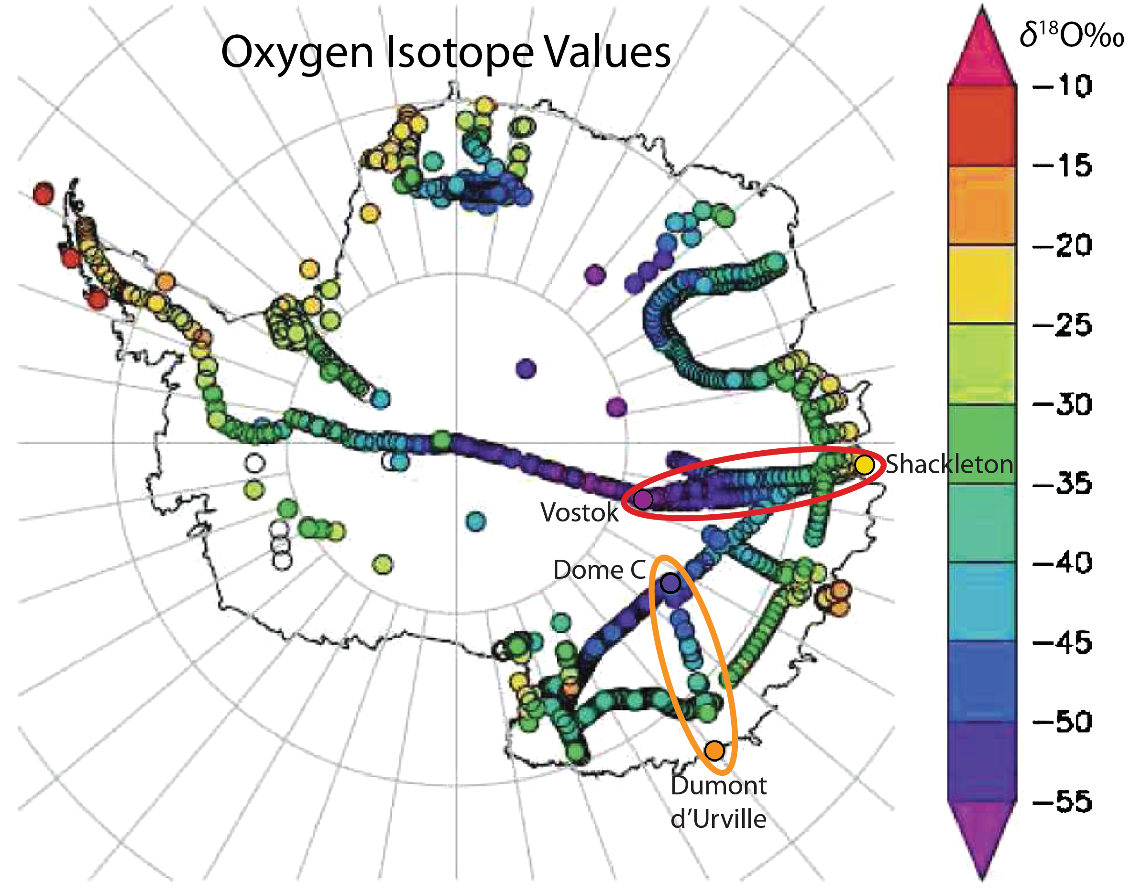

**Part 2. Applying the modern isotope-temperature relationship to infer PAST temperature change!**

Now you can use the isotope/temperature relationship (per mil/˚C) you determined in Part 1 to infer the temperature changes recorded in the oxygen isotopes in the Dome C ice core. Here we will use 800,000 years of *δ*18O (‰) data from the EPICA (European Project for Ice Coring in Antarctica) Dome C Ice Core, found in the Excel spreadsheet DomeC_d18O_ Part2.xlsx.

**Observations of oxygen isotope changes over time**

1. Go to Tab 1: Understanding the Data In Column B, you have the Age of the ice before present, where the present has been defined as 1950. This is written as Age (year BP 1950). In Column C, you have the Dome C *δ*18O isotope data in per mil. The graph shows Age on the x axis and *δ*18O isotope values on the y axis. Describe in words how the oxygen isotope value in the Dome C ice core has changed over the past 800,000 years.

**Convert Isotopes to Temperature**

1. Now go to Tab 2: Temperature Conversion, where you will use the isotope/temperature relationship that you determined in Part 1 to convert the *δ*18O isotope values to temperature values. Putthe value in the red box.
2. In Column E, divide the *δ*18O data (column C) by the isotope-temp relationship (red box value) under the heading "Temperature Scaling" (green box). The Excel directions are at the top of the spreadsheet tab. Explain below why this calculation allows you to determine temperature from the ice core record.
3. You should now see data for temperature versus age plotted for the past 800,000 years! Describe in words how the temperature at Dome C has changed over the past 800,000 years.

**Calculate the Average Temperature and Anomaly from the past 1,000 years**

Rather than interpret the absolute temperature value, it is often easier to interpret climate records by calculating the *anomaly*, or difference from the average value in a region. Here, we will calculate the temperature anomaly at Dome C as compared to the past 1,000 years before present (BP).

1. Click on Tab 3: Temperature Anomaly. Calculate the average temperature for the past 1,000 years BP from Column in the red box.
2. In Column G (Labeled Temperature Anomaly), write a formula to calculate the temperature anomaly (difference between average (1000 years) temperature and *δ*18O data), and then copy the formula into all rows in that column (*hint: you will need to keep using the red box cell in your formula in all rows, so use the notation $E$4 in your formula*).
3. The new temperature anomaly data (column G) versus age (column B) should automatically appear in the graph to the right. How do the maximum and minimum temperature values from the glacial cycles compare to the past 1,000 years?

**Incoming solar radiation: how does it affect glacial-interglacial cycles?**

We can now compare the temperature anomaly data showing the glacial-interglacial cycles over the past 800,000 years with variations in incoming solar radiation (insolation), which varies as a result of changes in the Earth’s orbital patterns.

1. Click on Tab 4: Insolation. You will see a graph comparing the insolation anomaly (determined from known changes in the Earth’s orbital pattern) with the temperature anomaly data you calculated. During which periods of insolation do you find lower temperatures? High temperatures?
2. Are there any obvious periodicities (recurring spacing between peaks) in the insolation data?
3. Is there a strong or weak relationship between the two records? Are they positively or negatively correlated (that is: does it go up and down together (pos) or opposite (neg))?
4. Do you observe any lags (delays) in the temperature response to orbital forcing?
5. Why do you think temperature may not directly track the amount of solar radiation?

**Temperature Anomaly and CO2 Data Comparison**

We can also compare the temperature anomaly calculations with other paleoclimate data over the past 800,000 years!

1. Click on Tab 5: CO2 data. You should see a graph that shows both the carbon dioxide concentration from air bubbles trapped in the ice and your calculated temperature anomaly, plotted together over the past 800,000 years. What do you observe in comparing the two records? Is there a strong or weak relationship? Is it positively or negatively correlated (that is: does it go up and down together (pos) or opposite (neg))?
2. Explain the relationship you observe between the temperature change and carbon dioxide concentrations in the atmosphere.

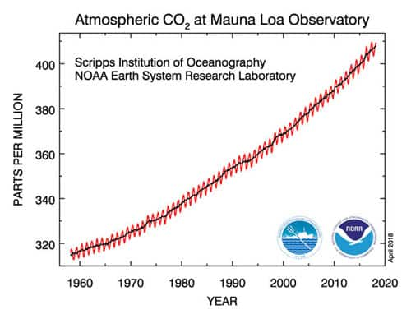

1. Compare the CO2 concentrations from the Dome C ice core record (in ppmv) with modern observed atmospheric CO2 concentrations (shown below). What do you notice about differences in their absolute values? Ranges?

**Extension: Comparison with other paleoclimate records**

Take a look at the data from the final two tabs in the Excel spreadsheet if you have additional time.

*Tab 6: Methane*

1. Compare the variations of methane data to the temperature anomaly.
2. What do you observe between these two records?
3. Is there a strong or weak relationship? Is it positively or negatively correlated?
4. Is the relationship between methane and temperature closer than CO2 and temperature?
5. What processes do you think link methane and temperature?
6. Why would methane have a different response time than CO2?

*Tab 6: Dust*

1. Compare the variations of dust data to the temperature anomaly.
2. What do you observe between these two records?
3. Is there a strong or weak relationship? Is it positively or negatively correlated?
4. Provide an explanation for why dust varies the way it does between glacial-interglacial periods