**Rubric and Answers to Questions**

The following gives the answers to open-ended questions and the suggested rubric. We suggest having students also turn in completed notebooks, although the instructor need not grade those, but rather, can view those during class. Answers to questions indicate successful completion of the notebook. Instructors may choose to only grade a few questions and revise the point total accordingly. For example, they could grade only the pre-class activities and the post-activity reflection.

Rovibrational_spectra_1: 26 pts

Pre-class activities:

1. *Radiative balance*: the incoming radiation equals the outgoing radiation (1 pt)  
   *Greenhouse effect*: Greenhouse gases trap outgoing infrared radiation, re-emitting up to space and down to Earth, causing Earth's surface to warm until it re-achieves radiative balance. (1 pt)  
   *downwelling radiance*: radiation emitted by greenhouse gases to the surface (1 pt)
2. Polar data is useful for understanding climate because polar land ice has the potential to raise sea level. Melting the Greenland ice sheet would raise sea level ~7 m and the influx of freshwater would have effects. (Accept any reasonable answer) (1 pt)

Pause for Analysis: Polar spectrum

1. Students may say CO2, methane, etc. (accept any answer; 1 pt)
2. a) The radiance would be 0 (accept any answer; 1 pt)  
   b) The radiance would be higher (accept any answer; 1 pt)
3. They may note m-shapes, or the rapid variations (accept any answer; 1 pt)

Part 2 - Try Your Skill

1. 1 pt each for any reasonable answer for 1-6:
   1. H2O: pure rotation ~510 cm-1
   2. CO2: 667 cm-1
   3. O3: 1042 cm-1
   4. N2O: 1285 cm-1
   5. CH4: 1311 cm-1
   6. H2O: 1595 cm-1

The spectral features typically have an “m” shape. (6 pts)

Pause for Analysis: Polar vs. Oklahoma spectra

1. They will probably note that the Oklahoma Spectrum is higher. They also may note that it is smoother up to 800 cm-1 and above 1300 cm-1, and has more variation from 800 to 1300 cm-1. They may note that the Oklahoma spectrum seems to be maxing out with a downward slope (shape of Planck function) (accept any reasonable answer; 2 pts)
2. Hopefully they will note that Oklahoma summer is hotter than polar winter, and thus the radiance is overall higher. They are unlikely to realize the higher radiance is also due to higher water vapor amount, even if they have previously learned that warmer air has more water vapor at the same relative humidity. Other explanations they will not know include: the Oklahoma spectrum is smoother up to 800 cm-1 and above 1300 cm-1 because water vapor is maxing out, or saturating the possible emission here. This maximum emission has the shape of a Planck function of the near-surface air temperature. From 1300 to 1800 cm-1, spikes above this smooth curve are due to calibration errors. The Oklahoma spectrum has more variation from 800 to 1300 cm-1 because there are myriad water vapor lines in this region that are becoming more pronounced – they are not noticeable in the much drier polar spectrum. (accept any reasonable guess; 1 pt)
3. The mystery gas is water vapor (accept any reasonable guess; 1 pt)

Try your skill – Determine the identity of the mystery gas

1. The spectrum increases where the gases emit, but doesn’t change much in the region of the mystery gas. (1 pt) It agrees with the Oklahoma spectrum where CO2 and ozone emit and is slightly lower were CH4, CH4, and H2O emit. (1 pt)
2. Agreement is much better for the rest of the spectrum too. (1 pt)
3. This is a really big change in water vapor (from 400 to 18000 ppm)! The change in water vapor saturation with temperature is complicated, but is considerably faster than linear (see <https://earthobservatory.nasa.gov/features/WaterVapor/water_vapor3.php>) (1 pt)
4. The mystery gas is water vapor. It emits throughout the spectrum, and the emission increases dramatically with temperature. This makes it the most important greenhouse gas. Because we live on a water world, when temperature increases due to fossil fuel emissions, more water evaporates into the air, after which the greenhouse effect of water vapor causes further warming. This represents a positive feedback that magnifies the effect of increased CO2 emissions. (1 pt)

Post-activity reflection

1. The downwelling radiance for the Oklahoma spectrum is higher than that for polar regions due to higher temperatures and higher water vapor. (1 pt)
2. Water vapor is the most important greenhouse gas because it emits throughout the infrared and enhances warming due to a positive feedback loop. CO2 and methane are important because they are increasing dramatically due to human activities, and are particularly important when water vapor is extremely low, as in polar regions (1 pt)
3. The features typically have an “m” shape. (1 pt)

Rovibrational_spectra_2: 15 pts

Pre-class activities:

1. **selection rule (1 pt):** a constraint that specifies the allowed transitions from one state to another (for vibrational spectroscopy, a molecule must have a permanent dipole moment that couples to the oscillating electric (or magnetic) field of the photon)  
   **forbidden transition (1 pt):** transition that is absent from spectrum or very weak. Forbidden transitions “violate” a selection rule (the J=0 to J=0 transition is “forbidden” for diatomic molecules since the selection rule is ΔJ=+/-1).
2. k = 1.38 x 10-23 J/K (1 pt)
3. 1 cm-1 = 1.986 x 10-23 J (1 pt)

Pause for Analysis: Rotational constant

1. Inferred rotational constant of CO2: ~0.36 (2 pt)
2. Literature value of above: 0.39021 (1 pt)
3. B varies from j=1 to j=15 by ~8% (1 pt)

Pause for analysis: Degeneracy and population

1. higher J means greater degeneracy because rotational states are 2J+1 degenerate (from angular momentum quantum number, mJ) (2 pt)
2. The product function will look like an increasing then decreasing curve (2 pt)  
   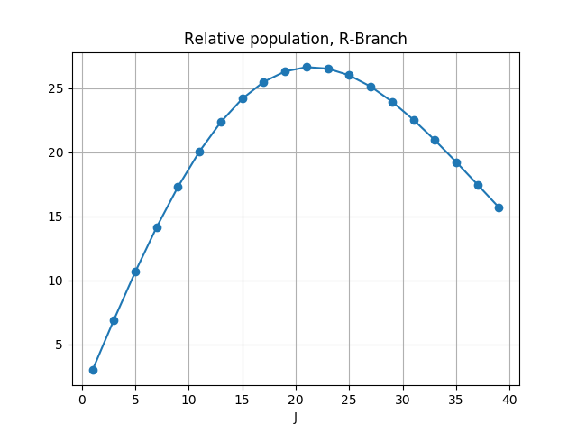

Pause for analysis: Maximum population

1. A temperature of about 270 K is required to get the maximum population coincide with the highest line in the observed spectrum. (2 pt)

Pause for Analysis: Matching the spectrum

1. How well do your modeled and observed R-Branches agree? Should be pretty good.Some slight discrepancy in spacings, intensities are slightly lower, but trends agree. Ignore noise from other molecule in observed data on right-hand side (1 pt)

Rovibrational_spectra_3: 10 pt

Part 1. Pause for analysis

1. The position of the peak moves to higher wavenumbers with temperature (1 pt)

Part 2. Pause for analysis

1. The shape of the curve may remind them of the Planck / blackbody radiation function (accept any answer; 1 pt)
2. Nothing happens if you continue to increase H2O (because the spectrum is saturated) (1 pt)
3. As gas concentration increases and emission gets stronger and stronger, the features become saturated and the M-shape fills in, until the spectrum resembles a Planck or blackbody function (1 pt)

Part 2 the second. Pause for analysis

1. 235 K (1 pt)

Pause for Analysis: polar vs. mid-latitude spectra

1. 302 K (1 pt)
2. It is a lot warmer than polar winter (302 vs 235 K) (1 pt)
3. 302 K = 84 F, 235 K = -37 F. These are reasonable temperatures for Oklahoma summer and Polar winter (1 pt).

Post-activity reflection

1. In the first technique we determined the temperature required to get the maximum population of a model rovibrational spectrum to coincide with the highest line in the observed spectrum. In the second technique we found the temperature that fit a Planck function to the radiance in a region where it was saturated, and thus depended on the near-surface temperature. (2 pts)