**Assembly Homework Ch 4**

**Your Name: Student ID (學號):**

1. Print your executing results 20% (貼上執行結果20%)

Problem 1 初始

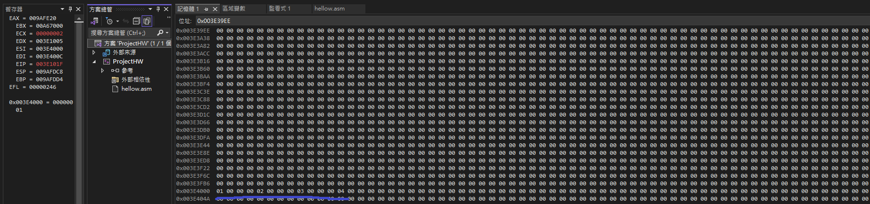

結束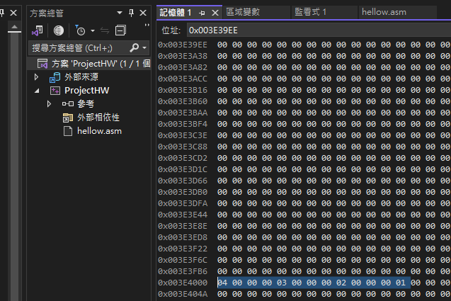

Problem 2

2. Source Code 20% and Comments 60% (程式原始碼20%與程式註解說明60%)