SF2 Image Processing

First Interim Report

Simple Image Filtering
A simple image filtering process was developed by generating a lowpass filter, h(n), as a sampled half-cosine pulse with unity DC gain. This was convolved with each row of the test image.
Running the convolution a second time over the transpose of the result of the first convolution had the effect of filtering by each column of the image as well. The 15-by-15 filter thus used is separable, that is the convolution by row, then column is associative. Therefore there is no difference in the resulting filtered image if the columns are filtered first. This can be checked by finding the maximum difference between pixels i,j in the two images. Matlab finds this difference to be O[10⁻¹³], which is within the precision of the calculation. Thus there is no difference between the two images.
Changing the filter length does not affect the separability of the filter, but does change the effect it has on the image. Increasing the filter length increases the blurring effect. Since the filter is lowpass, the 'blurring' is a removal of high frequency components of the image such as the picket fence and the weatherboarding on the building. With a filter length of 51 taps, the picture is effectively unrecognisable. Using a 5 tap filter results in an image that has much less information removed than with 15 taps.
The information lost from the filtered image can be identified by subtracting the lowpass filtered image from the original. This creates a highpass filtered image, which is recognisable by having no DC information (i.e. the basic shade across the image is constant), and edges picked out by high and low intensity pixels. As expected, the information contained in the highpass image is only that removed from the lowpass. Thus with a 5 tap filter, only very high frequency components remain, whereas with a 51 tap filter the image looks much more 'normal', with only a measure of 'depth' removed, corresponding to the lack of DC information.
The highpass image has an average DC level of 0, so has low image energy, whereas the lowpass image contains all the DC information (without the sharp edges), and thus has high energy.
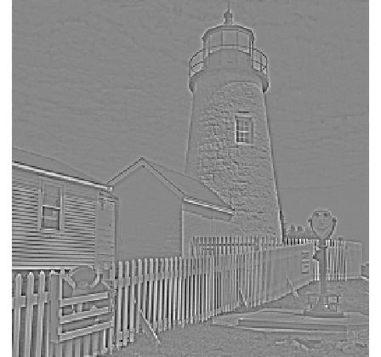Figure 1: Highpass, 5 tap filter
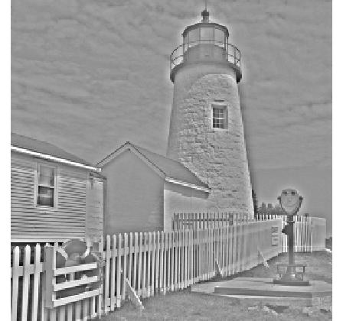Figure 2: Highpass, 15 tap filter

The Laplacian Pyramid

Quantisation and Coding Efficiency
Figure 3: A four level Laplacian Pyramid with 3 tap filter
The Laplacian pyramid allows perfect reconstruction of the original, but quantising each layer of the pyramid by the same amount can result in a smaller encoded image. Using a quantisation step size of 17,, and taking the reference scheme to be direct quantisation of the image, we get get the following compression ratios for different pyramid sizes:
 | Direct Quantisation | 1 Level Pyramid | 2 Level Pyramid | 3 Level Pyramid | 4 Level Pyramid
Compression Ratio | 1 | 1.41 | 1.61 | 1.65 | 1.66
rms Error | 4.934 | 5.417 | 6.063 | 6.923 | 7.757
Table 1: Effect on reconstruction error of pyramid encoding with quantisation
The benefit of using the pyramid scheme is clear, but it can also be seen that the marginal benefit of increasing the pyramid size decreases. The rms error increases with pyramid size, showing that the reconstructed image quality suffers with increasing compressibility. This is because of the interpolation process during reconstruction - quantisation errors get magnified as they are interpolated. The more layers in the pyramid, the greater this error becomes.
The compression ratios of different schemes can only be sensibly compared if the image quality remains constant. We use rms error as a quantifiable proxy for image quality. By adjusting the quantisation step used in each pyramid size we can obtain an approximately constant rms error across schemes.
 | Direct Quantisation | 1 Level Pyramid | 2 Level Pyramid | 3 Level Pyramid | 4 Level Pyramid
Step Size | 17 | 15 | 14 | 12 | 11
rms Errror | 4.934 | 4.787 | 5.073 | 5.058 | 5.067
Compression Ratio | 1 |  |  |  | 1.30
Table 2: Quantisation step sizes adjusted for constant reconstruction error, effect on achievable compression
When adjusted for image quality, the benefit of pyramid encoding is reduced, but still present.
The efficiency of pyramid encoding can be increased again by observing that quantisation of the lowpass image has a great impact on the reconstructed image quality, but quantisation of Y0, the final highpass image is less detrimental. Thus a scheme which quantises each level to an optimum amount would do better. The equal MSE criterion achieves this by forcing the quantisation of each level to make an equal contribution to the MSE of the reconstructed image.
The appropriate ratio of quantisation step sizes can be found by finding the MSE due to an impulse in each level of the pyramid. The inverse of the rms error then gives the ratios:
Y0 | Y1 | Y2 | Y3 | X4
1 | 0.67 | 0.36 | 0.19 | 0.094
Table 3: Step size ratios
The image quality is very similar between the two quantisation schemes (as designed), but the compression ratio is improved by using the equal MSE scheme.
4 Level Pyramid | Equal Step Size | Equal MSE
rms Error | 4.934 | 4.394
Compression Ratio | 1.30 | 1.45
Table 4: Increase in compression achievable with equal MSE scheme
There is a very slight reduction in visible quantisation error in the equal MSE reconstruction. This could be due to the low quantisation of the lowpass image, which contains most of the information about large regions of shading.
Figure 4: Reconstructed from equal step size quantisation
Figure 5: Reconstructed from equal MSE quantisation
Figure 6: Reconstructed from 1 level, k=1.41 scheme | k | Δ | Compression Ratio
4 Level Pyramid | 0.5 | 22.5 | 1.50
4 Level Pyramid | 0.71 | 21 | 1.57
4 Level Pyramid | 1 | 18.5 | 1.58
4 Level Pyramid | 1.41 | 14.5 | 1.48
4 Level Pyramid | 2 | 9 | 1.22
3 Level Pyramid | 0.5 | 22.5 | 1.49
3 Level Pyramid | 0.71 | 21 | 1.55
3 Level Pyramid | 1 | 18.5 | 1.56
3 Level Pyramid | 1.41 | 15 | 1.49
3 Level Pyramid | 2 | 9 | 1.21
2 Level Pyramid | 0.71 | 21 | 1.44
2 Level Pyramid | 1 | 19.5 | 1.51
2 Level Pyramid | 1.41 | 17 | 1.53
2 Level Pyramid | 2 | 10.5 | 1.28
1 Level Pyramid | 0.5 | 24 | 0.91
1 Level Pyramid | 0.71 | 24 | 1.04
1 Level Pyramid | 1 | 24 | 1.21
1 Level Pyramid | 1.41 | 22 | 1.40
1 Level Pyramid | 2 | 12 | 1.24
Table 5: Compression ratio when k is varied. Reconstruction error is kept constant.
As before, the compression ration is improved with more levels in the pyramid. The optimum choice of k depends on the number of levels. With 1 or 2 levels, it is best to choose k = 1.41. This is because of the trade-off between high k, which increases quantisation, and therefore compression, and low k, which improves quality. In a 2 level scheme, k does not have as much influence as it does with higher levels, as there are no k^2 or k^3 terms, so amount of more severe quantisation caused by k is reduced. This causes the balance to prefer k = 1.41. With 3 or 4 levels, variations in k have a greater effect, and the balance occurs at unity.
Figure 7: Reconstructed from 4 level, k=1, 3 tap filter scheme
Figure 8: Reconstructed from 4 level, k=1, 5 tap filter scheme

Changing the Filter
The above analysis was performed with a 3 tap filter. By altering the filter to a 5 tap version, we can change the properties of the encoding scheme. The new step size ratios are:
Y0 | Y1 | Y2 | Y3 | X4
1 | 0.91 | 0.51 | 0.26 | 0.13
Table 6: Step size ratios for a 5 tap filter

 | k | Δ | Compression Ratio
4 Level Pyramid | 0.71 | 19 | 1.43
4 Level Pyramid | 1 | 17 | 1.44
4 Level Pyramid | 1.41 | 12.5 | 1.30
Table 7: Effect of k when a 5 tap filter is used. Reconstruction error is constant.
Compared to the original, the reconstructed images have lost fine detail (such as in the sky and the grass). This is due to quantisation removing information about fine transitions, then the interpolation during reconstruction causing blurring rather than the posterised effect see in direct quantisation of the original. The same blurring also has the effect of reducing the apparent pixellation of the original, since the pixellation is simply high frequency variation.
The 5 tap filter has a lower frequency cut-off resulting in less information carrying all the way down to the lowpass image. This is reflected in the higher step size ratio for X4 with a 5 tap filter, as there is less information to lose through quantisation. In terms of image quality this has the effect of keeping more of the highest frequency information [see grass in fig], making the image appear 'sharper', and where information has been lost (e.g. in the sky), the resulting reconstruction is smoother, as the reconstruction is working with less information in the lowpass image.

