Design Documentation

1. List of technologies and design patterns used

a) Technologies:

- Asp.Net Core 3.1

- Entity Framework Core

- LocalDb

- Microsoft’s cryptography library

b) Patterns:

- Dependency Injection

- Singleton

- Options

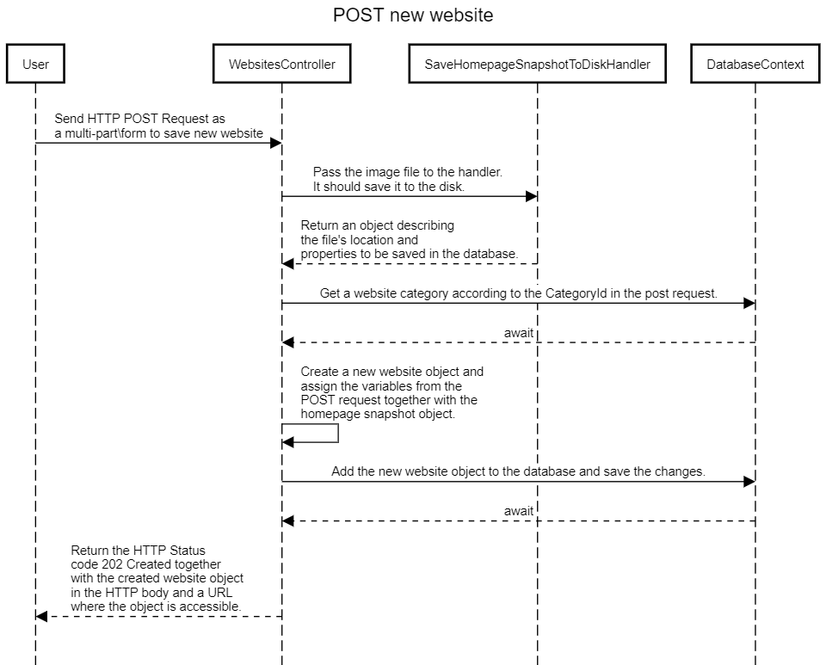2. Sequence diagram

3. Component interaction diagram

