Design Documentation

1. List of technologies and design patterns used
a) Technologies:
- Asp.Net Core 3.1
- Entity Framework Core
- LocalDb
- Microsoft’s cryptography library
b) Patterns:
- Dependency Injection
- Singleton
- Options

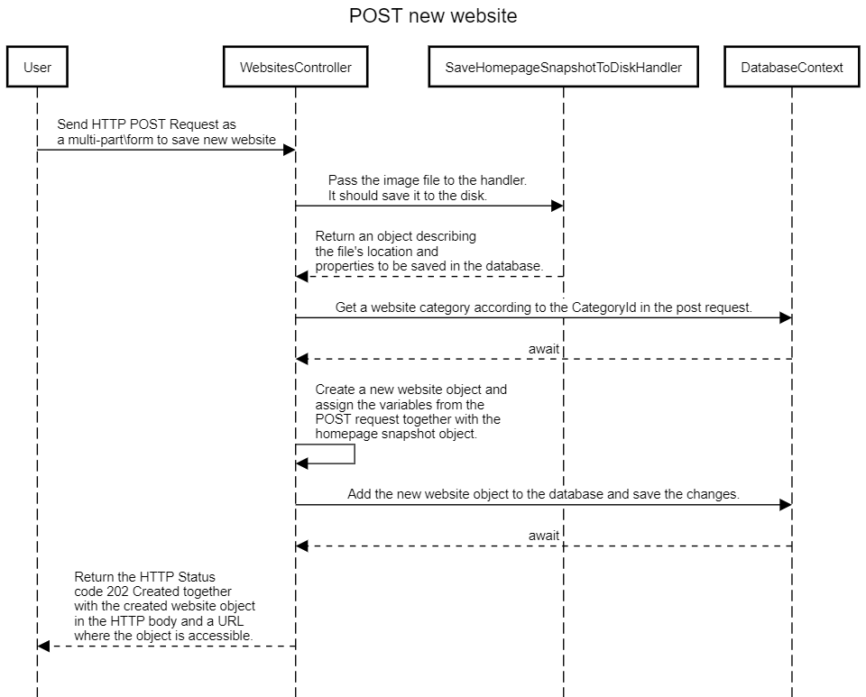
2. Sequence diagram

3. Component interaction diagram

