**Impact of Different Pricing Model on Peak Demand**

Nagihan Cay

Carolyn P. Forney

Ece Tug

Tokumaru Yahashi

**1. INTRODUCTION**

In the last few decades, rising populations and usage of electrical devices such as smartphones and computers have increased electrical demand. However, using different types of devices, and using these devices in different time periods cause fluctuations in electricity usage and demand. Beside this it has an effect like decreasing the electricity generation efficiency. In addition to these effects, it causes some environmental problems. Specially generating electricity from coal has a lot of problems, such that air pollution, radioactive emissions, and an enormous carbon footprint.

On the other hand, since the unknown usage patterns increase the cost of generation of electricity, this situation becomes costly. Thus, the residential bills reflect this with a high price. The classic pricing model is Fixed Price (FP) where the user pays the same price no matter what time of the day it is. For reducing the electricity bills, some companies offer different pricing models. One of the most well-known is Time-of-Use (TOU) which offers different prices for different time periods. These time periods are defined as off-peak, mid-peak, and on-peak. Off-peak period refers to the time when the electricity demand is low. In the mid-peak period, the demand is higher than in off-peak. The on-peak refers to the time period when the demand is the highest. However, during the on-peak time period, the home occupants need more electricity usage because this time period covers such the time between 5:00 pm and 10:00 pm. At these times, the user needs more electricity to meet their needs such as cooking and washing clothes. Thus, they have a hard time trying not to us electricity in on-peak time period without changing their patterns, and TOU has no benefit for reducing the bills.

Besides TOU, another pricing model offered is Real Time Pricing (RTP). In this case, the next day’s prices are determined by the usage patterns of the previous days. At this model, the hours are priced with higher cost when the demand is increased. RTP reflects the current market value of electricity. As in TOU, to get benefit of real time pricing model, house occupants have to change their daily behaviors, or monitor the prices frequently to learn which time periods are low cost and which ones are high cost; otherwise they can use the electricity in higher price most of time.

Although the different pricing models are offered to reduce the electricity bills, since the residences usually use the electricity with the highest price, the peak demand time occurs during high pricing time. Thus, this new pricing models have no effect reducing the electricity bill without some user strategy. For solving this problem, we implement some user strategies to flatten demand at different times so less demand means less cost on the user side and the power company side. Peak times are reduced with the help of the new technologies such as Smart buildings. There are many works that focus on shifting demand from high pricing time to low pricing time. For this purpose, the appliances, and batteries are charged in off-peak time with low cost, and the power that is stored is used during on-peak time. Thus, the bill is reduced. However, shifting the demand through the off-peak time period can create new peaks in off-peak time period.

Annual peak load is the highest aggregate demand for electricity throughout the year. To meet annual peak load, the Ontario electrical grid is used. Ontario electricity market and government want to save money from reduction of peak load. Thus, they defer same large infrastructural costs to reduce the cost of generation and electricity prices. The government is willing to spend $12 billion over the next 30 years for large initiatives to reduce peak load. Based on these initiatives, people can reduce their peak load with using two main ways. One of them is that people can store energy during off peak periods, and use it to fulfill some of their load during peak periods. The other one is that people can change the time of their loads, known as demand response. Both of them are approaches used in the coming smart grid.[2]

If the price of electricity during peak periods is much higher than off-peak periods, the cost of installing the battery is returned to the homeowners by saving on their electricity bills. Therefore, storage can be profitable for them. However, if people cannot use the right electricity pricing scheme, the storage adoption can be more expensive. Moreover, with the wrong pricing scheme, storage owners can actually increase peak load rather than decrease it. Thus, selecting electricity pricing scheme under different power consumption patterns is very important for storage.

On the other hand, optimal energy storage is very important for the smart grid to provide demand load management that is used by the power utility operators. The operator controller gets power demand requests and uses energy storage control policy to minimize long-term average grid operational costs. For capturing the increasing marginal cost for the operators, these costs are generated. To decrease the cost of power consumption, storage management is performed at the level of consumer. However, to minimize grid operational cost, storage management is performed at the side of utility operator.[1]

In this project, we try to explore what the affect will be to the power line in communities where users have different pricing models and user strategies. In other words, if users use different pricing model and strategies, we want to see how it affects the total consumption of the power line and price from the community perspective.

**2. RELATED WORKS**

In the smart power grid, demand load management is principally used by power utility operators so as to decrease the grid operational costs. The operator controller gains power demand requests with various power requirements and durations and it has access to one energy storage device of finite capacity. Related to it, energy storage control policy is designed to minimize long-term average grid operational costs. [1] Also, a threshold control policy is used to generate to maintain balanced power consumption from the grid at all times for the online dynamic control problem during the presence of continual generation and completion of demands. This policy adaptively performs charging or discharging of the storage devices.

There are some works [2] to find the best pricing scheme for the storage because the storage cost is very high. The result shows some pricing models have no benefit, and the storage is not profitable for the consumers.

One of the algorithms for reducing the electricity bill is SmartCharge [3]. It achieves to the goal by storing the electricity during the low pricing time. The algorithm uses the machine learning technique to predict the future demand so it decides when to switch the home's power supply between the grid and the battery array.

PeakCharge[4] is the approach to flatten the demand. It solves the flaw of SmartCharge where users may all charge/discharge at the same time causing the peak demand to move to the off-peak period and may actually increase demand because of the battery energy inefficiency. It uses peak aware algorithm thus the charging algorithm that optimizes the use of energy storage when a peak demand surcharge is occurred is optimized. Also this algorithm is used for simulation of battery charging in this paper.

Scheduling the power consumption is another aspect of flattening the electricity usage and reducing the bill. In this case, there are several approaches offered. These approaches are usually based on developed some platforms that manages the demand of the user. One of the approaches is Energy Consumption Control (ECC) platform [5] balances consumption demands against the production capacity over volume and time so it can achieve its purpose that is optimizing the power grid. The main goal is to flatten the energy consumption peaks against the available power production by applying a time shifted consumption pattern.

Another approach for scheduling the electricity usage is Direct Adaptive Control of Electricity Demand [6]. The proposed approach is the Internet traffic management approaches of proactive and reactive congestion control for fine grained management of customer demand without human intervention. The approach averts grid congestion, reduces capital costs, and eliminates a portion of the carbon footprint of the grid.

SmartCap [7] is another approach that offers a system monitors and controls the household loads automatically. Also, this system is the approach that we use for scheduling the appliances in our project. The key step in SmartCap is flattening the electricity demand of a house without affecting the home occupants’ daily routines. The goal of SmartCap is to schedule the appliances, and decide which appliance is loaded first. Since it uses a schedule, the demand can be flattened. For the scheduling of the appliances, Least Slack First (LSF) policy is used.

Demand Side Load Management Using a Three Step Optimization Methodology[8] is one of the methods to manage the electricity demand to flatten the demand. The goals are to optimize using the renewable energy sources and the current grid capacity efficiently. Thus, the proposed method can achieve its goals such that suppressing the fluctuation of the production of renewable sources, and flattening the power demand. These goals are called as global objectives. The structure is tree and the root node of this tree is the global planner that tries to achieve global objectives. The objectives are tried to achieve locally instead of applying the approach to the complete set of houses. Thus, when all local best solutions are found, the solution for all houses is also found. This feature provides fast solution dynamically but increasing the iteration causes the proposed approach slows down when finding the best solution.

Even with all these approaches try to solve flattening the demand, since the behavior of the home occupants is not predictable, the approaches are more efficient on background loads, and battery charging than the appliances that are used interactively such microwave, or coffee maker. Also, deploying a new system can be expensive. Thus, return of investment can take more times when comparing the efficiency of reducing the bill.

**3. PROJECT**

In section 3, implementation of the project is mentioned by divided into two categories as Scheduling of Appliances and Battery Charging.

**3.1 Scheduling of Appliances**

When scheduling the electricity consumption, the appliances part can be problematic. In a house, there are several appliances. Some of them have regular usage pattern but the electricity usage pattern of some appliances cannot be predicted easily. For instance, the refrigerator, or window air conditioners consume electricity regularly thus we do not need to make prediction for those kind of appliances. However, for appliances such as a microwave, or a coffee maker are used when the occupant needs to use so their electricity consumption depends on how frequently is used by the home occupants.

For our projects, to solve this problem we used SmartCap as the approach for scheduling the electricity consumption of the appliances. SmartCap is used a policy called Least Slack First (LSF). Slack time is proportional to slack energy for stable load and environmental conditions. There is a controller to decide when loading is on or off. This decision is made based on some parameters that keep the appliances in stable environmental conditions. These parameters are called guardband. For example, the temperature of the refrigerator is the guardband, and when the temperature increases, the controller knows that the refrigerator needs power to decrease the temperature that the refrigerator needs to work stable. However, there are many appliances in one house so the problem is how to decide which appliance needs energy more than the other ones. For solving this problem, LSF is used as a policy by the controller to decide which appliance is loaded at a time. If the slack time of an appliance hits zero, and the environmental conditions of the appliance is not in the normal conditions, the loading turns on. When loading turns on for an appliance, the slack time for this appliance increases. Also, during loading the power, the appliance cannot consume the power. Whenever the loading turns off, the appliance starts to consume the power, so the slack time of the appliance starts to decrease.

In our approach, we think that each appliance has some attributes that holds the current states, slack time, the status of loading such on or off, type such heater or cooler, guard band. The current state specifies the current parameter of the appliance at *t* time, so the controller can compare the guardband of the appliance is in the normal conditions or not. Since the loading turns on when the slack time hits zero, the slack time is used for determining how much time the appliance has to work stable without loading. The status of loading is on or off thus the controller can permit loading only one appliance at a time. A controller is also an object, and each controller has an array of which the type is appliances thus each controller can control all appliances in this array. To find the appliance has the least slack time, the controller first orders the appliances according to their slack time in ascending order so the controller can pick the appliance that has the least slack time up to load. Also each controller has a timer attribute. This timer is for controlling the period of the schedule because the loading schedule is started after the end of each period. Beside the appliance and the controller objects, there are two global variables. One of them is the threshold. Since in SmartCap approach, the number of the loading cannot exceed the threshold, the number of the loading must be controlled. If it exceeds the threshold in the period, the loading is stopped even though there is an appliance that needs power. For this purpose, the other global variable is the total power supply that is a counter. At the beginning of every period, the counter starts from zero.

The main contribution of SmartCap is flattening the demand because of the scheduling. The approach provides loading only one appliance at time. Thus, the power consumption is reduced when comparing the scheduling approach with no scheduling approach. Figure 1(a) shows no scheduling loading. Since there is no control mechanism, all appliances can be loaded at a time. Thus, the power consumption can reach 3000 W where each appliance needs 1000 W. However, as in Figure 1 if a scheduler can be used for loading appliances, the only one appliance can be loaded at a time because the controller permits loading only one appliance that has the least slack time. In this case, the peak demand reaches only 1000 W. This result is three times less than the result of no scheduling loading.

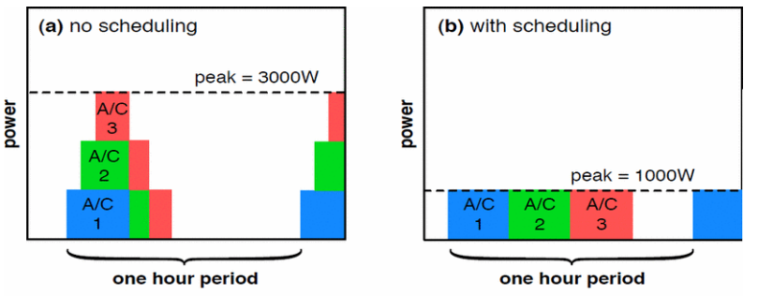

Figure 1 - No Scheduling and Scheduler Loading [7]

Since we had no real data, we did not know which metrics were using to find power consumption of the appliances. Instead we created some unreal data, and we thought that there were only three appliances and one controller. Thus we used arrays instead of creating objects for controller and appliances. For each appliance, the maximum capacity, the amount of power that is loaded at a time was assigned. After consumption started, the first loaded is done for the appliance of which the slack time is over first as in the least slack time approach. However, we have not a lot of appliances, we do not use the threshold to check the number of loading in one period.

SmartCap is an approach for flattening the demand. However, there is no information about how to use under different pricing model. Also, the power needs of many appliances such coffee maker, microwave oven cannot predicted easily because the usage pattern of home occupants can vary. Thus, in real time pricing model, the price prediction can be difficult and not be precise. [7]

**3.2 Battery Charging**

For our battery charging algorithm we used the algorithm from the Scaling Distributed Energy Storage for Grid Peak Reduction paper.[4] This PeakCharge paper is based off the SmartCharge paper previously mentioned, but with the goal of fixing SmartCharge’s flaw. As previously mentioned in SmartCharge assuming all consumers use the same pricing plan, they will all charge at the same time (the cheapest period of the day). This can cause a community’s peak demand to flip to the low price period and even increase demand due to the energy conversion loss. Instead in an attempt to flatten demand all around we can include a peak demand surcharge. This surcharge is charged on the customers highest peak demand. This leads to the algorithm used in the paper. The algorithm switches between a greedy approach and a peak aware approach. The algorithm works as follows, first the price of electricity in the time period (in our case 1 hour) is compared against the average price. Next the demand of that time period (again 1 hour) is compared against the average demand. The action taken by the battery is finally determined by evaluating the following inequality.

(xMax*ELOSS*MaxCost*T)-(xMax*MinCost*T) > xMax*SURCHARGE

xMax is the maximum rate the battery can charge. ELOSS is the loss in energy from the battery conversion. MaxCost is the maximum cost the price gets in the day. MinCost is the minimum cost the price gets in the day. T is the time period of MinCost. SURCHARGE is the cost during the highest demand period of the day. “The left side of the inequality is the maximum monetary benefit of greedily charging the battery at its maximum rate during the low-price period and then discharging it during the high-price period, while the right side is the cost of the peak demand surcharge from charging the battery at its maximum rate.”[4]. If this inequality is true, then we want to greedily charge/discharge the battery because the cost with the surcharge is not greater than then the benefit of greedily charging/discharging. If the inequality is not true we want to switch to the peak-centric approach and charge/discharge at a rate to try to keep average demand. The true algorithm is based on 4 cases. Case1: If price is low and demand is low, if the inequality holds charge at the maximum rate else charge at rate to keep average demand. Case2: If price is low and demand is high, if the inequality holds charge at the maximum rate else discharge at rate to keep average demand. Case3: If price is high and demand is low, if the inequality holds discharge at the maximum rate else do nothing since demand is below average and the price is expensive we don’t want to increase/decrease demand in this case. Case4: If price is high and demand is high, if the inequality holds discharge at the maximum rate else discharge at rate to keep average demand.[4]

**4. EVALUATION**

For our evaluation we created a simulator using C++. We chose C++ since most of our members were more familiar with it. We created a House class, a Community class, and a Driver. The user will control the simulation through a configuration file called conf.txt. The user can control the number of houses in the community, the energy files for each house, the pricing plans applied to the houses and the user strategies (just battery in our case) applied to the houses. We used 20 different houses’ data for this evaluation. We had access to 40 houses’ data, but many did not have data for a long enough period of time. We choose 2 months as our experiment time, so we eliminated houses based on that amount of time. We still wanted to test larger communities though so we just repeated houses in experiments involving more than 20 houses (at most every house is repeated once). The pricing plans we tested with were 2 different TOU plans, an RTP plan generated from 2 months of Day Ahead Pricing data from the Ameren energy company’s website [9]. The fixed price plan we decided based on the averages of the other 3 plans and we settled on.08kWh. Note we did test some fixed-price with battery implemented. While there is no monetary gain for the user by doing this and more energy may be used overall it could still be a tool to be used by power companies to flatten demand.

For the metrics of the battery charging algorithm we closely followed how the experiment was conducted in the Scaling Distributed Energy Storage for Grid Peak Reduction paper[4]. So our battery capacity was chosen as 50% average daily demand. Capacity, average demand, average price were calculated based on a 1 week training period. The maximum charging rate was capacity/8 and surcharge was set to $3. Note that because the surcharge price was so high our simulation only does the peak-centric approach since the left side of the inequality will never be greater than the right side. This was the surcharge price used in the original paper and we decided to follow the paper in this case. In we had more time we would try other surcharge prices. Note that unless a RTP plan was being used, the inequality would be only ever be true or false since none of the variables used in the inequality would change after initialization. With the RTP plan we wanted to implement an additional function to create a vector of each day’s min/max prices, but we seemed to have a memory problem when we tried to include it and so currently RTP only uses the min/max for the first day. Since none of the prices of our RTP plan would be able to make the inequality true, it didn’t matter in our experiments, but we still wanted to include this function. We leave the function we tried to write commented as future work to be corrected.

Figure 2 shows the aggregate energy data for the 20 different houses we used. House 9 wasn’t really using any energy so we can say that person was on vacation. Otherwise you can see there is a variety of different energy usage from the houses.

Figure 3 shows the aggregate energy of our houses with no strategy. We use mainly the 40 houses aggregate energy is a baseline later on when comparing the battery strategy. Figure 4 shows the pricing of communities with no user strategy. This is sort of the control, showing the aggregate prices of each set of houses in the community when the price plan is 100%.OntarioTOU is the most expensive, then Fixed Price, Illinois and then RTP is the cheapest.

Figure 2

Figure 3

Figure 4

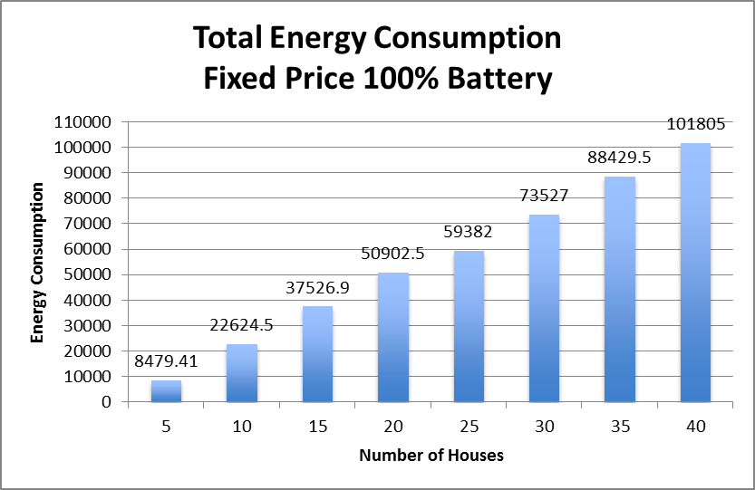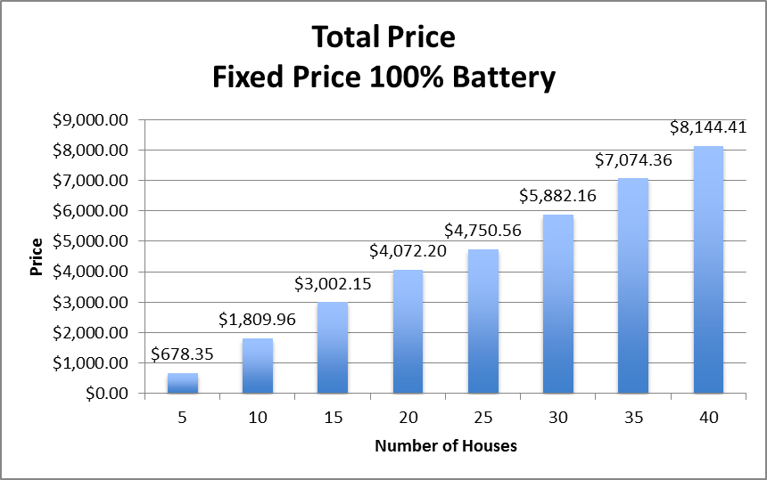

Figure 5(a) Figure 5(b)

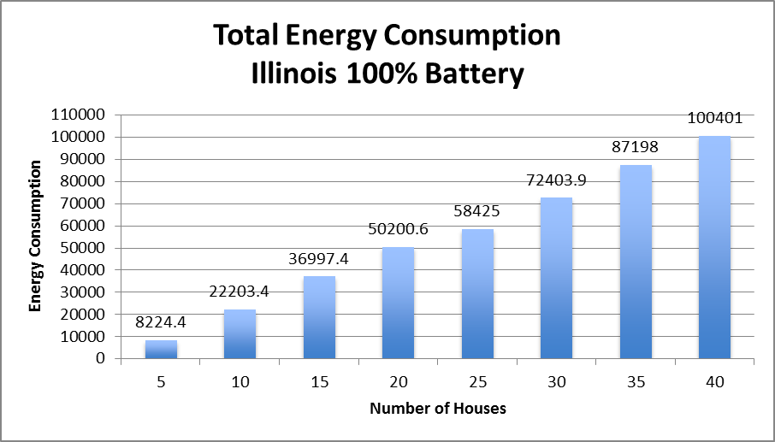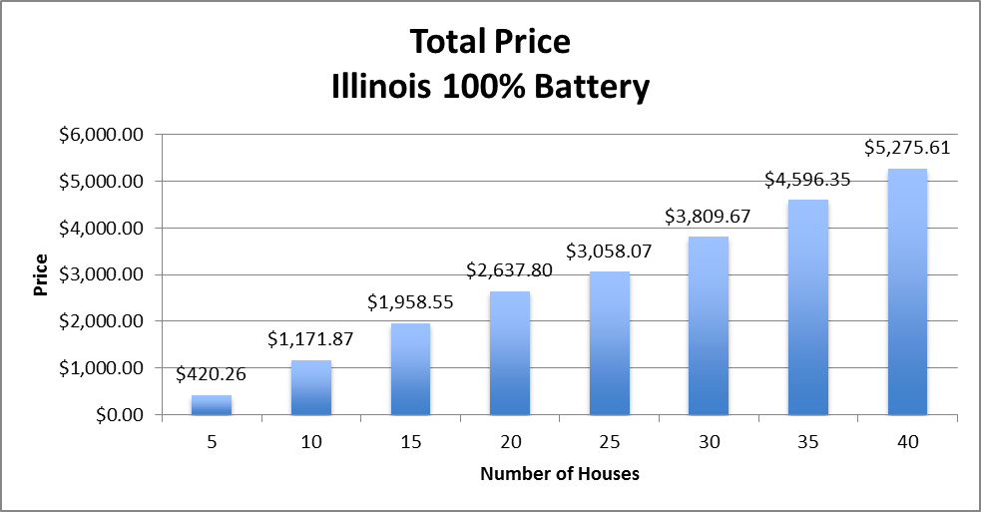

Figure 5(c) Figure 5(d)

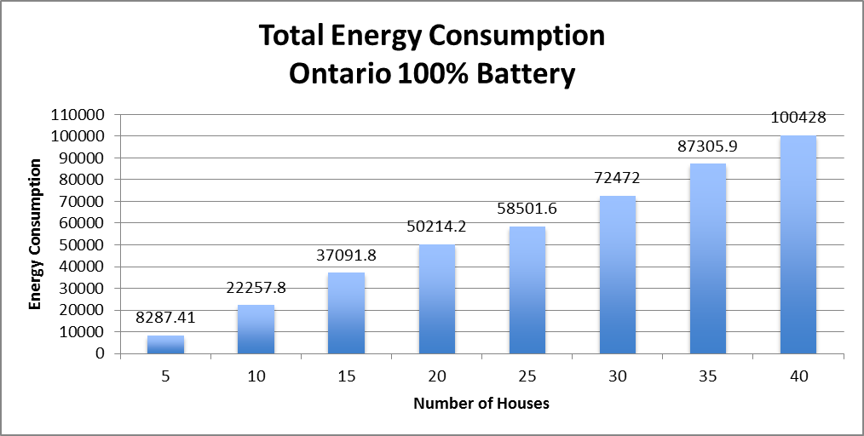 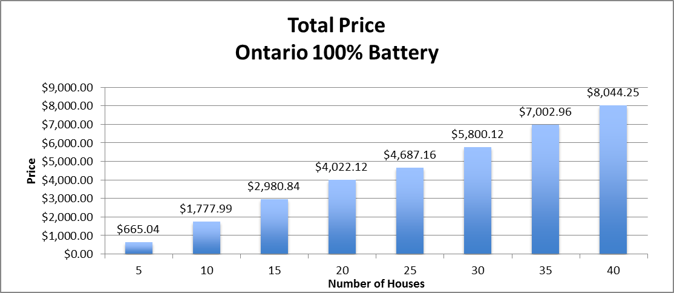

Figure 5(e) Figure 5(f)

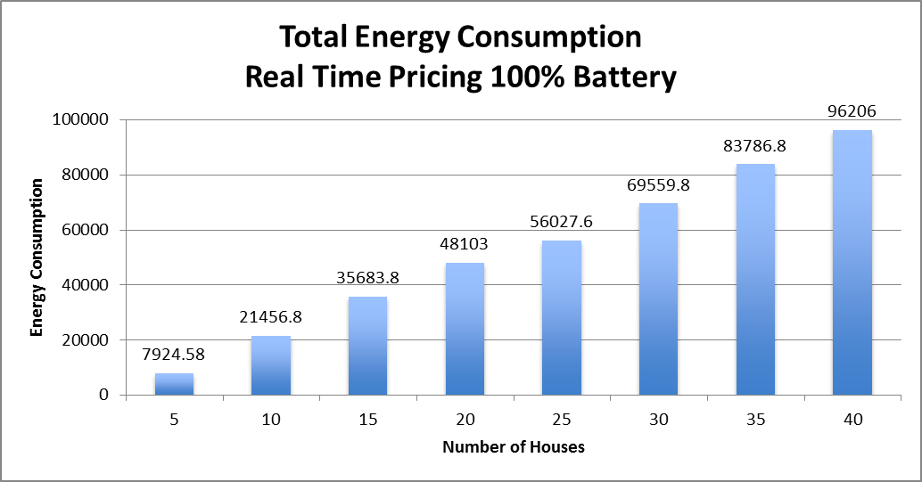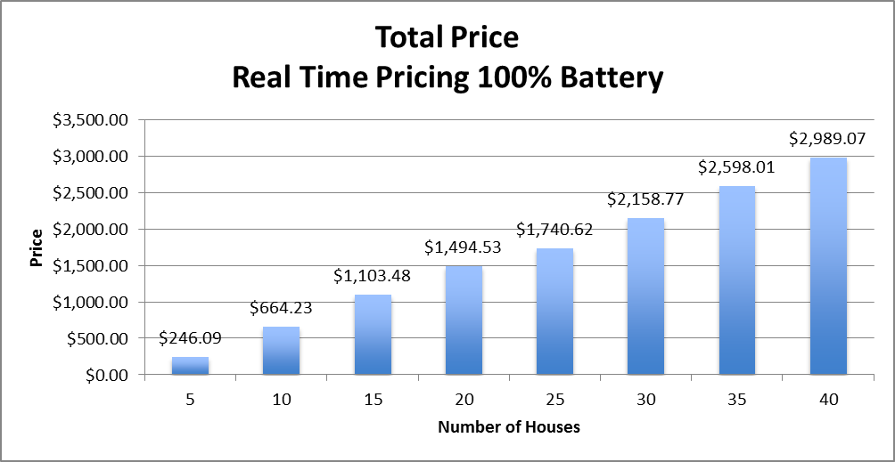

Figure 5(g) Figure5(h)

Figures 5(a)-5(h) show the aggregate energy consumption and aggregate price for the 4 different price plans with 100% battery strategy applied. RTP is the cheapest overall with $2989.07 being its maximum price with 40 houses compared to $5275.61IllinoisTOU, $8144.41 Fixed Price, and $8044.25 OntarioTOU. Fixed-Price probably would have cost the most if OntarioTOU didn’t have higher price rates. In our tests the following power usage was always true RTP<IllinoisTOU<OntarioTOU<Fixed Price. Fixed Price predictably is the highest since the price is always the same and the loss of energy from the battery conversion. RTP seems to be the cheapest and the most energy efficient in our tests.

Figure 6

Figure 6 shows how the battery strategy reduces peak demand. This figure is for 40 houses and only shows a portion of the 56 day time period used in our tests for clarity. As it can be seen peak demand is significantly. The algorithm is trying to sustain the average demand which also shows through this figure. Over time reducing peak demand like this in many houses can possibly save the power companies a lot of money.

The next thing we tested was the percent of 2 plans with different percent of the battery strategy applied to see if there was some sort of ideal plans to battery vs no strategy ratio. Note that we used the same 40 houses in all of the following results. Figure 7(a) shows the aggregate price of Illinois TOU vs. Fixed Price and Figure 7(b) shows the aggregate price of RTP vs. Fixed Price. Figure 7(c) shows the aggregate price of Illinois TOU vs. RTP and we used a bar graph in this case for clarity as the values are very close together. In Figure 7(a) the x axis is the percent of the community that has the Illinois TOU applied to it, while each line represents a different percent of the battery strategy applied to it. In Figure 7(b) the x axis is the percent of the community that has the RTP applied to it, while each line represents a different percent of the battery strategy applied to it. In both of these cases the value of the x axis also implicitly implies the percent of the fixed price plan that is applied. For example if we have 25%RTP then that means 75% Fixed Price is implied.

The aggregate price changes significantly as we apply more of either RTP or the TOU plan. The reason is because the Fixed Price is generally much more expensive than either of the other two in this case. In addition, applying the battery strategy to the Fixed Price plan will cost more as well because we use more energy. Even at 100% Illinois TOU the price actually starts increasing as we apply more batteries. This is most likely the battery actually being unable to flatten demand to the average demand. This probably means the battery is not getting enough charge to discharge and reduce demand at certain times. Since it is actually costing the customer more money, the customers most likely won’t accept the battery strategy because they would not get a benefit out of it even if peak demand gets flattened. The pricing for RTP is much cheaper than the other plans so it seems that that 100%RTP and 100%battery might be the best option from our results. This will save the customer the most in terms of money with the RTP plan. One thing to note however, applying various percentages of the battery to 100%RTP only saves a few cents overall compared to RTP with no battery. This is likely only because the time we used, 2 months, was relatively small. So this would not save the customer much money in the long run. In fact even using a small battery might mean the customer is losing money due to the high cost of batteries. The customer may accept it however since it does keep the price similar to the no battery rate and is a greener option. Also, the significant effect on reducing the peak demand may be worth it for the power companies to invest. With RTP and TOU applied the pricing is much cheaper than combinations’ including fixed price, but the pricing is still more expensive than 100%RTP as Figure 7(c) shows. Therefore in our case there is no benefit to have any other plan than RTP.

Figure 7(d) and Figure 7(e) show the results of the aggregate power of Illinois TOU vs. Fixed Price and aggregate power of RTP vs. Fixed Price. An interesting observation to note is that the RTP plan uses generally way less energy than the TOU plans when directly comparing the two. In our case what is probably happening is that the prices are significantly different at different times so the battery is charging more in TOU. Also, as previously mentioned the demand is not being completely flattened in the Illinois TOU case which increases the amount of energy used. Between 0-50% of the Fixed Price plan being applied the energy signatures between Figure 7(d) and Figure 7(e) are very similar. The energy difference from using a large percentage of RTP with a large percentage of the battery strategy is very minimal compared to using no strategy. In Figure 7(e), when the RTP is at 100% and battery is 100% the energy usage is only 96206 kWh compared to no strategy which is 96199.5 kWh. Even for 75% RTP and 100%battery the energy is 97837.8 only around 1600kWh difference. Figure 7(f) show the results of the aggregate power of RTP vs. Illinois TOU. Again as previously mentioned RTP seems to have the least energy usage with the battery in our simulation so 100%RTP is still better than any combination of RTP vs.TOU.

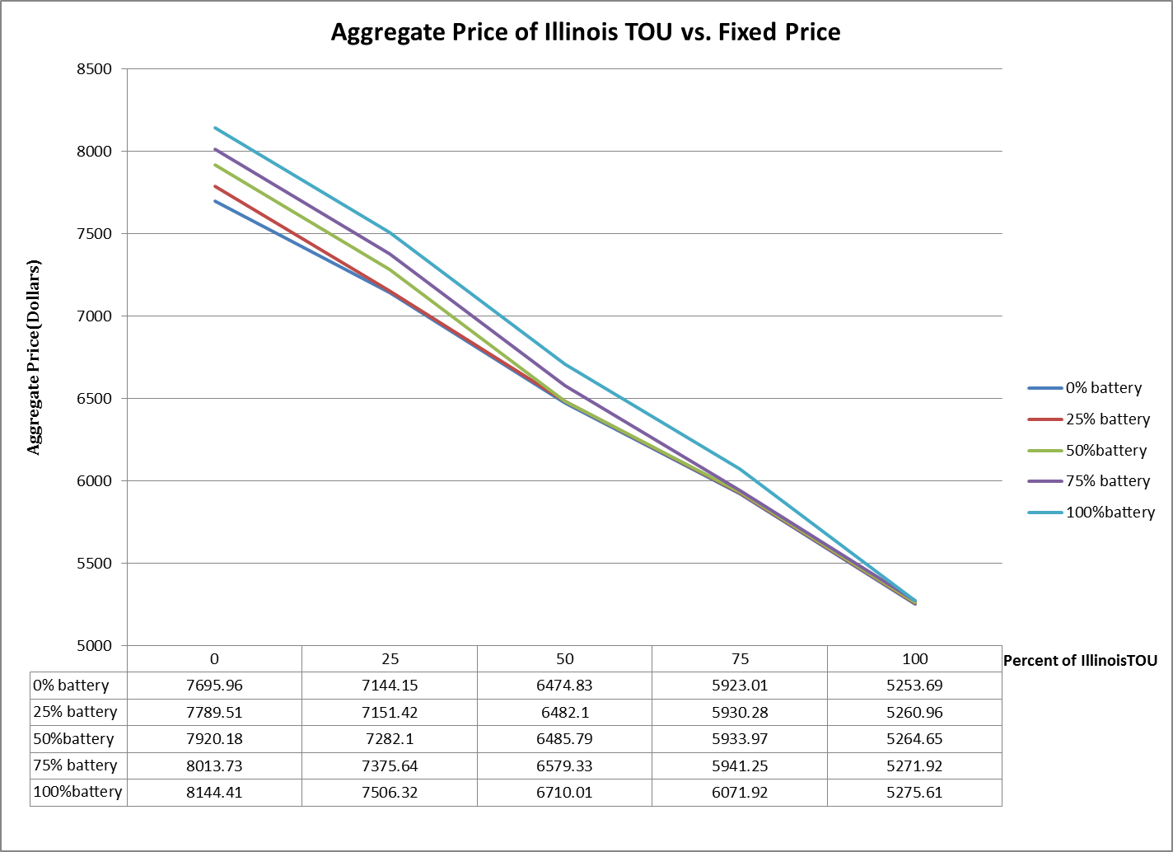

Figure 7(a)

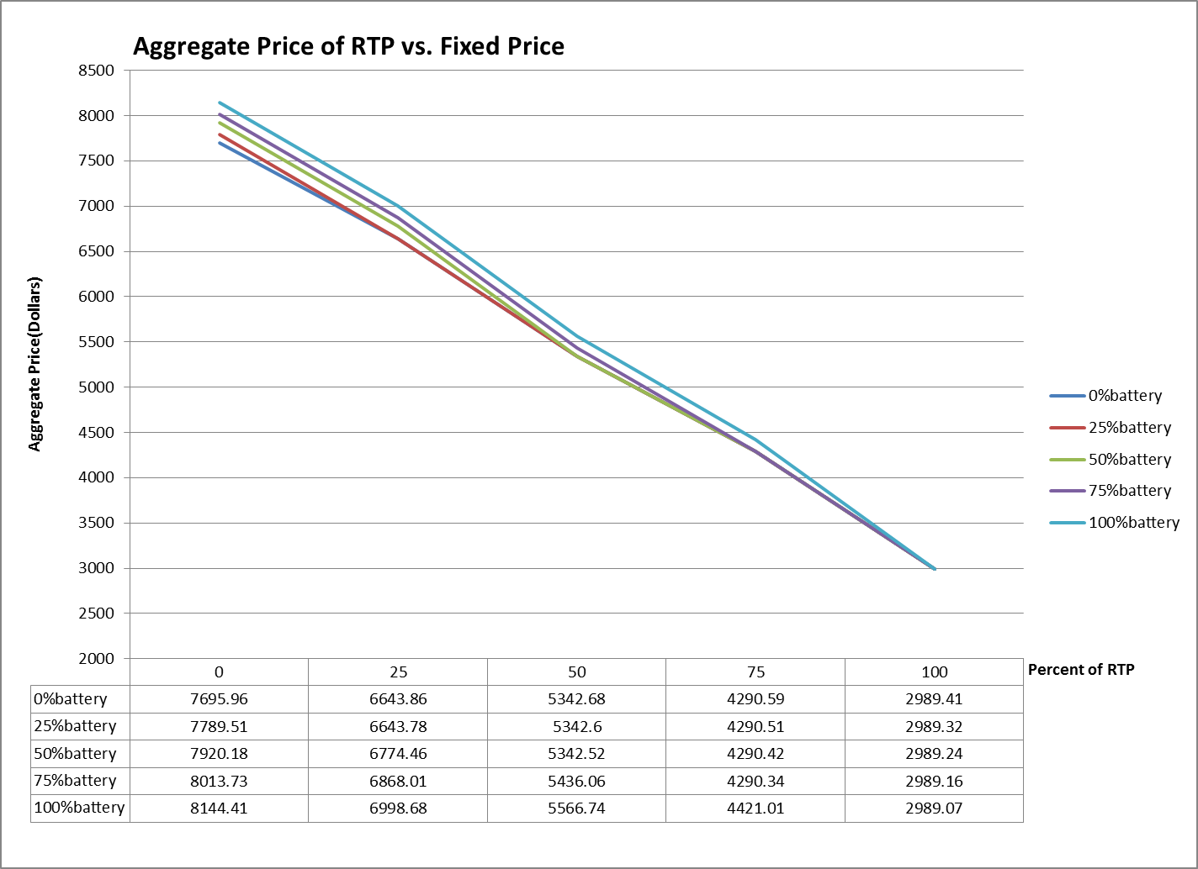

Figure 7(b)

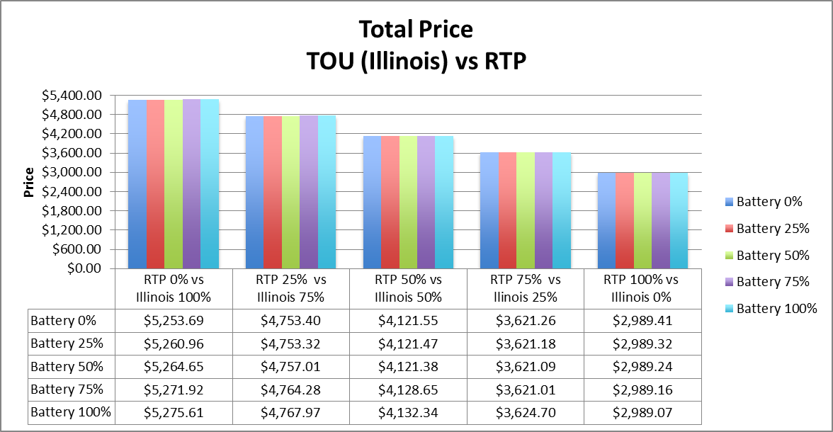

Figure7(c)

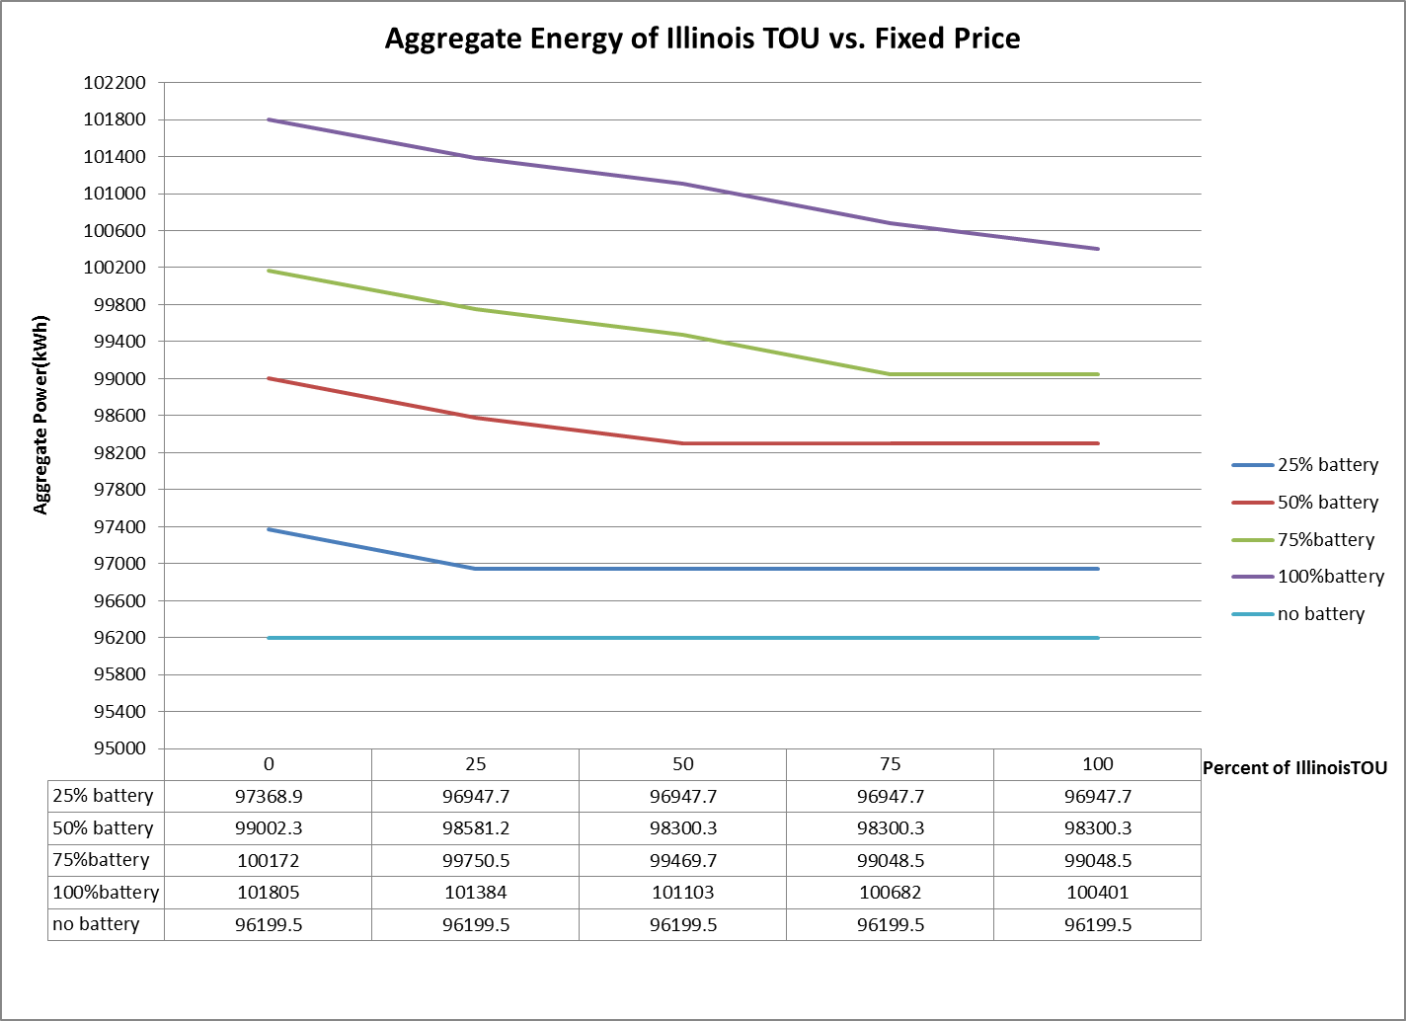

Figure 7(d)

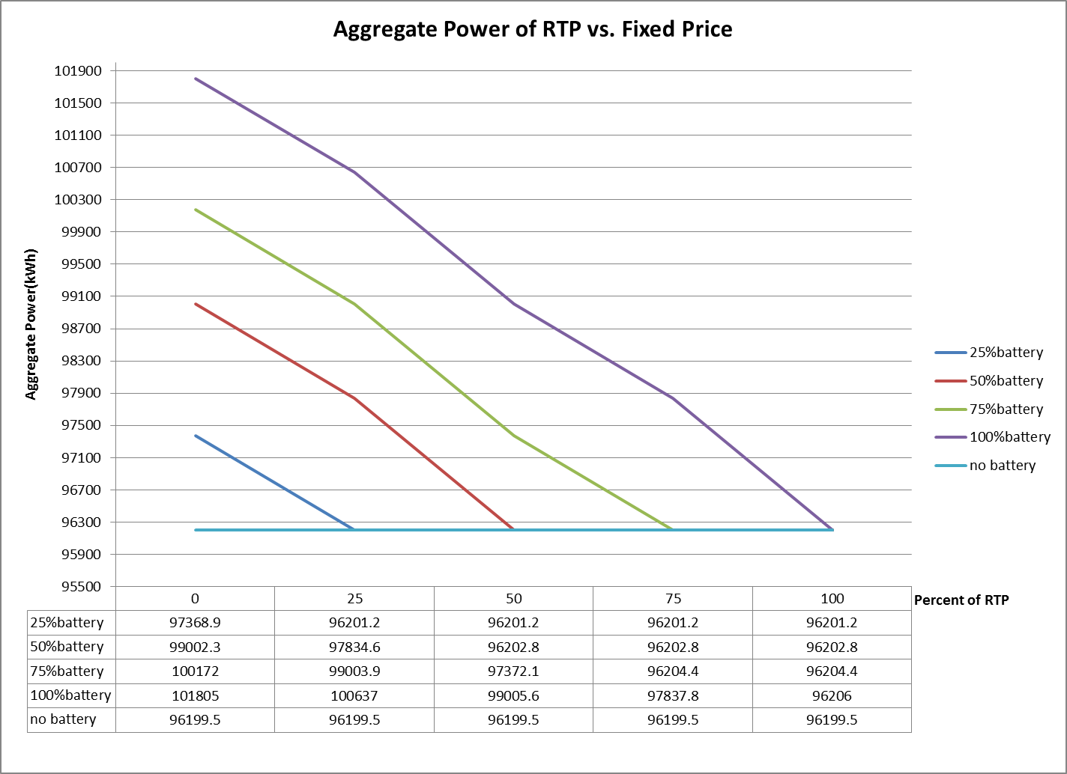

Figure 7(e)

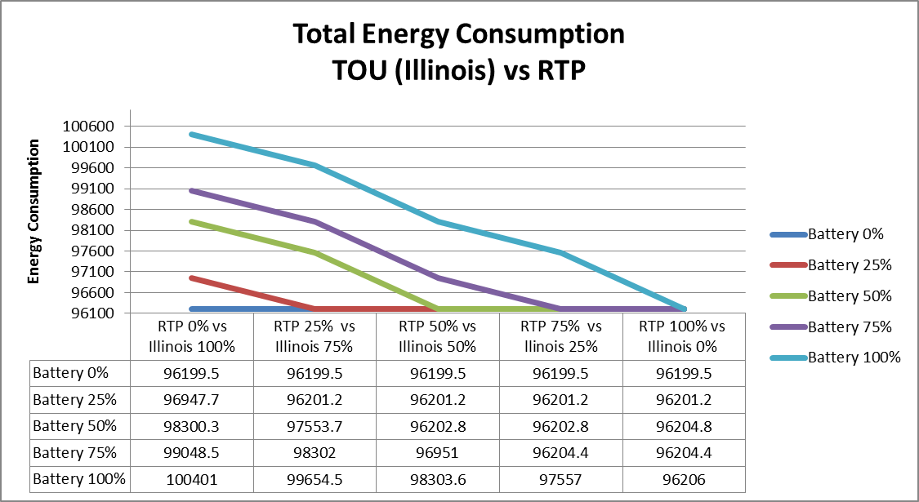

Figure 7(f)

**5. CONCLUSION**

High peak demand is very costly in terms of money, power efficiency, and carbon footprints. Reducing peak demand is therefore important to minimize these problems. Understanding how the balance between communities pricing plans and user strategies affects the peak demand is key to solving this problem. After testing three types of pricing plans and two user strategies we have not found an ideal combination of multiple pricing plans in a community. In our evaluation, using RTP 100% with 100% battery may be the best solution. It is the cheapest plan, but only by a few cents. It has the best power efficiency of all the battery simulations. At 100% it would reduce the peak load considerably. However the user must still take into account the cost of the battery and either predicting the RTP price or the overhead from downloading the RTP prices online. While the end user does not get a huge benefit from installing the battery, the power companies may still wish to incentivize the battery to the customer to reduce the peak demand. The TOU simulation showed an increase in price instead of a decrease showing that the battery algorithm is not always optimal. Although the pricing for TOU and RTP was very different we did use prices from Illinois so the pricing difference was not because of different regions. Therefore it seems that RTP has many more benefits than TOU. However, many power companies do not currently offer RTP. So it may still be beneficial to look at the community knowing that in reality a community may only have TOU or Fixed Price. It may benefit more power companies if they start offering RTP to customers. It is also possible that additional user strategies may work better with other pricing plans besides RTP.

**6. FUTURE WORKS**

Since we have limited time and we had no real data for appliances, the first task of the future work is scheduling of the appliances. Also, SmartCap that is the approached used for scheduling the appliances does not mention how to use under different pricing model so we think the controller can be used not only for loading but also choosing the low price time period. However, if the controller cannot permit loading during the high price period, the power of the appliance can be deplete before loading. Thus, this situation creates a tradeoff between price and power need.

Second step for future work is comparing the battery charging and the appliance strategies. Thus, under different combinations we can get more meaningful results than using only battery charging because we will be able to apply different percentages of the appliance strategies and the batteries. Thus, there might be a better be a better solution than what we have currently.

Another idea is that it might be a better user strategy to do both the battery and appliance strategy. If one house can do this it might be better than the separate strategies. However, accomplishing this would require changing the controller’s algorithm to control the battery as well. Another future work is comparing the predicted and actual real time pricing. We used the predicted real time pricing in our simulations. However, the predicted real price can have a huge difference from the actual price. Thus, we want to see how the real prices reflect the true aggregate price.

Finally, we will want to change some parameters of the code. We only tested the 50% daily demand average for the battery. We may wish to try another method to try different battery capacities. Also, we only used 1 week as the training data, so in the future we should use a longer time period to get more accurate results. We could not get the implemented function to create a vector of RTP low and high prices of the day. So in the future we would like that to be functional. As previously mentioned, we will leave the dysfunctional code commented out in the House class. We also only tested with a high surcharge which caused the greedy approach to never be taken. In the future we should test with a surcharge that may use the greedy approach as well.

**7. CONTRIBUTIONS**

Summarizing Different Pricing Models

* + Leveraging External Battery
    - Carolyn Forney
    - Tokumaru Yahashi
    - Ece Tug
  + Scheduling Electrical Appliances
    - Nagihan Cay

Writing Pseudo Code

* + Leveraging External Battery
    - Carolyn Forney
    - Tokumaru Yahashi
  + Scheduling Electrical Appliances
    - Nagihan Cay
    - Ece Tug

Implementation

* + David Skoada
  + Carolyn Forney
  + Tokumaru Yahashi

Simulation

* + Carolyn Forney
  + Tokumaru Yahashi

Graphs

* + Figures 2,34,6,7
    - Carolyn Forney
  + Figures 5,7(c), 7(f)
    - Tokumaru Yahashi

Writing the Final Report

* + Introduction
    - Nagihan Cay
    - Ece Tug
  + Related Works
    - Nagihan Cay
    - Ece Tug
  + Project
    - Scheduling of Appliances
      * Nagihan Cay
      * Ece Tug
    - Battery Charging
      * Carolyn Forney
  + Evaluation
    - Carolyn Forney
  + Conclusion
    - Carolyn Forney
  + Future Works
    - Carolyn Forney
    - Nagihan Cay

**8. REFERENCES**

1. I. Koutsopoulos, V. Hatzi, and L. Tassiulas. Optimal Energy Storage Control Policies for the Smart Power Grid. In SmartGridComm, September 2011.
2. T. Carpenter, S. Singla, P. Azimzadeh, and S. Keshav. The Impact of Electricity Pricing Schemes on Storage Adoption In Ontario. In e-Energy, May 2012
3. Aditya Kumar Mishra, David E. Irwin, Prashant J. Shenoy, Jim Kurose, Ting Zhu: SmartCharge: Cutting The Electricity Bill in Smart Homes with Energy Storage, e-Energy 2012: 29
4. Aditya Mishra, David Irwin, Prashant Shenoy, Ting Zhu: Scaling Distributed Energy Storage for Grid Peak Reduction, e-Energy 2013: 3-14
5. A. Sch¨ ulke, J. Bauknecht, and J. H¨ aussler. Power DemandShifting with Smart Consumers: A Platform for Power Grid friendly Consumption Control Strategies. In SmartGridComm, October 2010.
6. S. Keshav and C. Rosenberg. Direct Adaptive Control of Electricity Demand. Technical Report CS-2010-17, University of Waterloo, September 2010.
7. Sean Kenneth Barker, Aditya Kumar Mishra, David E. Irwin, Prashant J. Shenoy, Jeannie R. Albrecth: SmartCap: Flattening Peak Electricity Demand in Smart Homes, PerCom 2012: 67-75
8. V. Bakker, M. Bosman, A. Molderink, J. Hurink, and G. Smit. Demand Side Load Management Using a Three Step Optimization Methodology. InSmartGridComm, October 2010.
9. Ameren:“Day-Ahead Prices in Dollars/KWH for RTP” From 02-07-11 to 04-03-11. Retrieved from: https://www2.ameren.com/RetailEnergy/realtimeprices.aspx