

Administrator Guide

Version 0.4

Created by: Stewart Watkiss www.watkissonlineco.uk

Available from: PenguinTutor www.penguintutor.com



Introduction

The wQuiz program is a customisable program designed for running interactive quizzes over the Internet. The program was first designed for use on the www.firstaidquiz.com web site, but has since been made updated to make it more flexible and made available to the public.

From version 0.4 the quiz engine is written in php and designed for use on a Linux server with the Apache server, and a MySQL back-end. The quiz should work with other operating systems, web servers, and databases, but I am unable to give any support or advice on variations of this.

The test system is based on Ubuntu Linux 11.10, PHP 5.3.6, MySQL 5.1.58, running on a i686 based kernel.

The latest release of the source code is available from: http://www.penguintutor.com
During development CVS snapshots are available from the SVN repository available at: http://code.google.com/p/wquiz/ . Unless you are wanting to help with development, or want a feature only included in the development snapshot it is recommended that you only use the release versions.

You can see examples of the program in use at: http://www.penguintutor.com or http://www.firstaidquiz.com .

License / legal information

The source code is released as Open Source under the GPL License. Terms of the license are available in the file gpl.txt contained within the archive or can be retrieved from http://www.gnu.org/licenses/gpl.html.

The license applies to the source code, and documentation, but does allow you to create custom templates, which you can retain copyright of.

I would be grateful if you provided a link to the www.penguintutor.com site from your quiz, or from elsewhere on your site to acknowledge the work that has gone in to creating the quiz. The supplied sample templates include this already. This is not a condition for use, so if you do not want to then there is no obligation to do so. I would also like to hear about any sites that do use the quiz, again this is voluntary.

This is provided as “free” software and comes with no warranty, or guaranteed support. If you do not agree with the conditions, including the full GPL license then you should not use this software.

Installation or Upgrade

Easy install

The easy install process attempts to automate the initial install as much as possible.

First extract the archive file to an appropriate location within the web site directory. The archive will expand into a directory called quiz, but that directory can be renamed after it is extracted.

On Linux system:
tar -xvf wquiz-*.tar.gz

If using a Windows PC or a Mac to upload then the files are also available in a zip file which can be extracted locally and then uploaded using ftp etc.

To allow the automated install then the webserver will need to be able to write to files within the file system. If it does not have this permission then the files can be created manually, but it is recommended to provide the following access for the install to go smoothly. Read Write and Execute permission is required for the quiz/ directory, by the user / group that the server runs under. On Ubuntu this is normally www-data, on other distributions this may be http, apache or apache2

After extracting the files open quiz/admin/install.php through the web-browser.

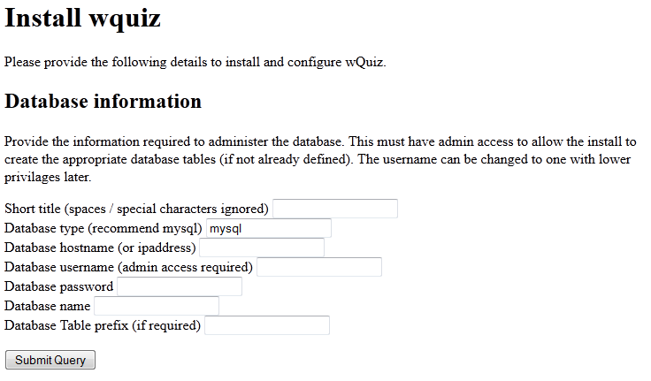

To allow the install to create the database then a database account with full admin access should be used. If the database has been created manually then the account only needs update access to that specific database. The files can be updated later to lower the permissions to restrict access to within the quiz database.

The following information needs to be entered:

Short title – This is a short name to refer to the database by. It is not seen by end users, but will be used to create a secondary configuration file. It cannot be set to wquiz.

Database type – This should normally be mysql. If installing on Windows and you have Microsoft SQL then you could enter mssql, but the database will need to be installed manually and mssql is not supported. Entering any other type of database will require a new database class to be created to support the alternative database type.

Database hostname – This should be the fully-qualified host domain name or ip address where the database is installed.

Database username – The database administrator username.

Database password – The password for the above account.

Database name – The database to use for the quiz related tables.

Database table prefix – A prefix to put before table names. All the table names are prefixed with quiz_ anyway, and this would be before that. This can be used to allow the quiz to coincide with other applications within the same database (eg if your hosting provider restricts the number of databases that can be created). This is optional and can be left blank if not required.

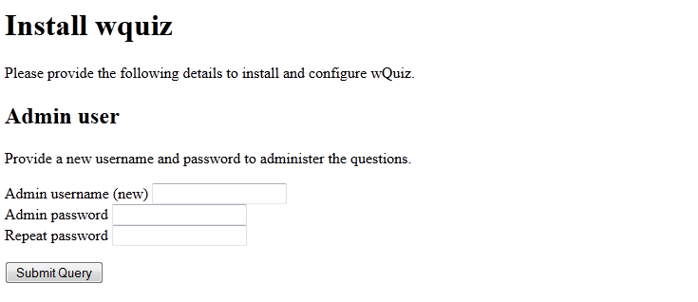

A username and password is requested. This is to administer the questions and does not relate to access to the database.



In the event of any issues, where possible, the install will advise on how to create the relevant file or database manually before allowing to proceed to the next stage.

One installed you can login to administer the quiz by going to quiz/admin/ through a web browser.

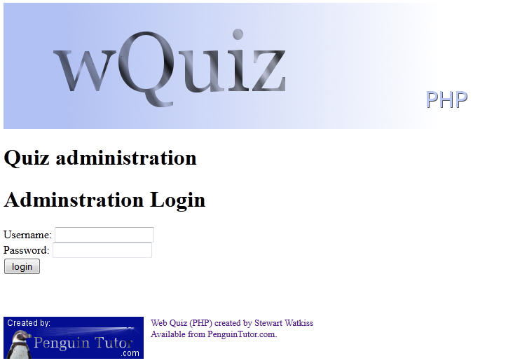

After install you should continue to read this guide for details of how to customise the quiz to your needs.

Manual install

Details of how to install the program manually are provided in Appendix A.

Securing the install

When installed as above the default setup of most web servers should protect the database information. It is however recommended to move this into a more secure location in case of a security vulnerability in the software, browser or from any other software installed on the server.

The first thing to do is to move the secondary config file outside of the web directory.

The Configuration File – wquiz.cfg

The configuration for the quiz is contained in a single configuration file called quiz.cfg. This is stored in the main directory in the same place as the normal quiz files are contained. The syntax of the file is important, and any errors will prevent the quiz from working. Care should be taken whenever any changes are made to the file. It is also recommended that a backup is made before editing the file, so that it can be restored in the event of any problems.

This is a php format file and all usual php conventions apply (eg. // or /* */ denotes comments).

The configuration file holds some important user and database information. The apache daemon needs to be able to read the file, but other than that it is recommended that you restrict those who can read the file.

Settings

This section includes the settings that you may need to customise. These can be edited through the settings page in the admin pages.

$dbname
This should be correct for most systems using the mysql database.
If you want to use a different database name to "quiz" then change that part of the string. e.g. if you want your database to be "myquiz" change the entry to: $dbname="DBI:mysql:myquiz:localhost";
Some hosting companies may include your username in the database name, so you may have to use username_quiz in that part of the dbname field.

If you are using a different server name then change the localhost value to the IP address of the server (and if not using the default mysql port number append with :portnumber). You can change the database type by replacing mysql with an alternative perl database engine type, but if so the install script may not work.

$dbuser
Set this to the username with access to the database.

If you are installing the application, and you want to let the install script create the database for you then this will need sufficient permission to create a new database (which can be changed to a user with lower privilege later if required).

Other than the install script (where admin rights may be necessary) the user will just need update access to the tables, used in this install.

$dbpass
The password to go with the above username

$dbtable
This is the name of the table used to hold the questions. This should be unique to each install

$dbsessiontable
This should be the same as $dbtable followed by _session

$dbactivetable
This should be the same as $dbtable followed by _active

$dbsettingsnumtable
This should be the same as $dbtable followed by _settings_num

$adminuser
The username to logon to administer the quizzes with. This is not configured anywhere else.

$adminpass
The password for the above user. It is very important that this is changed as the default password is available to anyone. The password is stored as plain text.

$adminsessiontimeout
The value in minutes for a admin session to remain logged in for. After the admin session has been inactive for this number of minutes the administrator will need to log back in to continue in administrator mode. The default value is 240, which gives a 4 hour session timeout.

$sessionexpiry
This is the number of minutes before a regular quiz session will be flagged as inactive. A user can still continue their session after this time until the database clean-up is next performed. It should be seen as the minimum time a session will be allowed to stay unused before it can be deleted.
This is configured in seconds, and has a default value of 14400, which is 4 hours.

$sessionsbeforecleanup
This lists the number of times that quiz sessions have to complete before the clean-up is performed. This is to reduce the load put on the database through clean-up operations, and to improved performance as the database tables are locked during the clean-up operation.

Offline Mode

The offline mode can be enabled or disabled. A risk in enabling the offline mode is that it could be used for cheating, and it could be used to make it easier for people to copy the questions. The following entries are required to use the offline mode.

$offlinequiz
This is set to 0 to disable the offline mode, or 1 to enable it. If this is enabled then the next entry is mandatory.

$offlinecountfile
This needs to point at a file that exists and has a single integer number. The apache daemon will need write access to the file.
This file is used to ensure that when using the offline quiz that each user is given a unique session.

Administrator Details

These details are required for the automatic notification of problems with the quiz engine.

$emailerror
This is used to set the type of errors to email on. The email notification can be disabled by setting the value to 0. 1 is used for critical messages, 3 is used for major messages, 4 for warnings and 5 for debug messages. The sample config file has the messages set to 4, but you may prefer to the set the value at 3 depending upon the number of messages received.

$smtpserver
The address of the smtp server used to send out email notifications. SMTP Authentication is not currently supported.

$hellostring
This should be set to the domain of the server. It is the hellostring used in the smtp handshake. The smtp protocol requires that the mails should still be sent even if this isn't correct.

$adminemail
This is the email address to send notifications to.

$fromemail
This is the email address that the notifications will come from.

Header and Footer Files
The header and footer files allow some html code to be inserted into the templates. These are typically used where you want to maintain a menu separately from the html templates. By updating the menu in the appropriate file then it can be updated across the entire quiz templates.

$headerfile
This is typically used for a top menu, or could be used for a side menu. The file should either be an absolute file name, from the top of the filesystem, or a relative file name from the quiz directory.

$footerfile
This is typically used for a footer or bottom menu, or could be used for a side menu. The file should either be an absolute file name, from the top of the filesystem, or a relative file name from the quiz directory.

Formatting Options
These options affect the way that the quiz is formatted in the browser.

$answercols
This sets the number of columns to display when viewing the results.

Alternative Style Sheets
There is currently support for alternative style sheets. This may be dropped in future versions, so if you implement this please post to the PenguinTutor Forum. If this is used by others then it will be kept, but if not may be dropped.

@csscategories
A list of different css categories.

%cssfile
A list of the different files, one per category.
These should be “category” => “filename/url”, separating each pair by commas.
%cssextra
A list, one per category that provides html code to be inserted. This is used to allow users to click on a link and change style sheet.
This should be “category”=> “html text”

%cssindex
This is used to provide different links to the index page at the end of the quiz. Using this alternative pages can be used for different styles.
This should be “category” => “url”

@ignoreboterrors
This is a list that can be used to exlude robots from giving errors. You should probably use robots.txt rather than this, but it can be used for any web robots that don't obey the robots.txt file.
This may be dropped in future.
Note this only affects email notification, and the error message given to the robot. It does not block users from using the quiz.

Quiz Specific Configuration
The final section provides the individual configuration for the specific quiz. This will need to be customised for each quiz. This may be moved to a separate database configuration table in future, but migration instructions will be provided.

@category
List of all the current quizzes. A quiz can be temporarily removed by excluding it from this array.

@allowedcategory
A list of all the quizzes allowed, current or future. This must include all the entires from @category, but also any others that are being created.

%quiznames
A list associating the quizname (as defined in @category), with a user friendly title.

%numquestions
The number of questions for each quiz. There must be at last one more question in the database than the number specified here.

%quizintro
Some text, or html that is shown at the start of the quiz. This should give some summary details about the quiz.

Template Files

The quiz requires 10 template files, which create the look and feel for the quiz. These are stored in the templates directory. There are samples provided in the samples/templates directory which can be customised to fit in with your site or you can create the templates from scratch.

The templates are just html or xhtml files, and are named with extension .html. The files are plain html with some variables listed using %%variable%%. The variable information will be replaced with the text from the program. Listed below are the different template files and the variables that can be used.

It is not necessary to use all the variables in each template file. If you miss some of the variables then it may prevent a certain feature being available.

index.html
This is used by the first page of the site. It should present a list of the different quizzes, and ask for the user name, before posting the information to the details.pl page.
The following variables are supported: %%css%%; %%cssextra%%; %%cssurl%%; %%footer%%; %%header%%; %%index%%; %%quiznames%%; %%urlextra%%.

details.html
Provides information about the quiz before allowing the user to start answering the questions.
The following variables are supported: %%css%%; %%footer%%; %%header%%; %%index%%; %%info%%; %%numquestions%%; %%urlextra%%; %%urlstring%%.

question.html
Displays the question to the user.
The following variables are supported: %%css%%; %%footer%%; %%header%%; %%image%%; %%index%%; %%numquestions%%; %%questiontext%%; %%question_num%%; %%quizname%%; %%urlback%%; %%urlcheck%%; %%urlextra%%; %%urlnext%%; %%username%%.

check.html
Provides a display of all the question numbers, and whether they have been answered. Gives the user the opportunity to revisit any questions before having the quiz marked.
The following variables are supported: %%checks%%; %%css%%; %%footer%%; %%header%%; %%index%%; %%quizname%%; %%urlextra%%; %%urlstring%%; %%username%%.

score.html
After marking shows the results of the quiz.
The following variables are supported: %%answers%%; %%css%%; %%footer%%; %%header%%; %%index%%; %%numquestions%%; %%percentage%%; %%quizname%%; %%score%%; %%urlstring%%; %%urlextra%%; %%username%%.

review.html
Used to review individual questions. Shows the question and the result.
The following variables are supported: %%correctanswer%%; %%css%%; %%footer%%; %%givenanswer%%; %%header%%; %%image%%; %%index%%; %%numquestions%%; %%questiontext%%; %%question_num%%; %%quizname%%; %%ref%%; %%status%%; %%urlback%%; %%urlextra%%; %%urlnext%%; %%urlscore%%; %%username%%.

help.html
Displays the user help page.
The following variables are supported: %%css%%; %%footer%%; %%header%%; %%helptext%%; %%index%%; %%menu%%; %%version%%.

offline.html
This is the off-line equivalent of index.html. It provides a welcome page and selection menu for the off-line quiz. This is not required if the off-line quiz is disabled.
The following variables are supported: %%footer%%; %%header%%; %%index%%; %%quiznames%%; %%style%%.

offlinequestions.html
This is for the off-line quiz, it is not required if the off-line quiz is disabled.. It displays the list of questions, in a printable format.
The following variables are supported: %%footer%%; %%header%%; %%index%%; %%questions%%; %%quizname%%; %%serial%%; %%style%%; %%urlstring%%

offlineanswers.html
This is for the off-line quiz, it is not required if the off-line quiz is disabled.. It displays the answers in a printable format.
The following variables are supported: %%footer%%; %%header%%; %%index%%; %%questions%%; %%quizname%%; %%serial%%; %%style%%; %%urlstring%%

Template Variables

%%answers%%
This variable gives a list of the results from the completion of the quiz. Each entry will be a link to connect to the review question page.
Available in: score.html

%%checks%%
This lists the questions and states whether they have been answered or not. The answers are provided as links to the relevant question page, so that the user can review or change their answer before the exam is marked.
Available in: check.html

%%correctanswer%%
This is used when reviewing the question to display the correct answer.
Available in: review.html

%%css%%
This is used to link to the CSS style sheet. It should normally be used in a stylesheet “link” tag.
Available in: index.html; details.html; question.html; check.html; score.html; review.html; help.html

%%cssextra%%
This provides the CSS Extra text, normally used to allow the user to change style sheets before starting the quiz.
Available in: index.html

%%cssurl%%
This gives the name of the style.
Available in: index.html;

%%footer%%
This embeds a copy of the footer file, as specified in the quiz.cfg file.
Available in: index.html; details.html; question.html; check.html; score.html; review.html; help.html; offline.html; offlinequestions.html; offlineanswers.html

%%givenanswer%%
This is used when reviewing an answered question, providing the answer that the user had provided.
Available in: review.html

%%header%%
This embeds a copy of the header file, as specified in the quiz.cfg file.
Available in: index.html; details.html; question.html; check.html; score.html; review.html; help.html; offline.html; offlinequestions.html; offlineanswers.html

%%helptext%%
This provides the html text of the context sensitive help page.
Available in: help.html

%%image%%
If images are available in the quiz, then this will embed the image into the html. If images are not defined then it will instead just place an empty string.
Available in: question.html; review.html

%%index%%
The %%index%% variable provides a link to the index page. Used when providing alternative index pages in quiz.cfg.
Available in: index.html; question.html; check.html; score.html; review.html; help.html; offline.html; offlinequestions.html; offlineanswers.html

%%info%%
Provides the summary information about the quiz.
Available in: details.html

%%menu%%
Gives the menu for the help page. Allows the user to select another page to the default context sensitive help.
Available in: help.html

%%numquestions%%
Displays the number of questions in the current quiz.
Available in: details.html; question.html; score.html; review.html

%%percentage%%
The approximate percentage of the questions answered correctly.
Available in: score.html

%%questions%%
This differs depending upon the page it is called from. If used in offlinequestions.html, then it provides a list of all the questions. If used in offlineanswers.html, then it provides a list of all the correct answers.
Available in: offlinequestions.html; offlineanswers.html

%%questiontext%%
Provides the question text to the user.
Available in: question.html; review.html

%%question_num%%
Gives the number of the question currently being answered / reviewed. This is relative within the quiz, not the question reference number (see %%ref%%).
Available in: question.html; review.html

%%quizname%%
This gives the name of the currently selected quiz.
Available in: details.html; question.html; check.html; score.html; review.html; offlinequestions.html; offlineanswers.html

%%quiznames%%
This gives a list of all available quizzes as <option> tags.
Available in: index.html; offline.html

%%ref%%
The %%ref%% variable gives the individual question reference number, as used in the question administration panel. This is used to give the user a reference number for the question so that they can report incorrect questions.
Available in: review.html

%%score%%
Gives the number of questions answered correctly.
Available in: score.html

%%serial%%
Provides a unique serial number to tie together the off-line questions, with the corresponding off-line answers.
Available in: offlinequestions.html; offlineanswers.html

%%status%%
Gives details of whether the question was answered correctly or not.
Available in: review.html

%%style%%
Provides details of the requested style.
Available in: offline.html; offlinequestions.html; offlineanswers.html

%%urlback%%
Gives a html link to the previous question.
Available in: question.html; review.html

%%urlcheck%%
Gives a html link to the check page.
Available in: question.html

%%urlextra%%
Gives additional information to be added to a url string, so that the relevant information is maintained (e.g. style). It is used by adding the %%urlextra%% variable to the end of a href entry.
Available in: index.html; details.html; question.html; check.html; score.html; review.html

%%urlnext%%
Gives a html link to the next question.
Available in: question.html; review.html

%%urlscore%%
Gives the link to the score page
Available in: review.html

%%urlstring%%
Provides the string to add to the end of a page url (same as urlextra, but is prefixed with a ?)
Available in: details.html; check.html; score.html; offlinequestions.html; offlineanswers.html

%%username%%
Provides the name of the user, or “Anonymous” if no name has been provided.
Available in: details.html; question.html; check.html; score.html; review.html

%%version%%
Gives the version of the quiz engine.
Available in: help.html

Administration Interface

The administration interface is available from the admin directory in the installation, e.g. /quiz/admin/index.pl
The administration tools provide a web interface that allows you to manage the questions. Although it is possible to customise the administration interface by updating the admin/templates files, it is not recommended, as these are overwritten whenever a new version is installed.

Login Page

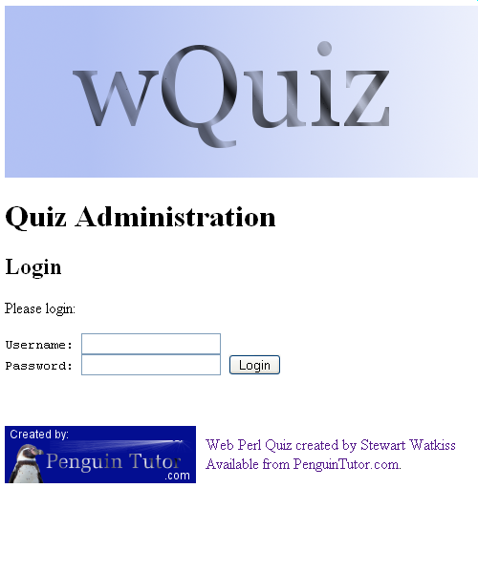
Before you are allowed to update any of the questions you first need to login. To login you require the admin username and password as specified in the quiz.cfg file.

Quiz Administration Page

After successfully logging onto through the administration page click on “manage questions”. The Manage Quiz option, is for future use, and is not yet implemented.

Manage Questions

The manage questions page will list any existing questions.

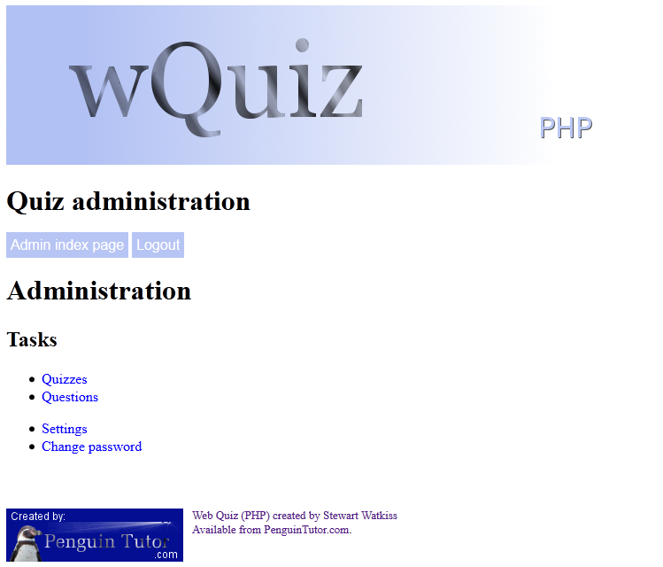
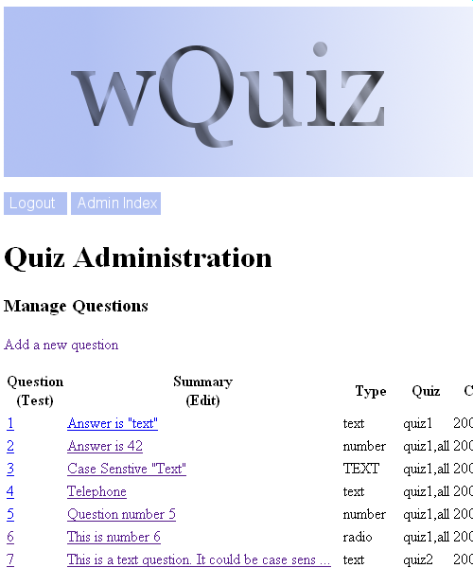
New questions can be added by clicking on “Add a new question”. To edit an existing question, click on the Summary field. To test a question click on the question number.

Add / Edit Question

Adding and editing a question will take you to a page with the question details. For a existing question (edit) then this will have the current information already filled in. For a new question then all fields will be blank.
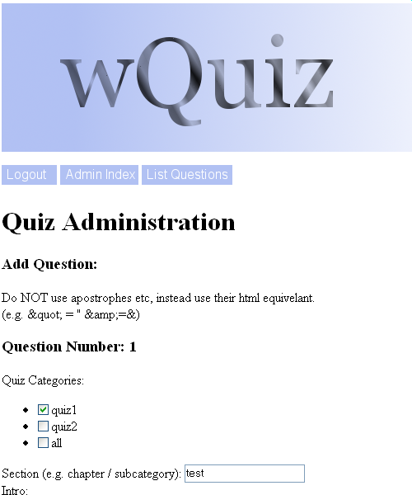

Quiz Categories
Select the quiz or quizzes that this applies to.

Section
This is a chapter, or subcategory. Currently this is a freeform text, but future versions may limit the choice of sections. This is currently made available to the administrator only.

Intro
This is the text part of the question. Normally this will ask the user a question, for them to respond to. The entry can be plain text, or html encoded text. If implementing a picture only question this could be left blank.

Input
For a text or number field then this should contain any pre or post text, as well as an initial value. This must be in the format: pre,current,post . If there is no information to display (normal) then enter two commas ,, .
For radio or checkbox question then this should list all the options separated by commas. If you want to include a comma in the answer then it needs to be entered as html (i.e. &#44;).

Question Type
The type of question.
- text – case insensitive text question
- TEXT – case sensitive text question
- number – either in range or as a single number
- radio – user can select one of the options
- checkbox – user can select multiple options

Answer
This should supply the correct answer, in computer readable format. If the answer is to be a number, then it should be entered as min,max (or a single number), text should be entered as a perl regular expression, but without the '/' characters. For a radio then this should be a single number which matches the appropriate option (start counting at 0). For a checkbox then this should be a list of the correct answers without any separator. e.g. 03 for the 1st (0), and 4th (3) answer.

Reason
This is the answer in human readable format. The recommended convention is to give a full explanation about the answer, but surround the actual words that match the answer with <b> </b> tags.

Reference
This is free text to display information for question verification. It is not currently shown to the user, but that may be a feature of future versions.

Hint
This is reserved for future use. It has no affect on the current version of the quiz.

Image
Provide a url to any image to display alongside the question.

Comment
The comment will not be shown to the user. This is for administrative reference only.

Contributor
Record details of the person that had submitted the question. Not currently displayed to the user.

Contributor Email
Email address for the contributor. Will not be shown to the users.

Clicking Save, will update the question in the database, and return a summary about the question. Clicking on List Questions will then go back to the list of questions where more questions can be added if required.

Test Question
The question can be tested by clicking on the question number from the list question screen.

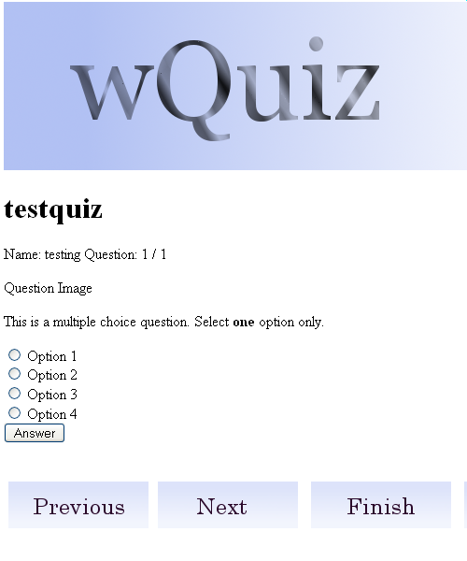
The template loaded will be the main quiz template. If relative paths are used for images then these may not display correctly. Clicking on answer will test the question and tell you if you answered it correctly or not. It will not attempt to update the with the answer details. This is therefore not a comprehensive test, but can be used to check the logic of a question.

More Information

For more information, or a copy of the source code go to: www.PenguinTutor.com

Appendix A – Manual Installation

The installation instructions are provided in the docs directory. These instructions provide an alternative if there is a problem following the installation, or you'd rather create the database and tables manually. This also provides details of the tables if you want to use a different backend database. Although you may also need to make additional changes to the code (not provided).

The database and tables can be created manually using the command line mysql client or a GUI based interface such as phpmyadmin or the MySQL query browser. You will need the appropriate permissions to make the updates to the database.

First create the database (e.g. create database quiz)
and select the database as your active database (use quiz).

Then issue the following commands to add the tables:

- create table quizname (question int primary key auto_increment, quiz varchar(254) NOT NULL, section varchar(254) NOT NULL, intro TEXT NOT NULL, input TEXT NOT NULL, type varchar(10) NOT NULL, answer varchar(100) NOT NULL, reason TEXT NOT NULL, reference varchar(100) NOT NULL, hint varchar(254) NOT NULL, image varchar(200) NOT NULL, comments varchar(200) NOT NULL, qfrom varchar(50) NOT NULL, email varchar(50) NOT NULL, created date NOT NULL, reviewed date NOT NULL);

- create table quizname_session (session_id varchar(254) primary key, startsession datetime NOT NULL, quizname varchar(254) not null, status int not null, name varchar(254) not null);

- create table quizname_active (session_id varchar(254), qnum int not null, question int not null, answer varchar(254) not null, PRIMARY KEY (session_id , qnum));

- create table quizname_settings_num (settingkey char(25) primary key, settingvalue int not null);

You will also need to copy and customise the templates and update the quiz.cfg file as described in this document.

