

User Guide

Version 0.3.2

Created by: Stewart Watkiss www.watkissonlineco.uk

Available from: PenguinTutor www.penguintutor.com



Introduction

The wQuiz program is a customisable program designed for running interactive quizzes over the Internet. The program was first designed for use on the www.firstaidquiz.com web site, but has since been made updated to make it more flexible and made available to the public.

The program is released as Open Source code. This means that not only can others use the program free of charge, but that if anyone wants to improve, or customise it then they can as long as they also make the source code available to others, and allow them the same permissions.

The license applies to the source code, and documentation, but does allow people to create their own custom templates, which they retain their own copyright for.

The code is released under the GPL (General Public License) terms of the license are available at: http://www.gnu.org/licenses/licenses.html#GPL

The source code is available from: http://www.penguintutor.com

That's enough of the technical details, this is a user guide. From now on this describes the operation of the quiz if you are a user of a already deployed quiz. If you would like to see some existing quizzes in action then you should visit: http://www.penguintutor.com or http://www.firstaidquiz.com .

Although this guide gives details of the typical behaviour of the quiz it can be heavily customised, so some features of the quiz may not work, or may work differently on an individual quiz.

Welcome Page

The quiz used in this example is available on the Internet at:
http://www.penguintutor.com/cgi-bin/demoquiz/index.pl

If the site implements multiple quizzes then the first page will allow you to select which quiz you would like to try. Some sites may have only a single quiz, and so instead provide their own customised welcome page.

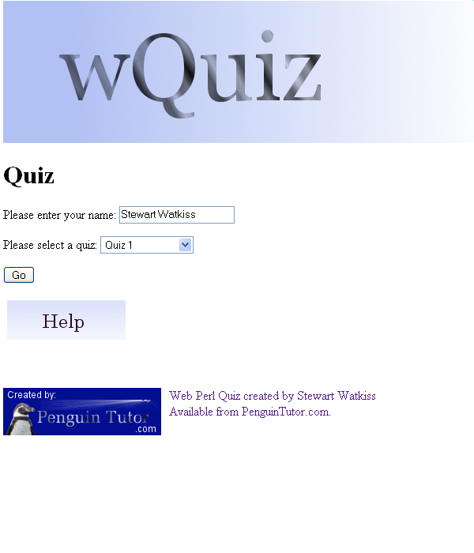
The page may also ask you for your name. The name is logged so that it can be used as a reference for looking at problems etc. No other personal information is collected by the quiz program. If you would like to remain anonymous then you can normally just leave the name field blank and you will be assigned the name “Anonymous”.

The name you choose will normally be shown throughout the quiz, including on the score page so you should enter your real name in this field.

Do not use any special characters. Most European names should work, but there may be some exceptions. If there are two people doing the quiz together do not enter the + or & keys, but instead type “and” in full.

The welcome page may also provide a link to an offline version of the quiz. See the Offline Section of this guide.

Click on the Go button to start the quiz.

Quiz Details Page

The next page will give a summary of information about the quiz. At this point your session has been set-up and the questions will have been selected.

It may provide details of the number of questions that are available. Clicking on start will go to the first question of the quiz.

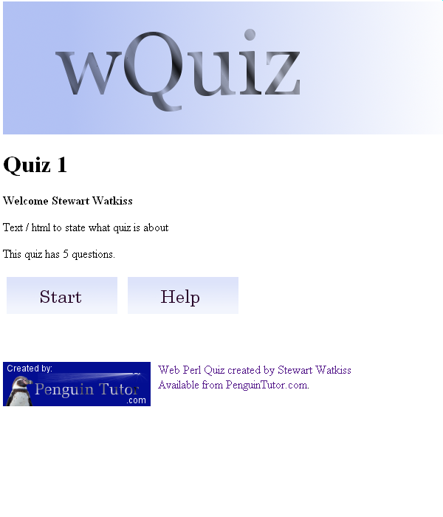

Questions
The question page will be shown when you are first presented with the questions, and also if you want to change the question later.

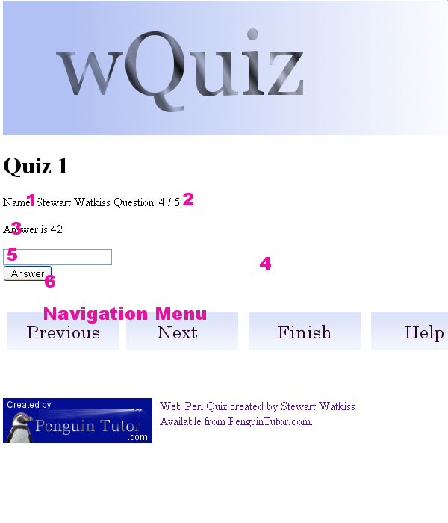

The quiz will normally consist of the following information.

1) Name – The name of the person as given in the Welcome Page.

2) Question Number – The current question number, and the total number of questions in the current quiz.

3) Question Text – This is the main part of the question. This may be excluded on some picture based quizzes.

4) Question Image – This is optional and may not exist on some quizzes.

5) Answer Field – This provides a means to enter your answer. See the different question types below for more details.

6) Answer Button – This button must be pressed after entering your answer for each question. If you navigate away from the question using either the forward or back buttons then the question will not be registered.

Navigation Buttons

The navigation buttons at the bottom of the screen allow you to move back and forward throughout the questions. If you try and go before the first question then you will receive a pop-up window telling you that you are already on the first question. If you click forward when on the last question then you will go to the “Finish” page.

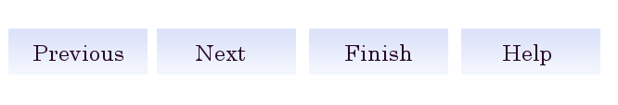

Finish / Review – Clicking on this will finish the quiz and give you an opportunity to review your questions before marking your answers.

Text Question

A text question will present a field to type the details of your answer in. The answer may or may not be case sensitive depending upon the set-up of the question. Any trailing spaces will be removed, but the rest of the entry will be marked as is.

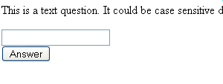

Number Question

Where a question asks for a number then it will present a text box for the answer. The answer should be entered as numerical digits. If a text string is entered in a field which is expecting a number then the quiz will advance to the next question, but the answer will not be entered. When reviewing the quiz you will be given an opportunity to go back and change your answer to a numeric answer.

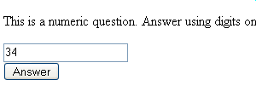

Multiple Choice Question

A multiple choice question will list a number of possible answers. Clicking on the “tick box” will select that answer. The question could ask for a single answer (a radio button), or could allow multiple answers to be selected (checkbox). A multiple answer question does not necessarily need more than one answer to be selected, it just allows that to be the case.

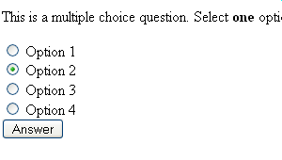

The fields may be shown differently depending on whether only a single answer is permitted, or if multiple answers are allowed. On the Mozilla Firefox browser, if only a single answer is permitted then the “tick box” will be a circle, which is filled when selected, if multiple answers are permitted then the tick box will be a square box containing a tick when selected.

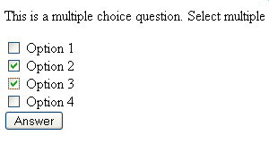

Finish / Review Page

The Finish / Review page provides an opportunity to review your answers before marking the questions. Any questions which have not been answered properly. If a question is labelled as: “Not Answered”, then you should review those questions.
You can return to any question and review or change your answer as appropriate.

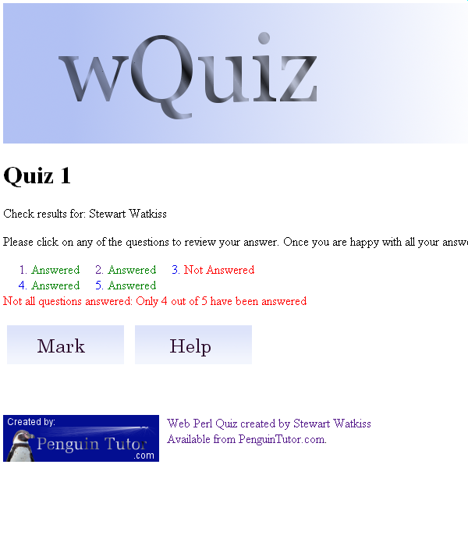

If there are any questions still unanswered then there will be a message “Not all questions answered:” which will provide details of the number of unanswered questions.

Clicking on the Mark button will end the quiz and mark the answers, giving you your score and an opportunity to review your marked answers.

Score Page

After clicking on the mark button your answers will be marked and you will be presented with details of how well you have done. At this point you can no longer go back and change your answers.

The score page will give details of how well you have achieved by telling you the number of correct answers, and the approximate percentage of correct answers.

The page will also list all the the questions and whether they were correct, incorrect or not answered. Clicking on any of the questions will take you to the review question page for that question.

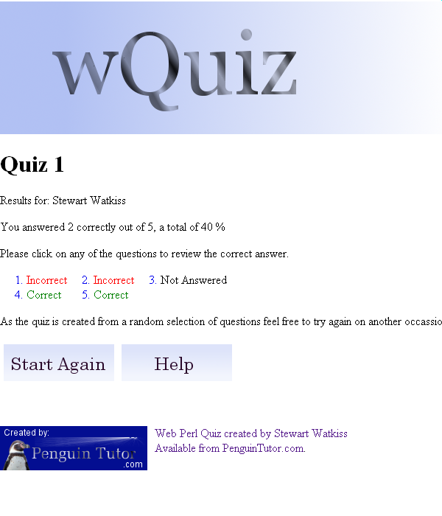

After you have finished reviewing your answers you can click on “Return to Main Page” to start the quiz again, or to continue navigating the site.

Review Answered Question

After marking the questions you can review your answer, and see details of the correct answer.

The review page passes all the information as presented on the question page, with an additional part providing details of whether the answer was correct, incorrect or not answered as well as the answer given and the correct answer.

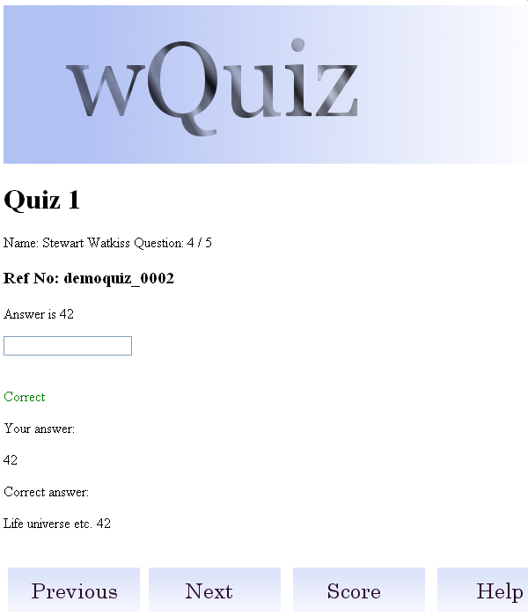

The navigation buttons can be used to move between the different questions, or the score button will return to the review screen allowing you to continue your review.

Help Window

Each of the pages of the quiz include a help button. Clicking that button will open the help panel in a separate window (or tab if using the Mozilla Firefox browser). The help window can be closed, returning you to the main quiz by clicking on the close button.

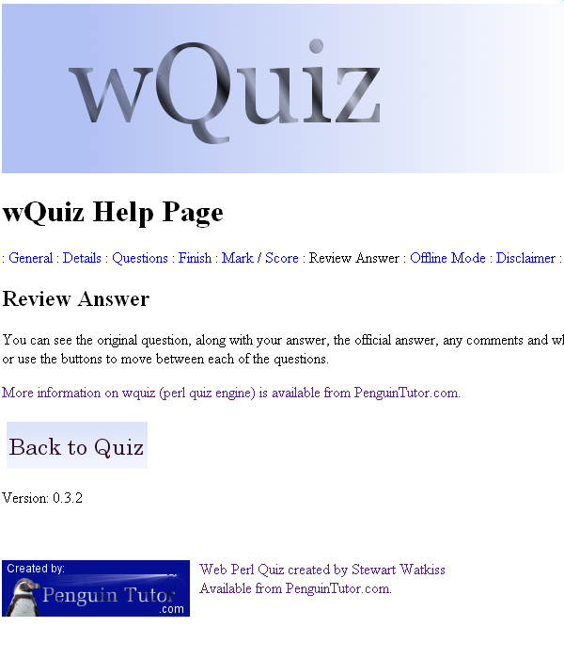

The help window is context sensitive and will display the appropriate page for the current part of the quiz. The menu at the top of the screen will allow you to move to the other help pages.

Off-line Quiz

The off-line quiz can be used to print off the questions for use away from the computer or without Internet access. When starting the quiz you may be given the option to include images or not, which will show images on the question page. Images will not be displayed on the answer page regardless of the question (unless a special quiz using picture answers is created).

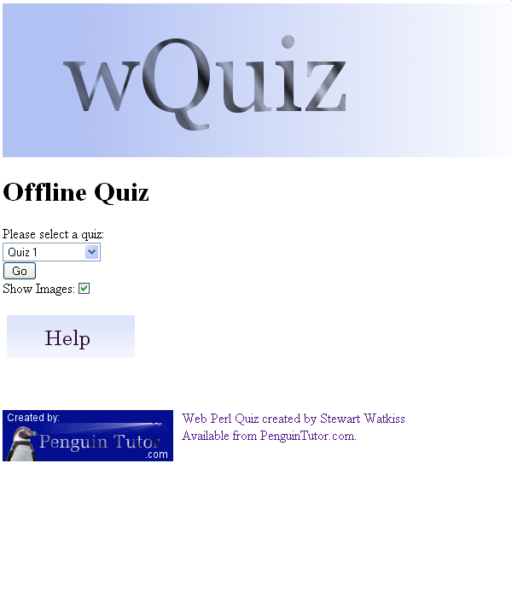
You will then be presented with a list of the questions, which you can print. You can then click on the answers button to see the correct answers.

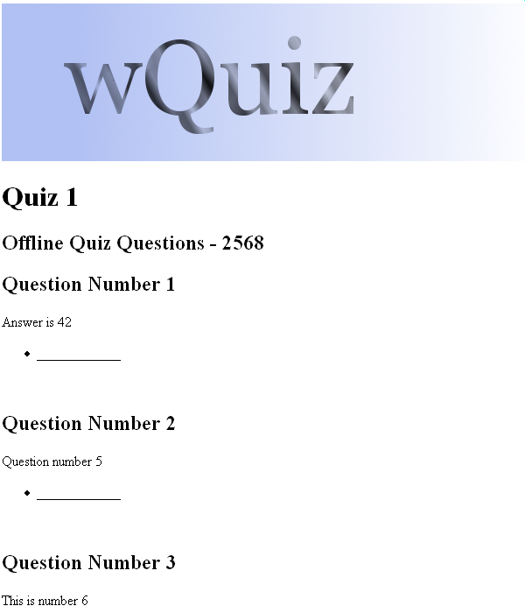

The off-line quiz will display a serial number at the top of the question and answer pages. This should be used to ensure that you have the correct answer printout to correspond with the question printout.

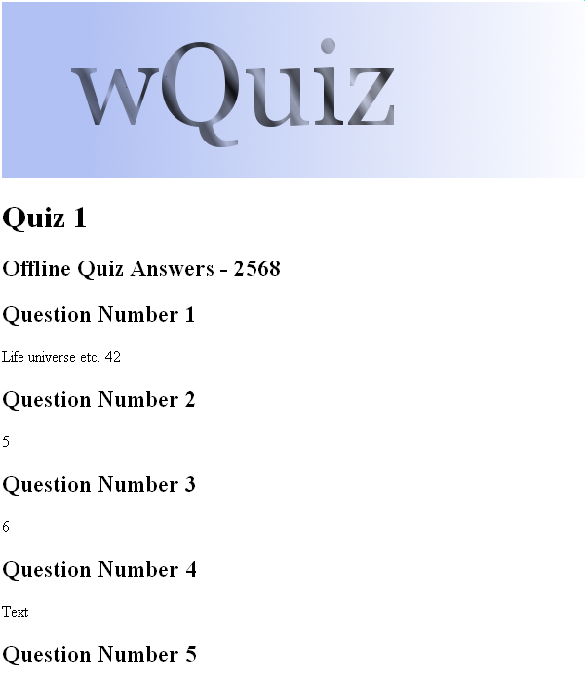

Question Selection

Every time that the quiz is run a random selection is made from the available questions. This may or may not include some of the questions from the last time that you attempted the quiz.
There is currently no provision for asking a certain number of questions from certain categories, although that is something that may be investigated in future.

Web Browser Support

The quiz engine is capable of producing standard html / xhtml pages (xhtml is currently available as transitional), it should therefore work with any browser. There are a few features that require javascript to be enabled, but with the exception of a few error messages, and possibly the on-line help, the quiz will still work with javascript disabled.

If a specific quiz does not work in your browser, then it is most likely due to the way the quiz administrator / site web master has designed the site, rather than the quiz software itself. You should contact the web master for the web site in question, before reporting it as a wQuiz bug.

More Information

For more information, or a copy of the source code go to: www.PenguinTutor.com

