

Administrator Guide

Version 0.4

Created by: Stewart Watkiss www.watkissonlineco.uk

Available from: PenguinTutor www.penguintutor.com



Introduction

The wQuiz program is a customisable program designed for running interactive quizzes over the Internet. The program was first designed for use on the www.firstaidquiz.com web site, but has since been made updated to make it more flexible and made available to the public.

From version 0.4 the quiz engine is written in php and designed for use on a Linux server with the Apache server, and a MySQL back-end. The quiz should work with other operating systems, web servers, and databases, but I am unable to give any support or advice on variations of this.

The test system is based on Ubuntu Linux 11.10, PHP 5.3.6, MySQL 5.1.58, running on a i686 based kernel.

The latest release of the source code is available from: http://www.penguintutor.com
During development CVS snapshots are available from the SVN repository available at: http://code.google.com/p/wquiz/ . Unless you are wanting to help with development, or want a feature only included in the development snapshot it is recommended that you only use the release versions.

You can see examples of the program in use at: http://www.penguintutor.com or http://www.firstaidquiz.com .

License / legal information

The source code is released as Open Source under the GPL License. Terms of the license are available in the file gpl.txt contained within the archive or can be retrieved from http://www.gnu.org/licenses/gpl.html.

The license applies to the source code, and documentation, but does allow you to create custom templates, which you can retain copyright of.

I would be grateful if you provided a link to the www.penguintutor.com site from your quiz, or from elsewhere on your site to acknowledge the work that has gone in to creating the quiz. The supplied sample templates include this already. This is not a condition for use, so if you do not want to then there is no obligation to do so. I would also like to hear about any sites that do use the quiz, again this is voluntary.

This is provided as “free” software and comes with no warranty, or guaranteed support. If you do not agree with the conditions, including the full GPL license then you should not use this software.

Installation or Upgrade

Easy install

The easy install process attempts to automate the initial install as much as possible.

First extract the archive file to an appropriate location within the web site directory. The archive will expand into a directory called quiz, but that directory can be renamed after it is extracted.

On Linux system:
tar -xvf wquiz-*.tar.gz

If using a Windows PC or a Mac to upload then the files are also available in a zip file which can be extracted locally and then uploaded using ftp etc.

To allow the automated install then the webserver will need to be able to write to files within the file system. If it does not have this permission then the files can be created manually, but it is recommended to provide the following access for the install to go smoothly. Read Write and Execute permission is required for the quiz/ directory, by the user / group that the server runs under. On Ubuntu this is normally www-data, on other distributions this may be http, apache or apache2

After extracting the files open quiz/admin/install.php through the web-browser.

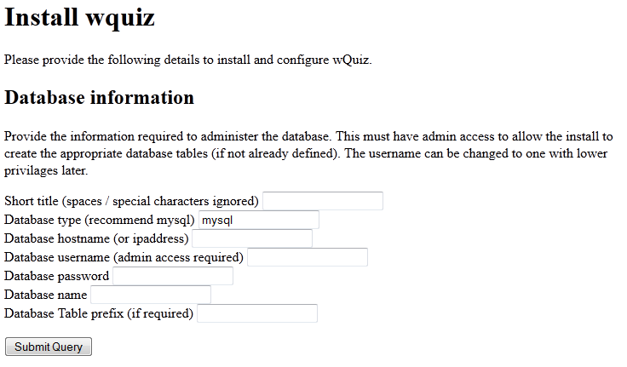

To allow the install to create the database then a database account with full admin access should be used. If the database has been created manually then the account only needs update access to that specific database. The files can be updated later to lower the permissions to restrict access to within the quiz database.

The following information needs to be entered:

Short title – This is a short name to refer to the database by. It is not seen by end users, but will be used to create a secondary configuration file. It cannot be set to wquiz.

Database type – This should normally be mysql. If installing on Windows and you have Microsoft SQL then you could enter mssql, but the database will need to be installed manually and mssql is not supported. Entering any other type of database will require a new database class to be created to support the alternative database type.

Database hostname – This should be the fully-qualified host domain name or ip address where the database is installed.

Database username – The database administrator username.

Database password – The password for the above account.

Database name – The database to use for the quiz related tables.

Database table prefix – A prefix to put before table names. All the table names are prefixed with quiz_ anyway, and this would be before that. This can be used to allow the quiz to coincide with other applications within the same database (eg if your hosting provider restricts the number of databases that can be created). This is optional and can be left blank if not required.

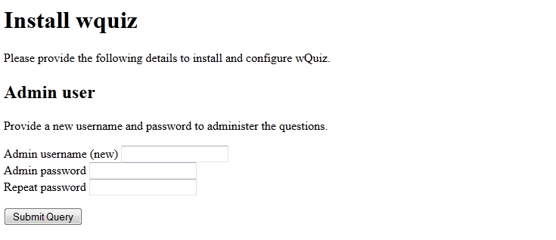

A username and password is requested. This is to administer the questions and does not relate to access to the database.



In the event of any issues, where possible, the install will advise on how to create the relevant file or database manually before allowing to proceed to the next stage.

One installed you can login to administer the quiz by going to quiz/admin/ through a web browser.

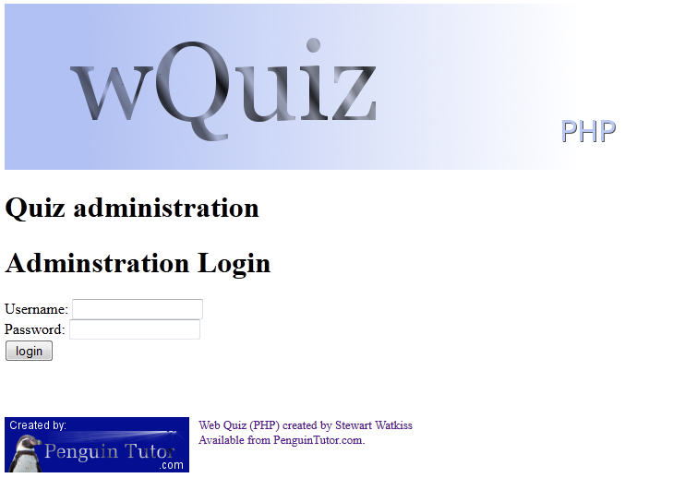

After install you should continue to read this guide for details of how to customise the quiz to your needs.

Manual install

Details of how to install the program manually are provided in Appendix A.

Securing the install

When installed as above the default setup of most web servers should protect the database information. It is however recommended to move this into a more secure location in case of a security vulnerability in the software, browser or from any other software installed on the server.

The first thing to do is to move the secondary config file outside of the web directory. This will provide additional security in case of a misconfiguration on the web server etc. The file is called <quizname>.cfg and can be moved anywhere on your server as long as the web server can still read that file. If your document root is /var/www/home then you may want to move the file to /var/www.
Then update the wquiz.cfg file with the correct path to the file.

You can also update the config file with a username with a lower authority than the admin user required for the install. The user will need update / delete / add access to all the quiz tables.

Configuring wQuiz

Configuration is handled through the admin pages.

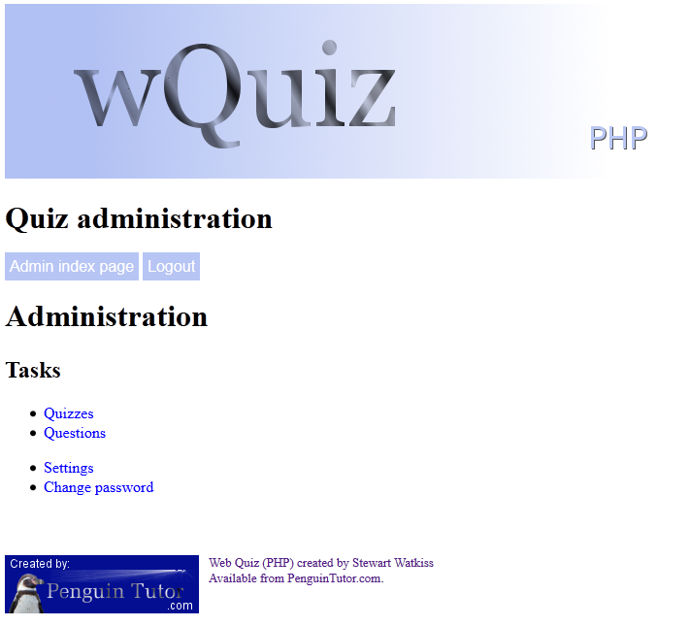

Adding a new quiz

After installing the first step is to add the first quiz.

This can be added by choosing Quizzes and then Add new quiz

The form should be filled in as follows:

Quiz name - A short name to refer to the quiz. It is used by the admin functions only and is not something that is seen by the user. Do not include any spaces or special characters.

Title – The name of the quiz that the user will see

Number of questions – Enter a number of questions to show in each quiz. This is for the normal online quiz.

Number of offline questions – Enter a number of questions to show in each quiz. This is for the offline quiz. If you are not using the offline quiz then set this to 0.

Quiz introduction text – Summary of the quiz that is provided to the user before they start. Include html mark-up as required.

Priority – The order in which the quiz is listed on the quiz menu screen. The higher the number the earlier it appears on the list.

Enable online – Enable the online quiz – ticked means enabled.

Enable offline – Enable the offline quiz – ticked means enabled.

You can make changes to the quiz (except for Quiz name) at any time by choosing Quizzes from the main menu.

Adding or editing a question

Questions can be added or edited through the Question screen.
It is recommended that a quiz is added first, but it is possible (though not particularly useful) to create a question without any quizzes being defined.

Quizzes – Tick any quizzes for which this question is relevant to

Intro – Text provided to the user for the question. Include html mark-up as required.

Question type – select from the following:
text – regular expression text
TEXT – regular expression text – case sensitive
number – a range of numbers
radio – multiple choice questions
checkbox – multiple choice which allows more than one answer

Input – formatting for the question answer line
For radio or checkbox this should be comma seperated options (eg Answer 1,Answer 2, Answer 3)
For number or text this should be in the format of prefix,default answer,suffix (eg. Up to,,seconds – or ,,%). It must include two commas even if left blank. If special characters (including the comma and the ¬ symbol) is required within a list then it needs to be entered as html code (eg. &#44; for a comma or &not; / &#172 for the ¬ symbol).

Answer – correct answer / logic to test for correct answer
text – perl format regular expression without any start / terminating characters. It does not allow additional characters unless specified (eg test will work for test buy not for testing, but test.* will work for either : d[iae]+b[iae]+t[iea] - a way of having answer diabetes even if spelt incorrectly)
radio – number of the correct answer starting at 0
checkbox – digit of correct answer starting at 0 (eg. 013 is 1st, 2nd and 4th answer)

Reason – explanation of answer. It should normally include the answer as well, preferably with bold / strong html mark-up.

Reference – Where the question comes from. It is not currently shown to the user, but may be in future versions.

Hint – Not used in current version – will allow html tags.

Image – picture to show if appropriate. This should be entered as a url (relative to the quiz directory or fully-qualified). It can be on a different server.

Comments – not shown in the quiz. For admin purposes only.

Qfrom – Name of the question contributor (not disclosed to users)

Qemail – Email address of the contributor (not disclosed to users)

The configuration files – wquiz.cfg and <quizname.cfg>

The configuration for the quiz database is normally split between two configuration files. The first is called wquiz.cfg and its usual purpose is to provide a link to the second file. The second file provides the database details and is named after the short quiz name provided during install .cfg.
The second file can be moved outside of the document root directory (see Securing the install earlier).

The syntax of the file is important, and any errors will prevent the quiz from working. Care should be taken whenever any changes are made to the file. It is also recommended that a backup is made before editing the file, so that it can be restored in the event of any problems.

This is a php format file and all usual php conventions apply (eg. // or /* */ denotes comments).

The configuration file holds some important user and database information. The apache daemon needs to be able to read the file, but other than that it is recommended that you restrict those who can read the file.

Example files are provided below.

wquiz.cfg – 1st stage configuration file:

<?php
//wQuiz configuration file
//Do not edit this directly
//Link to custom config file
$cfgfile = '/var/www/quiz1.cfg';
?>

<quizname.cfg> - 2nd stage configuration file (in this case quiz1.cfg):

<?php
//wQuiz configuration file
//Database details
$dbsettings = array(
'dbtype' => 'mysql',
'username' => 'dbuser',
'password' => 'password',
'hostname' => 'localhost',
'database' => 'database_name',
'tableprefix' => 'prefix_'
);
?>

Database settings

The following describe the database settings contained within the cfg file above.

dbtype

This is the type of database used for the questions. Normally this should be mysql.
An alternative is mssql (not fully tested or supported). Any other database would need it's own custom interface class to be created. The install script will only work if using mysql for the database.

hostname
This should contain the fully qualified domain name or IP address of the database server.
If you are using a different server name then change the localhost value to the IP address of the server (and if not using the default mysql port number append with :portnumber).

username
Set this to the username with access to the database.

If you are installing the application, and you want to let the install script create the database for you then this will need sufficient permission to create a new database (which can be changed to a user with lower privilege later if required).

Other than the install script (where admin rights may be necessary) the user will just need update access to the tables, used in this install.

password
The password to go with the above username

tableprefix
This is a prefix to include before the table names for the quiz. This should be used to install the quiz into the same database as another program / instance to ensure that table names don't conflict. It is not required (set to '') if the database is dedicated to this quiz.

Settings within the database

Other than the database details which are provided above all other configuration options are contained within the settings table in the database.

These can (with some exceptions) be changed through the settings page in the admin pages.

Title
The title used within the HTML headers. This could be the title for your website or reference to the quiz.

Description
Description used within the HTML headers.

Admin theme
The name of the theme for the admin pages (it is not normally required to change this from default).

Quiz theme
The theme used for the quiz (see later section on customising the theme)

Start text
Text shown at the start of the quiz, after the choose quiz form. This can be used to provide information on the relevant quizzes or to provide any disclaimers etc. HTML mark-up can be included within the text.

Show answer button
Is there an answer button for the question (default false)

Review Text
Text shown when quiz complete. HTML mark-up can be included within the text.

Review show unanswered
At the end should we tell the user if they skipped any questions?

Review enabled
Can the user review the answers before submitting for marking?

Answer view enable
Can the user see what questions they got correct / wrong

Answer summary enable
Can the user see the summary information on the answers after completing the quiz

Allow PHP includes within the template files
This will allow php includes (in the form of <?php include(“<filename>”)?> ) to be included. This is a security risk if an unauthorised user is allowed to edit the theme files. This means that themes can access any of the parameters within the code. If enabled then only allow trusted themes to be installed and ensure that edit access to the themes, and the included files is restricted to authorised users.

Login expiry time
Number of seconds that the admin user session remains before expiring

Maximum number of questions in a quiz
The maximum number of questions that can be used within a quiz (prevents admin from creating a quiz with too many entries).

Summary length
In admin view how many characters to display in the summary listing (you could increase if you use a browser with a wider screen).

Offline Mode

The offline mode can be enabled or disabled on a per quiz basis. A risk in enabling the offline mode is that it could be used for cheating, and it could be used to make it easier for people to copy the questions.

Administrator Details

The administrator username is created on install and the password can be changed through the “change password” option.
If this password is forgotten then a database adminstrator with database write access will need to manually edit the entry within the settings table. The password is encoded with md5. The md5 is not a particularly secure encryption and so it is important that access to read the settings in the database is restricted.

Themes

The look and feel of the pages is set by using themes. There is a default theme supplied with the software. A new theme can be created to provide customisation. The default should not be edited as those will be replaced by future software upgrades.

The admin and normal themes can be chosen independently depending upon the setting. The admin theme does not normally need to be changed, but it is recommended to create a custom theme for the normal theme.

The supplied theme is designed to be html 5 compliant. To ensure html 5 compliance changes to the themes need to be validated.

Theme prefix
The theme prefix is used to determine which files are used by different parts of the quiz.

The admin themes is used by the admin functions.
The quiz theme files are used by the quiz in normal mode
The offline theme files are used by the quiz in pop-up offline mode (ie print the offline pages). They are not used by the offline.php index file which uses the normal quiz files.
The iframe theme files are used where the theme is embedded within an iframe

The quickstart.php is designed to be embedded within a different page and so does not use the themes.

Theme suffix

The theme suffix is used to determine where the theme file is applied.

_header.php
The headers files are included first before the quiz content.

_footer.php
The footer files are included after the quiz content.

wquiz.css
A basic cascading style sheet (css) file is included in the default theme. This can be customised within a custom theme (see below) or a separate local css can instead be referenced within the header.php file.

Creating a custom theme

To create a custom theme copy the default theme (within the themes directory) to a new directory name. Edit the files within that theme and update the setting to point to the new theme (directory) name.

Variables in a custom theme
The following variables can be used within a theme file and will be substituted with the appropriate value. The variable names are not case sensitive, but it is advised to use the same case as below in case this changes in future versions.

%%Title%%
Title for the overall quiz as set in the settings.

%%Description%%
Description for the overall quiz as set in the settings.

%%QuizTitle%%
Name of the current quiz (or blank if not in a quiz)

%%QuestionNumber%%
Question number (or blank if not applicable)

%%HeaderJavascript%%
Allows the inline javascript code to be included. This can be include this entry in all header templates as it will be ignored if not required
- should normally be the last entry before </head>

%%ThemeDirectory%%
Include this anywhere that the path to the theme directory is required (trailing / is included)

Including other PHP / html files

Additional php or html include files can be included within the theme files as long as this is enabled in the settings.

These must be entered using the following format:
<?php include('____');?>
which must be on a single line – as the only <?php entry on that line.
No other PHP code can be included within the theme except through an include or by including them within the included file.
The PHP require / require_once statements are not supported

Upgrading from version 0.3

The change from version 0.3 series (0.3.0 to 0.3.2) to 0.4 is significant. This is a complete rewrite using a different programming language. Whilst part of the upgrade process has been simplified there are some tasks that need to be done manually.

The following steps need to be followed in this order.

1/ Install the new quiz using the instructions above, or the manual process in Appendix A.
2/ Visit the page quiz/admin/upgrade.php through your web browser.
Login using the username / password created during the install
Provide the full filename (including path) to the 0.3 version of the configuration file
3/ Check the quizzes are entered correctly
Disable any that are not to be active
Re-order to preferred order (using priority)
Check text – change any \“ to “ - update any markup to be html 5 compliant

More Information

For more information, or a copy of the source code go to: www.PenguinTutor.com

Appendix A – Manual Installation

After extracting the appropriate files to the correct place on your web server the database and tables can be created manually using the command line mysql client or a GUI based interface such as phpmyadmin or the MySQL query browser. You will need the appropriate permissions to make the updates to the database.

First create the database (e.g. create database <databasename>)
and select the database as your active database .

Then create the tables as below (adding any prefix if required).

"CREATE TABLE IF NOT EXISTS quiz_quiz (quizname varchar(255) NOT NULL, title varchar(255) NOT NULL, numquestions int(11) NOT NULL default '0', numquestionsoffline int(11) NOT NULL default '0', quizintro text NOT NULL, priority int(11) NOT NULL default 1, enableonline tinyint(1) NOT NULL default '0', enableoffline tinyint(1) NOT NULL default '0', PRIMARY KEY (quizname))"

"CREATE TABLE IF NOT EXISTS quiz_questions (questionid int(11) NOT NULL auto_increment, section varchar(254) NOT NULL default '', intro text NOT NULL, input text NOT NULL, type varchar(10) NOT NULL default '', answer varchar(100) NOT NULL default '', reason text NOT NULL, reference varchar(100) NOT NULL default '', hint varchar(254) NOT NULL default '', image varchar(200) NOT NULL default '', audio varchar(200) NOT NULL default '', comments varchar(200) NOT NULL default '', qfrom varchar(50) NOT NULL default '', email varchar(50) NOT NULL default '', created date NOT NULL default '0000-00-00', reviewed date NOT NULL default '0000-00-00', PRIMARY KEY (questionid))",

"CREATE TABLE IF NOT EXISTS quiz_questionrel (relid int(11) NOT NULL auto_increment,quizname varchar(255) NOT NULL,questionid int(11) NOT NULL,PRIMARY KEY (relid))",

"CREATE TABLE IF NOT EXISTS quiz_settings (settings_key varchar(50) NOT NULL, settings_value varchar(255) NOT NULL, PRIMARY KEY (settings_key))"

Add the following entries to the quiz_settings table

'theme_quiz' => 'default',
'theme_admin' => 'default',
'buttons_navigation_enabled' => 'a:5:{i:0;s:5:"first";i:1;s:8:"previous";i:2;s:4:"next";i:3;s:4:"last";i:4;s:6:"review";}', //serialised array
'buttons_navigation_labels' => 'a:5:{s:4:"next";s:2:">>";s:5:"first";s:3:"|<<";s:8:"previous";s:2:"<<";s:4:"last";s:3:">>|";i:0;b:0;}',
'review_text' => '<p>Quiz complete.</p><p>Would you like to review your answers before submitting?</p>',
'review_show_unanswered' => 'true',
'review_enable' => 'true',
'answer_view_enable' => 'true',
'answer_summary_enable' => 'true',
'template_allow_include' => 'true',
'admin_login_expirytime' => '3600',
'quiz_max_questions' => '1000',
'summary_length' => '45',
'buttons_show_answer_button' => 'false'

These are all the default values that can then be edited through the settings page as required.

You will also need to copy and customise the theme and update the config files as described in this document.

More details about regular expressions are available from http://www.penguintutor.com/tutorials/viewdoc.php?doc=programming-regularexpressions

