# CMIS242 Project 3 Test Cases

By Brian Yu

Contents

CMIS242 Project 3 Test Cases 1

Goal 1

Test Cases 1

Test Case 1 – Draw a hollow, magenta, rectangle with dimensions 50x30 at coordinates (25,25) 1

Test Case 2 – Draw a solid, yellow, oval with dimensions 25x10 at coordinates (150,100) 1

Test Case 3 – Draw a solid, black, oval with dimensions 150x150 at coordinates (10,10) 3

Test Case 4 – Draw a hollow, blue, rectangle with abcx30 dimensions at (xyz,0) coordinates 4

Test Case 5 – Draw a hollow, orange, oval with dimensions 300x300 at coordinates (120,30) 5

Test Case 6 – Draw a hollow, orange, oval with dimensions 50x50 at coordinates (50,75) 6

Results 7

## Goal

The goal of my test cases was to cover the typical use cases of the Geometric Drawing app as well as if it could handle empty fields, invalid inputs, and shapes that wouldn’t fit in the drawing panel gracefully. The test cases are run sequentially to also test the number of shapes requirement.

## Test Cases

### Test Case 1 – Draw a hollow, magenta, rectangle with dimensions 50x30 at coordinates (25,25)

**Expected Output:** A hollow, magenta, rectangle with dimensions 50x30 at coordinates (25,25) is drawn in the drawing panel and the number 1 is printed in the top left corner.

**Actual Output:**

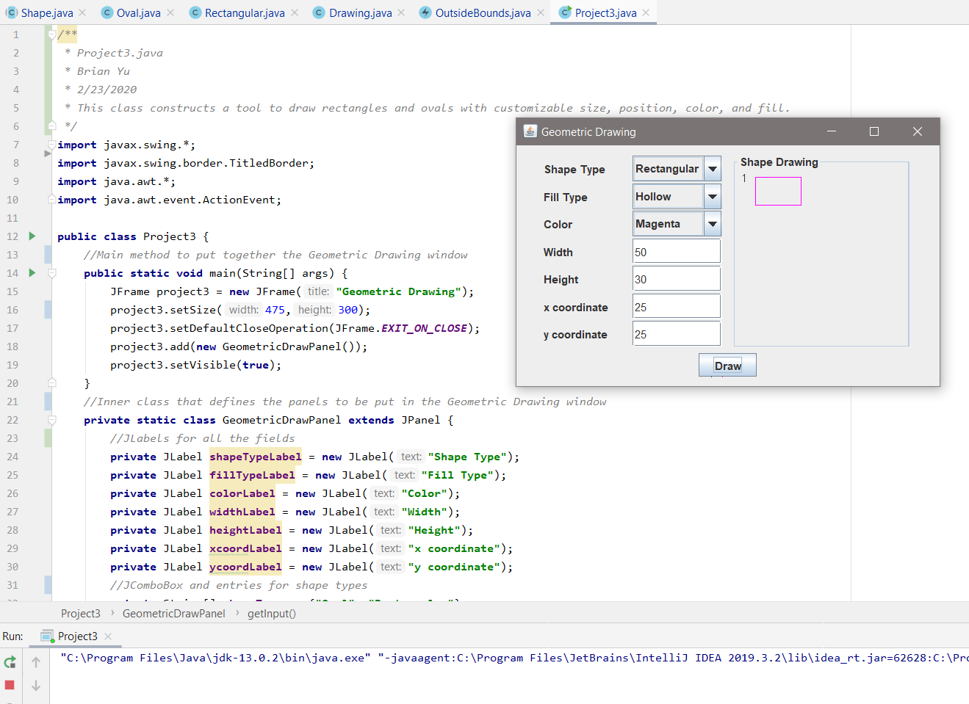

### Test Case 2 – Draw a solid, yellow, oval with dimensions 25x10 at coordinates (150,100)

**Expected Output:** A solid, yellow, oval with dimensions 25x10 at coordinates (150,100) is drawn in the drawing panel and the number 2 is printed in the top left corner.

**Actual Output:**

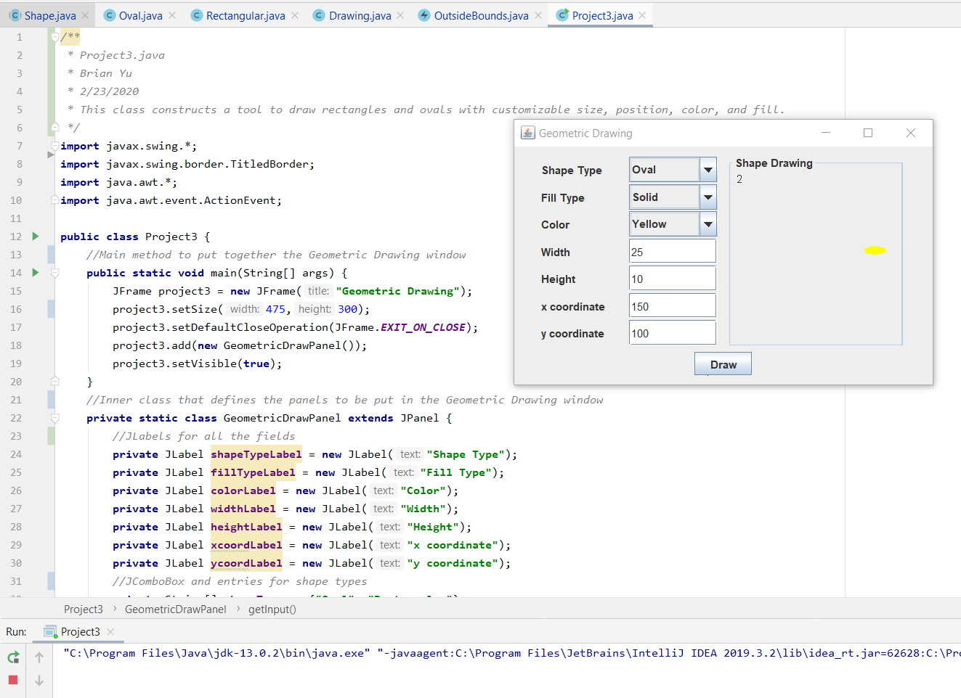

### Test Case 3 – Draw a solid, black, oval with dimensions 150x150 at coordinates (10,10)

**Expected Output:** A solid, black, oval with dimensions 150x150 at coordinates (10,10) is drawn in the drawing panel and the number 3 is printed in the top left corner.

**Actual Output:**

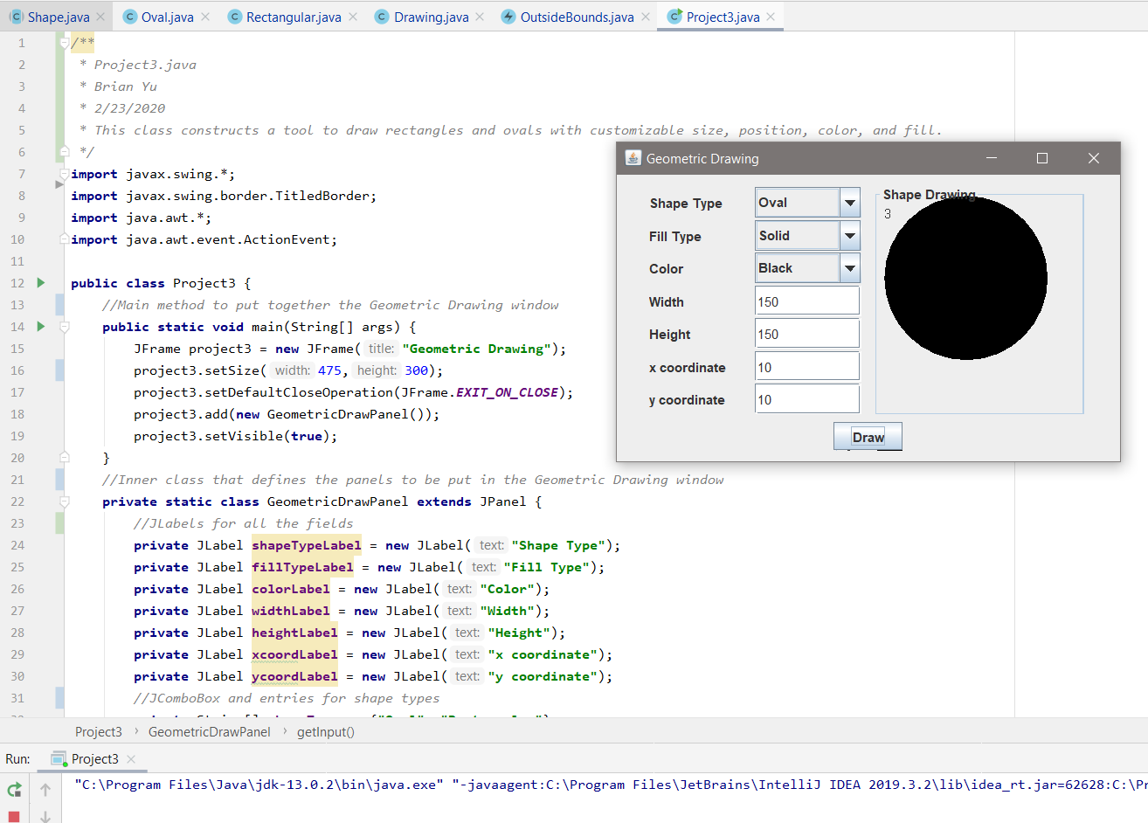

### Test Case 4 – Draw a hollow, blue, rectangle with abcx30 dimensions at (xyz,0) coordinates

**Expected Output:** A dialog window should open up with prompt “Incorrect values entered.”

**Actual Output:**

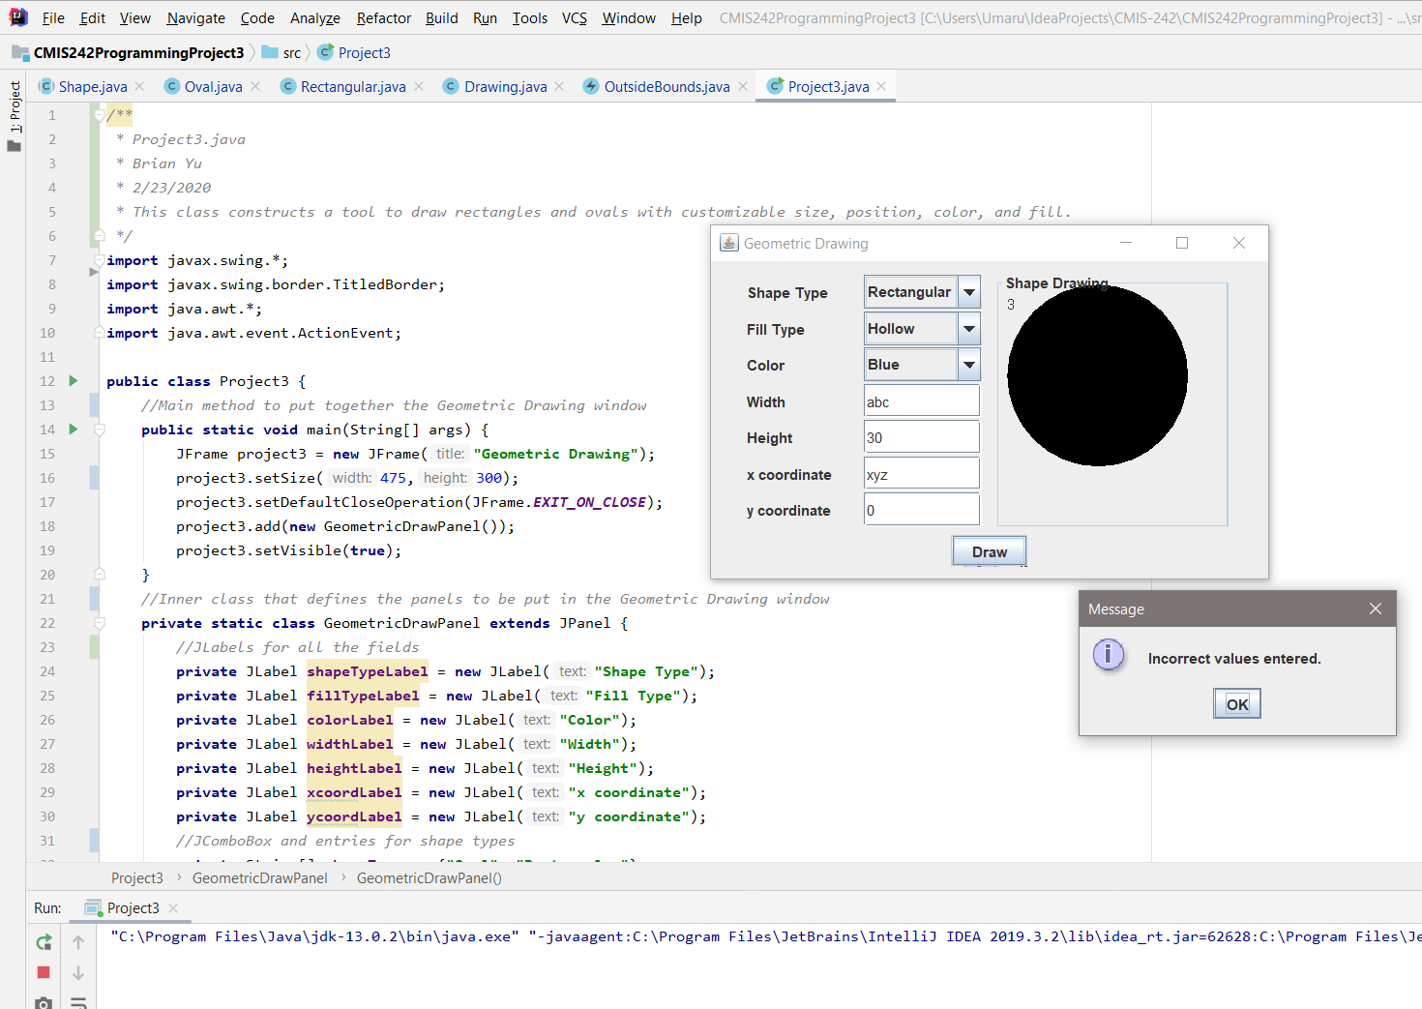

### Test Case 5 – Draw a hollow, orange, oval with dimensions 300x300 at coordinates (120,30)

**Expected Output:** The dialog with prompt “Desired shape is bigger than drawing panel” should appear.

**Actual Output:**

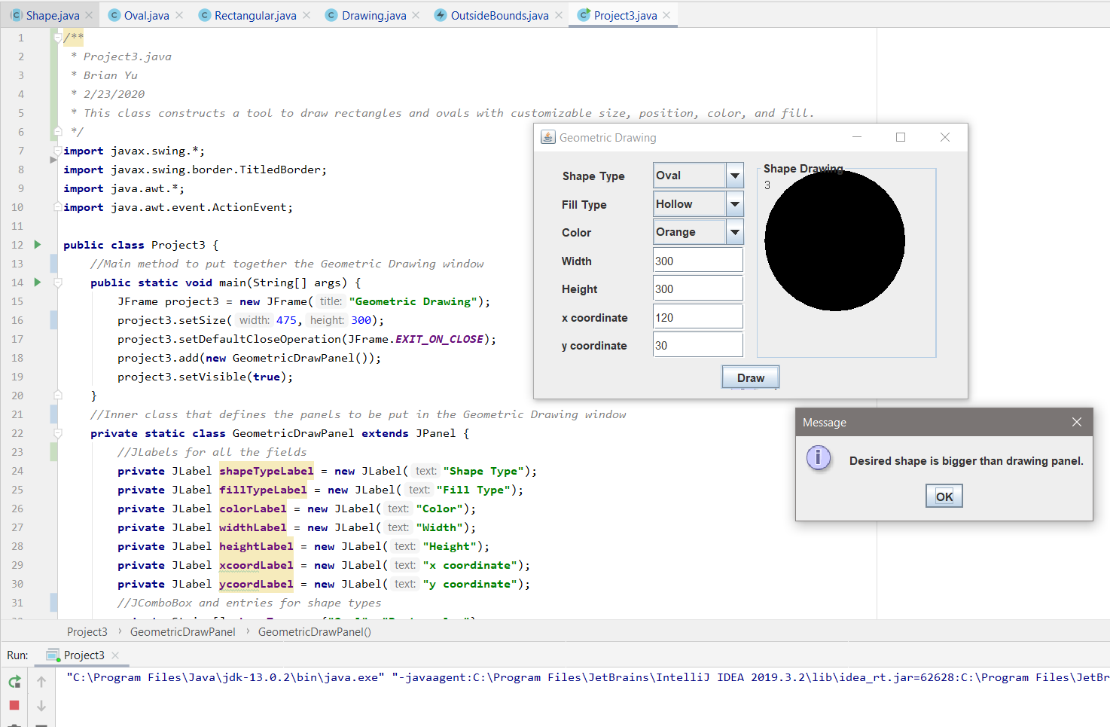

### Test Case 6 – Draw a hollow, orange, oval with dimensions 50x50 at coordinates (50,75)

**Expected Output:** A hollow, orange, oval with dimensions 50x50 at coordinates (50,75) should be drawn with the number 4 printed in the top left corner.

**Actual Output:**

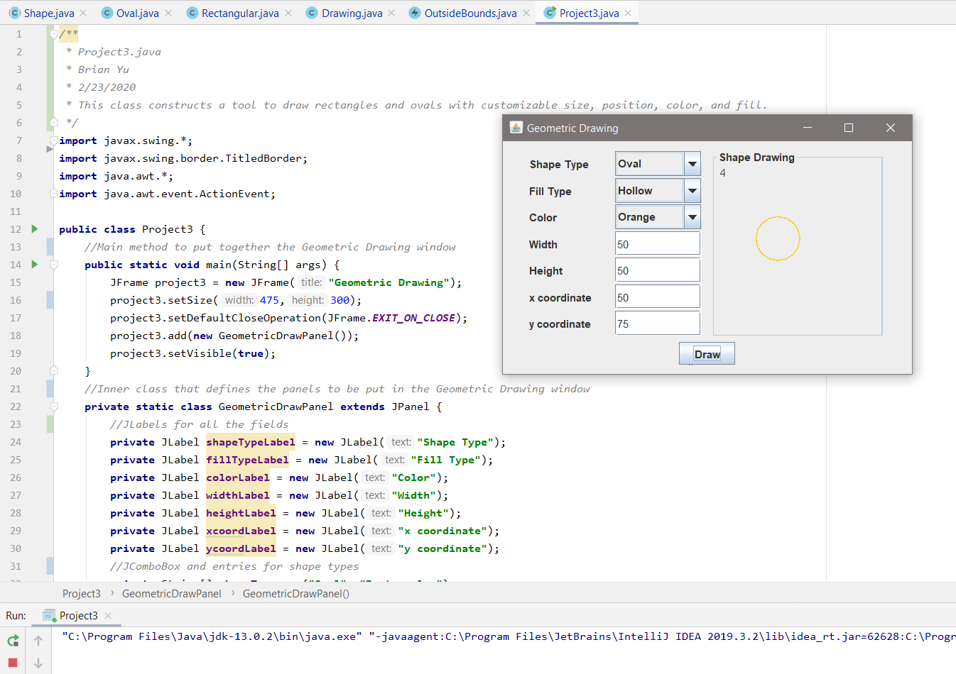

## Results

