# CMIS242 Project 4 Test Cases

By Brian Yu

## Goal

The goal of my test cases was to cover the typical use cases of the Real Estate Database application as well as if it could handle empty fields, invalid inputs, duplicate transaction ids, and non-existent transaction ids gracefully.

Contents

CMIS242 Project 4 Test Cases 1

Goal 1

Test Cases 2

Test Case 1 – Store valid transaction id and property info 2

Test Case 2 – Find previously entered property object using valid transaction id 3

Test Case 3 – Change the status of the previously entered property object using valid transaction id 4

Test Case 4 – Attempt to remove the previously entered property with invalid transaction id 6

Test Case 5 – Remove previously entered property with valid transaction id 8

Test Case 6 – Attempt to add new property with invalid formatted values but valid transaction id 10

Test Case 7 – Attempt to enter in property with duplicate transaction id 12

Test Case 8 – Attempt to change status of non-existent property 14

## Test Cases

### Test Case 1 – Store valid transaction id and property info

**Expected Output:** A pop-up window informs the user that the information has been properly stored.

**Actual Output:**

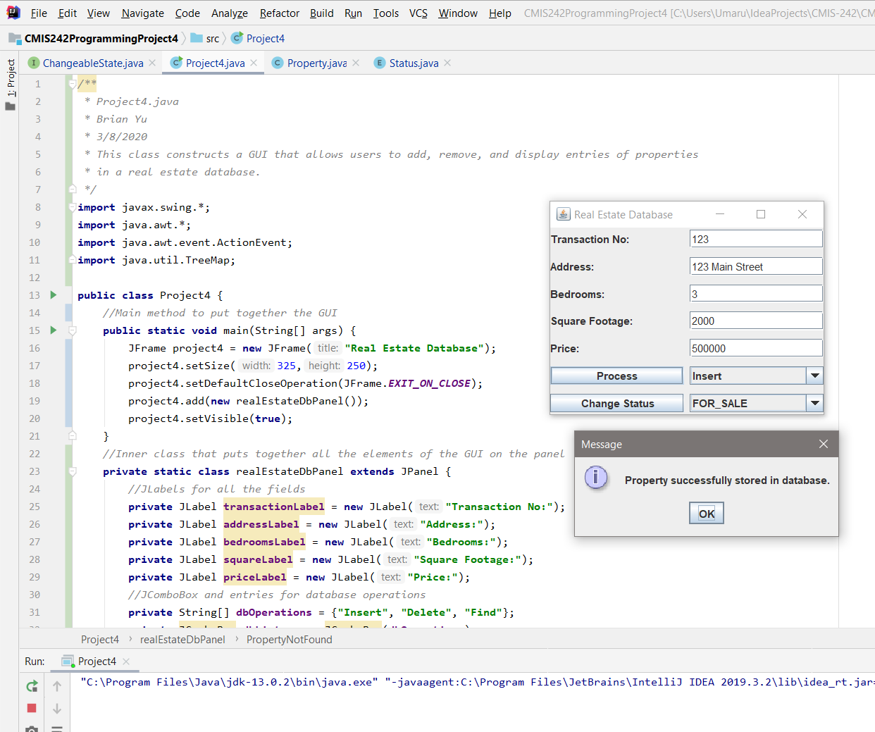

### Test Case 2 – Find previously entered property object using valid transaction id

**Expected Output:** A pop-up window should appear with the property information that corresponds to the transaction id.

**Actual Output:**

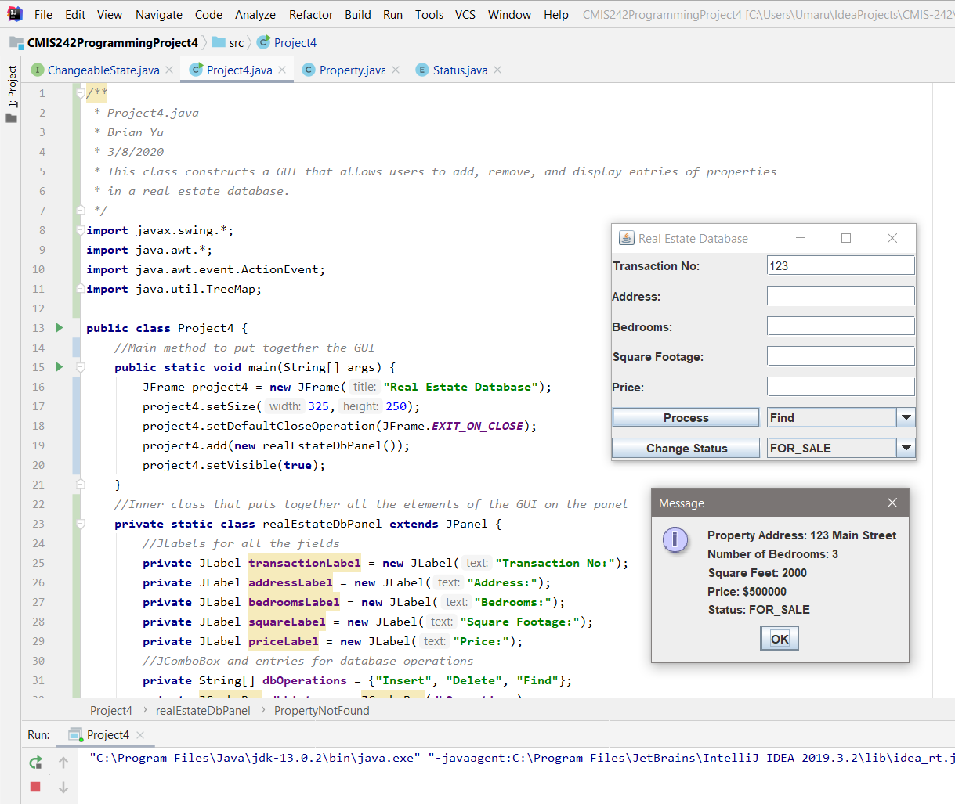

### Test Case 3 – Change the status of the previously entered property object using valid transaction id

**Expected Output**: A pop-up window informs the user that the status has been changed successfully. Finding the property should open a pop-up window with the appropriately changed status.

**Actual Output:**

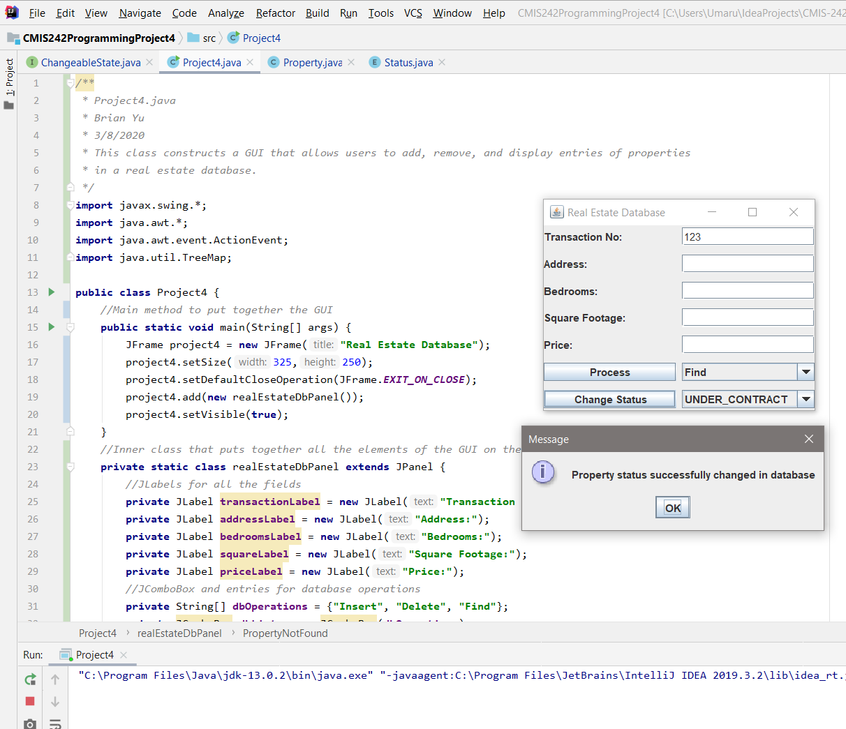

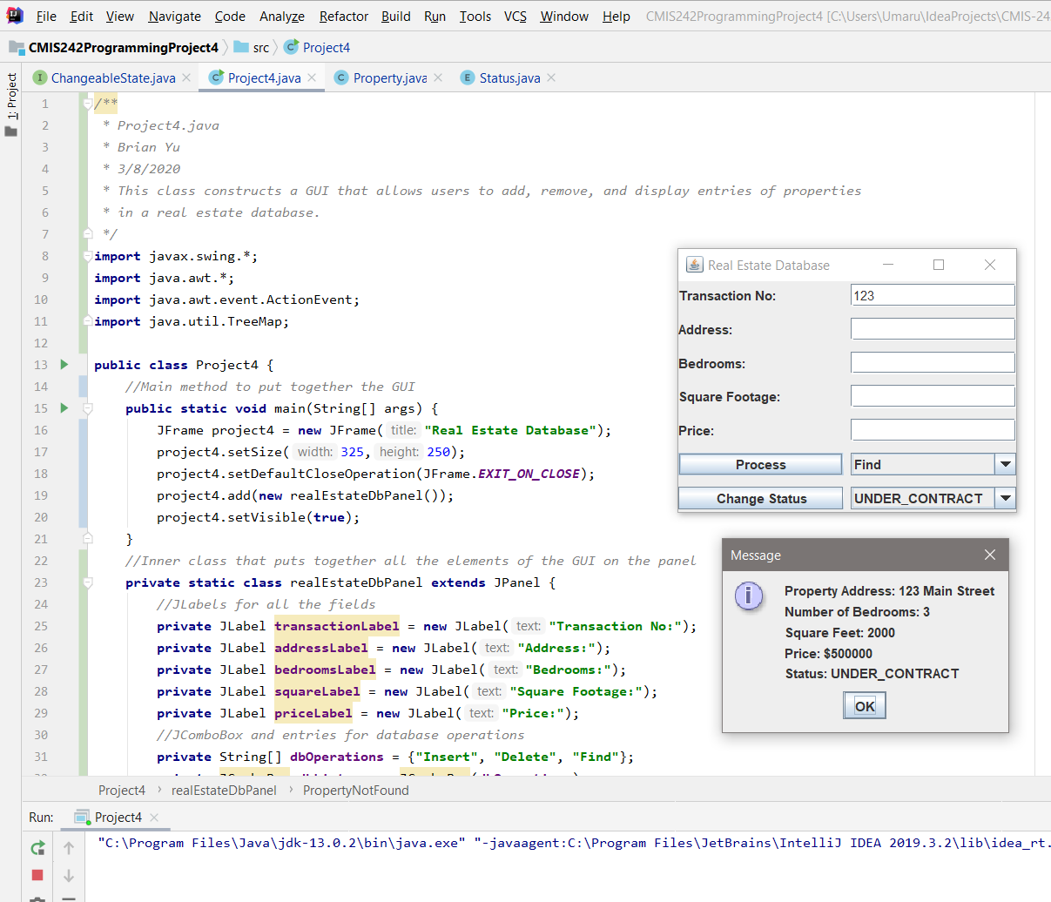

### Test Case 4 – Attempt to remove the previously entered property with invalid transaction id

**Expected Output:** A pop-up should inform user that the transaction id does not exist. Finding the valid transaction id should show the property still exists in the database.

**Actual Output:**

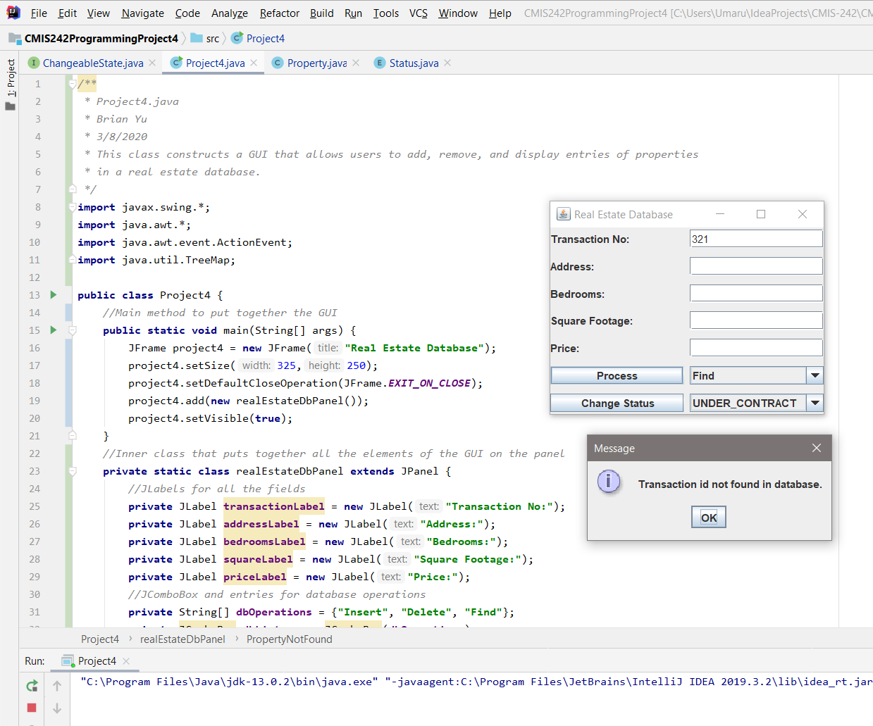

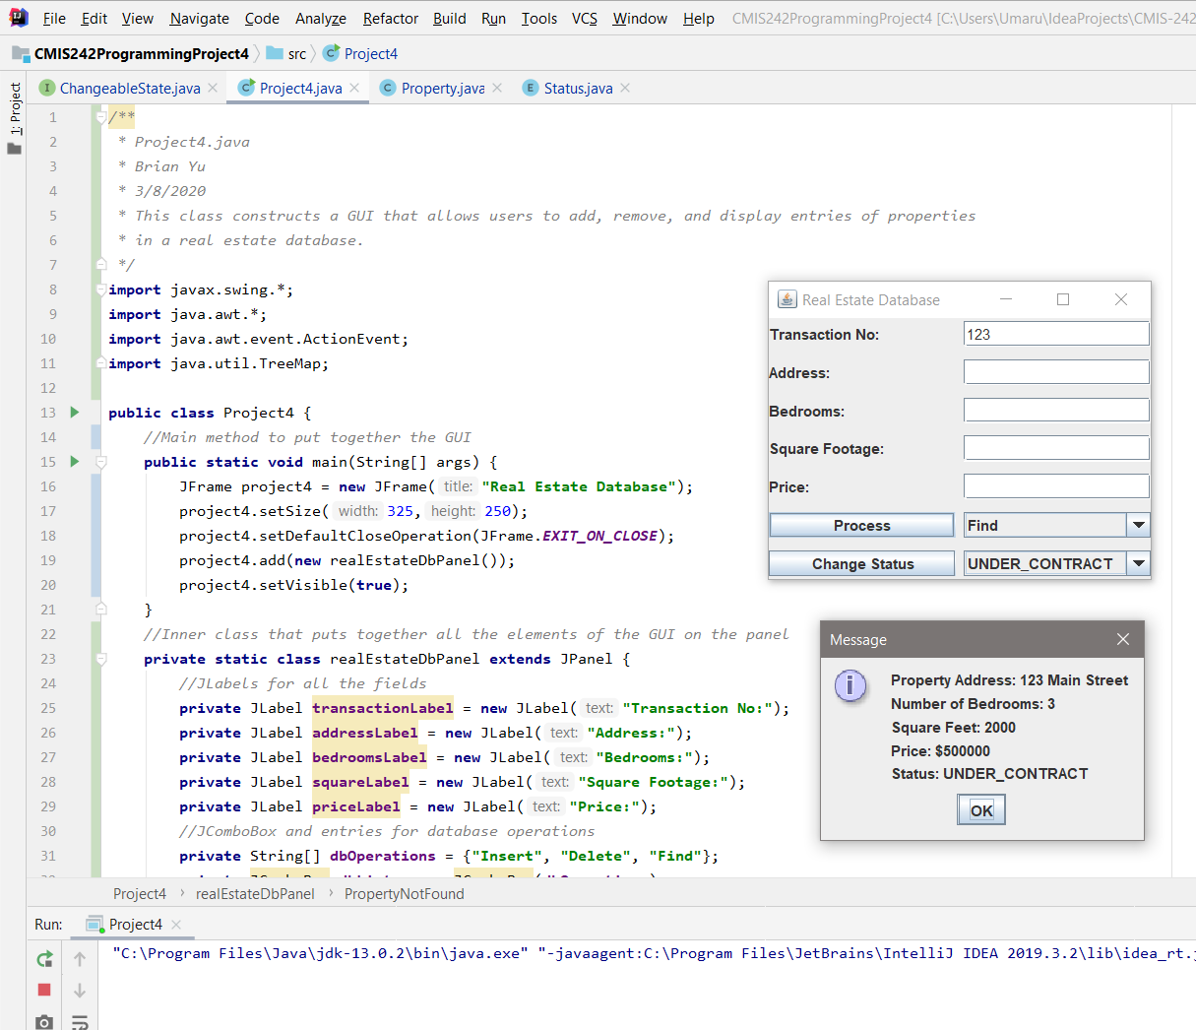

### Test Case 5 – Remove previously entered property with valid transaction id

**Expected Output:** A pop-up appears to inform the user that the property has been successfully deleted and attempting to find the property after will generate a pop-up saying the property doesn’t exist.

**Actual Output:**

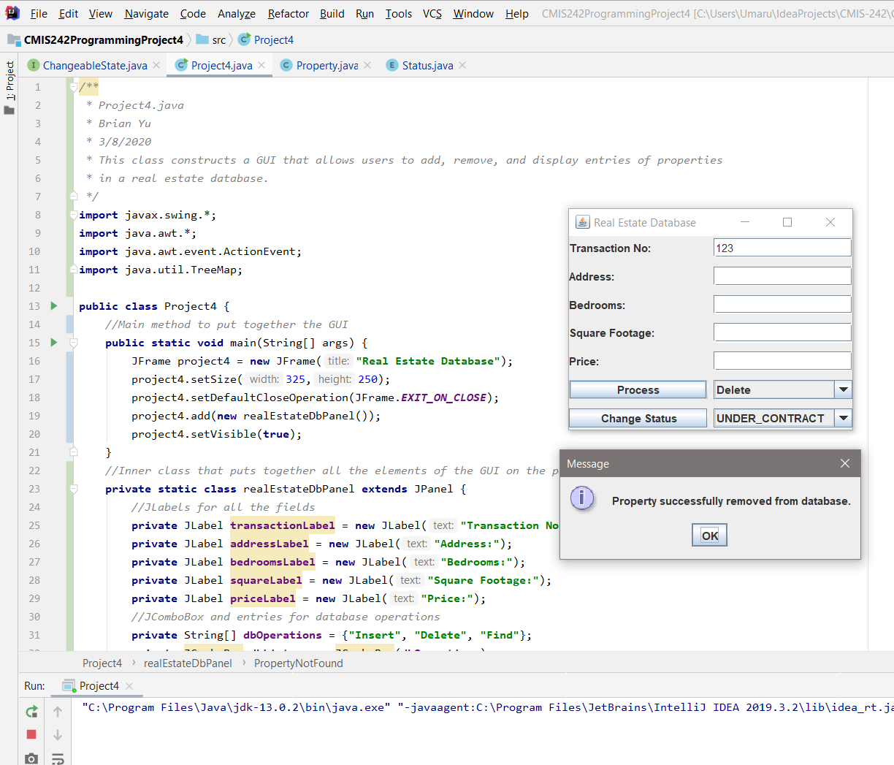

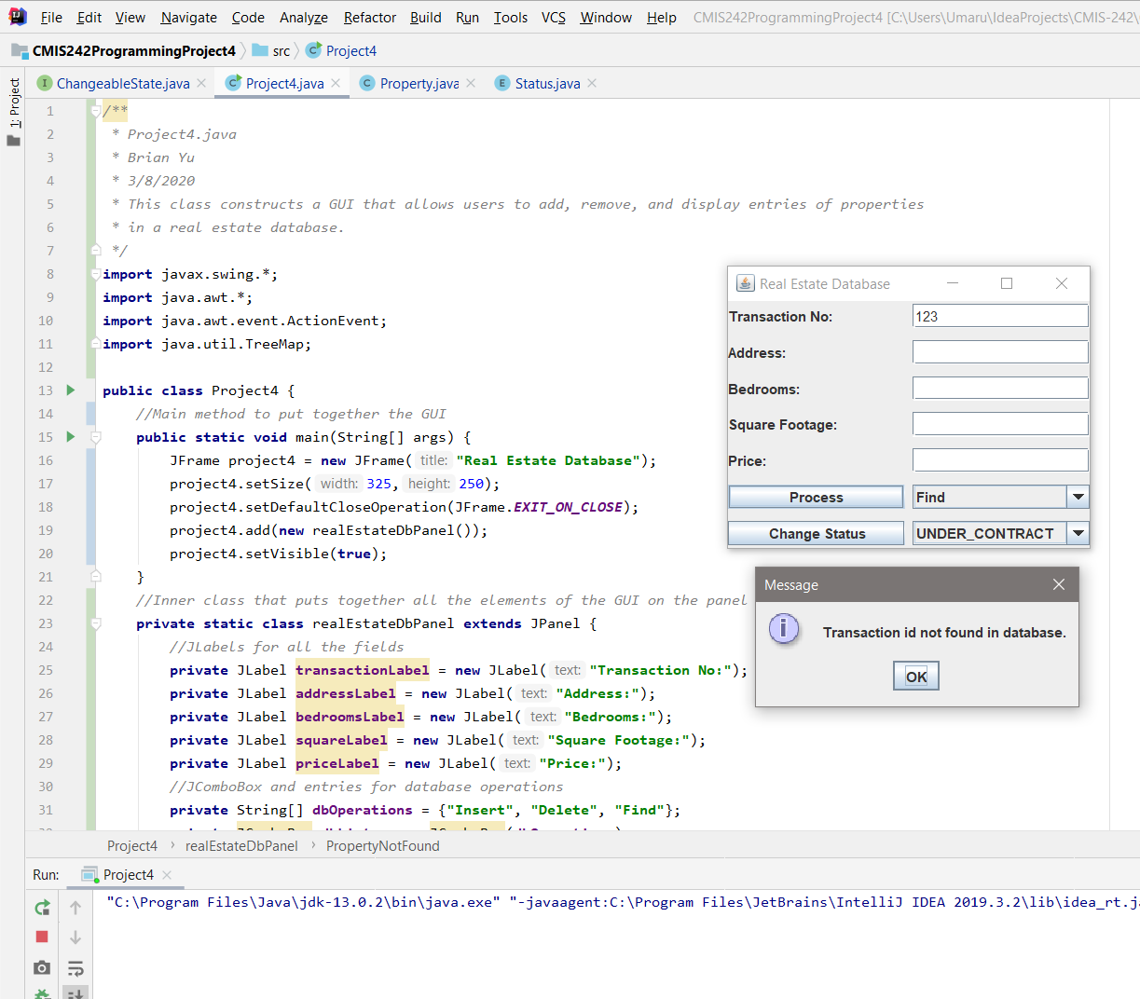

### Test Case 6 – Attempt to add new property with invalid formatted values but valid transaction id

**Expected Output:** A pop-up should inform the user that invalid values have been entered and attempting to search the transaction id will generate a pop-up saying no such property with transaction id exists.

**Actual Output:**

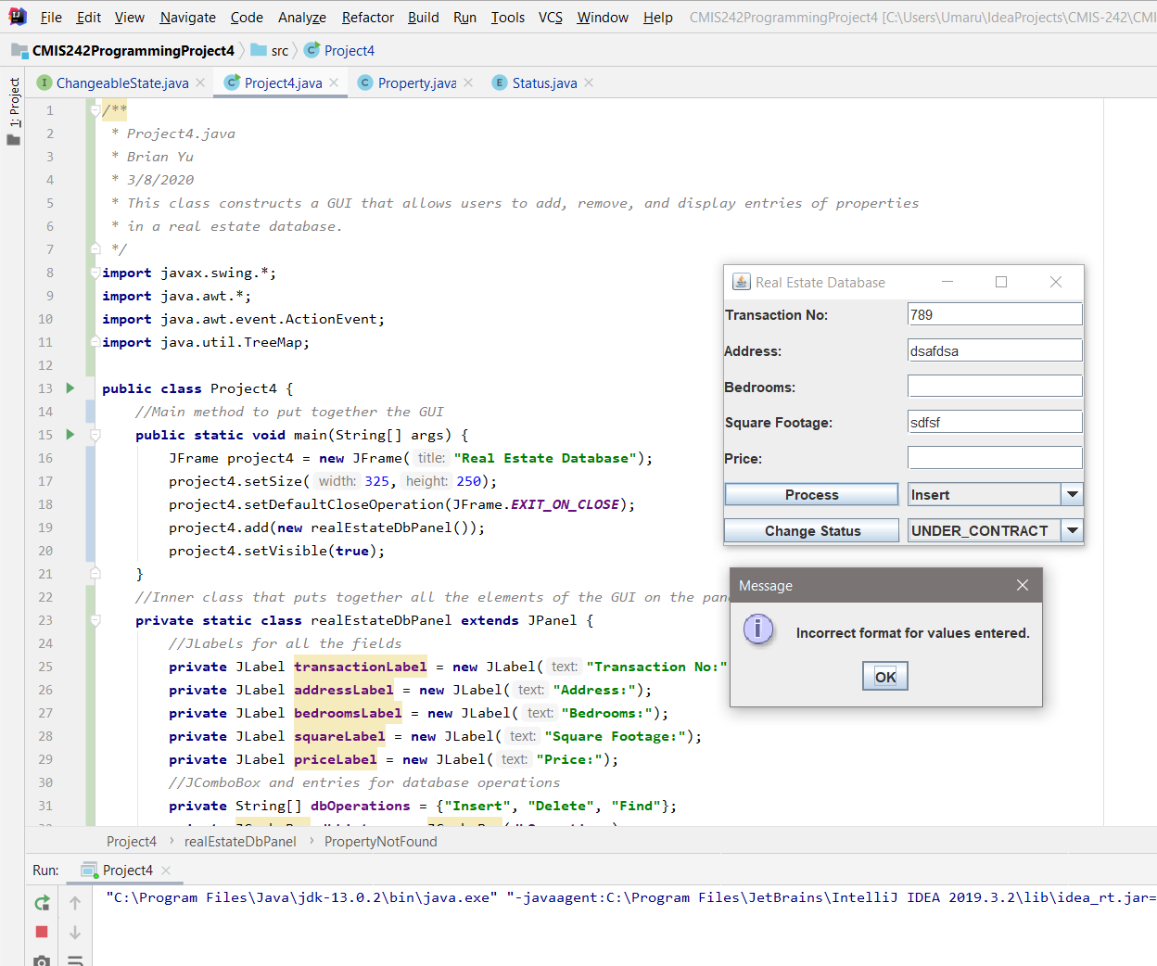

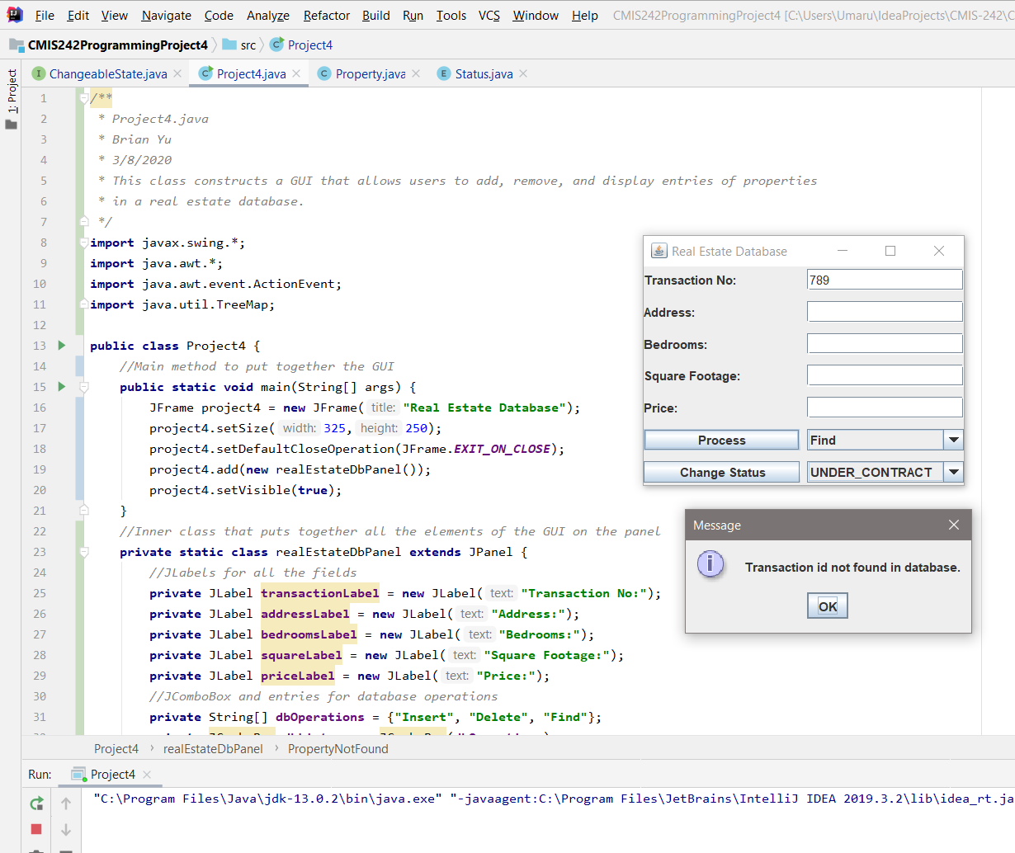

### Test Case 7 – Attempt to enter in property with duplicate transaction id

**Expected Output:** A pop-up should inform user that the property already exists and finding the property should show the existing property information rather than the new property information.

**Actual Output:**

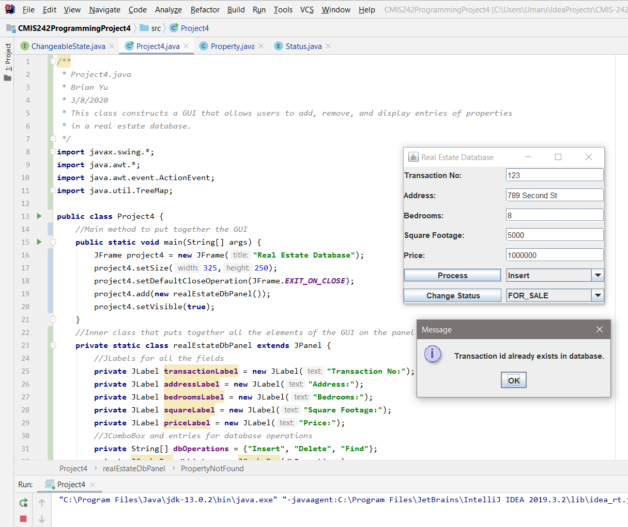

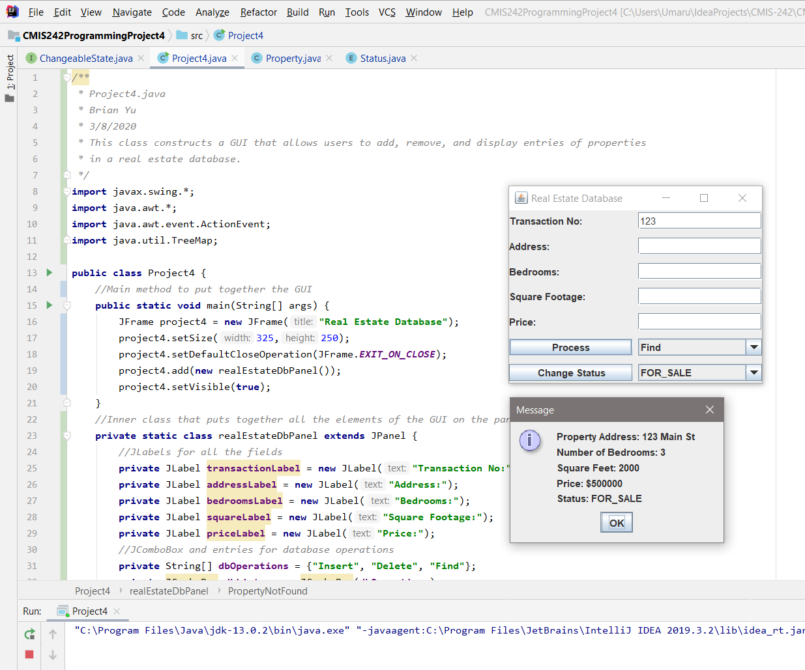

### Test Case 8 – Attempt to change status of non-existent property

**Expected Output:** A pop-up should appear informing user that the property does not exist.

**Actual Output:**

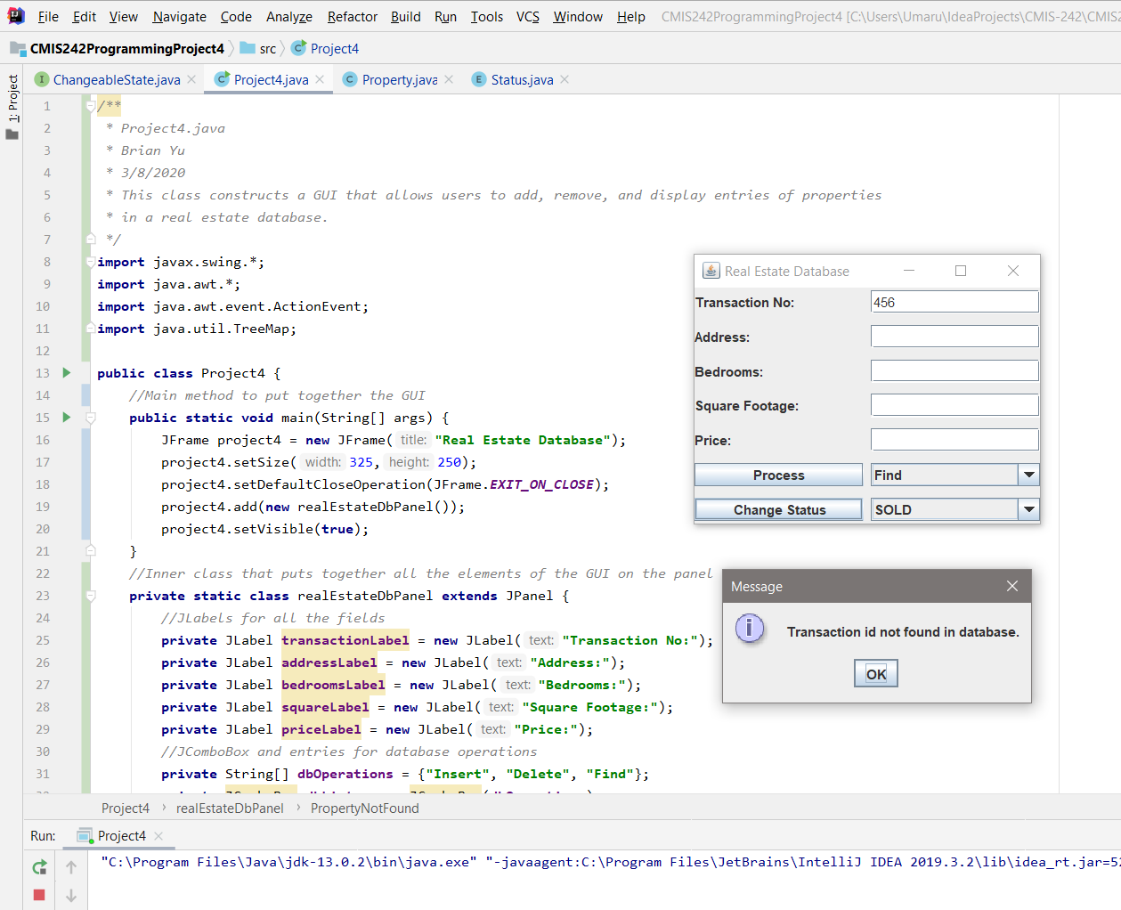

## Results

