Pengxiang Zhang (PZY0711)

Dr. Tumblin

EECS-351-1

15/11/2021

Project C: Abstractionism Wonderland

# User’s Guide

To look around of the 3D grid can be controlled using the keyboard with keys “W”, “S”, “A” and “D”.

To zoom in and out can be controlled using the keyboard with keys “↑” and “↓”.

To change material can be controlled by pressing the keyboard with keys “M”.

You may use the control on the webpage to control the lighting/shading.

Figure - Initial View

This is the view when the user first loads the webpage. It shows 4 3D object on the screen and control material/lighting/shading/position/ambient/diffuse/specular. Control from keyboard can also used to control the camera.

Figure – Change material and add Blinn-phone

User can easily change the material (Dull copper in the figure) and different lighting/shading method(Ground shading with Blinn-Phong in figure)

Figure – Change Shininess/position/ambient/diffuse/specular

User may also change Shininess/position/ambient/diffuse/specular using the control easily. In this figure it has been set to random value for demo.

Figure – Light Control

Light can also being controlled easily, In this figure, light has been turned off.

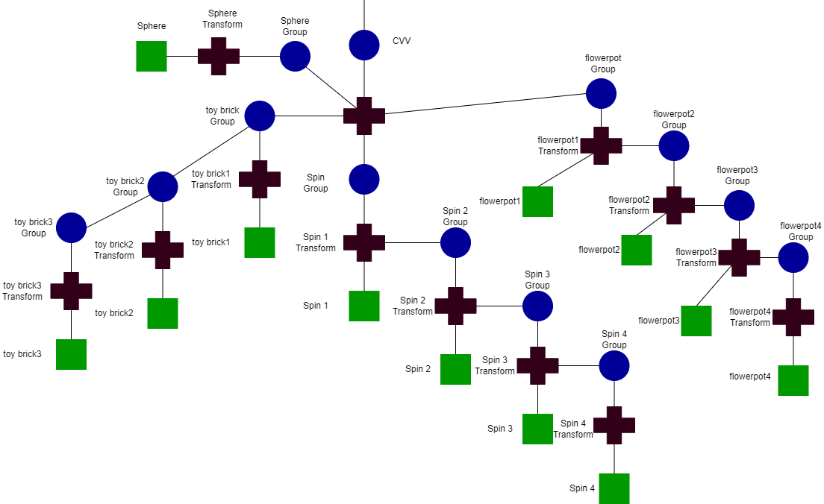

Figure – Scene Graph