Lab 4  
Pengzhao Zhu   
Section: 112D

# B) Prelab Questions

*Will it be necessary to remap the specified port?

*Yes, PD6 (BLUE_LED) doesn’t have its own channel. So it will be necessary to remap

*the port for PART A of this lab (to output to the BLUE_LED).

1. What would happen if the RGB period was $FFFF instead of $FF?

**If the RGB period was $FFFF, we would have more options for different resolution and different light intensity. If the RGB was $FFFF instead of $FF but with the same $0E for compare (as in Part A), the BLUE_LED would be a lot less brighter.**

1. How many TC0 channels are necessary to control all three LEDs in the µPAD’s RGB LED?

**Three TC0 channels are necessary to control all three LEDs in the uPad’s RGB LED**

# C) Problems Encountered

The first problem I encountered in this lab was the initialization of PWM and remap of the capture pin. The section on Timer/Compare/PWM was very confusing in the manual and I didn’t know which waveform generator mode to use. It wasn’t until I went to office hour that I figured out I can use single slope PWM mode for the lab (to output to LED).

The second problem I encountered in this lab was setting up the two interrupts used to debounce the switch. I couldn’t get my code to debounce properly, so the count value would increment more than once per switch press. To solve the problem, I set the timer delay to 5ms for the interrupt to debounce properly.

# D) Future Application

By completing this lab, I gained more knowledge of the timer system and the use of interrupts in microprocessors. The use of the timer capture and waveform generation functions will allow me to write more efficient codes for microprocessors. A precise count of real time using the timer system will be necessary for complex time dependent systems.

The second major skill I learned in this lab was the use of interrupts. Interrupts allow me to trigger a section of code that I want to run without polling the condition. It saves time, memory, and processing speed and will be necessary in any embedded systems that I will work on in the future.

# E) Schematics

N/A

# F) Pseudocode/Flowcharts

Part A Pseudocode:

Set up r23 to be 0x00 for the 32Mhz subroutine

rcall CLK (to set up 32Mhz clock)

Initialize Stack Pointer to 0x3FFF

Set Blue LED to be output

Remap PORTD ; move location of 0C02 from Px2 to Px6

Set the PER register of PORTD to 0xFF ;0xFF for 0-255 of RGB LED

Set Timer clock on Port D to be CLK/1024

Use CTRLB to enable Compare/Capture C and enable single-slope PWM

Set TCD0_CCC to 0x0E

Invert the signal outputted to PORTD pin 6 using PORTD_PIN6CTRL (because LED is low-true)

DONE:  
 rjmp DONE

CLK (32 MHZ subroutine)

push r16

set OSC_CTRL to be the 32 MHZ oscillator

NSTABLE:

Check if 32MHZ oscillator is stable

If stable, go to STABLE

If not stable, go back to NSTABLE

STABLE:

Write IOREG (0xD8) to CPU_CCP to enable change

Select the 32 MHZ oscillator

Write IOREG (0XD8) to CPU_CCP to use prescaler

Use r23 initialized outside the subroutine to set it up so it remains 32Mhz

pop r16

ret

Part C Pseudocode:

.org 0x0000  
 rjmp MAIN

set up ISR name to jump to when encountered PORTF_INTO_vect

.org 0x100

MAIN:

Set up r17 to be a counter register for how many time the ISR has been executed

Set up r23 to be 0x00 for the 32Mhz subroutine

rcall CLK

Initialize Stack Pointer to 0x3FFF

Set 8 LED on PORTC to be output

Turn the 8 active low LED off

Enable low level interrupt for INT0

Set PF2 (Tactile switch S1) as the source for INT0

Set PF2 (Tactile switch S1) as input

Configure Pin2 of PortF to be falling edge trigger using PORTF_PIN2CTRL

Enable low level interrupt in the PMIC

sei

ldi r16, 0x70 ; to toggle the LED in an infinite loop

LOOP:

sts PORTD_OUTTGL, r16

rjmp LOOP

ISR: ;ISR to output count to 8 LED

push r19

push r18

put CPU_SREG into r18

push r18

increment r17

Takes one’s complement of r17 because LED are active low

sts PORTC_OUT, r17

Takes one’s complement of r17 to ensure correct count

Clear interrupt flag using PORTF_INTFLAGS. Write a one to it

pop r18

Put value of r18 back to CPU_SREG

Pop r18

Pop r19

reti

CLK (32 MHZ subroutine)

push r16

set OSC_CTRL to be the 32 MHZ oscillator

NSTABLE:

Check if 32MHZ oscillator is stable

If stable, go to STABLE

If not stable, go back to NSTABLE

STABLE:

Write IOREG (0xD8) to CPU_CCP to enable change

Select the 32 MHZ oscillator

Write IOREG (0XD8) to CPU_CCP to use prescaler

Use r23 initialized outside the subroutine to set it up so it remains 32Mhz

pop r16

ret

Part D Pseudocode:

.org 0x0000  
 rjmp MAIN

set up ISR name to jump to when encountered PORTF_INTO_vect

set up TIMER_ISR name to jump to when encountered TCD0_OVF_vect

.equ debounce_timer= (32000000*.005)/1024

.org 0x100

Set up r23 to use in the 32Mhz subroutine

Set r17 to be a register for how many times the ISR has been executed

rcall CLK

Initialize Stack Pointer to 0x3FFF

Set 8 LED on PORTC to be output

Turn the 8 active low LED off

rcall DEBOUNCE (to set up interrupt)

ldi r16, 0x70 ; to toggle the LED in an infinite loop

LOOP:

sts PORTD_OUTTGL, r16

rjmp LOOP

DEBOUCNE:

Push r16

Enable low level interrupt using PORTF_INTCTRL

Set PF2 (Tactile switch S1) as the source for INT0

Set PF2 (Tactile switch S1) as input

Configure the source to be falling edge trigger using PORTF_PIN2CTRL

Enable low level interrupt in the PMIC

Sei

Pop r16

Ret

ISR:

Push r18

Put CPU_SREG into r18

Push r18

Push r16

Setting the CNT back to zero

Set the PER for 5ms (math before the main code)

Configure timer clock for CLK/1024

Enable low level timer interrupt

Disable PORTF external interrupt

Pop r16

Pop r18

Value in r18 back to CPU_SREG

Pop r18

Reti

Timer_ISR:

Push r18

Value in CPU_SREG t or18

Push r18

Push r16

Disable Timer

Disable Timer Interrupt

Check if switch is set

brts NOT_ACTIVE

increment r17

Take one’s complement of r17

Value in r17 to PORTC_OUT

Take one’s complement of r17

NOT_ACTIVE:

Enable PORTF external interrupt

Clear the Interrupt Flag

Pop r16

Pop r18

Value in r18 to CPU_SREG

Pop r18

reti

CLK (32 MHZ subroutine)

push r16

set OSC_CTRL to be the 32 MHZ oscillator

NSTABLE:

Check if 32MHZ oscillator is stable

If stable, go to STABLE

If not stable, go back to NSTABLE

STABLE:

Write IOREG (0xD8) to CPU_CCP to enable change

Select the 32 MHZ oscillator

Write IOREG (0XD8) to CPU_CCP to use prescaler

Use r23 initialized outside the subroutine to set it up so it remains 32Mhz

pop r16

ret

Part E Pseudocode:

.org 0x0000  
 rjmp MAIN

set up EDGE_ISR name to jump to when encountered PORTF_INTO_vect

set up DEBOUNCE_TIMER_ISR name to jump to when encountered TCC0_OVF_vect

set up BLINK_ISR name to jump to when encountered TCE0_OVF_vect

.equ debounce_timer= (32000000*.005)/1024

.equ blink_timer =(32000000*.1)/1024

Put values of RGB into a Table in Program Memory (use 4 tables)

.org 0x100

Set up r23 to use in the 32Mhz subroutine

Set r17 to be a register for how many times the ISR has been executed

Set r20 as the count register for the 8 LED

Set r22 to be 0

rcall CLK

Initialize Stack Pointer to 0x3FFF

Set 8 LED on PORTC to be output

Turn the 8 active low LED off

rcall DEBOUNCE

rcall PWM

rcall BLINK

DONE:  
 rjmp DONE

DEBOUNCE:

Initialize the EDGE_ISR system

Ret

PWM:

Initialize the PWM system

Ret

BLINK::

Initialize the .1 second blink ISR

Ret

BLINK_ISR:

If r17 = 0 { ;there is be a single bit in a register that will be inverted so it will alternate

; the blinking of LED

Load first table to output nothing

} else if r17 =1 {

Load second table to blink between 2 colors of INCREDIBLE HULK

} else if r17 =2 {

Load third table to blink between 2 colors of HOLIDAY

} else if r17 =3 {

Load third table to blink between 2 colors of HOLIDAY

If r17 = 4 or greater than 4 {

Set r17=4

}

Setting the CNT back to zero

Clear the interrupt flag

Reti

EDGE_ISR: ; to trigger when S1 is pressed

Initialize debounce timer for .5 ms

Enable Timer interrupt

Disable Port Interrupt

Reti

DEBOUNCE_TIMER_ISR:

Disable Timer

Disable Timer Interrupt

Enable Port Interrupt

Reti

BLINK_ISR:

Disable Timer

Disable Timer interrupt

Move to the next value in table because .1 second has been pressed already

Reti

CLK (32 MHZ subroutine)

push r16

set OSC_CTRL to be the 32 MHZ oscillator

NSTABLE:

Check if 32MHZ oscillator is stable

If stable, go to STABLE

If not stable, go back to NSTABLE

STABLE:

Write IOREG (0xD8) to CPU_CCP to enable change

Select the 32 MHZ oscillator

Write IOREG (0XD8) to CPU_CCP to use prescaler

Use r23 initialized outside the subroutine to set it up so it remains 32Mhz

pop r16

ret

G) Program Code

Part A Code

/* Lab 4 Part A

Name: Pengzhao Zhu

Section#: 112D

TA Name: Chris Crary

Description: This Program configures the PWM system and output a blue hue of $0E to the blue LED

*/

.include "ATxmega128A1Udef.inc" ;include the file

.list ;list it

.org 0x0000 ;start our program here

rjmp MAIN ;jump to main

.equ stack_init=0x3FFF ;initialize stack pointer

.org 0x100 ;start at 0x100

MAIN:

ldi r17, 0x00 ;setting for 32MHZ subroutine

rcall CLK ;call subroutine to set up 32MHZ clock

ldi YL, low(stack_init) ;Load 0xFF to YL

out CPU_SPL, YL ;transfer to CPU_SPL

ldi YL, high(stack_init) ;Load 0x3F to YH

out CPU_SPH, YL ;transfer to CPU_SPH

ldi r16, 0b01000000 ;load r16

sts PORTD_DIRSET, r16 ;set blue LED to be output

ldi r16, 0b00000100 ;load r16

sts PORTD_REMAP, r16 ; to move location of OC02 from Px2 and Px6

ldi r16, 0xFF ;load r16

sts TCD0_PER, r16 ;load lower byte of PER

ldi r16, 0x00 ;load r16

sts TCD0_PER+1, r16 ;load high byte of PER

ldi r16, 0b00000111 ;load r16

sts TCD0_CTRLA, r16 ;Timer clock for clk/1024

ldi r16, 0b01000011 ;load r16

sts TCD0_CTRLB, r16 ; bit 6 is Compare C enable. bit 2-0 is single-slope PWM

ldi r16, 0x0E ;load r16

sts TCD0_CCC, r16 ;load CCC

ldi r16, 0x00 ;load r16

sts TCD0_CCC+1, r16 ;setting the compare value to 0x000E

ldi r16, 0b01000000 ;load r16

sts PORTD_PIN6CTRL, r16 ;invert the signal because the LED are low true

DONE:

rjmp DONE ;infinite loop

CLK: ;take in a r17 value for prescaler. 32MHZ = 0x00 for prescale

push r16 ;push r16

ldi r16, 0b00000010 ;bit 1 is the 32Mhz oscillator

sts OSC_CTRL, r16 ;store r16 into the OSC_CTRL

NSTABLE:

lds r16, OSC_STATUS ;load oscillator status into r16

bst r16, 1 ;check if 32Mhz oscillator is stable

brts STABLE ;branch if stable

brtc NSTABLE ;loop again if non-stable

STABLE:

ldi r16, 0xD8 ;writing IOREG to r16

sts CPU_CCP, r16 ;write IOREG to CPU_CCP to enable change

ldi r16, 0b00000001 ;write this to r16. corresponds to 32Mhz oscillator

sts CLK_CTRL, r16 ;select the 32Mhz oscillator

ldi r16, 0xD8 ;writing IOREG for prescaler

sts CPU_CCP, r16 ;for prescaler

sts CLK_PSCTRL, r17 ;r17 will be initialized outside the subroutine for prescale. 32/8=4MHZ

pop r16 ;pop r16

ret ;return to main routine

_____________________________________________________________________________________

Part C Code

/* Lab 4 Part C

Name: Pengzhao Zhu

Section#: 112D

TA Name: Chris Crary

Description: This Program configures the Xmega port interrupt to trigger when S1 is pressed.

It will then output how many time S1 has been pressed to the 8 LED.

No debounce performed

*/

.include "ATxmega128A1Udef.inc" ;include the file

.list ;list it

.org 0x0000 ;start our program here

rjmp MAIN ;jump to main

.org PORTF_INT0_vect ;tell the ISR where to jump to

rjmp ISR

.equ stack_init=0x3FFF ;initialize stack pointer

.org 0x100

MAIN:

ldi r23, 0x00 ;setting for 32MHZ subroutine.

ldi r17, 0x00 ;counter register for how many time the ISR has been executed

rcall CLK

ldi YL, low(stack_init) ;Load 0xFF to YL

sts CPU_SPL, YL ;transfer to CPU_SPL

ldi YL, high(stack_init) ;Load 0x3F to YH

sts CPU_SPH, YL ;transfer to CPU_SPH

ldi r16, 0xFF

sts PORTC_DIRSET, r16 ;set the 8 LED to be output

sts PORTC_OUT, r16 ;turn the 8 active low LED off

ldi r16, 0x40

sts PORTD_DIRSET, r16 ;set the BLUE LED to be output

sts PORTD_OUT, r16 ;set the BLUE LED to be output

ldi r16, 0x01 ;enable low level interrupt for INT0

sts PORTF_INTCTRL, r16

ldi r16, 0x04

sts PORTF_INT0MASK, r16 ;set PF2 (tactile switch S1) as the source for INT0

sts PORTF_DIRCLR, r16 ;set PF2 (tactile switch S1) as input

ldi r16, 0b00000010 ; the last 3 bits "010" corresponds to falling edge sense trigger

sts PORTF_PIN2CTRL, r16

ldi r16, 0x01

sts PMIC_CTRL, r16 ;enable low level interrupt in the PMIC

sei ;setting the I bit

ldi r16, 0x70 ;0x70 to toggle the pin. Used in the infinite loop

LOOP:

sts PORTD_OUTTGL, r16 ;keep toggling the LED

rjmp LOOP ;infinite loop in the main code

ISR:

push r19 ;push the necessary registers and also the status register

push r18

lds r18, CPU_SREG

push r18

inc r17 ;to increase r17 by 1 everytime the ISR is executed

com r17 ;takes one's complement of r17 because LED are active low

sts PORTC_OUT, r17

com r17 ;takes one's complement again so r17 is correct the next time we execuate the ISR

ldi r19, 0x01 ;load r19

sts PORTF_INTFLAGS, r19 ;clear the interrupt flag

pop r18 ;return the registers to their original value. including the status register

sts CPU_SREG, r18

pop r18

pop r19

reti

CLK: ;take in a r17 value for prescaler. 32MHZ = 0x00 for prescale

push r16 ;push r16

ldi r16, 0b00000010 ;bit 1 is the 32Mhz oscillator

sts OSC_CTRL, r16 ;store r16 into the OSC_CTRL

NSTABLE:

lds r16, OSC_STATUS ;load oscillator status into r16

bst r16, 1 ;check if 32Mhz oscillator is stable

brts STABLE ;branch if stable

brtc NSTABLE ;loop again if non-stable

STABLE:

ldi r16, 0xD8 ;writing IOREG to r16

sts CPU_CCP, r16 ;write IOREG to CPU_CCP to enable change

ldi r16, 0b00000001 ;write this to r16. corresponds to 32Mhz oscillator

sts CLK_CTRL, r16 ;select the 32Mhz oscillator

ldi r16, 0xD8 ;writing IOREG for prescaler

sts CPU_CCP, r16 ;for prescaler

sts CLK_PSCTRL, r23 ;r17 will be initialized outside the subroutine for prescale. 32/8=4MHZ

pop r16 ;pop r16

ret ;return to main routine

_____________________________________________________________________________________

Part D Code

/* Lab 4 Part D

Name: Pengzhao Zhu

Section#: 112D

TA Name: Chris Crary

Description: This Program configures the Xmega port interrupt to trigger when S1 is pressed.

It will then output how many time S1 has been pressed to the 8 LED.

Debounced performed with a second timer interrupt. Added to the first interrupt

*/

.include "ATxmega128A1Udef.inc" ;include the file

.list ;list it

.org 0x0000 ;start our program here

rjmp MAIN ;jump to main

.org PORTF_INT0_vect ;tell the uP where to jump to when edge interrupt is triggered

rjmp ISR

.org TCD0_OVF_vect ;tell the uP where to jump to when timre interrupt is triggered

rjmp TIMER_ISR

.equ stack_init=0x3FFF ;initialize stack pointer

.equ debounce_timer= (32000000*.005)/1024 ;.equ for the PER value of the timer interrupt

.org 0x100

MAIN:

ldi r23, 0x00 ;setting for 32MHZ subroutine.

ldi r17, 0x00 ;counter register for how many time the ISR has been executed

rcall CLK ;call CLK to configure 32MHZ clock

ldi YL, low(stack_init) ;Load 0xFF to YL

sts CPU_SPL, YL ;transfer to CPU_SPL

ldi YL, high(stack_init) ;Load 0x3F to YH

sts CPU_SPH, YL ;transfer to CPU_SPH

ldi r16, 0xFF

sts PORTC_DIRSET, r16 ;set the 8 LED to be output

sts PORTC_OUT, r16 ;turn the 8 active low LED off

ldi r16, 0x40

sts PORTD_DIRSET, r16 ;set the RGB LED to be output

sts PORTD_OUT, r16 ;turn the RGB LED off

rcall DEBOUNCE

ldi r16, 0x70

LOOP:

sts PORTD_OUTTGL, r16 ;keep toggling the BLUE LED

rjmp LOOP

DEBOUNCE:

push r16

ldi r16, 0x01 ;enable low level interrupt for INT0

sts PORTF_INTCTRL, r16

ldi r16, 0x04

sts PORTF_INT0MASK, r16 ;set PF2 (tactile switch S1) as the source for INT0

sts PORTF_DIRCLR, r16 ;set PF2 (tactile switch S1) as input

ldi r16, 0b00000010 ; the last 3 bits "010" corresponds to falling edge sense trigger

sts PORTF_PIN2CTRL, r16

ldi r16, 0x01

sts PMIC_CTRL, r16 ;enable low level interrupt in the PMIC

sei ;setting the I bit

pop r16

ret

ISR:

push r18 ;push the necessary registers. including the status register

lds r18, CPU_SREG

push r18

push r16

ldi r16, 0x00 ;setting the CNT back to zero

sts TCD0_CNT, r16

ldi r16, low(debounce_timer) ;set the timer for 5ms to debounce

sts TCD0_PER, r16 ;need to load low and high byte of PER

ldi r16, high(debounce_timer)

sts TCD0_PER+1, r16

ldi r16, 0b00000111 ;Timer clock for clk/1024

sts TCD0_CTRLA, r16

ldi r16, 0x01 ;enable timer interrupt

sts TCD0_INTCTRLA, r16

ldi r16, 0x00 ;disable PortF external interrupt

sts PORTF_INTCTRL, r16

pop r16 ;pop the necessary registers. including the status register

pop r18

sts CPU_SREG, r18

pop r18

reti

TIMER_ISR:

push r18 ;push the necessary registers. including the status register

lds r18, CPU_SREG

push r18

push r16

ldi r16, 0x00 ;disable timer

sts TCD0_CTRLA, r16

ldi r16, 0x00

sts TCD0_INTCTRLA, r16 ;disable timer interrupt

lds r16, PORTF_IN ;to check if switch is still active

bst r16, 2

brts NOT_ACTIVE

inc r17 ;to increase r17 by 1 everytime the ISR is executed

com r17 ;takes one's complement of r17 because LED are active low

sts PORTC_OUT, r17

com r17 ;takes one's complement again so r17 is correct the next time we execuate the ISR

NOT_ACTIVE:

ldi r16, 0x01 ;enable PortF external interrupt

sts PORTF_INTCTRL, r16

ldi r16, 0x01 ;clear the interrupt flag

sts PORTF_INTFLAGS, r16

pop r16 ;prepare to return from interrupt

pop r18

sts CPU_SREG, r18 ;pop the necessary registers. including the status register

pop r18

reti

CLK: ;take in a r17 value for prescaler. 32MHZ = 0x00 for prescale

push r16 ;push r16

ldi r16, 0b00000010 ;bit 1 is the 32Mhz oscillator

sts OSC_CTRL, r16 ;store r16 into the OSC_CTRL

NSTABLE:

lds r16, OSC_STATUS ;load oscillator status into r16

bst r16, 1 ;check if 32Mhz oscillator is stable

brts STABLE ;branch if stable

brtc NSTABLE ;loop again if non-stable

STABLE:

ldi r16, 0xD8 ;writing IOREG to r16

sts CPU_CCP, r16 ;write IOREG to CPU_CCP to enable change

ldi r16, 0b00000001 ;write this to r16. corresponds to 32Mhz oscillator

sts CLK_CTRL, r16 ;select the 32Mhz oscillator

ldi r16, 0xD8 ;writing IOREG for prescaler

sts CPU_CCP, r16 ;for prescaler

sts CLK_PSCTRL, r23 ;r17 will be initialized outside the subroutine for prescale. 32/8=4MHZ

pop r16 ;pop r16

ret ;return to main routine

_____________________________________________________________________________________

Part E Code

/* Lab 4 Part E

Name: Pengzhao Zhu

Section#: 112D

TA Name: Chris Crary

Description: This Program blinks the RGB between two color combination with a .1 blink alternation period

Four settings in total (4 sets of combination for RGB blink )

It will also output the number of times S1 is pressed to the 8 LEDs

*/

.include "ATxmega128A1Udef.inc" ;include the file

.list ;list it

.org 0x0000 ;start our program here

rjmp MAIN ;jump to main

.org PORTF_INT0_vect ;for the edge trigger debounce interrupt

rjmp EDGE_ISR

.org TCC0_OVF_vect ;for the 5 ms timer debounce interrupt

rjmp DEBOUNCE_TIMER_ISR

.org TCE0_OVF_vect ;for the .1 second blink timer interrupt

rjmp BLINK_ISR

;Have to use TCC0 and TCE0 because PER OF TCD0 is used for PWM

.equ stack_init=0x3FFF ;initialize stack pointer

.equ debounce_timer= (32000000*.005)/1024 ;.equ for PER of debounce timer ISR

.equ blink_timer =(32000000*.1)/1024 ;.equ for PER of blink timer ISR

.org 0x100

Table :.db 0x00, 0x00, 0x00, 0x00, 0x00, 0x00 ;table for no LED light up

Table1:.db 0x9A, 0x2C, 0x8A, 0x07, 0xFF, 0x49 ;table for INCREDIBLE HULK

Table2:.db 0x1F, 0x1F, 0xC2, 0x0D, 0x8D, 0x3C ;table for HOLIDAY

Table3:.db 0x16, 0x46, 0xFA, 0xA5, 0x21, 0x00 ;table for UF

.org 0x200

MAIN:

ldi r23, 0x00 ;setting for 32MHZ subroutine.

ldi r17, 0x00 ;counter register for how many time the ISR has been executed

ldi r22, 0x00 ;bit0, capture D(BLUE). BIT1, capture C(Green). Bit 2, capture (RED) . 0 means forward, 1 means back

;register so I know which data to take

ldi r20, 0x00 ;counter register for the 8 LED

rcall CLK

ldi YL, low(stack_init) ;Load 0xFF to YL

sts CPU_SPL, YL ;transfer to CPU_SPL

ldi YL, high(stack_init) ;Load 0x3F to YH

sts CPU_SPH, YL ;transfer to CPU_SPH

ldi r16, 0xFF ;just want to see the outputted

sts PORTC_DIRSET, r16 ;set the 8 LED to be output

sts PORTC_OUT, r16 ;turn the 8 active low LED off

rcall DEBOUNCE ;call subroutine to initialze port edge interrupt

rcall PWM ;call subroutine to initialize PWM

rcall BLINK ;call subroutine to set up .1 second switch interrupt

DONE:

rjmp DONE

PWM:

push r16

ldi r16, 0x70

sts PORTD_DIRSET, r16 ;set the RGB LED to be output

sts PORTD_OUT, r16 ;turn the RGB LED off

ldi r16, 0b00000111 ; remap the RGB LED

sts PORTD_REMAP, r16

ldi r16, 0xFF ;load r16

sts TCD0_PER, r16 ;load low byte of PER

ldi r16, 0x00 ;load r16

sts TCD0_PER+1, r16 ;load high byte of PER

ldi r16, 0b00000111 ;Timer clock for clk/1024

sts TCD0_CTRLA, r16

ldi r16, 0b01110011 ; enablc Compare A,B,C. bit 2-0 is single-slope PWM

sts TCD0_CTRLB, r16

ldi r16, 0x00

sts TCD0_CCC, r16 ;CCC is for blue LED

sts TCD0_CCC+1, r16 ;need to load low and high byte

sts TCD0_CCB, r16 ;CCB is for Green LED

sts TCD0_CCB+1, r16 ;need to load low and high byte

sts TCD0_CCA, r16 ;CCA is for Red LED

sts TCD0_CCA+1, r16 ;need to load low and high byte

ldi r16, 0b01000000 ;invert the signal because they are low-true LED

sts PORTD_PIN6CTRL, r16 ;invert 3 pins between there are Red, Green, and Blue LED. 3 of them

sts PORTD_PIN5CTRL, r16

sts PORTD_PIN4CTRL, r16

pop r16

ret ;return

DEBOUNCE:

push r16

ldi r16, 0x02 ;enable medium level interrupt for INT0

sts PORTF_INTCTRL, r16

ldi r16, 0x04

sts PORTF_INT0MASK, r16 ;set PF2 (tactile switch S1) as the source for INT0

sts PORTF_DIRCLR, r16 ;set PF2 (tactile switch S1) as input

ldi r16, 0b00000010 ; the last 3 bits "010" corresponds to falling edge sense trigger

sts PORTF_PIN2CTRL, r16

ldi r16, 0x03

sts PMIC_CTRL, r16 ;enable low level and medium level interrupt in the PMIC

sei ;setting the I bit

pop r16

ret

BLINK: ;initialize the timer/timer interrupt for .1 second blink

push r16

ldi r16, low(blink_timer) ;set the timer for .1 between blink

sts TCE0_PER, r16 ;need to load low and high byte

ldi r16, high(blink_timer)

sts TCE0_PER+1, r16

ldi r16, 0b00000111 ;Timer clock for clk/1024

sts TCE0_CTRLA, r16

ldi r16, 0x01 ;enable low level timer interrrupt

sts TCE0_INTCTRLA, r16

pop r16

ret ;return from subroutine

EDGE_ISR: ;initialization for edge interrupt

push r18 ;push the necessary registers and status register

lds r18, CPU_SREG

push r18

push r16

ldi r16, 0x00 ;setting the CNT back to zero

sts TCC0_CNT, r16

ldi r16, low(debounce_timer) ;set the timer for 5ms to debounce

sts TCC0_PER, r16 ;need to load low and high byte of PER

ldi r16, high(debounce_timer)

sts TCC0_PER+1, r16

ldi r16, 0b00000111 ;Timer clock for clk/1024

sts TCC0_CTRLA, r16

ldi r16, 0x02 ;enable medium timer interrupt

sts TCC0_INTCTRLA, r16

ldi r16, 0x00 ;disable PortF external interrupt

sts PORTF_INTCTRL, r16

pop r16 ;pop the necessary registers. including the status register

pop r18

sts CPU_SREG, r18

pop r18

reti ;return from interrupt

DEBOUNCE_TIMER_ISR: ;initialization for the 5ms timer used for debounce

push r18

lds r18, CPU_SREG ;push the necessary registers and status register

push r18

push r16

ldi r16, 0x00 ;disable timer

sts TCC0_CTRLA, r16

ldi r16, 0x00

sts TCC0_INTCTRLA, r16 ;disable timer interrupt

lds r16, PORTF_IN ;to check if switch is still active

bst r16, 2

brts NOT_ACTIVE ;if set, it means it is not active

inc r17 ;if active, increment r17. r17 is a counter

;the rest of separate. the next 4 line of code are for 8 LED count

inc r20 ;to increase r20 by 1 everytime the ISR is executed

com r20 ;takes one's complement of r20 because LED are active low

sts PORTC_OUT, r20 ;output the value

com r20 ;takes one's complement again so r20 is correct the next time we execuate the ISR

NOT_ACTIVE:

ldi r16, 0x02 ;enable PortF external medium level interrupt

sts PORTF_INTCTRL, r16

ldi r16, 0x01 ;clear the interrupt flag

sts PORTF_INTFLAGS, r16

pop r16 ;prepare to return from interrupt

pop r18 ;pop the necessary registers. including the status register

sts CPU_SREG, r18

pop r18

reti

BLINK_ISR:

push ZL ;pushes the necessary registers. including the status register

push ZH

push r18

lds r18, CPU_SREG

push r18

push r16

cpi r17, 0 ;check the counter for how many times tactile switch S1 is pressed

breq STORE ;Jump to different part of the code depending on r17 value

cpi r17, 1

breq STORE1

cpi r17, 2 ;should be self explanatory

breq STORE2

cpi r17, 3

breq STORE3

STORE: ;load corresponding tables

ldi ZL, low(Table<<1) ;r17=0, no output

ldi ZH, high(Table<<1)

rjmp CHECK

STORE1:

ldi ZL, low(Table1<<1) ;load corresponding tables

ldi ZH, high(Table1<<1) ;r17=1, INCREDIBLE HULK color

rjmp CHECK

STORE2:

ldi ZL, low(Table2<<1) ;load corresponding tables

ldi ZH, high(Table2<<1) ;r17=2, HOLIDAY color

rjmp CHECK

STORE3:

ldi ZL, low(Table3<<1) ;load corresponding tables

ldi ZH, high(Table3<<1) ;r17=3, UF Color

CHECK:

bst r22, 0 ;r22 is just a register so I how which half of the table to load

brtc LOAD ;will be inverted everytime

adiw ZH:ZL, 3 ;add 3 to counter for blinking

LOAD:

ldi r16, 0x08 ;force restart of the TC system

sts TCD0_CTRLFSET, r16

lpm r16, Z+ ;load corresponding table values for each capture

sts TCD0_CCC, r16 ;CCC is for blue LED

ldi r16, 0x00 ;need to load low and high byte

sts TCD0_CCC+1, r16

lpm r16, Z+ ;load corresponding table values for each capture

sts TCD0_CCB, r16 ;CCB is for green LED

ldi r16, 0x00 ;need to load low and high byte

sts TCD0_CCB+1, r16

lpm r16, Z+ ;load corresponding table values for each capture

sts TCD0_CCA, r16 ;CCA is for red LED

ldi r16, 0x00 ;need to load low and high byte

sts TCD0_CCA+1, r16

com r22 ;take one's complement of r22. so it will load different half of the table set next time

cpi r17, 4 ;compare r17 with 4

brsh RESET ;branch if greater or equal to 4

brne SKIP ;otherwise, branch to SKIP

RESET:

ldi r17, 0 ;when counter half reach 4. start over. load r17=0

SKIP:

ldi r16, 0x00 ;setting the CNT back to zero

sts TCE0_CNT, r16

ldi r16, 0x01

sts TCE0_INTFLAGS, r16 ;clear the interrupt flag

pop r16

pop r18 ;pop the necessary register and prepare to return from interrupt

sts CPU_SREG, r18

pop r18

pop ZH

pop ZL

reti

CLK: ;take in a r23 value for prescaler. 32MHZ = 0x00 for prescale

push r16 ;push r16

ldi r16, 0b00000010 ;bit 1 is the 32Mhz oscillator

sts OSC_CTRL, r16 ;store r16 into the OSC_CTRL

NSTABLE:

lds r16, OSC_STATUS ;load oscillator status into r16

bst r16, 1 ;check if 32Mhz oscillator is stable

brts STABLE ;branch if stable

brtc NSTABLE ;loop again if non-stable

STABLE:

ldi r16, 0xD8 ;writing IOREG to r16

sts CPU_CCP, r16 ;write IOREG to CPU_CCP to enable change

ldi r16, 0b00000001 ;write this to r16. corresponds to 32Mhz oscillator

sts CLK_CTRL, r16 ;select the 32Mhz oscillator

ldi r16, 0xD8 ;writing IOREG for prescaler

sts CPU_CCP, r16 ;for prescaler

sts CLK_PSCTRL, r23 ;r17 will be initialized outside the subroutine for prescale. 32/8=4MHZ

pop r16 ;pop r16

ret ;return to main routine

H) Appendix

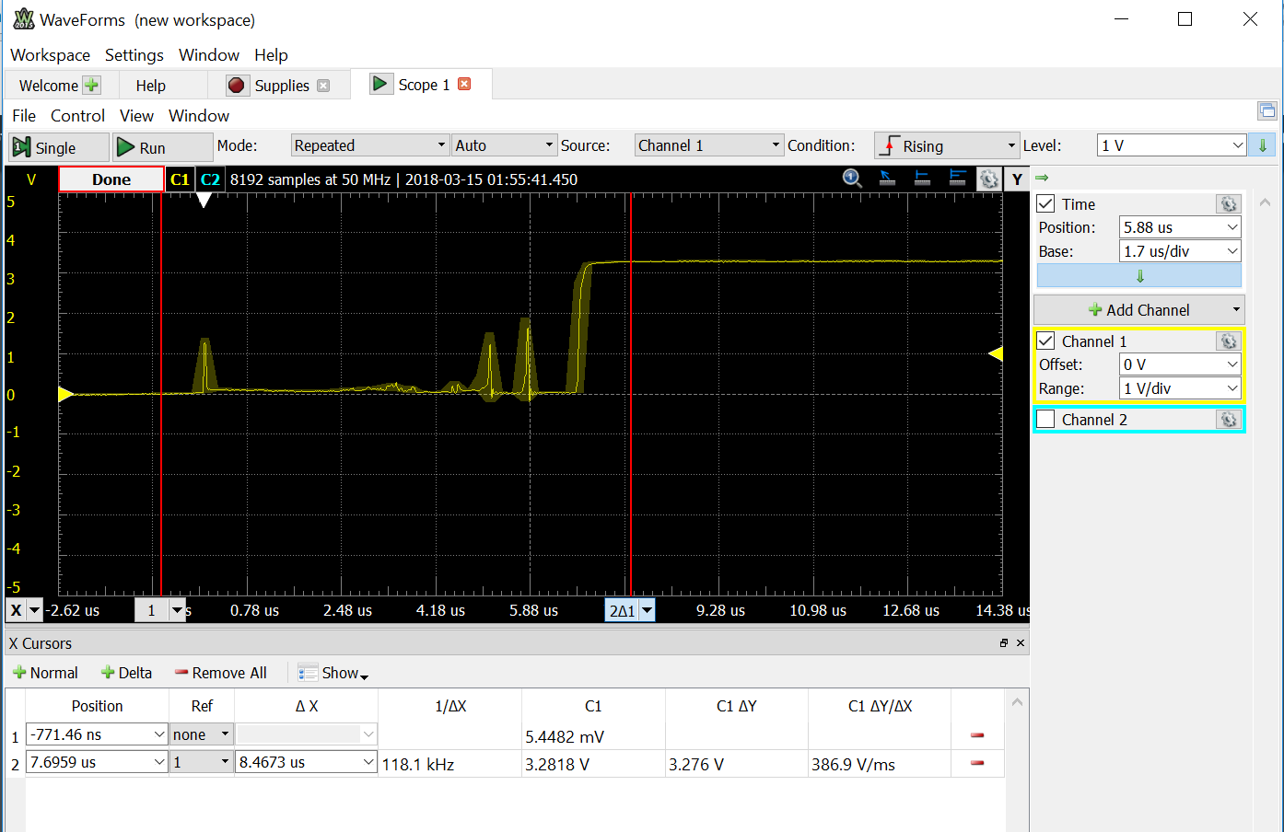

Figure 1: Rising Edge Trigger of DIP Switch Screenshot 1 (On to Off position)

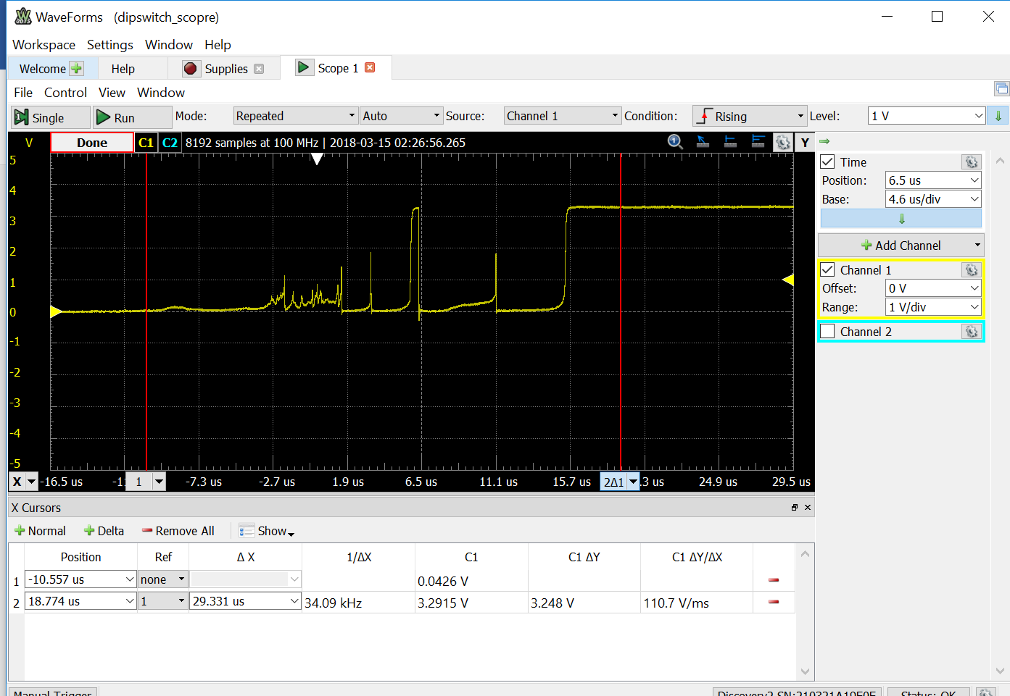

Figure 2: Rising Edge Trigger of DIP Switch Screenshot 2 (On to Off position)

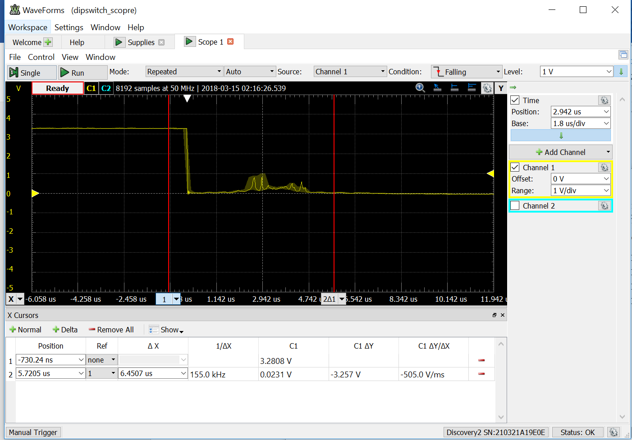

Figure 3: Falling Edge Trigger of DIP Switch Screenshot 1 (Off to On position)

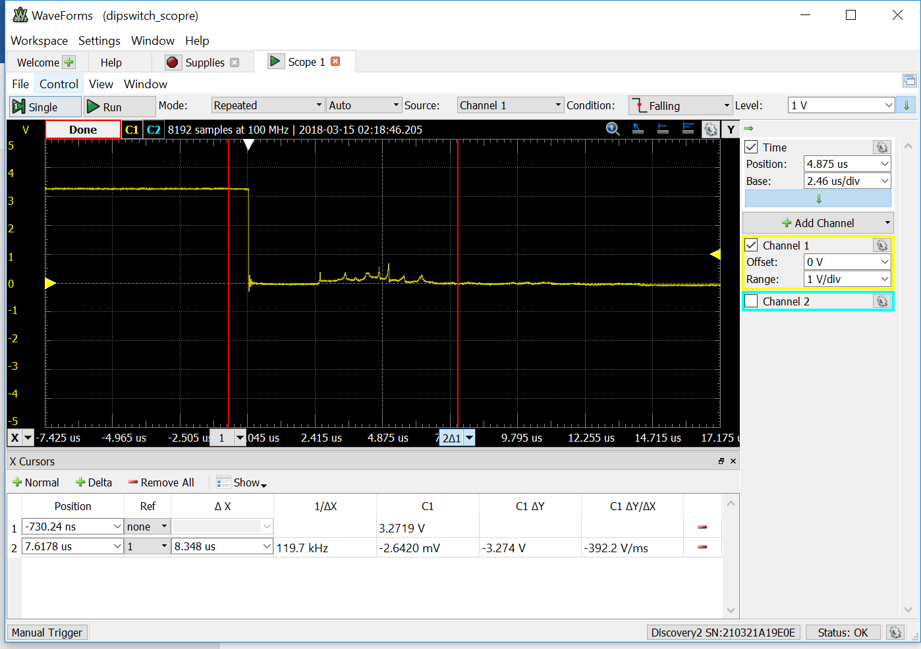

Figure 4: Falling Edge Trigger of DIP Switch Screenshot 2 (Off to On position)

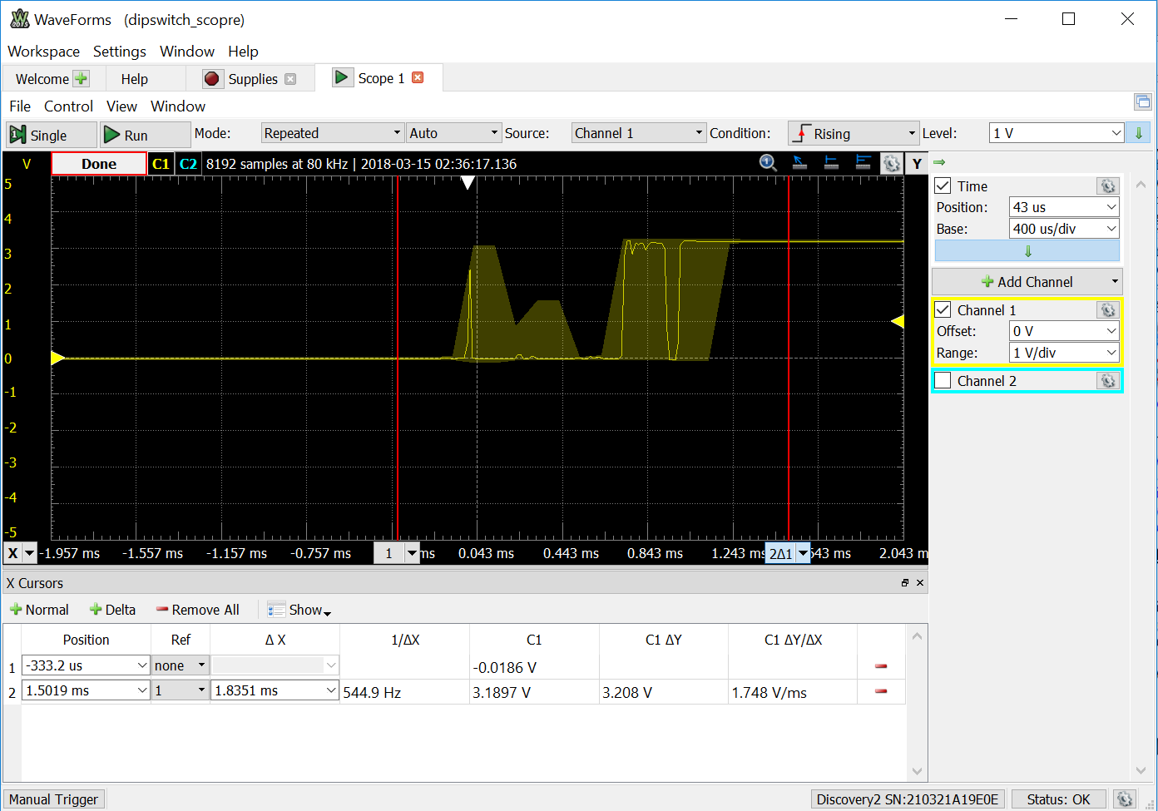

Figure 5: Rising Edge Trigger of Tactile Switch Screenshot 1 (Switch Release)

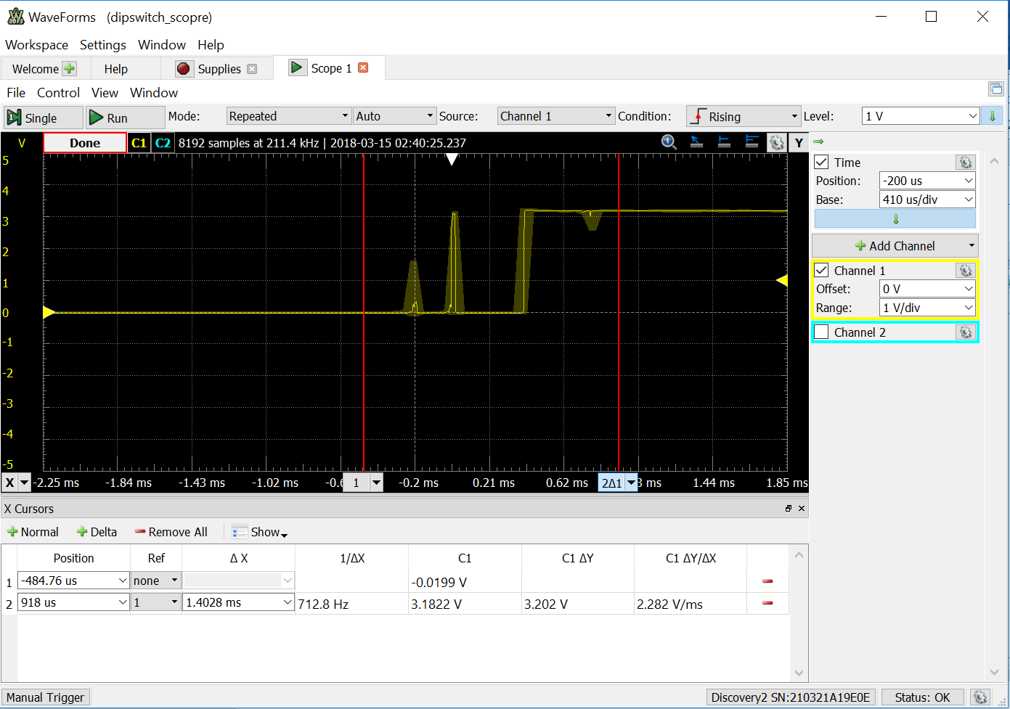

Figure 6: Rising Edge Trigger of Tactile Switch Screenshot 2 (Switch Release)

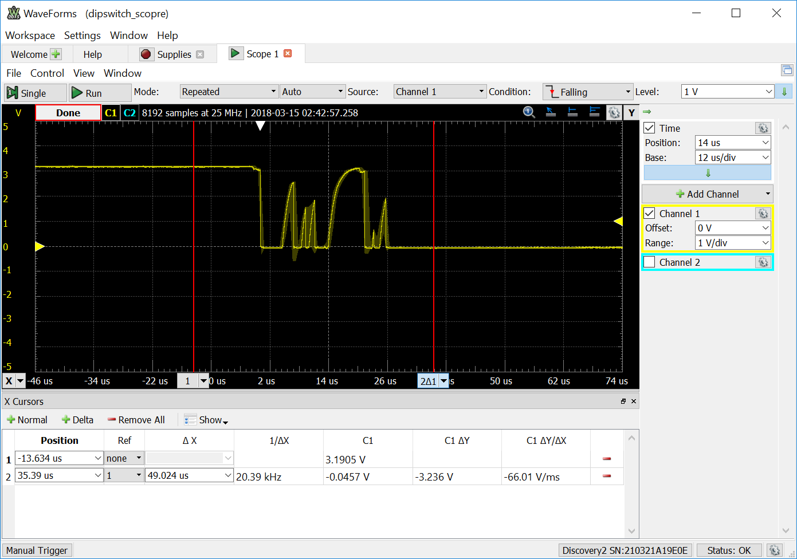

Figure 7: Falling Edge Trigger of Tactile Switch Screenshot 1 (Switch Press)

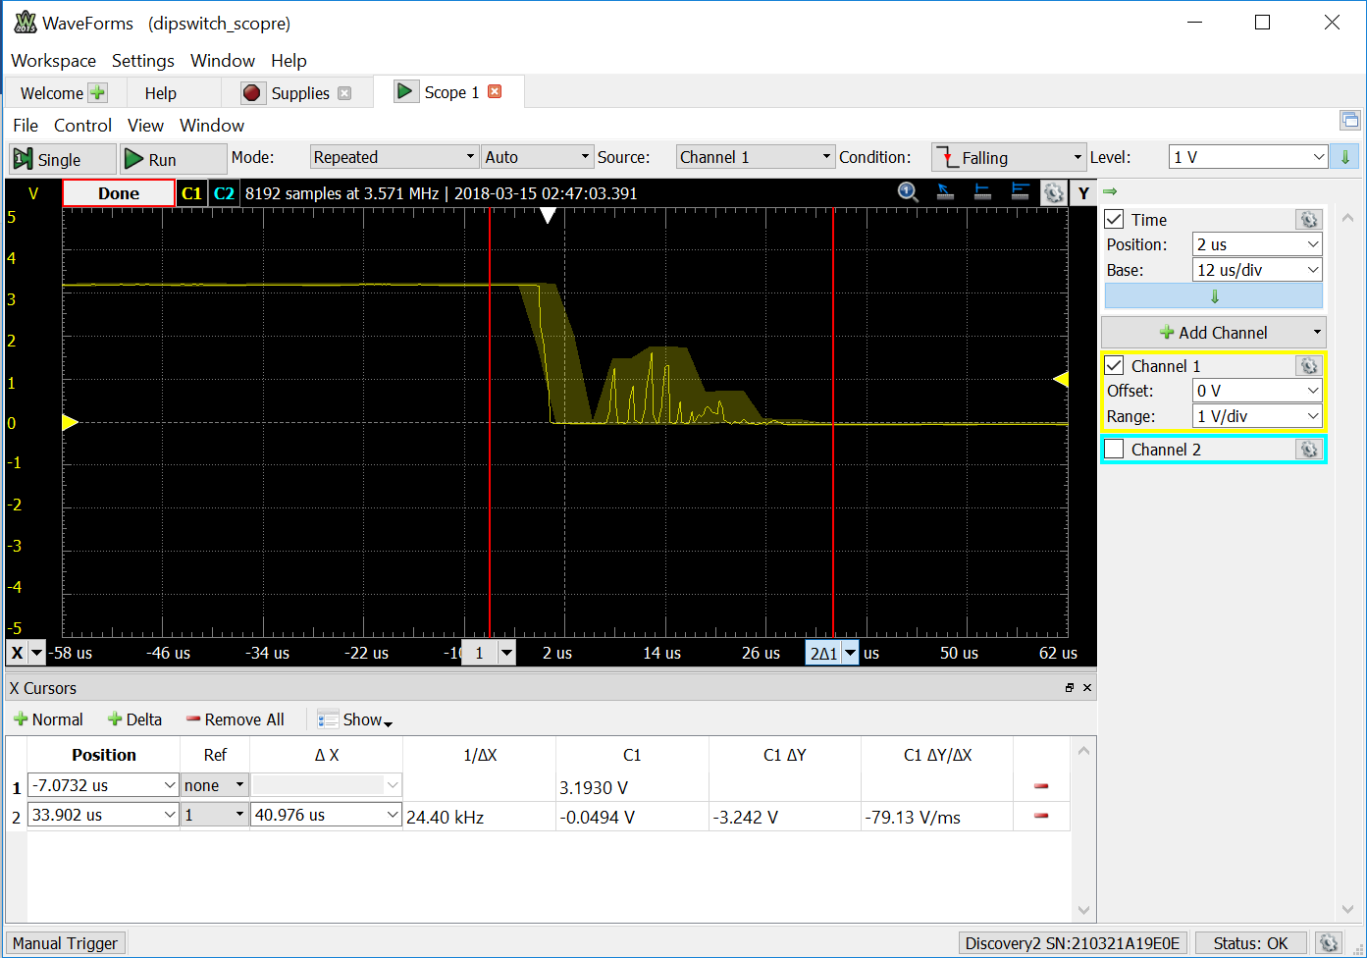

Figure 8: Falling Edge Trigger of Tactile Switch Screenshot 2 (Switch Press)