Personal AI Agent Platform
Product Requirements & Technical Feasibility Assessment
v1 Specification • Engineering Review
Prepared: June 2026

Contents

Part 1 — Initial Requirements

This part restates the product requirements as originally specified, preserved as the baseline against which the feasibility assessment in Part 2 is made.

Vision
Build a next-generation AI personal agent platform that proactively assists users by understanding their goals, context, schedules, communications, and activities. The system combines an Android client, a cloud-based agentic reasoning engine, connected services, and dynamically generated user interfaces to deliver timely, personalized, actionable assistance.
The platform should feel less like a chatbot and more like an intelligent chief of staff that continuously monitors user-authorized information sources and surfaces relevant actions, insights, reminders, and recommendations.

Goals
- Understand user goals through onboarding.
- Continuously maintain user context.
- Monitor authorized information sources.
- Detect important and time-sensitive events.
- Prioritize information on behalf of the user.
- Generate actionable recommendations.
- Present information through dynamically generated UI components.
- Support voice-first interactions when appropriate.
- Minimize user effort while maintaining user control.

Functional Requirements

1. User Onboarding
Establish an understanding of the user's goals, priorities, workflows, and preferences. Users shall be able to:
- Enter goals through text or voice.
- Define personal and work-related objectives.
- Define preferred communication styles.
- Define notification preferences.
- Update goals at any time.
Onboarding output includes a personalized user profile, agent operating instructions, an initial workflow model, and a priority framework.

2. Android Client
The Android application shall provide onboarding, manage authentication and permissions, collect approved local context, render backend-generated UI, support voice and text interactions, execute approved actions, and display alerts and recommendations.
Context sources may include: calendar events, notifications, contacts, device-usage signals, location (if authorized), installed-application metadata, Android App Functions integrations, and future MCP-compatible integrations.
UI surfaces: dynamic dashboard, AI activity surface, action / alert / timeline / workflow cards, voice interaction panel, and settings & permissions management.

3. Connected Services
Supported connectors: Gmail, Google Calendar, Google Drive, Slack, Teams, Notion, Jira, CRM systems, and future third-party integrations. The platform shall read authorized data, maintain synchronization, extract relevant context, detect important changes, and feed context into agent reasoning.

4. Agentic Reasoning Engine
Continuously reason over user context to determine what matters: understand goals, analyze incoming context, prioritize events, detect opportunities, identify risks, recommend actions, and generate user-facing experiences. Reasoning tasks include meeting preparation, missed-follow-up detection, important-email identification, scheduling conflicts, travel preparation, deadline monitoring, relationship management, and productivity coaching.

5. Event Prioritization
Events are scored across four priority levels:
- Critical — immediate attention (meeting in 15 minutes, flight boarding, production outage, urgent escalation).
- High — action needed within hours (overdue follow-up, deadline tomorrow, missing required document).
- Medium — relevant but not urgent (weekly review, suggested planning).
- Low — informational only (trends, insights, recommendations).

6. Voice Assistant Integration
The platform shall support text-to-speech alerts, voice onboarding, voice queries, and voice-driven actions (e.g., “You have a customer meeting in 30 minutes”, “Three important emails require your attention”).

7. Dynamic UI Generation
The backend generates not only recommendations but also the UI structure to display them; the Android client acts primarily as a rendering engine. Component types include priority cards, action cards, timeline cards, insight cards, and workflow cards. The backend returns structured UI instructions (component type, title, priority, actions) plus a voice prompt rather than plain text.

System Design — Core Components

High-Level Architecture
The diagram below maps the end-to-end flow from the Android client through cloud orchestration and back to the device. Each block is color-coded by its feasibility rating (see Part 2): green = build with confidence, amber = feasible with managed risk, red = constrained / redesign. The blue dashed line is the dynamic-UI render loop that returns the structured UI contract to the client.
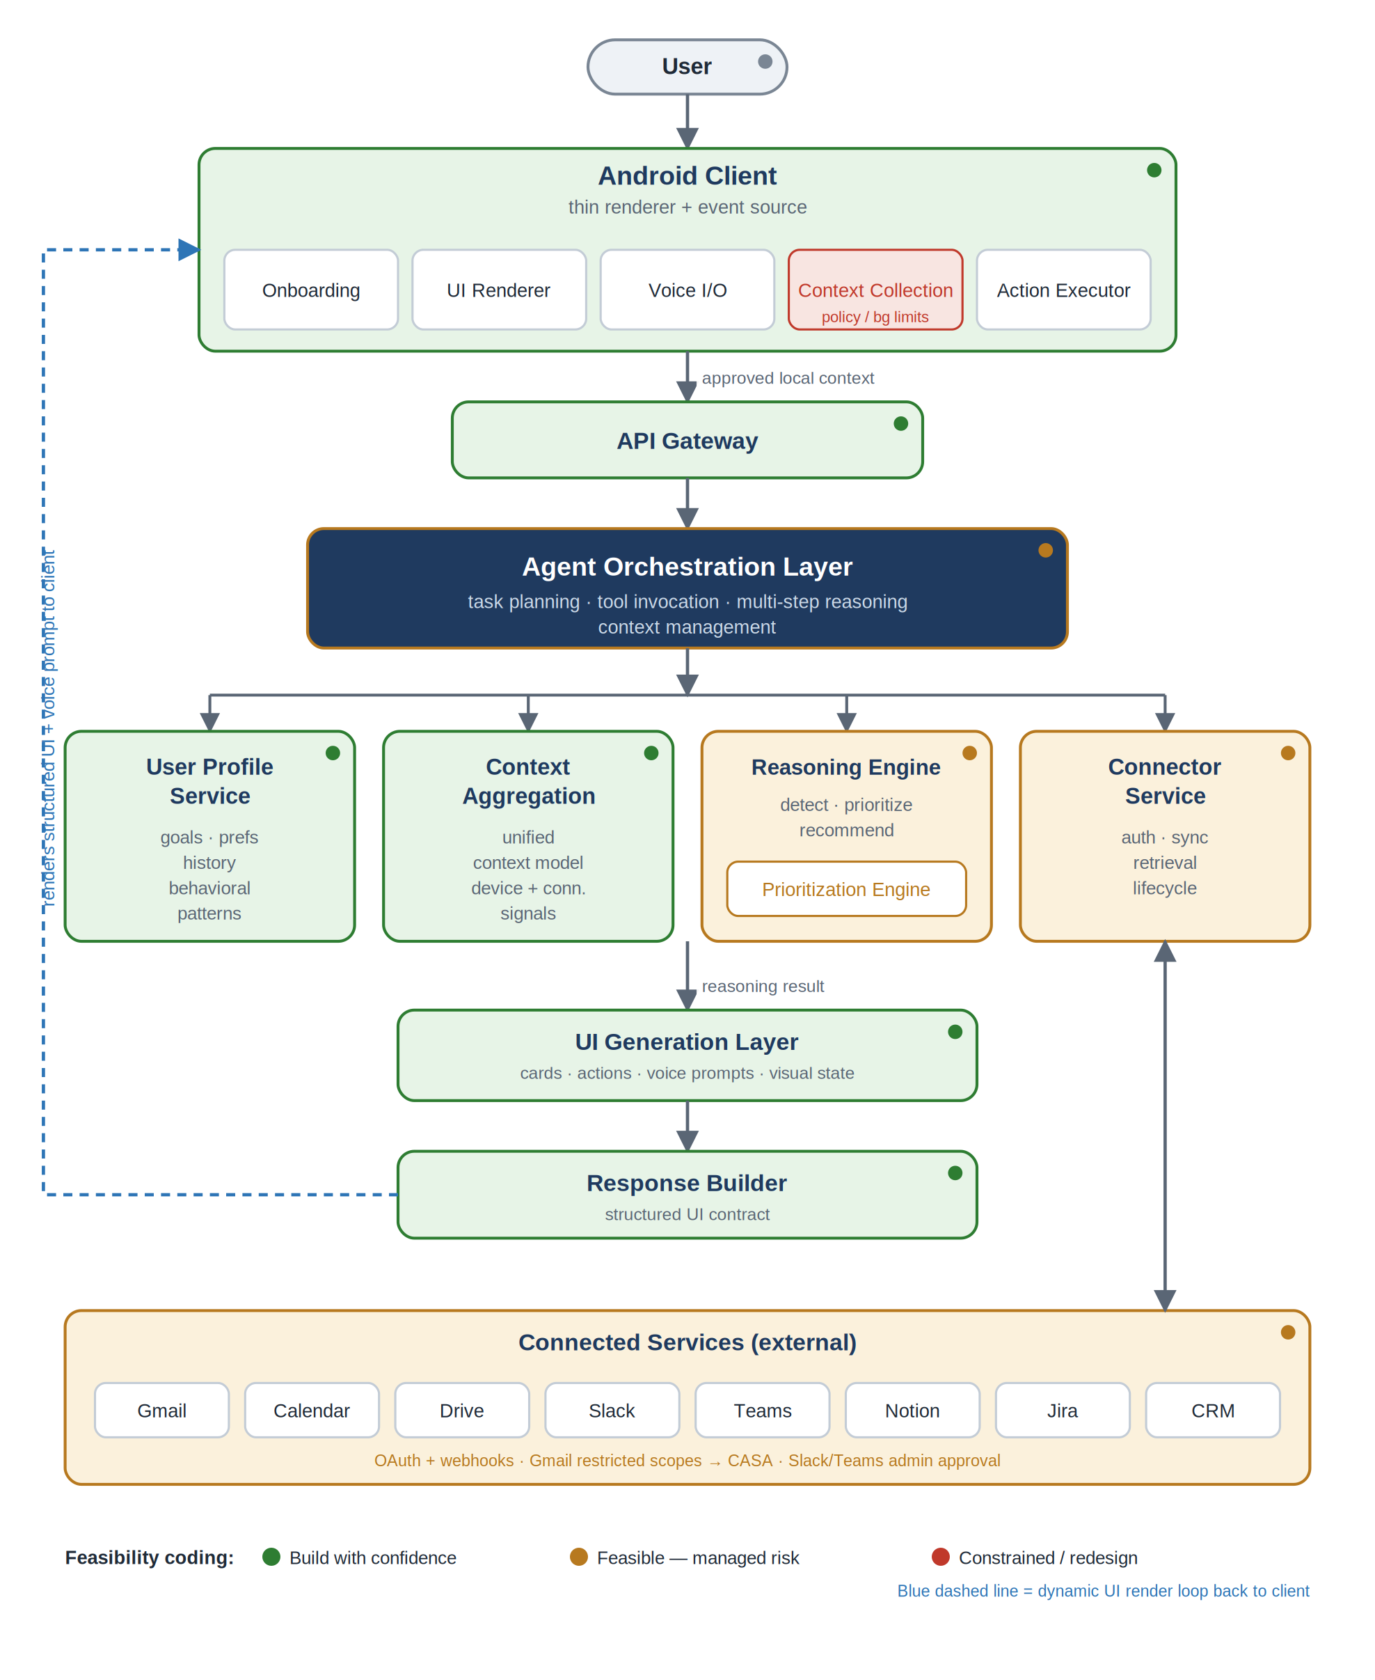
Figure 1. Reference architecture, color-coded by feasibility rating.

Component Responsibilities
The feasibility assessment in Part 2 is organized around these components from the high-level architecture.
Component | Responsibility
Android Client | Onboarding, auth, permissions, local context collection, UI rendering, voice/text, action execution.
User Profile Service | Stores goals, preferences, history, priorities, behavioral patterns.
Context Aggregation Service | Collects device, calendar, communication, workflow, and connector context into a unified model.
Agent Orchestration Layer | Agent execution, task planning, tool invocation, context management, multi-step reasoning.
Connector Service | Authentication, synchronization, data retrieval, connector lifecycle.
Prioritization Engine | Event scoring, urgency detection, attention ranking, notification decisions.
UI Generation Layer | Converts reasoning results into cards, actions, display priorities, voice prompts, visual states.
Response Builder | Assembles structured UI contract returned to the client.

Non-Functional & Scope Baseline
- Performance: UI updates < 1s; near-real-time context ingestion; high-priority alerts delivered immediately.
- Reliability: 99.9% availability; graceful degradation on connector failure.
- Scalability: multi-tenant, horizontal scaling, connector isolation.
- Extensibility: plugin-based connectors; new UI component types and reasoning agents without architectural changes.
- Security: explicit consent, revocable permissions, encryption in transit and at rest, data minimization, account deletion, audit visibility.
- Out of scope: modifying Android OS behavior, replacing system services, controlling third-party apps without approved APIs, autonomous high-risk actions, acting without authorization.

Part 2 — Technical Feasibility Assessment

Each component below is rated on a single axis: can it be built and shipped as drawn? “Feasibility” is separated from “quality” and “policy” — most components build; the risk concentrates in platform constraints, compliance, and the accuracy of the reasoning layer. The summary table is the at-a-glance view; component detail follows.

Feasibility Summary
System Component | Feasibility | Headline
Android Client (shell, render, onboarding, auth, text) | BUILD WITH CONFIDENCE | Proven server-driven-UI pattern. No blockers.
Android Context Collection (device monitoring) | CONSTRAINED / REDESIGN | Background limits + Play permission policy are the main risk.
Connector Layer (Gmail, Calendar, Drive, Slack, Teams) | FEASIBLE — MANAGED RISK | Code is routine; compliance (CASA, admin approval) is the cost.
Agentic Reasoning Engine | FEASIBLE — MANAGED RISK | Buildable now; prioritization quality + LLM cost are the risks.
Event Prioritization Engine | FEASIBLE — MANAGED RISK | Trivial to build, hard to make trustworthy. Quality problem.
Voice Integration | BUILD WITH CONFIDENCE | Triggered TTS/STT easy. Always-on/wake-word is constrained.
Dynamic UI Generation Layer | BUILD WITH CONFIDENCE | Reliable with a fixed card library. Extensibility claim overstated.
AI Surface (animations, status) | BUILD WITH CONFIDENCE | Pure frontend. Low risk.
Backend Services (profile, context, orchestration, gateway) | BUILD WITH CONFIDENCE | Standard microservices.
Security & Consent Baseline | BUILD WITH CONFIDENCE | Standard; design in from day one.
App Functions / cross-app orchestration | CONSTRAINED / REDESIGN | Caller side is system-only (Gemini/OEM). Needs redesign.

Legend: ■ Build with confidence ■ Feasible — managed risk ■ Constrained / redesign

Component-by-Component Assessment

Android Client (shell, rendering, onboarding, auth, text)
Verdict: BUILD WITH CONFIDENCE
What's straightforward
- Onboarding, authentication, permissions UI, text chat, and settings are ordinary app engineering.
- Server-driven UI against a fixed card library (priority / action / timeline / insight / workflow) is a proven pattern (Airbnb-style SDUI). A model emitting constrained JSON against a known schema is dependable today.
Challenges & limitations
- The constraint that makes SDUI reliable is the fixed schema — see the UI Generation Layer note on extensibility.
Recommendation: Treat the client as a thin renderer + event source. Keep the component schema versioned and validated on both ends.

Android Context Collection (device monitoring)
Verdict: CONSTRAINED / REDESIGN
What's straightforward
- Calendar (Calendar Provider), contacts, and foreground location are standard permissioned reads.
Challenges & limitations
- “Continuous monitoring” on-device fights Doze, App Standby, and background-execution limits. The device cannot be an always-on sentinel.
- Notification reading via NotificationListenerService is heavily Google Play policy-restricted; approval is difficult, scrutinized, and revocable.
- Installed-app metadata (QUERY_ALL_PACKAGES) has been restricted since Android 11 and is frequently rejected in review.
- Device-usage signals (UsageStatsManager) require a special-access permission with real UX friction.
- Android 17 tightened background-audio restrictions, affecting voice playback while backgrounded.
Recommendation: Invert the architecture: push “continuous” to the cloud via connector webhooks; treat the device as an event source plus renderer. Do not make notification or app-inventory access load-bearing for core prioritization.

Connector Layer (Gmail, Calendar, Drive, Slack, Teams, Notion, Jira, CRM)
Verdict: FEASIBLE — MANAGED RISK
What's straightforward
- OAuth + webhook/polling sync to each service is well-understood engineering.
- Change detection and context extraction per connector are standard.
Challenges & limitations
- Gmail restricted scopes require an annual third-party CASA security assessment — real cost and weeks of lead time.
- Slack and Teams require per-workspace admin approval; enterprise rollout is gated by IT.
- “CRM systems” is unbounded — each is a separate integration with its own auth and rate limits.
Recommendation: Sequence connectors by compliance lead time, not by code difficulty. Start CASA early. Build a connector SDK so new integrations are plugins, per the extensibility goal.

Agent Orchestration & Reasoning Engine
Verdict: FEASIBLE — MANAGED RISK
What's straightforward
- Multi-step reasoning, tool invocation, and task planning over a unified context model are buildable with current LLMs.
Challenges & limitations
- Quality of prioritization is the actual product and is an ML/eval problem, not a buildability one — the hardest thing to validate from a spec.
- Running an LLM continuously over every user's context is expensive; naive “reason on every signal” will not scale on cost.
Recommendation: Gate the model behind cheap deterministic pre-filters so it only runs on candidate-worthy events. Invest early in an offline eval harness for prioritization accuracy and trust.

Prioritization Engine
Verdict: FEASIBLE — MANAGED RISK
What's straightforward
- Scoring, urgency detection, attention ranking, and notification decisions are trivial to implement.
Challenges & limitations
- Being trustworthy enough that users stop double-checking is the bar — a quality problem, not a feasibility one.
- Mis-ranked alerts erode trust fast; false positives are more costly than misses for a “chief of staff”.
Recommendation: Make the priority threshold tunable per user, log every decision, and use the audit trail to drive eval and personalization.

Voice Integration
Verdict: BUILD WITH CONFIDENCE
What's straightforward
- Triggered text-to-speech alerts and speech-to-text queries are easy.
- Voice onboarding and voice-driven actions over your own action set are feasible.
Challenges & limitations
- Always-on / wake-word listening is constrained on Android and battery-sensitive.
- Android 17 background-audio rules affect alert playback when the app is not foregrounded.
Recommendation: Ship triggered/on-demand voice first; defer always-on. Use foreground services or system notification channels for time-critical spoken alerts.

Dynamic UI Generation Layer
Verdict: BUILD WITH CONFIDENCE
What's straightforward
- Generating a constrained JSON layout against a fixed component library is reliable and is the platform's genuine differentiator.
Challenges & limitations
- “New UI component types without Android updates” is overstated: the client can recompose primitives it already ships, but a genuinely new component type needs a client update — unless you build a generic layout/rendering engine, which is a substantial undertaking.
Recommendation: Keep the fixed-library approach for v1. Treat a generic rendering engine as a later, scoped initiative — not an assumed free property.

AI Surface (animation, status, indicators)
Verdict: BUILD WITH CONFIDENCE
What's straightforward
- Activity visualization, thinking-state, priority/alert indicators are pure frontend with no platform risk.
Recommendation: Drive all animation states from the same structured response contract so the surface stays in sync with reasoning output.

Backend Services (profile, context aggregation, orchestration, gateway, response builder)
Verdict: BUILD WITH CONFIDENCE
What's straightforward
- Standard multi-tenant microservices: profile store, context aggregation, orchestration, API gateway, response builder.
- Horizontal scaling, connector isolation, and graceful degradation are well-trodden.
Challenges & limitations
- “Near-real-time ingestion” + 99.9% availability is achievable via webhooks; the latency/cost trade-off is the engineering work, not a wall.
Recommendation: Design the cost and latency budget alongside the reasoning gating so the two are co-tuned.

Security & Consent Baseline
Verdict: BUILD WITH CONFIDENCE
What's straightforward
- Explicit consent, revocable scopes, encryption in transit and at rest, data minimization, account deletion, and audit logging are standard.
Challenges & limitations
- Audit visibility for connected services and revocation must be first-class, not retrofitted — it interacts with every connector.
Recommendation: Build consent and audit as a cross-cutting service from day one; it is cheap early and expensive to retrofit.

App Functions / Cross-App Orchestration
Verdict: CONSTRAINED / REDESIGN
What's straightforward
- Your app can EXPOSE App Functions to the system (act as an on-device tool provider to Gemini).
Challenges & limitations
- As of May 2026, App Functions is in private preview / alpha and the caller-side EXECUTE_APP_FUNCTIONS permission is restricted to system-level callers — currently Gemini and OEMs only.
- Your app therefore cannot BE the agent that orchestrates the user's other installed apps via App Functions. That privileged seat belongs to Gemini.
- Depending on this path puts you in direct competition with Gemini's position rather than building on top of it.
Recommendation: Redraw cross-service action around your own connector layer (cloud APIs you control), not on-device App Functions invocation. Optionally expose your own App Functions so Gemini can call into your app — but do not rely on calling out.

The One Reframe
The biggest risks are explicitly not feasibility. Almost everything builds. What can sink this is (1) prioritization quality — the hardest thing to validate from a spec and the easiest to underestimate — and (2) the assumption of continuous on-device monitoring. Invert that assumption — make the cloud and connectors the always-on brain and the device a thin event-source-plus-renderer — and most of the Android platform constraints stop mattering.
Recommended sequencing:
- Lock the structured UI response contract and ship the client as a renderer against a fixed card library.
- Stand up the cloud-centric context + reasoning pipeline with cheap pre-filters gating the LLM.
- Start Gmail CASA and enterprise connector approvals early — they gate the timeline more than code does.
- Build the prioritization eval harness before scaling reasoning spend.
- Defer always-on voice and cross-app App Functions invocation; revisit when the platform APIs open up.

