# Course Project 1

We first download, extract and load the dataset in R

temp <- tempfile()  
fileUrl <- "https://d396qusza40orc.cloudfront.net/repdata%2Fdata%2Factivity.zip"  
download.file(fileUrl, temp)  
con <- unz(temp, "activity.csv")  
activity <- read.csv(con, header = TRUE)  
unlink(temp)

Let's calculate the total number of steps taken per day and plot a histogram.

dailySum <- aggregate(steps ~ date, activity, sum)  
hist(dailySum$steps, main = "Total number of steps taken per day", xlab="")

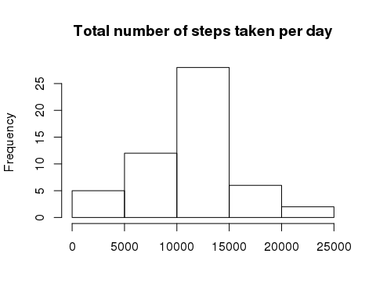

Here's the mean of the total number of steps taken per day.

mean(dailySum$steps)

## [1] 10766.19

Here's the median of the total number of steps taken per day.

median(dailySum$steps)

## [1] 10765

We create a matrix with intervals as columns and dates as rows.

activityMatrix <- with(activity, tapply(steps, list(Date = date, Interval = as.factor(interval)), sum))

Here we create the intervals for the x-axis of the time series plot.

uniqueIntervals <- unique(activity$interval)

We calculate the average number of steps taken per day per interval.

dailyStepsInt <- colMeans(activityMatrix, na.rm = TRUE)

Here's the time series plot of the average number of steps taken averaged across all days.

plot(1:length(uniqueIntervals), dailyStepsInt, type = "l", ylab = "Average number of steps taken each day", xlab = "Five-Minute interval")

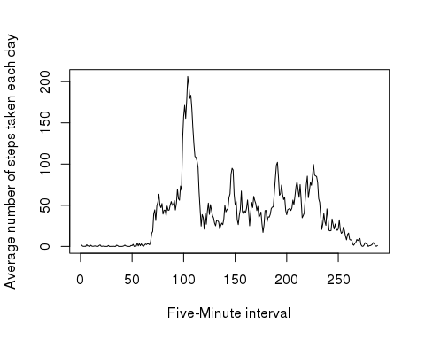

We see here that the 104th 5-minute interval contains the maximum number of steps on average across all the days in the dataset.

which(dailyStepsInt == max(dailyStepsInt))

## 835   
## 104

We impute missing values using the mean for the respective 5-minute interval.

intervalMeans <- colMeans(activityMatrix, na.rm = TRUE)  
  
for (i in 1:nrow(activityMatrix)){  
 for(j in 1:ncol(activityMatrix)){  
 if(is.na(activityMatrix[i, j])){  
 activityMatrix[i,j] = intervalMeans[j]   
 }   
 }  
}

Let's calculate the total number of steps taken each day after imputing missing values and make a histogram.

dailySumNew <- rowSums(activityMatrix)  
hist(dailySumNew, main = "Total number of steps taken per day with missing values imputed", xlab = "")

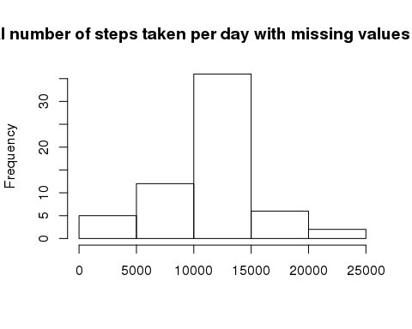

Here's the mean of the total number of steps taken each day after imputing missing values.

mean(dailySumNew)

## [1] 10766.19

Here's the median.

median(dailySumNew)

## [1] 10766.19

Clearly imputing missing values does not significantly change the estimates of the total daily number of steps.

Here, we subset our matrix separately for weekdays and weekends

weekdates <- character()  
for(i in 1:nrow(activityMatrix)){  
 weekdates[i] <- weekdays(as.Date(rownames(activityMatrix)[i]))  
}  
  
weekdates1 <- c("Monday", "Tuesday", "Wednesday", "Thursday", "Friday")  
  
columnNames <- colnames(activityMatrix)  
  
actWday <- subset(activityMatrix, weekdates %in% weekdates1)  
actWnd <- subset(activityMatrix, !(weekdates %in% weekdates1))  
  
dim(actWday)

## [1] 45 288

dim(actWnd)

## [1] 16 288

actWday <- mapply(actWday, FUN = as.numeric)  
actWnd <- mapply(actWnd, FUN = as.numeric)  
  
actWday <- matrix(actWday, ncol = 288, nrow = 45)  
  
actWnd <- matrix(actWnd, ncol = 288, nrow = 16)  
  
colnames(actWday) <- columnNames  
colnames(actWnd) <- columnNames

Finally, we have a panel plot containing time series plot of the average number of steps taken, averaged over all weekdays and weekends.

par(mfrow = c(1,2))  
plot(1:length(uniqueIntervals), colMeans(actWday), type = "l", ylab = "Average number of steps taken on weekdays", xlab = "Five-Minute interval")  
plot(1:length(uniqueIntervals), colMeans(actWnd), type = "l", ylab = "Average number of steps taken on weekends", xlab = "Five-Minute interval")

