Time Series Forecaster: Advanced Stock Market Analysis & Prediction Tool
Electrical & Computer Engineering & Computer Science (ECECS)

SEMESTER

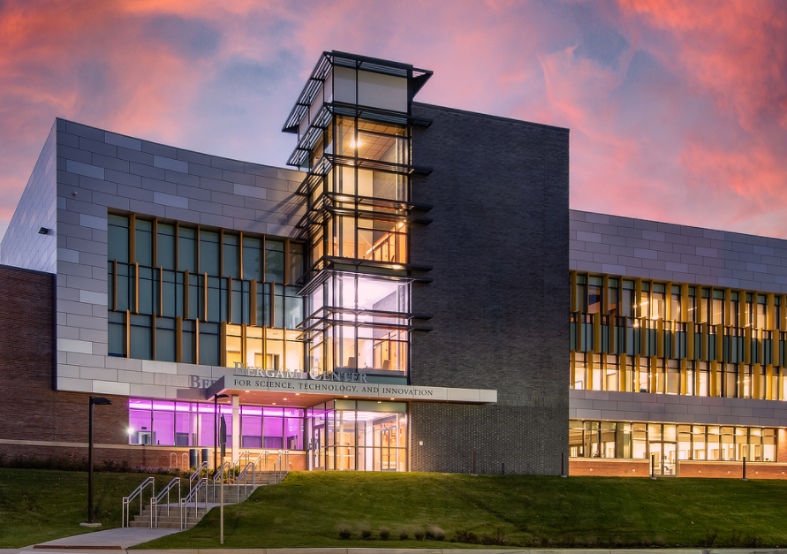



Contents
Project Name 2
Executive Summary 2
Technical Report 3
Highlights of Project 3
Submitted on: 3
Abstract 4
Methodology 5
Results Section 5
Discussion 6
Conclusion 6
Contributions/References 7

Time Series Forecaster: Advanced Stock Market Analysis & Prediction Tool

Executive Summary
This project presents a web-based application designed for advanced time series forecasting and analysis. Built using Streamlit, the app allows users to upload datasets, choose specific time series columns, and apply predictive models including ARIMA, SARIMA, and LSTM. The intuitive interface enables users to perform stationarity checks, visualize decomposition, and view model predictions with minimal technical background. The platform streamlines the forecasting workflow for business analysts, researchers, and data enthusiasts.


Team Members:  - Sunaina Makkena  - Anand Gopi Sai Krishna Polisetty  - Gajendra Varma Penmetsa | Questions ?  Contact : smakk5@unh.newhaven.edu
The system was developed in Python using:
- Streamlit for web app interface
- Pandas and NumPy for data processing
- stats models for ARIMA and SARIMA
- TensorFlow/Keras for LSTM neural networks
- matplotlib/seaborn/plotly for visualizations

It allows model customization (like p, d, q values for ARIMA/SARIMA and epochs/layers for LSTM), produces interpretive plots (ACF, PACF, decomposition), and outputs forecast vs actual comparisons along with residual diagnostics.

Technical Report
Time Series Forecaster: Advanced Stock Market Analysis & Prediction Tool

Highlights of Project
Model Choices: ARIMA, SARIMA, and LSTM
Visual Outputs: ACF, PACF, STL decomposition, forecasts, residuals
LSTM Integration: Allows for deep learning-based time series modeling
User Customization: Set train-test split and model parameters
Real-time Analysis: Immediate output on running analysis
CSV Upload Interface: Clean, step-by-step UI flow

Submitted on: 30th April 2025

Abstract
The Advanced Time Series Analyzer is a user-friendly tool for performing in-depth time series forecasting. It simplifies the process of data uploading, model configuration, and result interpretation through an interactive web interface. Supporting traditional statistical models as well as modern deep learning methods, the app is adaptable for a variety of time series problems in finance, retail, weather, and more.

Cover Page:

Title of the report: Time Series Forecaster: Advanced Stock Market Analysis &Prediction Tool
Name of the authors: Sunaina Makkena, Anand Gopi Sai Krishna, Gajendra Varma Penmetsa
Contacts: smakk5@unh.newhaven.edu
Date of publication: April 30th,2025

Executive Summary

The Advanced Time Series Analyzer provides a user-friendly web interface for sophisticated time series forecasting without requiring programming expertise. The tool supports multiple forecasting models (ARIMA, SARIMA, LSTM), delivers interactive visualizations, and offers comprehensive error metrics. It enables analysts, business users, and data scientists to quickly process historical data, identify patterns, and generate reliable predictions for business planning and decision-making across finance, retail, manufacturing, and other domains.

Introductory Section

Time series data—sequential observations collected over time—is fundamental to decision-making across finance, retail, manufacturing, and numerous other fields. The Advanced Time Series Analyzer transforms complex forecasting techniques into an accessible tool for professionals without requiring statistical or programming expertise.
This application addresses key challenges in time series analysis by automatically identifying patterns (trends, seasonality, cycles), applying appropriate models (ARIMA, SARIMA, LSTM), and evaluating prediction accuracy through clear visualizations and metrics. Users can upload historical data, configure model parameters through an intuitive interface, and generate reliable forecasts to support strategic planning and operational decisions.
Whether analyzing stock market trends, predicting sales volumes, or forecasting resource requirements, this tool provides the analytical capabilities needed to transform historical patterns into valuable future insights.

Review of available research

Traditional models like ARIMA and SARIMA are widely used for linear time series forecasting, while LSTM models handle more complex, nonlinear patterns. Research, including the M4 competition, shows that combining statistical and deep learning models can improve accuracy. However, these methods often require technical skills. This project addresses that gap by offering an easy-to-use tool that automates forecasting, aiming to match expert-level accuracy without requiring programming or statistical expertise.

Methodology

Title of the Project:
Time Series Forecaster: Advanced Stock Market Analysis &Prediction Tool

Business Understanding:

The goal of this project is to create an accessible forecasting tool that enables professionals to uncover patterns and make data-driven decisions using time series data—without needing deep statistical or programming knowledge. The tool is designed to help users across industries predict future values (e.g., sales, stock prices, resource demand) accurately by automating model selection and providing intuitive visualizations.

Data Understanding:
Historical time series datasets were collected from various publicly available sources such as stock market data (e.g., Yahoo Finance), retail sales, and energy consumption. These datasets include timestamps and numeric values (e.g., daily closing prices, monthly sales). A review of the literature supported the inclusion of variables like trend, seasonality, and lag values, which are critical for accurate modeling.

Data Preparation:
Data preprocessing steps included:
- Handling missing values via interpolation
- Converting timestamps to a uniform datetime format
- Resampling to ensure consistent intervals
- Normalizing or scaling values (for LSTM models) Feature engineering techniques such as creating lag features and decomposing seasonality were also used to enhance model input.

Modeling
- ARIMA: for stationary series with trend but no seasonality
- SARIMA: for seasonal time series data
- LSTM: for learning complex, nonlinear temporal relationships
The system uses automated methods (e.g., AIC, cross-validation) to select model parameters and fit the models to the data. Users can also manually configure model settings.
Evaluation
- Mean Absolute Error (MAE)
- Root Mean Squared Error (RMSE)
- Mean Absolute Percentage Error (MAPE)
Visualization tools were integrated to compare actual vs. predicted values, enabling users to interpret forecast accuracy clearly.

Results Section

- Data Engineering Pipeline: 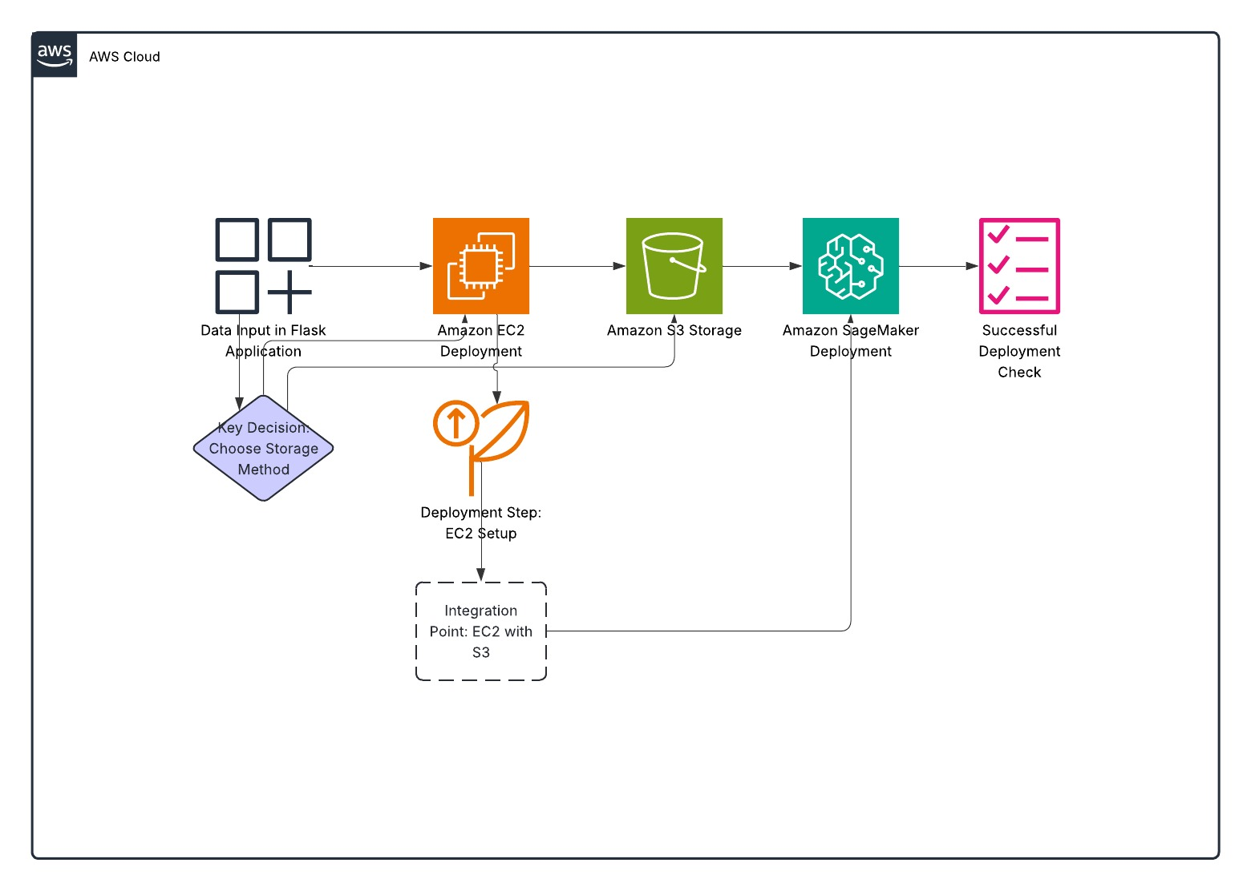

1. Data Ingestion
- Tool/Application: Flask (via app.py)
- How It Works:
  - Users upload CSV files through a web interface.
  - Data is read using Pandas and stored temporarily for analysis.
  - File ingestion is managed by the /upload route in app.py.

2. Data Storage
- Tools:
  - Amazon S3 (in the architecture diagram)
  - Local Server Storage (via uploads/ folder in Flask app)
- How It Works:
  - Uploaded CSVs are temporarily stored in uploads/.
  - In a production AWS setup, this can be integrated with Amazon S3 for scalable object storage.

3. Data Processing
- Tools:
  - Python (Pandas, NumPy, Seaborn, Matplotlib)
  - ARIMA, SARIMA from Statsmodels, and LSTM from TensorFlow/Keras
- How It Works:
  - Data is split into training and testing using prepare_timeseries_data.
  - Statistical and deep learning models are trained on the data using ARIMA/SARIMA/LSTM.
  - Plots are generated and encoded as images for visualization.

4. Data Consumption
- Tools/Apps:
  - Flask Web App Interface
  - API Endpoint (/api/model_results)
- How It Works:
  - Users select models and parameters on the UI.
  - Forecasts and evaluations are returned visually through HTML or as JSON via API.

Model Deployment
- Environment:
  - Models are deployed in a Flask application hosted on Amazon EC2 (as per the diagram).
  - TensorFlow models (LSTM) and Statsmodels models (ARIMA/SARIMA) are invoked on-the-fly.
  - Future option to deploy models with Amazon SageMaker as shown in the architecture diagram.

Data Visualization
- Tools:
  - Matplotlib, Seaborn, HTML tables (via render_template)
- Visual Outputs:
  - Time series plots
  - ACF/PACF plots
  - Seasonal decomposition
  - Forecast vs actual comparison
  - Residual analysis (residuals, QQ plot, distribution)

Deployment
- Stack:
  - Flask App on Amazon EC2
  - Model predictions and plots rendered in browser
  - Potential for integration with Amazon S3 for data and SageMaker for model hosting
- Integration Point: EC2 ↔ S3 (used for storage and model data passing)

Discussion
The flexibility of switching between ARIMA, SARIMA, and LSTM allows users to compare model performance across different types of time series. While ARIMA is efficient and interpretable, LSTM excels in capturing long-term dependencies. SARIMA proves valuable for seasonal datasets. However, LSTM requires more data and training time. The app makes these models accessible without writing code, making it suitable for non-programmers.

Conclusion
The Time Series Analyzer simplifies the forecasting pipeline by merging classic and modern forecasting techniques into an intuitive platform. It enhances exploratory data analysis, helps users select the right model, and provides clear visualizations for better decision-making.

Contributions/References
Contributions:
- UI & Integration: [Sunaina Makkena]
- Model Implementation: [Anand Sai Gopi Krishna Polisetty]
- Testing and Debugging: [Gajendra Varma Penmetsa]

References:
- Box, G.E.P., Jenkins, G.M. (1970). Time Series Analysis: Forecasting and Control
- Hochreiter, S., Schmidhuber, J. (1997). Long Short-Term Memory
- https://www.statsmodels.org/
- https://keras.io/
- https://streamlit.io/

