- Navigate to Apple store and search F5 access:
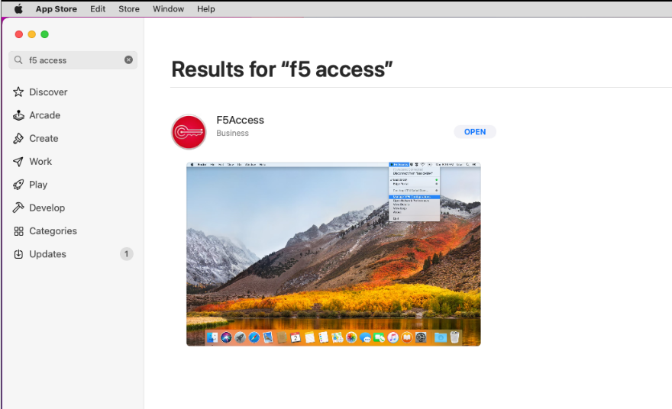

- Click to install:
- Open Installed software and Navigate to Manage VPN Configurations:
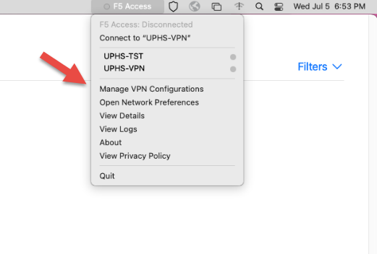
- Configure as shown in the picture:
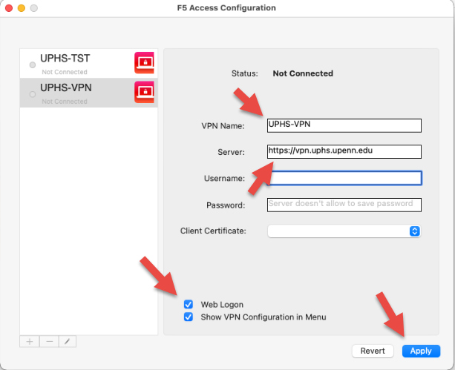
- Click on Just configured Server to connect:
