Turning Cellular into Secure Transport for Critical Infrastructure.
Security and identity for the access network

Utility providers operate tens or even hundreds of thousands of field devices, including meters, reclosures, operational technology, IT systems, surveillance equipment, and sensors at remote sites. Given the wide operational geography, cellular technology such as private LTE and 5G is proving to be the ideal access network to consolidate communications.

However, many existing devices do not have their own SIM card or cellular interface. In these situations mission critical organizations have often embraced Semtech Airlink Routers to achieve connectivity over cellular networks. This approach solves the connectivity problem very well, but it also introduces new architectural questions that directly impact security: endpoint identity, device-level visibility, carrier dependency, IP planning, and operational scale.

Some of the key challenges with cellular field connectivity - with or without private APN - are the following:

1. Lack of Visibility
Often the network owner lacks visibility into the devices and the traffic they send. If there are more than one device, this challenge is especially difficult to solve since the wireless router often NATs all the traffic.

2. Limited or no Threat Prevention
In order to adhere to Zero Trust best practices, we must continuously monitor the traffic traversing the network, especially traffic from critical assets. Often organizations use firewalls to help with the security of traffic to and from these wireless routers, but lack comprehensive defense against known and unknown malware, malicious DNS queries or attacks, malicious URLs and other related threats.

3. SIMs and carrier IPs are not enough as endpoint identity:
A SIM, APN, or carrier-assigned IP connects the router, but it may change or be spoofed and can therefore not be used as solid proof of identity. Instead, an inseparable identity criteria tightly bound to the box is needed.

4. Carrier design can become carrier lock-in
Utility IT departments need to coordinate address ranges, routing, private APNs, NAT behavior, redundancy, and failover with each carrier. Different carriers may not offer the same design, coverage, availability, or private addressing models. And private APNs have a cost.
Changing carriers or adding a second SIM shall not become a network redesign but a simple, transparent transport change.

5. Manual security does not scale
In cases where VPNs are used, per-router VPN settings, certificates, tunnel status, routes, renewals, revocation, and firewall policy cannot be handled manually across thousands of field routers. Either operations would slow down, or teams fall back to shared secrets, inconsistent templates, or stale configuration.

The Solution: A VPN Overlay – Make Cellular the Transport, Not the Architecture
The separation of concerns seems natural: Cellular providers supply radio access and transport, the utility shall own the end to end traffic. To achieve this, the architecture uses identity-bound secure access: a certificate-based IPSec VPN approach that makes cellular the transport layer, while the utility keeps control of identity, addressing, segmentation, visibility, and security policy.

Semtech Airlink Cellular routers support the EST (Enrollment over Secure Transport) protocol, enabling seamless interactions with Palo Alto Networks PKI solutions and corresponding certificate enrollment at scale.

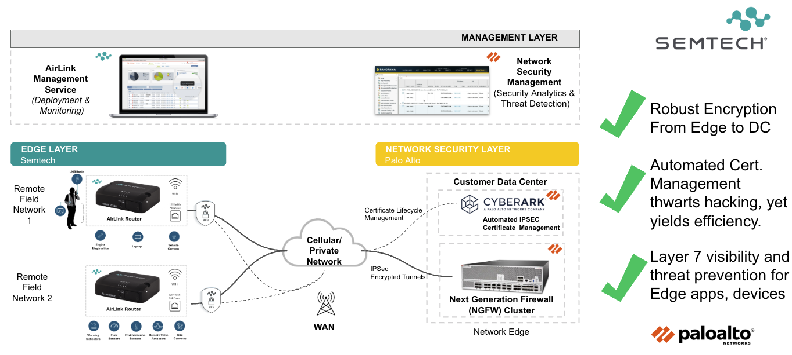

By abstracting field connectivity from the underlying cellular carrier, the architecture delivers following benefit to utility providers:

- Complete Visibility
As the architecture above shows, traffic is sent to a centralized NGFW for IPSec tunnel termination and traffic inspection. Using App-ID, the NGFW is able to ensure that only valid traffic is sent to and from the connected devices. Any anomalous traffic can be alerted on to ensure know spurious devices or traffic are on the network.

- AI Enabled Threat Prevention
Operational Technology (OT) traffic is secured through our Precision AI™ engine, a system that blends machine learning, deep learning, and generative AI to deliver autonomous, real-time protection. Built directly into their Next-Generation Firewalls (NGFW) this AI-driven approach provides non-intrusive, passive discovery to analyzing behavior rather than relying solely on static signatures. Precision AI enables inline prevention of zero-day attacks and evasive command-and-control (C2) threats targeting cyber-physical systems.

3. Identity-Driven Router Authentication
The IPSec endpoints are not trusted merely because traffic came from a certain carrier IP address. A SIM could be moved and an IP address could change or be spoofed. Fully automated Certificate enrollment based on protocols like EST (Enrollment over Secure Transport) ties the router HW to the identity of the box: The issued certificate is inseparably bound to the router’s serial number, and the VPN uses that certificate to identify the specific router — independent of SIM, carrier, or IP address.

4. Carrier independent IP planning
The cellular connection can use whatever carrier IP, SIM, APN, or mobile network is available. Inside the IPSec tunnel, the utility preserves its own end-to-end addressing plan for the actual devices behind the router. A router can use one carrier, change carrier, or use multiple SIMs for redundancy, while application traffic and security policy between field devices and the data center remain unchanged.

Lower Opex, Better Control and Stronger Security by Automation
This architecture pays back operationally. It reduces carrier dependency, manual configuration, troubleshooting effort, and the risk of inconsistent security design.

The main operational benefits are:

- Granular Application control and threat prevention: Every protocol can be dissected and individual message types be blocked or allowed only in one direction. Threats like message-floods, exploits or malicious traffic are detected at one central point.
- Carrier changes become transport changes: A new SIM, carrier, or mobile-side IP address does not require the utility to redesign its field addressing or security policy, private APNs are not a requirement for end-to-end IP-planning>
- Less manual configuration means fewer errors: Routers enroll automatically, receive the right configuration, build the VPN presenting the correct identity without field teams manually handling secrets or tunnel parameters..
- Certificate lifecycles are manageable: Certs can be issued, renewed, revoked, and tracked through enrollment records, revocation lists and online status checks
- Troubleshooting becomes easier: Operations teams can distinguish between carrier transport issues, router issues, endpoint issues, and application/security policy issues.

A VPN from the Airlink cellular modem/router to the utility data center is therefore not just encryption. It gives the utility a controlled architecture where identity, visibility, segmentation, application inspection, and operations are managed independently of the carrier network while allowing the utility to focus on its core mission of delivering safe, reliable, and efficient power while maintaining complete ownership and security of its operational data.

For an example of a joint solution leveraging the technology above, check out our Joint Solution Brief with Semtech Corporation and their Airlink routers.

