Technology Partner Program
Use Case Documentation
Author: SEMTECH



What is this document

Script for video recording
The original Integration Guide is a public document, currently reviewed version is here

We also need a video recording, which essentially illustrates the content of this guide. Hence we will:
- Split the guide into senses of 20-60sec each
- Add narration
- Generate callouts
- Review chapters / titles / structure
- Generate pause markers

After this, we will feed the document and other into an AI tool that generates the video.

FRAME STORY:

Scene 1:
Palo ALto NEtworks ⇒ Security
Semtech ⇒ Connectivity
Joint solution: Secure connectivity for utility providers.

Scene 2:

Integration Benefits
- End-to-end, context-aware security with local link protection, encrypted transport, application visibility, and threat prevention.
- Automated onboarding, configuration, fleet monitoring, and over-the-air (OTA) updates across thousands of devices.
- Unified visibility, logging, and policy enforcement across edge and firewall deployments.
- Open standards, no vendor lock-in—IPsec, EST, and REST APIs integrate easily with existing security infrastructure.
- Seamless public key infrastructure (PKI) and certificate lifecycle management (CLM) automate certificate provisioning and renewal, strengthening IPsec auth and preventing expiry outages.

Scene 3:

Integration Diagram

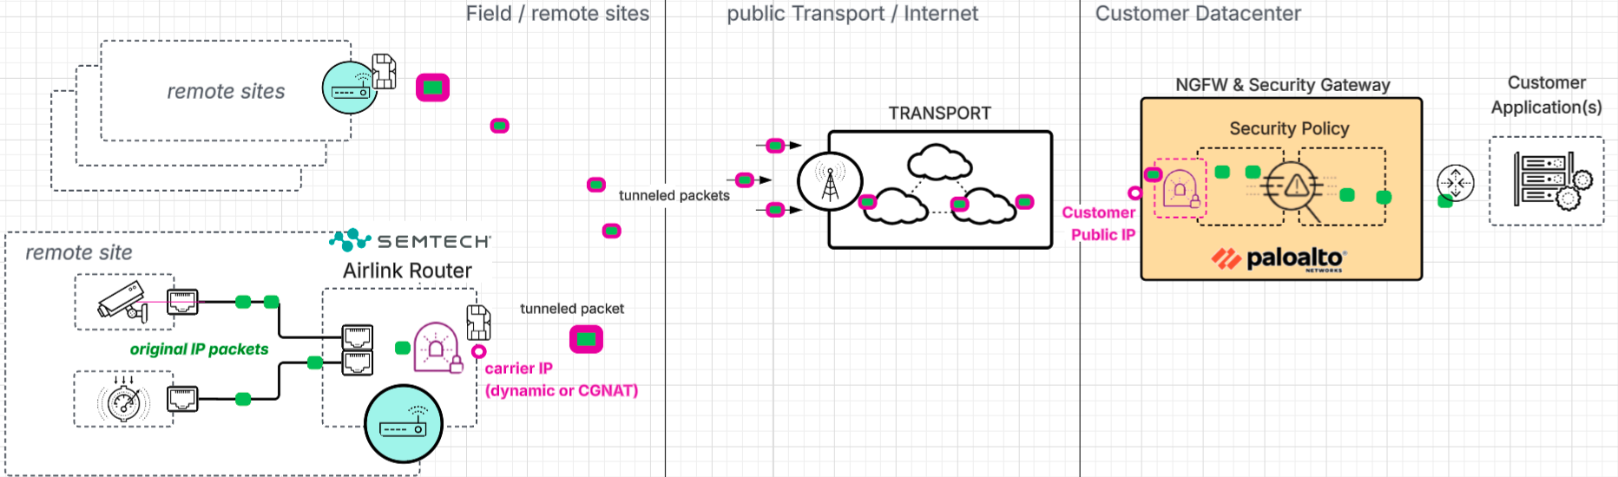

PRODUCTS USED
ZT-PKI for EST Enrollment
To set up EST enrollment in an Airlink Router, following data is needed
- EST Enrollment URL (e.g. https://ztpoki.venafi.com)
- EST Policy Label (a hash-type string that defines under which policy in the ZT-PKI a request must be handled and against which it will be authenticated)
- EST API key and API Key ID (as credentials for the EST request in the ZT-PKI)

IPSec shared information
To set up IPSec on both sides PanOS and Airlink, following information must match on both sides:
- Local Networks on each side:
  - The Airlink local Network that will be routed through the IPSec tunnel, and that is used by the devices wired to the Airlink. It is required to provide one unique network for each Airlink, or to cater via separate logical routers on the NGFW side for overlapping IP ranges. Within the IPSec tunnels belonging to one Logical Router or VRF, the IP network behind an Airlink must be unique.
  - The NGFW network(s) in the customer datacenter. Traffic from those network(s) is routed back into the IPSec tunnels if the Airlink local networks are destination

- Certificate certified Identities:
When the certificates are issued, the subjects need to add a “Subject Alternate Name” (SAN) into the Certification Request. This name does NOT need to be a registered DNS name or resolvable, it can be any name that the peers present to each other to mutually identify. In PanOS, the NGFW identifies the IKE GW to use for the connection/tunnel by searching this SAN in its list of available IKE Gateways.
- The Airlink SAN DNS:[airlink serial number] becomes the IPSec localID on the airlink and the IPSec remoteID on the NGFW
- The NGFW SAN DNS:[e.g. FW hostname or serial] becomes the IPSec localID on the NGFW and the IPSec remoteID on the Airlink routers

Before You Begin
Make sure you have the following available:
- Access to the local configuration interface of the Airlink Router. This can be either via ALMS or from local login.
- Access to the NGFW PanOS GUI
- Access to the ZT-PKI GUI to fetch API keys, CA labels and to manually enroll NGFW Certificates
- Planning Data: Airlink local network(s) at least 1 per Airlink, NGFW Datacenter Network, and the EST enrollment data for the Airlinks.

To be able to get a fully functioning IPSec tunnel and test it, you need one local device to connect to the Airlink router (e.g. a PC/Laptop)

To be able to enroll for EST or manual certificates, you must know which CA Policy and organisation/account is assigned to your project! You can not define anything in the PKI policies, but need to go to the right place to find your settings! This has proven to be a confusing step - make sure you know where to go before you start !
Note, that issued certificates are “sensitive”: Per se a certificate is public information and not needed to be kept secure (only the private key). But when you issue a certificate on an existing customer account in the PKI, it means that you generated a key that can access the customer's network now, because they trust that CA! Hence account discretion is important and you must not issue certificates without permission of the CA owner!

Overall Workflow
Note that the "Integration" materialises as a certificate-authenticated IPSec tunnel. Hence it is configured in a triangle on 3 platforms:
- Certificate preparation in the ZT-PKI
- IPSec client side configuration on the Airlink router
- IPSec passive/server side configuration in the NGFW

For your orientation in the process, follow this order of steps

# | Step | Execute  on | Description | Chapter  reference
1 | Verify CA Label | ZT-PKI | Fetch different parameters you need during the process from the PKI, save in a txt file until you're done. | Step 1 link
2 | Generate API Key | ZT-PKI | Keep that along with the other parameters from the previous step, to later define EST credentials | Step 2 link
3 | Download EST CA Certificates | ZT-PKI | Need to copy those later to Airlinks (all) and NGFW | Step 3 link
4 | Fetch TLS CA Certificates | web | Need to copy this later to Airlinks (all) | Step 4 link
5 | Generate NGFW Certificate Profile | NGFW | To ensure that EST certificates can be verified | Step 5 link
6 | Generate NGFW CSR | NGFW | NGFW does not have an EST client or Certificate Management Protocol that we can use with ZT-PKI. | Step 6 link
7 | Issue NGFW Certificate | ZT-PKI | For NGFW to authenticate towards Airlinks (all) | Step 7 link
8 | Import NGFW Certificate | NGFW | For NGFW to authenticate towards Airlinks (all) | Step 8 link
9 | Upload CA-Certs to Airlink | Airlink | To ensure that EST certificates can be verified | Step 9 link
10 | Configure Airlink EST Credentials | Airlink | Use API key for EST enrollment credentials | Step 10 ink
11 | Configure Airlink CSR | Airlink | Define how Airlink EST CSR will look like | Step 11 link
12 | Configure Airlink local Networks | Airlink | Define the networks that go through the IPSec tunnel | Step 12 link
13 | Configure Airlink IPSec | Airlink | Configure IPsec client crypto and local params | Step 13 link
14 | TEST BEFORE CONTINUING | NGFW | Check if IKE requests from Airlink are arriving | Step 14 link
15 | Verify Crypto Profiles | NGFW | Crypto settings for IKE and IPSec match on both sides | Step 15 link
16 | Configure IKE GW | NGFW | Define Airlink IKE negotiation parameters | Step 16 link
17 | Define Tunnel Interface | NGFW | L3NIC for decapsulation and LR/VRF assignment | Step 17 link
18 | Configure IPSec Tunnel | NGFW | L3 tunnel Object and local/remote network selectors | Step 18 link
19 | Add static Routes | NGFW | This might be customer specific, we propose a 2 LR setup that has been tested and can be extended easy | Step 19 link
20 | TEST BEFORE CONTINUING | NGFW | Tunnel should come up and traffic get through | Step 20 link
21 | Define NGFW Security Policy | NGFW |  | Step 21 link

Note about Bulk provisioning
This document describes the BASIC INTEGRATION PROCESS in manual steps. This is required to understand and test the architecture. Once a specific setup is verified, you can scale-up the Airlink deployment with different automations. Available are

- Panorama based: We provide a google sheet that allows you to enter Airlink information (serial number and local Airlink network). This information is used to create a provisioning file, which contains all other parameters (like FW local Cert to use, FW NIC and IP addresses, …) as default values. You start a macro in the google-sheet which will create a json provisioning file for any number of airlinks, dozens or hundreds. With this provisioning file and a python script we provide along as well, you can provision the IKE GW, IPSec tunnel and basic routing- and Security Policy into Panorama. NOTE: The panorama method requires that you have a NGFW connected to Panorama (device Group) and that both Panorama and NGFW are in sync!

- XSOAR based: With an optional XSOAR Integration, you can use a warroom command or a GUI automation (easy-button) that will read a VPN config from an Airlink router and provision the corresponding IKE GW, tunnel and security policy rules to an NGFW. This is based on the p5g-Integration in XSOAR and the topology files that define the relationships between Airlink routers/Edge devices and a Core NGFW (see Reference Architecture)

- Airlink Bulk Provisioning: Semtech has the cloud-based Airlink Management System, ALMS. (An on-prem variant exists but has not been used for our tests yet). Via ALMS it is possible to support “Workflows” and 'Templates" ; A Template is a similar construct like Templates in Panorama or Snippets in SCMN, it defines a basic configuration blueprint that can be deployed on scale. A Workflow is comparable to variables in Snippets or Template Stacks, it allows to set individual, per-box parameters (like serial-number or local network) within a template when applying it to many devices.

Palo Alto Networks Configuration
Configuring the Palo Alto Products requires steps in 2 different Platforms;

Settings in the ZT-PKI
ZT-PKI policies are currently set up by Professional Services. As a user of the service, you can log in and perform following actions:
- verify settings, such as policy settings or CA-Label (for EST enrollment)
- Generate API keys (needed for EST enrollment authentication of the Airlink routers)
- list issued Certificates
- manually revoke certificates

The current phase does NOT provide revocation lists or Online Status Checks (OCSP), nor further integrations like whitelisting of Airlink serial numbers or similar. Such are CUSTOMER SPECIFIC and will be added per project. During regular operation, it is normally not required to log in to the PKI and perform routine tasks, the renewal of Airlink certificates happens automatically.

NGFW currently has NO AUTOMATED certificate lifecycle management protocol like EST. It is therefore required to update the NGFW Certificate manually. We suggest to create an extended lifetime of at least 1 year. The corresponding private key (identity) will - if configured as described here - never leave the NGFW TPM. Hence longer lifetime can be considered secure.

Settings in the NGFW
The NGFW basic IPSec configuration comprises following steps:
- Ensuring basic crypto parameters and re-key timers match on Airlink and NGFW
- Define an IKE GW
- Define a tunnel interface and IPSec tunnel

In order to actually use the IPSec tunnel, you will also want to configure the following:
- Routing between transport-underlay, Service network and tunnels
- Security Policies to define traffic between Airlinks and Service networks

Steps to execute in the ZT-PKI
This chapter describes settings that are executed in the ZT-PKI. The actions are general and screenshots are examples. The order of steps is not chronological on one Platform, see the overview table
Login to the ZT-PKI currently requires SSO mapping. If you can not access, you probably have no CA assigned either! Login URL is

https://ztpki.venafi.com

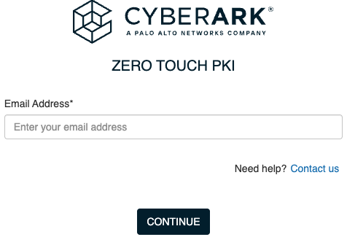

Upon successful login you land on the main dashboard of the ZT-PKI

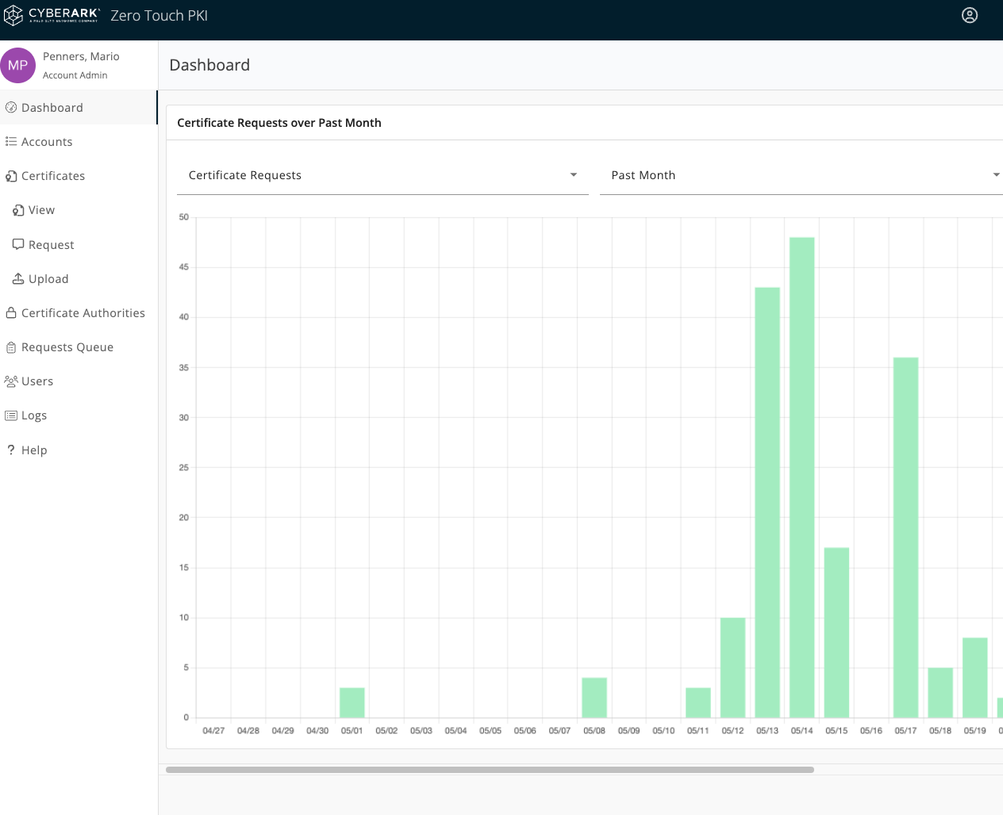

Step 1: Verify CA Label
(back to overview table)
Starting from the main Dashboard, to know your CA-Label, navigate to “Accounts” in the left side menu and select your account.
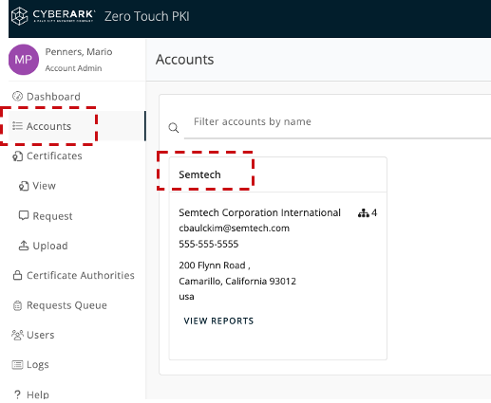

In the account page that opens after selecting your account, scroll down to the “Policies” section and open it. The lines represent “signing rules” that your CA checks before signing a request. Such can be e.g. authentication methods for requests, duration of issued certificates, usage allowed for a cert like code-signing vs. IPSec tunnels etc …. From the below screenshot, take a note of the “Policy ID” for your CA/Org! This will be used as ‘CA Label” later in the Airlink EST setup. Also note CA and Org for later reference.

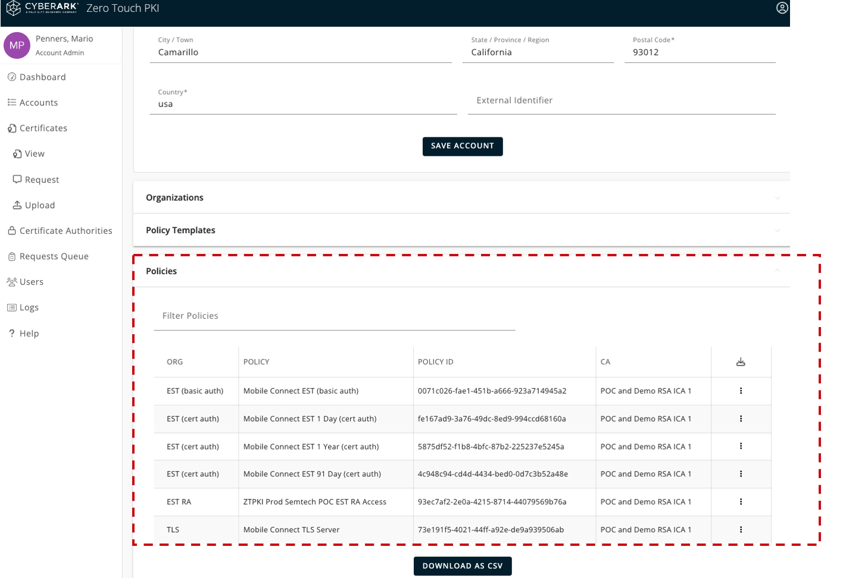

Step 2: Generate APi Key
(back to overview table)
In all workflows we tested so far, you will need an API key to authenticate the first enrollment of a new Airlink. To get the key, navigate from the main Dashboard to Users, select your User Name . In the page of your account, there is a button “Add API Key”

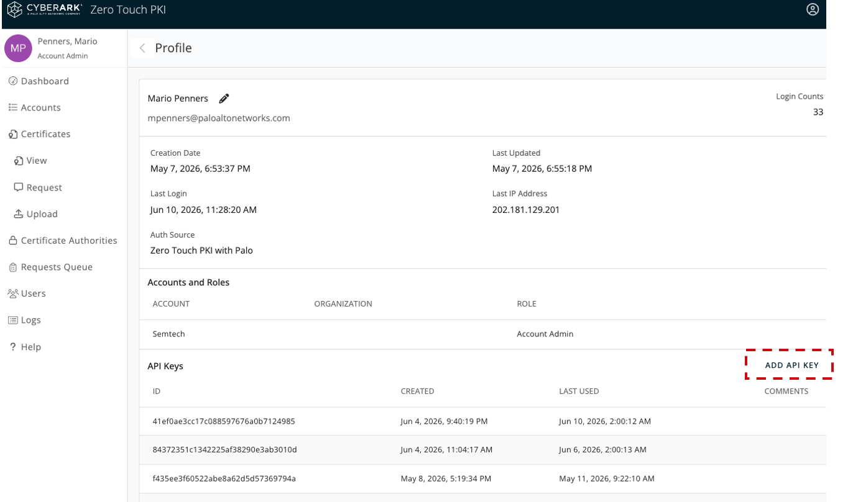

When you press the button, the key is immediately displayed AND added to the list of available keys. You will NOT be able to see that key again, copy it immediately along with the key ID. The 3 dots on the right side of each key later allow some basic key management like adding comments (where are you going to use that key or to whom you will give it, and “rolling", i.e. revoke old and generate new)

Step 3: Download EST CA Certificate
(back to overview table)
To verify any certificate, including “your own", you need the CA certificate of the signing CA, and of the CA that signed the signing CA (and any intermediates between your signing CA and the initial self-signed root-CA as well!) Our chains usually have a signing CA and a root CA, so it's 2 CA certs plus one leaf cert to identify a node (aka leaf)

The CA certificates belonging to your signing key are - from the main dashboard - under "Certificate Autjorities”; you should find the CA that matches your policy ID from Step 1 (rightmost column beside the policy ID) , select THAT CA if there are more than one. Inside the CA screen, you have a Download button in the upper right corner.

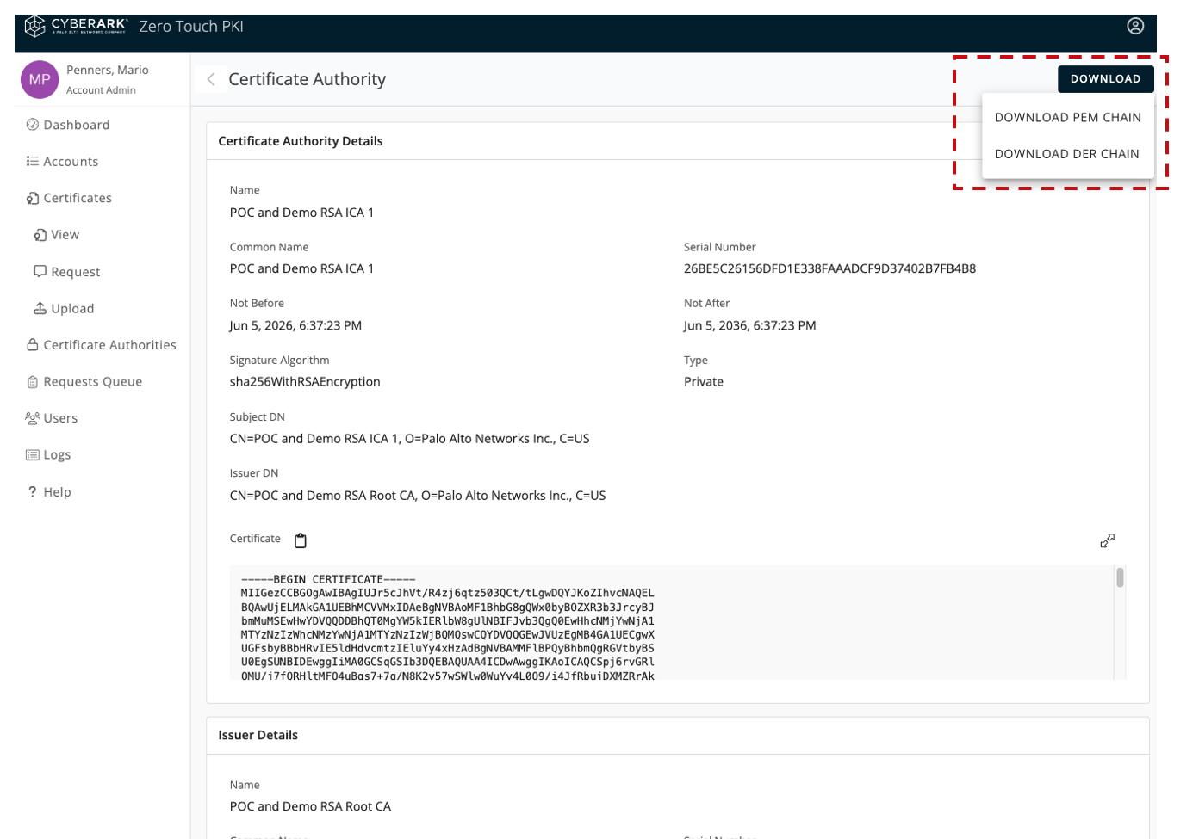

PEM formatted certificates are easier to handle and troubleshoot, they are base64 encoded ASCII blocks between —--CERTIFICATE—-- tags. DER formatted certificates are ASN.1 binary, its more difficult to look into the file and you can not simply “take out one piece of a chain” and use it alone, in PEM you can do that. Download the PEM Chain.

Step 4: Fetch TLS CA Certificates
(back to overview table)
EST (Enrollment over Secure Transport) is the certificate lifecycle management protocol that is used to fetch new certificates and to renew them. When an EST client like an Airlink is contacting a ZT-PKI to fetch a certificate, it is important that it is connecting to the CORRECT ZT-PKI and not some rogue system. Also, the transport protocol should be encrypted - TLS in case of EST.
Airlink routers do not have a “Trust store” like web-browsers have or a set if trusted CAs is preinstalled like with linux distributions. In order to contact the ZT-PKI via TLS and authenticate the ZT-PKI server during the TLS handshake, we need to manually add a trusted CA to the Airlink.

NOTE that this CA is different from the CA-certificates that belong to the keys signing the Airlink or NGFW leaf certificates! We do not have/own any keys for this commercial 3rd party CA!

Navigate to: https://www.identrust.com/support/downloads and find the following CA certs:
“IdenTrust Commercial Root CA 1” and “Hydrant Server CA1

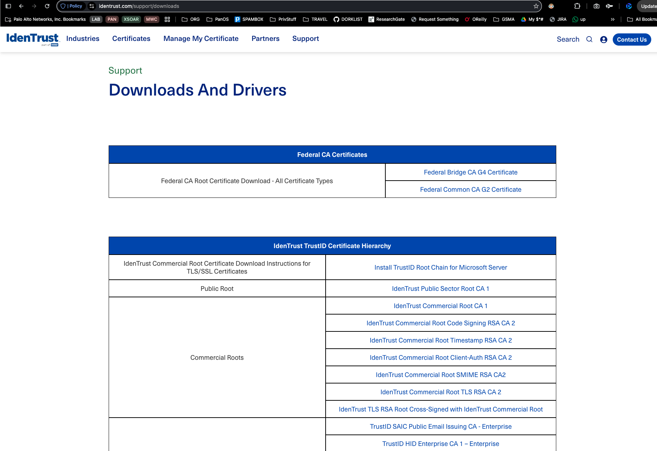

Those are currently used by the ztpki.venafi.com service (i.e. presented during EST TLS handshake)
The certificates come as p7b (PKCS#7) envelope, its a file format that usually contains certificate chains without private keys. They can be either format PEM (then you can open it in a text editor) or binary (then you get terminal garble/no open) See the Troubleshooting section if you run into problems when later using the downloaded certificates.

Step 7: Manually issue A Certificate by CSR
(back to overview table)
When working on the NGFW, you will generate a key-pair and have the public key signed by the ZT-PKI. Since the NGFW does currently not have an EST client or other supported certificate Lifecycle Management protocol, we do this manually.
Follow the instructions in Steps 5 and 6 on the NGFW, then you come back to the ZT-PKI with your PEM formatted Certificate Signing request from the NGFW (CSR)

In the ZT-PKI, navigate from the main Dashboard to “Request”. Select the “Org” and “CA” that are defined for your policy ID in Step 1. Then you will be able to paste in your CSR and parse it

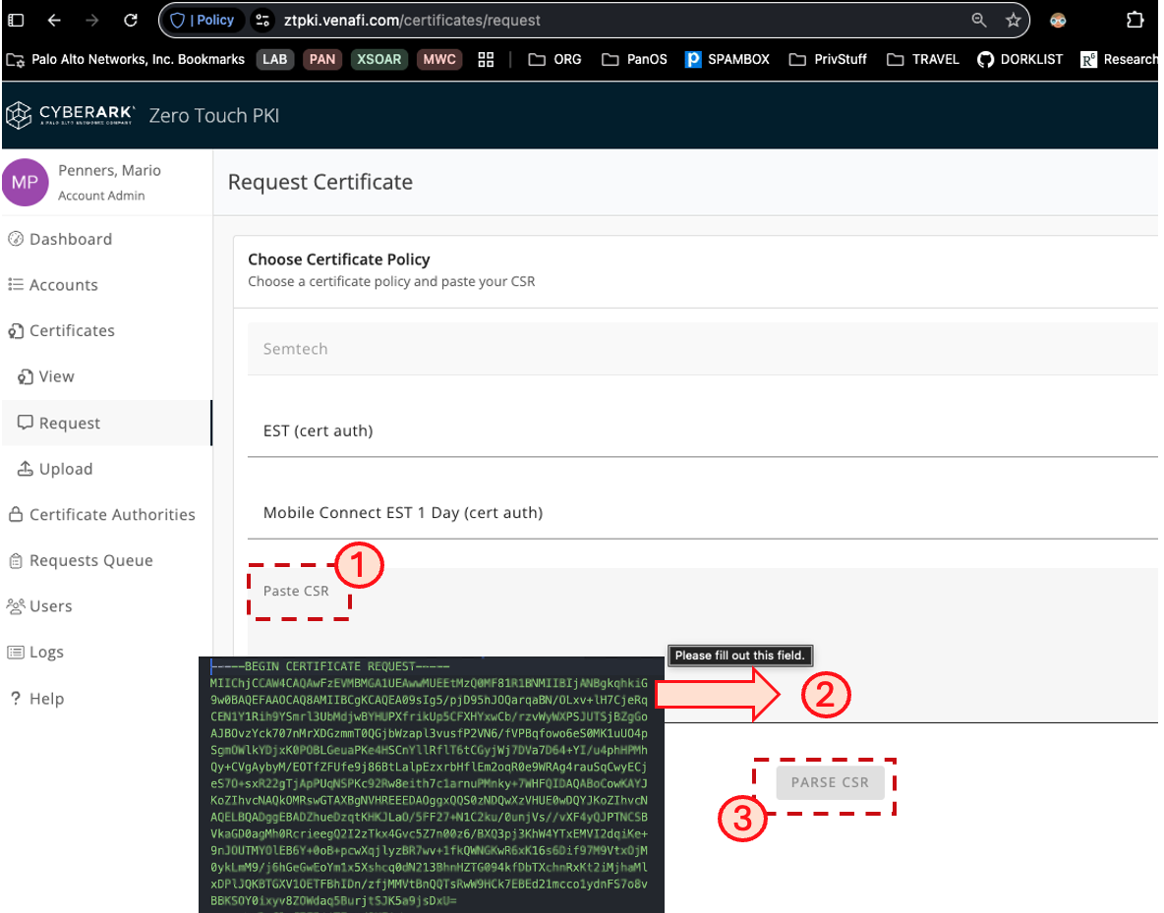

When the request is parsed you will be able to issue the certificate. Download the PEM format without chain. You can do this with any CSR (e.g. such created manually with openssl command in linux) If your CSR was generated in the NGFW, you can import the certificate and it should be matched with the open CSR that holds the private key (which did not leave the NGFW during this signing process!)

Steps to execute in the NGFW
This chapter describes settings that are executed in the NGFW.. The actions are general and screenshots are examples. The order of steps is not chronological on one Platform, see the overview table

Log in to the NGFW GUI as described here, make sure you have a basic networking setup (out of scope of this document)

Step 5: Generate a NGFW Certificate Profile
(back to overview table)
In order to be able to verify certificates that are issued via EST CA, we need to create a Certificate Profile that includes the EST CA chain.
In case you are using Panorama (bulk provisioning), the Certificate Profile must be generated into the template, leave the ‘shared” box active. The Certificate Profile in regular PanOS is found under Device -> Certificate management -> Certificate Profile , create a new profile by adding the EST CA Certificate Chain you downloaded in Step 3.

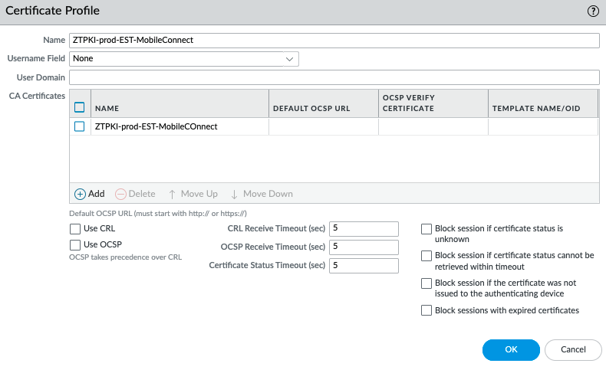

For maximum compatibility and ease of deployment, we have not checked any restrictions in the profile. For production purpose, restrictions or use of a CRL might be required!

Step 6: Generate a CSR in the NGFW
(back to overview table)
The process to obtain a Certificate from an external CA is found in the tech docs here, it comprises 3 actions:
Action 1: Create CSR in the NGFW (here in this Step 6)
Action 2: go to ZT-PKI and get the CSR signed (described in Step 7)
Action 3: come back here and upload signed certificate (Step 8)

Action 1: Create a CSR in the NGFW
Navigate to Device -> Certificate Management -> Certificates , press the “Generate” button in the bottom trim of the PanOS GUI)

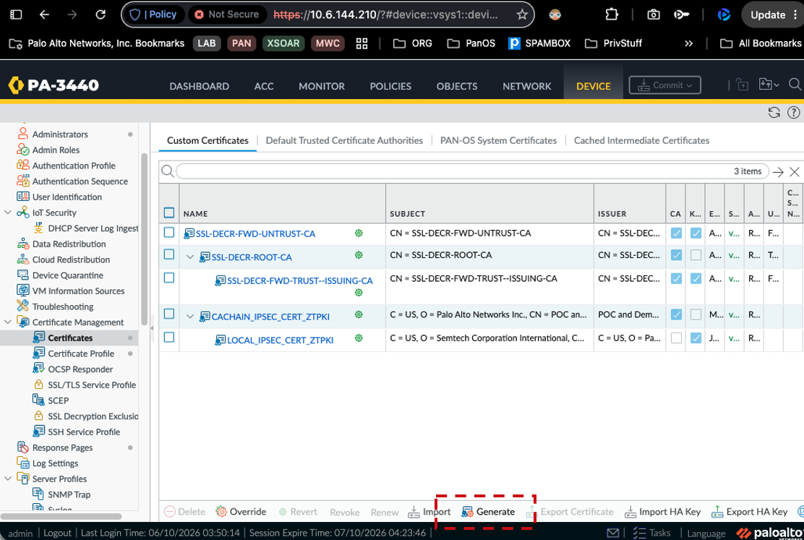

Fill the CSR as in the example below: Your “Subject Name” will be the certificates main identity. The SAN field on the bottom is key for IPSec, it defines what will later be the locaID (on PanOS side) or remoteID (on Airlink side) for the IPsec tunnel. This does not need to be resolved in DNS but it needs to match exactly and case sensitive to the IKE settings later.
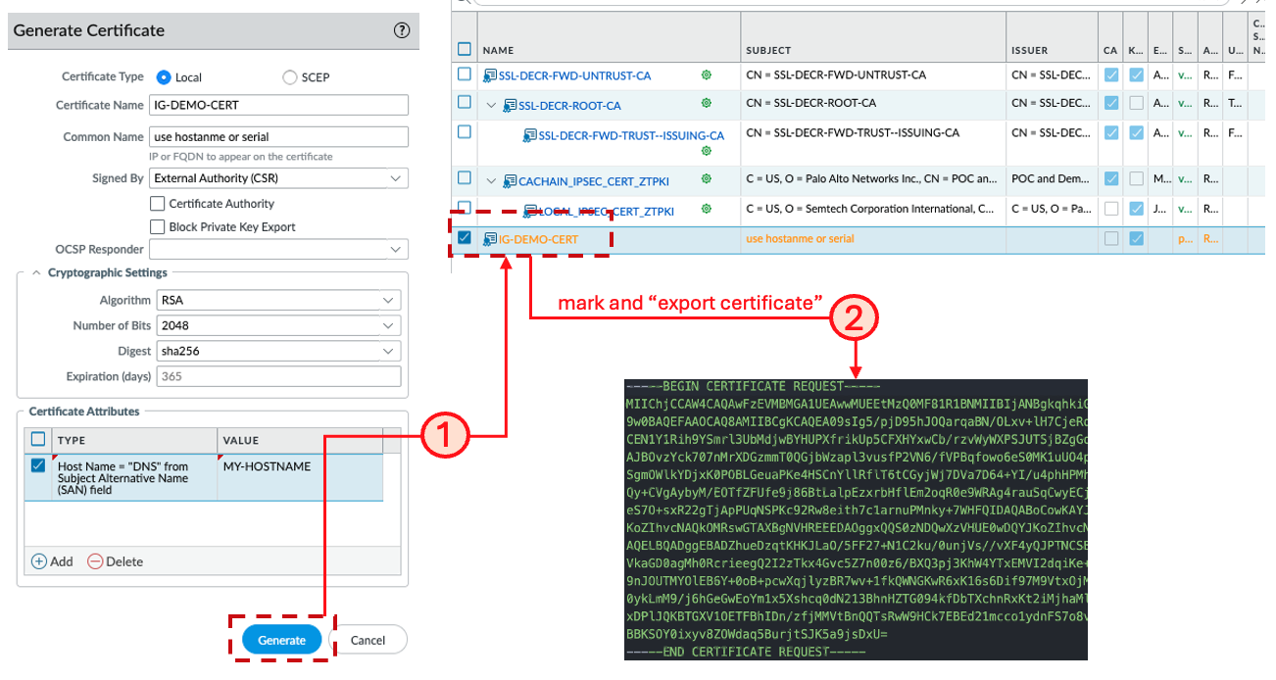

Action 2: Get the CSR signed (Step 7)
Once the CSR is created you see an orange colored certificate in the GUI that is “pending”, i.e. not yet a real certificate, but a CSR you just created. Exporting this file will create a PEM encoded request in your browsers downloads. Open that in an editor for the Step 7 / next action and get the CSR signed!

Step 8: Import the NGFW Certificate
(back to overview table)
After you have downloaded the Certificate (i.e. the parsed and signed CSR) in Step 7 from the ZT-PKI, you continue here with Action 3 and import it back into the NGFW. Press the “Import” button on the GUI bottom trim, use EXACTLY THE SAME certificate name than you have in the request, then browse to the PEM file (without chain) that you downloaded from the ZT-PKI after the CSR was signed.

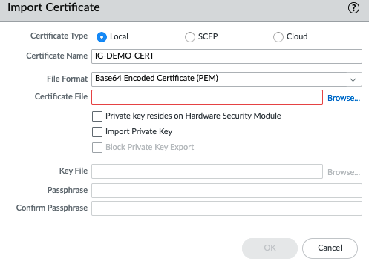

The previously orange CSR will now have turned blue and provide a real certificate, it will also be shown in the chain with the CA certificates that you installed in Step 5! If this is not the case and it looks different, you have to solve this first and IPSec will not work unless the NGFW recognises the certificate and chain properly! A working example:

Step 14: Look for IKE Connectivity Attempts from the Airlink
(back to overview table)
Up to Step 8, you have prepared the NGFW to authenticate an Airlink router using EST Certificates, but you have in Step 8 not defined any IPSec or IKE settings in the NGFW. During Steps 9-12, you will prepare the Airlink routers to initiate the IPSec connection! After completing Step 12, you should execute this test to see if it makes sense to continue with the NGFW IKE and IPsec configuration, or if you have a connectivity issue!

Verify in the NGFW that you receive ike traffic on the expected Interface and from an expected address: Once you open a public IP for IPSec access, you will immediately receive scans and traffic from unknown IPs. Check if the one you expect from your Airlink router is among it. If you don't know your Airlinks public IP, connect a computer to it and try “curl ifconfig.me” or “www.whatsmyip.com”
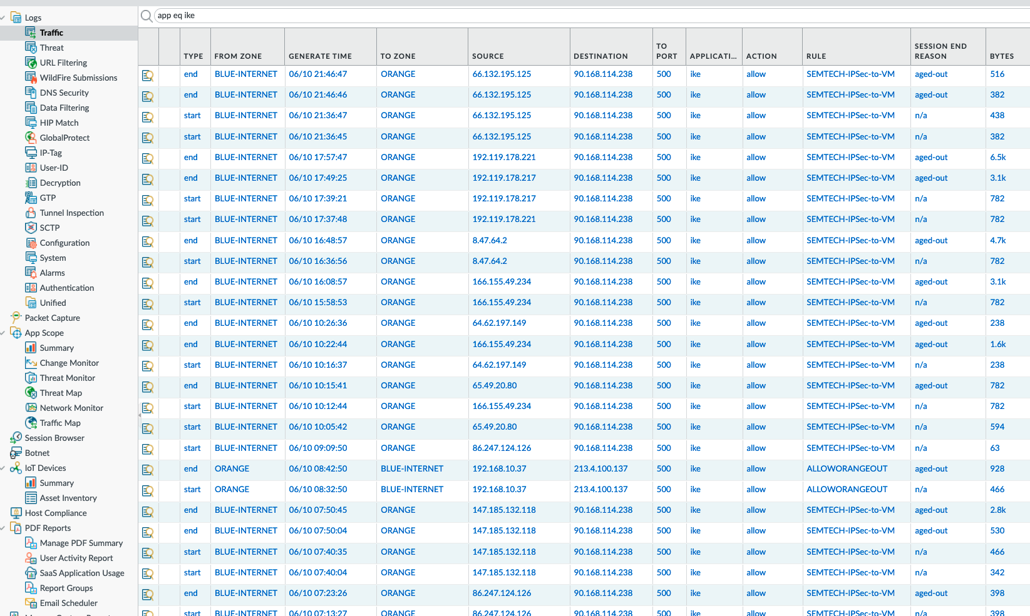

Step 15: Verify Crypto Profiles
(back to overview table)
Some values of the Airlink default crypto settings deviate from the PanOS default values. To adapt we change the profiles in PanOS rather than keeping changing it in every single Airlink. Note, that for the Automations / bulk deployment, we have to define the name of the default crypto parameter sets in the NGFW.

Action 1: Create your IKE crypto Profile, click in the PanOS GUI to “Network” -> “Network Profiles” -> “IKE Crypto”
In the low trim of the window, click “Add”, create a profile that must be exactly called “semtech_defaults” as follows

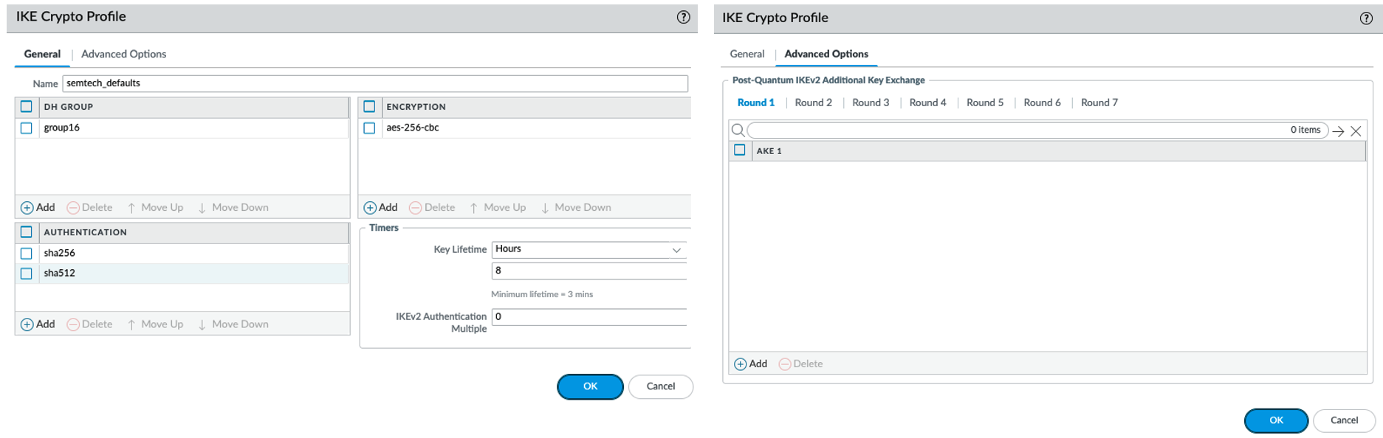

Action 2: Create your IPSec crypto Profile, click in the PanOS GUI to “Network” -> “Network Profiles” -> “IPSec Crypto”
In the low trim of the window, click “Add”, create a profile that must be exactly called “semtech_defaults” as follows

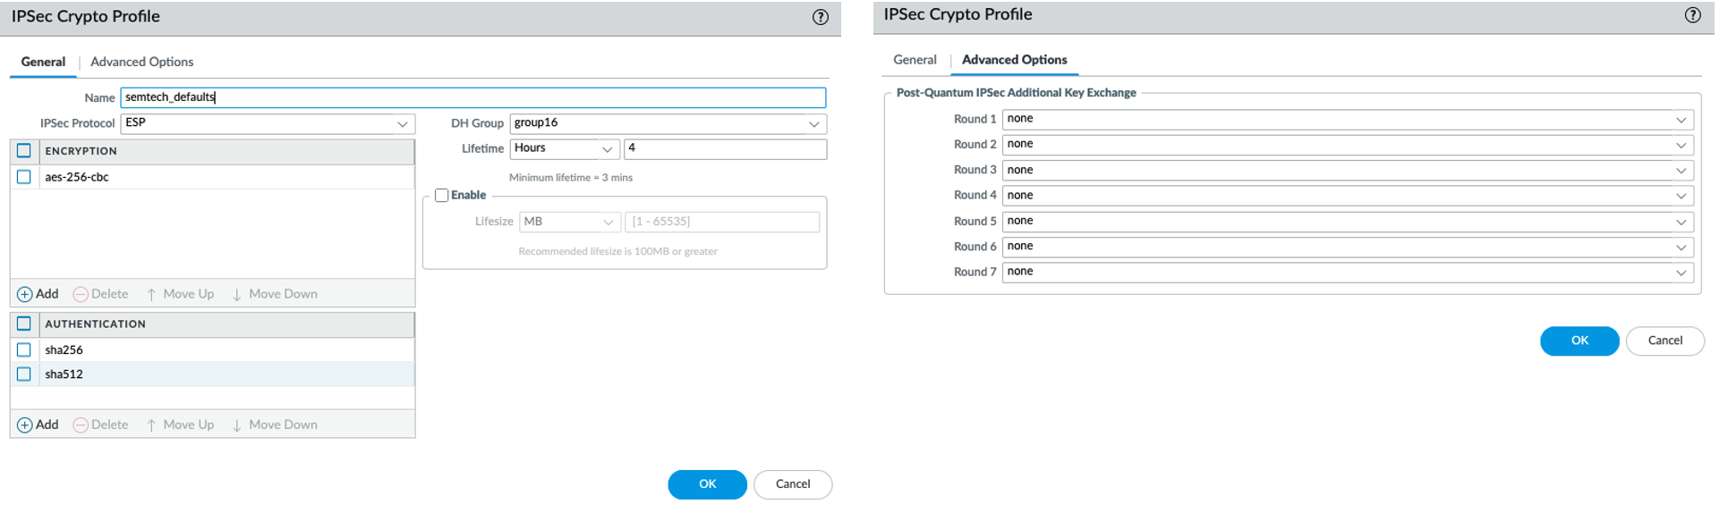
Note, it is important to set the timers as shown in the profiles, here and in Step 13! Per default, the IPsec tunnels die after a couple of hours because the re-key timings don't match unless adjusted as here! Since the NGFW is fully in passive mode, it could expire keys befoe the Airlink initiates a re-negotiation.

Step 16: Configure IKE GW
(back to overview table)
This is the central piece of the NGFW configuration, to authenticate the Airlink by Certificate and to allow tunnel creation. We need one IKE GW per one Airlink router, and one IPSec tunnel later per each IKE GW. In production you may encounter setups with hundreds or thousands of Airlinks, therefore you need a naming convention that maps unambiguously between the Airlink, the certificate, the IKE GW and the IPSec tunnel.
Our existing automations expect the IKE and IPSec objects to be named by the serial number of the Airlink, which is also carried in the Certificate, e.g. following is a view to automation-created IKE Gateways under “Network” -> “Network Profiles” -> “IKE Gateways”

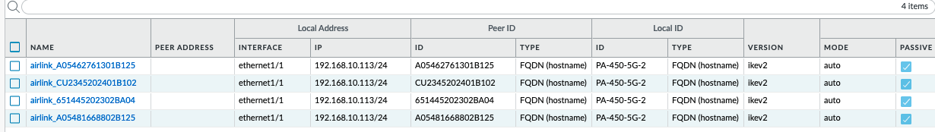

Set the IKE parameters as follows
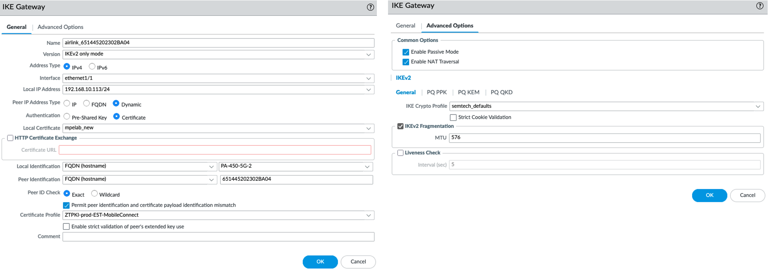

Regarding the above example, following additional comments:
- Interface ethernet1/1 is the NIC exposed to public Internet (from where the Airlink traffic arrives) and IKE/IPSec traffic
- The IP address in the PanOS GUI can only be chosen from available IPs on the NIC. In this example, the IPSec traffic passes NAT before it hits the IPSec GE (i.e. mpelab.duckdns.org that was defined in the Airlink Step 13 is sitting in front of this specific ethernet1/1 and NATing traffic inbound) In your example, this could also be directly a public IP or anything where the Airlink IKE traffic hits.
- Peer IP Address type “Dynamic” means that the Airlink IP address is not relevant, and that we can only act in Passive mode (which is set under IKE Advanced Options)
- The local Certificate is the file you imported in Step 8 into the NGFW, the Certificate Profile is the corresponding CA chain

Step 17: Define Tunnel Interface
(back to overview table)
The tunnel Interface is the actual termination point for the IPSec tunnel. We propose to create 2 Logical Routers within the default VRF: An Underlay for ethernet1/1 from the previous step, this is where the traffic enters the NGFW. ANd a separate Logical Router for services in the Datacenter. This allows for clean segmentation on the IP layer:
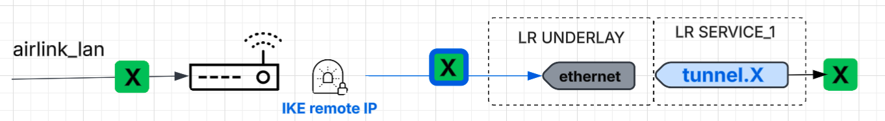

- Underlay traffic can come from different TelCo providers or networks and might even expose overlapping IP ranges if multiple private networks are involved. Keeping LR UNDERLAY separate completely separates the transport from the actual application traffic
- Application traffic gets decapsulated (i.e. separated from the UNDERLAY IP headers) in tunnel.X.. Placing the tunnel interface in a LR separate from UNDERLAY allows additionally overlapping IP addresses in the Airlink LANs. For such cases, each overlap can be kept inside an own SERVICE_x LR.

Besides terminating the IPSec tunnel, the tunnel.X interface has the following functions
- Get assigned to the security Zone to which the Airlinks application traffic will belong.
- Hold and DPD IP addresses, if you want to configure DPD (not done in current solution phase)
- Hold any addresses for dynamic exchange via routing protocols in case used (not done in current solution phase)
- Hold MTU and MSS settings to ensure the end-to-end connectivity between Service hosts and Airlink is working without re-sending or fragmentation issues.

Go to “Network” -> “Interfaces” -> “Tunnel” and define for each Airlink one tunnel interface

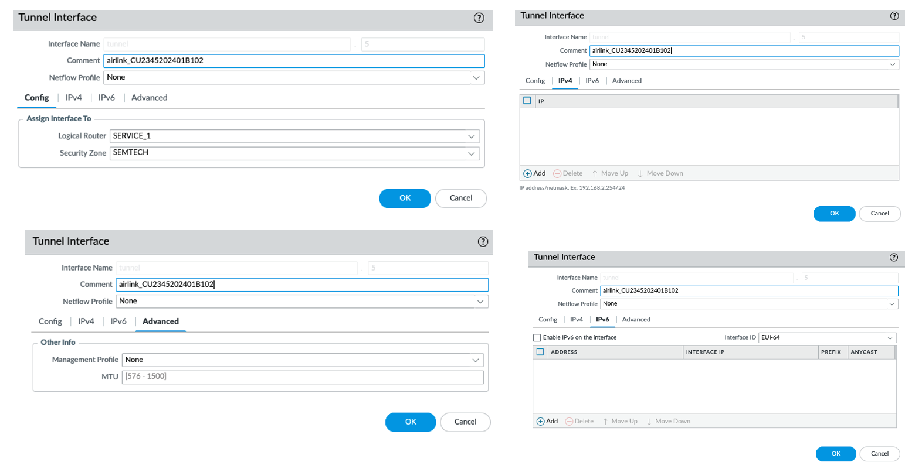

Step 18: Configure IPSec Tunnel
(back to overview table)
IPSec tunnel objects map the tunnel.X interface from Step 17 with the so-called “proxy selectors”, which are in fact just local and remote networks we defined already on the Airlink as local- and remote networks. From NGFW point of view we have:
- Local selectors, the Service_1 LR and all IP networks in it. We tested with one aggregated /24 network
- Remote selectors, we assume one local /24 on each Airlink. Local Airlink network segments must be unique or overlsaps be taken care for e.g. by creating additional service LRs.
Go to “Network” -> “IPSec Tunnels” and add a new tunnel for each Airlink:

Step 19: Add static routes
(back to overview table)
According to the definitions in Steps 17 and 18, you have now a tunnel.X interface that connects the incoming Airlink local-LAN traffic with your Service-1 LR. In order to make this wor, it is required to add static routes into the SERVICE_1 LR that point to the Airlin k local LAN networks via the corresponding tunnel.X.

Click in the PAnOS GUI to “Network” -> “Routing” -> “Logical Routers” -> “[your SERVICE_1]” or similarly called Service LR
Action 1: Add the tunnel.X interface to the LR. This ensures the decapsulated traffic can reach the services IPs.
Action 2: Create a static route that connects the airlink remote network via the corresponding tunnel.x interface

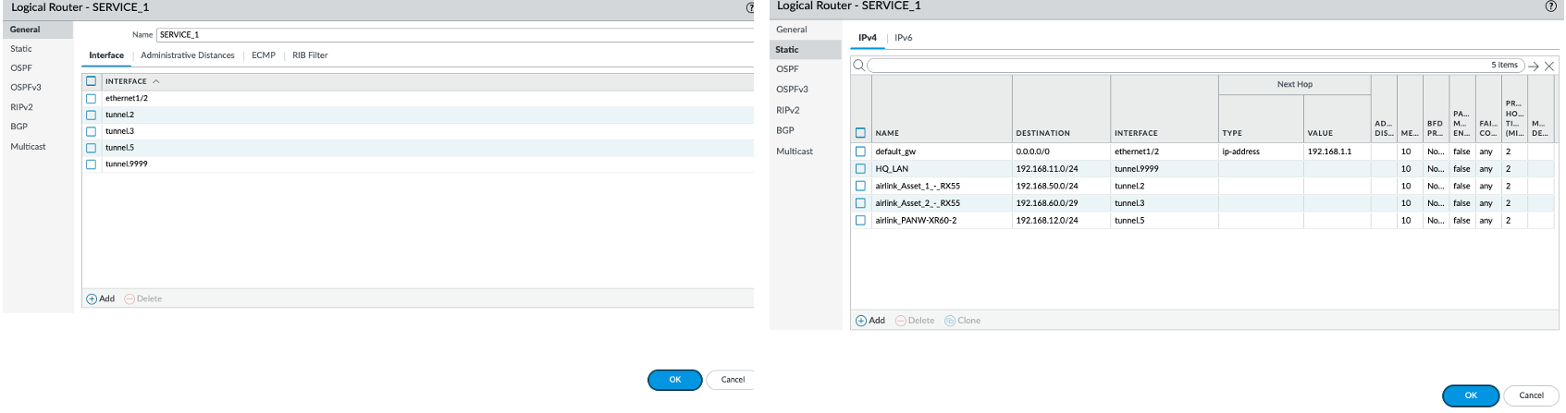
Note: On the remote end, Airlinks will automatically add the needed route to the Service_1 network when operated in LAN mode.

Step 20: Test if IPSec tunnel comes up
(back to overview table)
Airlinks in passive mode will try to connect to their IKE GW every 30seconds per default. If your test in Step 14 proves that the IKE traffic was reaching your NGFW, then the Steps 14-18 should have enabled the IPSec tunnel and show a green status after commit and at max 2-3 minutes. If the Test in Step 14 was successful and this step is not, then in most cases it is
- either an authentication related issue, e.g. with Certificate or Certificate Profile mismatch
- or a issue related to mismatches with the proxy selectors, e.g. if defined networks are not available or no interface in those networks can be reached, IKE will succeed but no tunnel will come up.
- or a basic crypto problem like mismatching proposals

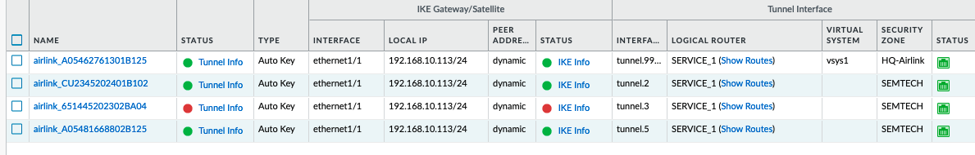

Once a tunnel is up, keep monitoring for at least 24hours to be sure it will stay up. Consider adding DPD for later project phases.

NOTE: In case your tunnel does NOT come up, or shows different stages on Airlink and NGFW, refer to the troubleshooting section “Airlink Local Firewall Rules”

Step 21: Define NGFW Security Policy
(back to overview table)
If your IPSec tunnel is coming up and routing between the local network and the Airlink is working, define Security Policies. We have enabled the following directives now:

- Airlinks can be assigned to security zones by assigning the tunnel.X interface of the corresponding Airlink. Hence you can have each airlink in an own zone, group them or join all Airlinks into one commonn Zone
- Services LR can be one or multiple Zones. They are assigned by the physical interfaces on the DC side (ethernet1/2)
- The underlay LR is a separate zone in which only IKE and encapsulated IPSec traffic is allowed.

Below is an example policy. We can use solution approaches like XSOAR or OneLayer to update the NGFW via Radius with IMSI-to-IP mappings, hence the correlation rule (rule 2)
Note, that we allow traffic into 2 directions, from the Airlink to the DC,, and also from the DC to the Airlink local LAN. For example DNP3 works usually “the other way around” and has the server in the field and the client in the DC; while modbus traffic in the below example reaches from a client in the field to a server in the DC.

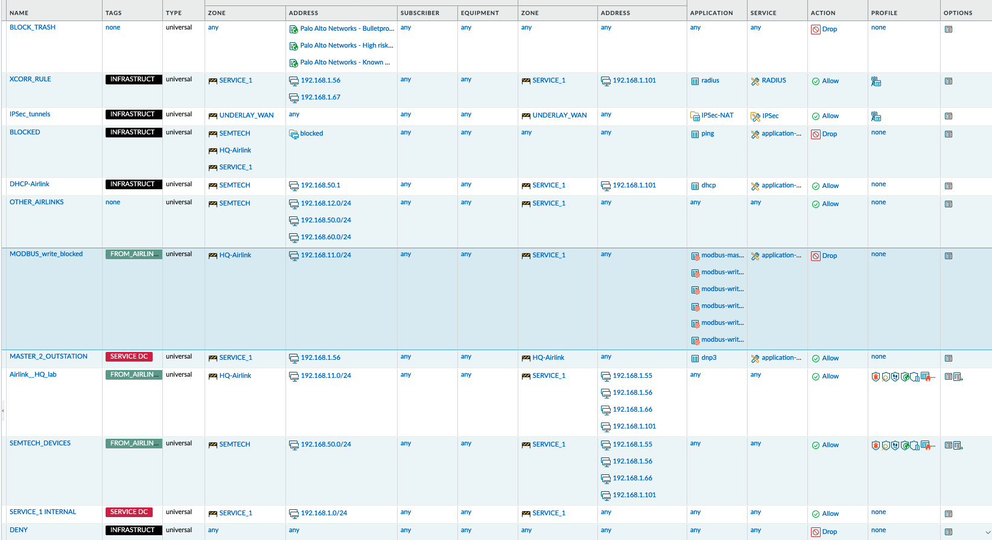

Partner Product Configuration
Configuring the Airlink Routers is straightforward. For bulk provisioning, we point to a procedure based on Templates and Workflows, which is out of scope of this basic guide. Below section describes in general, what settings need to be made on a single Airlink GUI to have it connect to the NGFW via IPSec.

How to connect to the Airlink router
You can access Airlink routers configuration GUI from their local port (default IP 192.168.1.1) or via ALMS. Once registered in ALMS, you only need to power-on the router and connect it to the Internet (SIM card or ISP link), then access it from your ALMS account.
If the Airlink has never been used, following documentation will help to get it connected and registered in ALMS:
- Airlink QuickStart Guide, here.
- AirlinkOS documentation, here.
- ALMS register Guide, here.

To reach the registered and powered-on Airlink from ALMS, log in to your ALSM account. Then click "Monitor”-> “Systems” on the top trim, in the next screen then select your system from the list of registered systems in your account
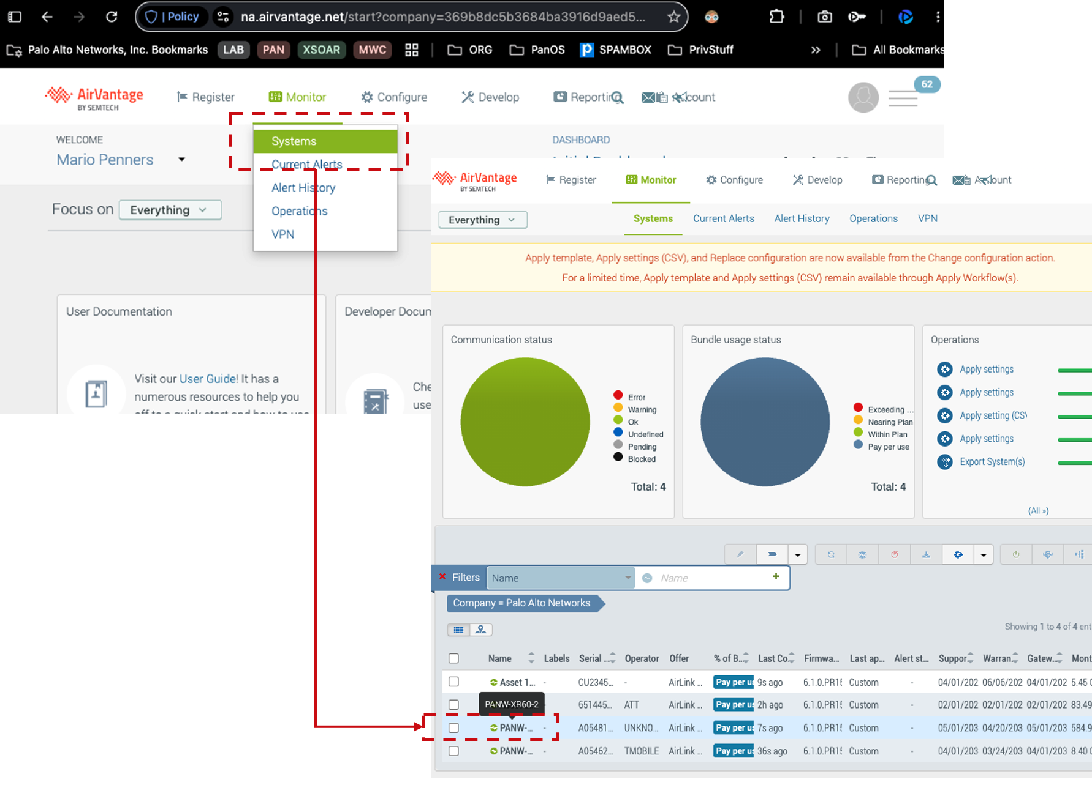
Once you have selected your system, choose “Configuration”on the system page, in the second trim! This will render the Airlink GUI into your current browser. Configuration functions are available here in the same way as in the local GUI, logs are local only.
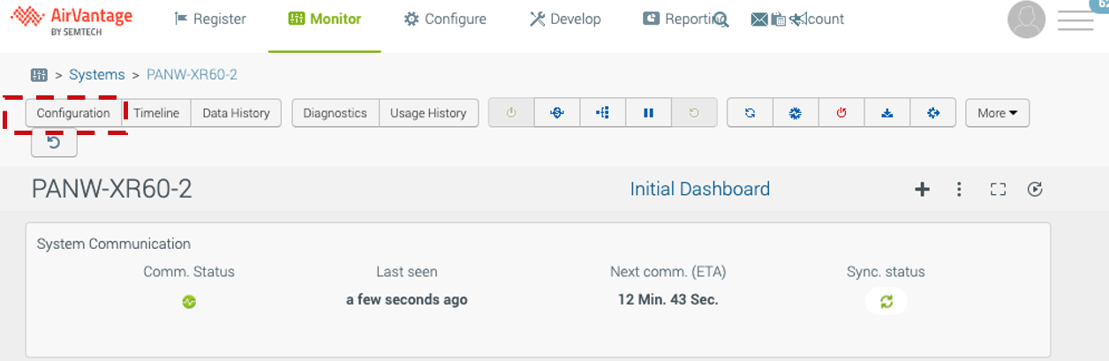

Step 9: Upload CA Certs to Airlink
When logged in to the Airlink main configuration GUI, click from the left side main menu “System”-> “Security”-> “Certificates”
Below Screenshot shows a fully populated GUI with all EST settings already made. To get there, start in the uppermost section ”Imported Certificates” and press the “Upload Certificate” button.

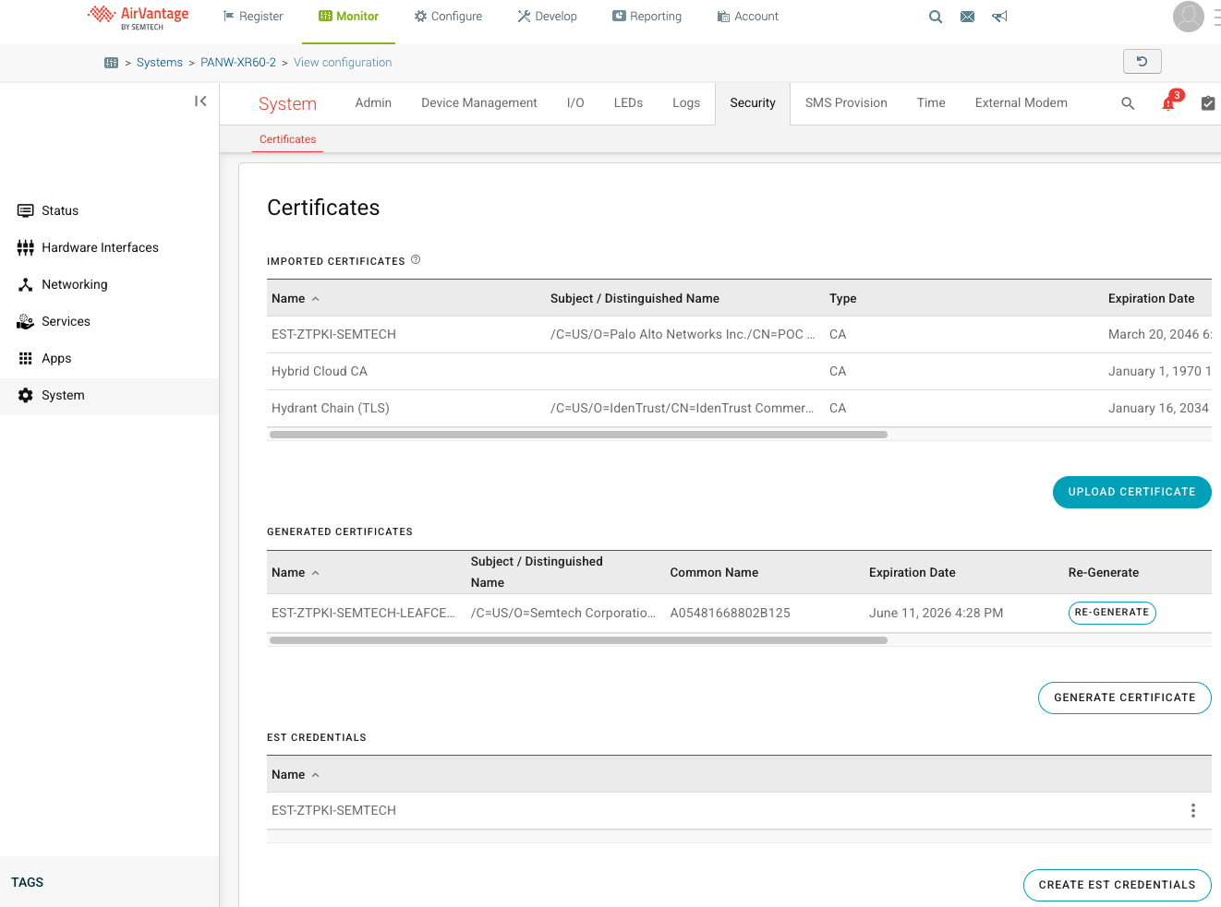
The popup window changes to below shape when you set the “Type” line to ‘Root certificate”.
Action 1: Now assign a Name for the TLS Certificate and upload the Chain we downloaded in Step 4, click create and save
Action 2: Repeat the same flow to upload the EST CA Certificate chain we obtained in Step 3, click create and save

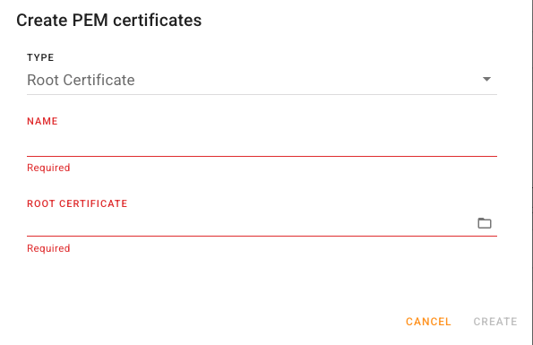
When you are done with this Step, you will have 3 CA certificate(s) chains, the 2 you created, plus a default “Hybrid Cloud” CA that had already been there before. Mind the status must be “valid” or your file is not accepted. It can take a few seconds before it is recognised.

Step 10: Configure Airlink EST Credentials
EST Credentials are used during Certificate enrollment, to authenticate your Airlink as a legitimate client who may obtain a certificate. You store the credentials and later refer to them when the actual Certificate Signing request is made and sent to the ZT-PKI.

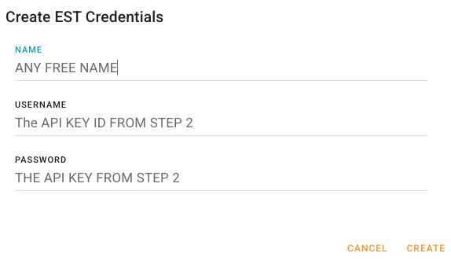

The credentials are obtained from the ZT-PKI as API key, in Step 2 of this document. Enter them here and create and save.

NOTE: Once entered, the credentials are never shown in cleartext again. To activate the “eyeball” icon, they have to be entered again first, this also applies when thee credentials are stored in a template. The idea is to prevent unauthorized access to it.
If you plan to later make this particular Airlink configuration a Template, then do NOT use a credential-set NAME that includes the serial number or information that is specific to only this router!

Step 11: Configure Airlink CSR
The actual CSR is configured in the central section “Generated Certificates”, press on “Generate Certificate” to define how your EST request will be made. In the window that will be popping up, following settings are possible or required:

Setting Name | Meaning / value | required
Name | Any name for the certificate to-be-requested here  If the certificate is granted, you will be referring to it under this name in the IPSec tunnel definition. | YES
Key Algorithm | RSA is best for compatibility (PQC to be discussed apart) | YES
Key Size | Default 2028 is sufficient. Longer certificate validity should have longer keys, also has more compatibility constraints | YES
Ues Device Serial Number for Common Name | Always put this to “Yes” | YES
Common Name | This is pre-set by above line and must be the serial number | YES
email | X.509 directory parameters to identify a “leaf” .  Those parameters are all optional, you can pre-fill it but depending on policy the CA might overwrite it or deny your request if the values contradict what is prepopulated in the policy. Mind, that you are filing a request rather than defining the final certificate ! | NO
Country
State
Locality
Organization
Organization Unit
Subject Alternate Name | DNS:[this-airlink-serialnumber]  It has to be in this format and it has to be exactly the serial number, or IPSec wont work. Example:  DNS: A05481668802B125 | YES
CMS URL | Base URL of the ZT PKI  https://ztpki.venafi.com | YES
CMS re-enroll URL | This is standardised and must be:  https://[CA-Label].est.ztpki.venafi.com  I.e. you insert the CA label before the path starting .est. …, e.g.  https://fe167ad9-3a76994ccd68160a.est.ztpki.venafi.com | YES
CA Label | The policy ID as obtained in Step 1 | YES
Re-enroll label | Normally this is empty (project specific differences possible) | NO
CMS Root CA Certificate | The TLS CA Chain (Hydrant Chain) from step 4, uploaded here in step 9 action 1 | YES
CMS Rot CA Credentials | The credential set we stored in step 10 (API Key) | YES
Cert-Auth Enroll after Basic | Enable this. It is a RFC compliant mechanism to use the existing cert instead of the API key when re-enrolling for a new cert (after initial was issued once) | YES

After you have made all settings and saved the "Generate Certificate” CSR, you can see on the right side of the section that the Airlink is now starting the enrollment process. After not more than 30seconds you should have a status “Valid” and see a certificate (i.e. Validity Date and Subject Name columns are now populated) . If your status is “valid” try also the Re-Enroll button and watch the actions, you must obtain a valid certificate again. The Re-Enrollment is needed to automatically obtain new certificates when existing ones are about to expire.

If you plan to later make this particular Airlink configuration a Template, then do NOT use a parameter-set NAME that includes the serial number or information that is specific to only this router!

Step 12: Configure Airlink Local Networks
When defining the IPSec Client settings, we must define which local network segment should be routed into the tunnel. This setting is needed on both ends, on the NGHFW side (as remote network) and on the Airlink (as local network) .
Airlink routers have a default LAN Segment and additional Network Objects that can be created, similar to PanOS Address Objects.

Action 1: To change the default Lan Segment, click in the left side main menu to "Networking” -> “Zone Settings” -> “Lan Segments” Edit the IP network to ensure there will not be accidental overlaps, and assign a unique IP range to each Airlink. E.g. if your Airlinks have only 2 LAN ports that you want to route upstream, a /29 network will do, including a GW IP in the Airlink itself plus 2 clients.

Action 2: To add a local network Object, click to "Networking” -> “Zone Settings” -> “Device / IP Network”, scroll to "Devices” and press ‘Create” ; Create an IP address Object that has the same IP network than your default LAN (e.g. 192.168.11.0/24) . Once you enter a valid IP Network address, the obligatory “Ethernet MAC Address” block will disappear.

Action 3: Create another network Object like in Action 2, but defining the Datacenter local network that is connected behind the NGFW. You will need this entry for IPSec remote network definition and automatic creation of routes via the tunnel

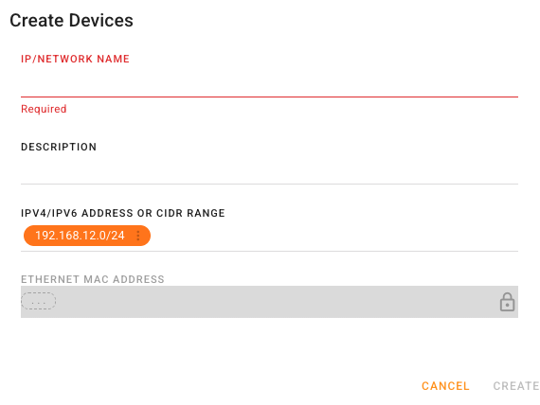

Step 12 optional: Configure DHCP-relay through the IPSec tunnel
We have used the Default LAN as local network Object and will use it as IPSec local network. If you do not want the Airlink router itself to assign the IP addresses inside this segment, you can also forward DHCP requests through the IPSec tunnel. For this you need to define a DHCP server on the NGFW or behind it, and set the IP address of this DHCP server here in the DHCP Relay settings of the Default LAN Segment.
Note, that extending the Layer 2 via the tunnel into the NGFW is a major design knob and that it enables IoT subscription to natively see the DHCP traffic, hence recognize and classify the individual devices behind the FW.

Step 13: Configure Airlink IPSec
IPSec client functionality is only defined in one central place at the Airlink routers. Open from the left side main menu the item “Networking” -> “VPN” -> “IPsec Tunnels” . You can have multiple VPNs on the Airlink and theoretically both could be active simultaneously. Practically, this would rather lead to routing issues unless your specific situation caters for it. We have tested Active-Standby situations where you can disable one VPN and enable the other, which works flawless. In that setup, the same local LAN is routed through the active VPN to different destination networks. However, default routes could be problematic/ambiguous.

Define a single IPSec tunnel between your local LAN and the remote Datacenter LAN: Following parameters are available and optional or required when pressing “Create IPSec Tunnel”

Setting Name | Meaning / value | required
Name | Name by which it will be VPN Parameter set will be visible later | Yes
Mode | Set to Client, means the active reaching-out side for IKE | Yes
LAN / HOST Mode | LAN Mode, encapsulate and route traffic from local segments | Yes
Rank | Use 1, also with 2 VPNs do not change | Yes
IKE Version | We use only IKEv2. Must match NGFW IKE Crypto Profile. | Must match NGFW
Multiple SAs for IKE | Multiple IPSec tunnels can be built to the same IKE peer, this is needed when using multiple subnets to route to or inside the tunnel | Usually no/off
MOBIKE | Mobile IKE, for driving vehicles allowing IP-address change during an IKE exchange. Enable depending on use case | Usually no/off
UDP Encapsulation | You can leave on Auto, it is usually used, never seen TCP for IPSec. | No
Authentication Type | Certificate ; Use PSK only for testing - it doesn’t scale in production | Yes
Certificate | The EST Certificate Name we created in Step 11 | Yes
Peers | The Public IP or related FQDN that the NGFW exposes to receive the IKE/IPSec traffic. Only this peer needs to be defined, the Airlink local IP can be “anything” and is not relevant for our setup. | Yes
Local Subnets | The local Network Segment defined in Step 12 actions 1 and 2 | Yes
Remote Subnets | The remote network in the DC defined in Step 12 action 3 | Yes
Exempt Subnets | Not needed ; Iocal subnets that explicitly must not go into the tunnel | No
Local Authentication ID | The SAN DNS:[Serialnumber] from the Certificate (Step 11) | Yes
Remote Authentication ID | The SAN DNS:[FW-host/name] from Step 6 (NGFW Certificate) | Yes
WAN Interfaces | Set to Cellular unless you use different uplink | Yes
Dead Peer Detection (DPD) | DPD parameters are ineffective in our setup since we do not have it fully configured on the NGFW. Using DPD would require setting an IP-address to the NGFW tunnel interfaces. | No
DPD Interval (Seconds) |  | No
IKE Rekey Time (Seconds) | 7200, must start re-keying before keys expire on NGFW (passive mode) | Must match NGFW
IKE Encryption | AES256 for easy compatibility (PQC to be discussed separately) | Must match NGFW
IKE Integrity | AES256 for easy compatibility (PQC to be discussed separately) | Must match NGFW
IKE Diffie Hellman Groups | DH16, different default in PanOS! | Must match NGFW
Perfect Forward Security (PFS) | Leave at enabled ; It is optional for IKE and requires one additional DH exchange within Phase 2, offers protection against later key compromises (but not PQC!) | Supported per default in the NGFW
ESP Rekey Timer (Seconds) | 7200, must start re-keying before keys expire on NGFW (passive mode) | Must match NGFW
ESP Encryption | AES256 for easy compatibility (PQC to be discussed separately) | Must match NGFW
ESP Integrity | AES256 for easy compatibility (PQC to be discussed separately) | Must match NGFW
ESP Diffie-Hellman Groups | DH16, different default in PanOS | Must match NGFW
VPN Link Monitors | Currently not used in our config (leave empty)

After all settings are in, press ‘Create” and “Save”; At this point the Airlink should start trying to reach the NGFW configured under “PEERS” ; Before continuing with the NGFW IKE/IPSec configuration, verify tha tthose requests are coming into the FW.
If you have local access to the Airlink, also check the log and monitor the status messages on the “Create VPN” button: Expected messages are “no SA found” or other crypto/authentication errors until the NGHFW is fully configured. If you see errors related to local Interfaces or can not ping the remote peer, ytou might have a transport/routing issue to solve before continuing.

After defining the IPSec tunnel with local and remote networks (or corresponding PRoxy Selectors in the Palo Alto IPSec tunnel configuration (Step 18) , ensure you have no Firewall rule created by AIrlink OS that will block your tunnel traffic (see Troubleshooting Section here)

Troubleshooting

NOTE: Use cases that do not match the use case(s) as documented in this integration guide, using a version of PAN-OS or a version of the partner product not listed as tested and validated are out of the scope of the integration as documented by this integration guide. Any additional use cases or variation from those use cases documented in this integration guide are out of the scope of this integration guide document. It is not outside the realm of possibility that unanticipated issues (i.e. scalability, concurrent API session limits, interoperability, other incompatibilities, etc.) could be encountered if out-of-scope use cases for this integration guide document are deployed. Therefore, after familiarizing yourself with the use cases documented in this integration guide, if there are plans to deploy use cases that are out-of-scope for this integration guide, it is highly recommended that the initial deployment be performed in a pilot/proof-of-concept environment prior to deployment within production.

Common troubleshooting steps

Check IKE/IPSec connectivity from PanOS CLI

Checking IKE logs
This is your bread and butter :
enable debug debug ike global on debug
enable full dump debug ike global on dump
disable debug debug ike global off
view logs less mp-log ikemgr-ng.log
tail follow yes mp-log ikemgr-ng.log

Check if there is an active IKE SA
admin@CORE-FW> show vpn ike-sa
There is no IKEv1 phase-1 SA found.
There is no IKEv1 phase-2 SA found.
There is no IKEv2 SA found.
admin@CORE-FW> show vpn ipsec-sa
There is no IPSec SA found.
admin@CORE-FW>

⇒ Instead of above you wanted to see an active SA and tunnel

Clear hanging IKE SAs and IPSec tunnels even if not currently visible

admin@CORE-FW> clear vpn ike-sa gateway
IKE-PRISMA IKE-PRISMA
<value> clear for given IKE gateway

admin@CORE-FW> clear vpn ike-sa gateway IKE-PRISMA
IKE SA for gateway ID 1 not found.
admin@CORE-FW> show vpn ike-sa
There is no IKEv1 phase-1 SA found.
There is no IKEv1 phase-2 SA found.
There is no IKEv2 SA found.

admin@CORE-FW> clear vpn ipsec-sa tunnel
WSTPRISMA WSTPRISMA
<value> clear for given VPN tunnel

admin@CORE-FW> clear vpn ipsec-sa tunnel WSTPRISMA
IPSec SA for tunnel WSTPRISMA not found.
admin@CORE-FW>

Restart the IKE SA (force re-negotiation)

admin@CORE-FW> test vpn ike-sa gateway IKE-PRISMA
Start time: Mar.11 12:05:54
Initiate 1 IKE SA.
admin@CORE-FW>

NOTE: If you have set passive mode in IKE GW, you will not start a negotiation and only can respond to it ! Also your entire IKE GW setup and routing must allow you to actually start a negotiation (commonly peer is “dynamic” so you won’t even know where to send a request)

Collecting VPN Config
Collect all configuration settings for a given IKE GW and related routing

#!/usr/bin/bash
#put the names of your own object instances here
: "${IKE_GW_NAME:=IKE-PRISMA}"
: "${IKE_CRYPTO_PROFILE_NAME:=IKE-PRISMA}"
: "${IPSEC_TUNNEL_NAME:=WSTPRISMA}"
: "${IPSEC_CRYPTO_PROFILE_NAME:=IPSEC_PRISMA}"
: "${TUNNEL_INTERFACE:=tunnel.1}"
: "${TUNNEL_INTERFACE_ZONE:=PRA-TUNNEL}"
: "${TUNNEL_ZONE_LR:=CORE_2_INTERNET}"
: "${DEVICE_NAME:=localhost.localdomain}"
: "${VSYS:=vsys1}"

# now collect the xpath values
while read XPATH; do
echo "show config running xpath $XPATH"
done <<EOXPATH
devices/entry[@name=\"${DEVICE_NAME}\"]/network/ike/gateway/entry[@name=\"${IKE_GW_NAME}\"]
devices/entry[@name=\"${DEVICE_NAME}\"]/network/ike/crypto-profiles/ike-crypto-profiles/entry[@name=\"${IKE_CRYPTO_NAME}\"]
devices/entry[@name=\"${DEVICE_NAME}\"]/network/tunnel/ipsec/entry[@name=\"${IPSEC_TUNNEL_NAME}\"]
devices/entry[@name=\"${DEVICE_NAME}\"]/network/ike/crypto-profiles/ipsec-crypto-profiles/entry[@name=\"${IPSEC_CRYPTO_NAME}\"]
devices/entry[@name=\"${DEVICE_NAME}\"]/network/interface/tunnel/units/entry[@name=\"${TUNNEL_INTERFACE}\"]
devices/entry[@name=\"${DEVICE_NAME}\"]/vsys/entry[@name=\"${VSYS}\"]/zone/entry[@name=\"${TUNNEL_INTERFACE_ZONE}\"]
devices/entry[@name=\"${DEVICE_NAME}\"]/network/logical-router/entry[@name=\"${TUNNEL_ZONE_LR}\"]/vrf/default/routing-table/ip/static-route
devices/entry[@name=\"${DEVICE_NAME}\"]/vsys/${VSYS}/rulebase/security/rules
devices/entry[@name=\"${DEVICE_NAME}\"]/vsys/${VSYS}/rulebase/nat/rules
devices/entry[@name=\"${DEVICE_NAME}\"]/vsys/${VSYS}/rulebase/pbf/rules
EOXPATH

Show working IPSec status output sample
admin@CORE-FW> show vpn ike-sa detail gateway
IKE-PRISMA IKE-PRISMA
<value> Show for given IKE gateway

admin@CORE-FW> show vpn ike-sa detail gateway IKE-PRISMA

IKE Gateway IKE-PRISMA, ID 1 192.168.1.10 => 144.125.90.106
Current time: Mar.11 12:17:42

IKE SA:
SPI: 57D57B99A1063996:B53D13349D134568 Init
State: Established
SN: 1
Authentication: PSK, peer PSK
Proposal: AES256-CBC/SHA256/DH14
ID local: fqdn:mpelab.duckdns.org
remote: ipaddr:144.125.90.106
ID_i: FQDN:mpelab.duckdns.org
ID_r: IPv4_address:144.125.90.106
NAT: ME
Message ID: rx 0, tx 142
Liveness check: sending informational packet after idle 5 seconds

Created: Mar.11 12:06:00, 11 minutes 43 seconds ago
Expires: Mar.11 20:06:00, rekey in 6 hours 24 minutes 53 seconds (23796 sec)

Child SA 1:
Tunnel 1 WSTPRISMA
Type: ESP Init
State: Mature
Message ID: 00000001
Parent SN: 1
SPI: DC741738 : 834DBC59
Algorithm: AES256-CBC/SHA256/DH14
TS local: Proto:any, 0.0.0.0-255.255.255.255, Ports:any
TS remote: Proto:any, 0.0.0.0-255.255.255.255, Ports:any
Created: Mar.11 12:06:00, 11 minutes 43 seconds ago
Expires: Mar.11 13:06:00, rekey in 36 minutes 28 seconds (2891 sec)

Child SA 141:
Type: INFO
State: Expired
Message ID: 0000008D
Parent SN: 1

admin@CORE-FW>
admin@CORE-FW> show vpn ipsec-sa summary

Total 1 tunnels found. 1 ipsec sa found.

AIrlink local Firewall rules
Ensure that your Airlink is not blo cking traffic that arrives through the IPSec tunnel. We noticed in AirlinkOS version 6.1 a behaviour that when you create the Objects for local and remote networks in the IPSec config of the Airlink (Step 13), a blocking rule in Networking -> Firewall Rules -> System Firewall Rules might be silently created

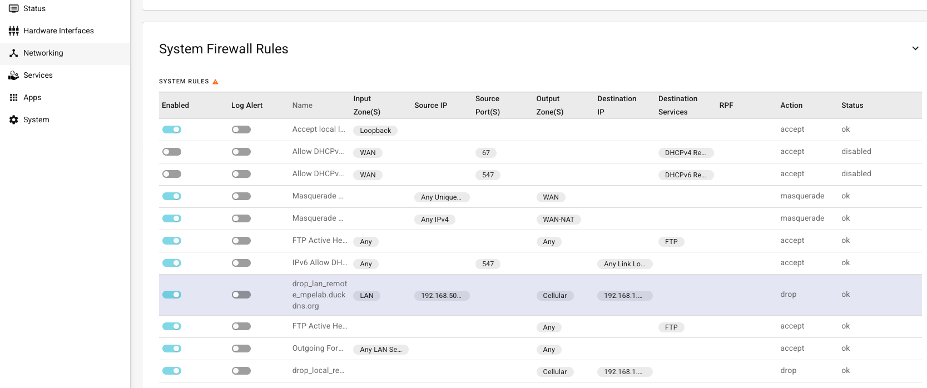

If a rule is enabled that blocks traffic for which Palo Alto NGFW has a Proxy Selector on tha tIPSec tunnel, then
- No traffic will pass through the tunnel
- Your IKE will work perfect but
- IPSec tunnel will remain status “red” in the NGFW GUI
- Airlink will show a tunnel as “Connected”

=> If you find this situation, check the Airlink Firewall rules and as second step the NGFW routing into the tunnel interface

Openssl CLI on Linux

You can use the openssl command shell from your regular MacOS/linux CLI to do basically anything around certificates and TLS/SSL itself.

Generate keypair and CSR
total 0
0 drwxr-xr-x 2 mpenners staff 64 Mar 27 07:52 .
0 drwxr-xr-x@ 11 mpenners staff 352 Mar 27 07:52 ..
[07:53:01][mpenners@M-N4MH2PC4VV][TESTA]# openssl req -new -newkey rsa:2048 -nodes -keyout ./device.key -out ./device.csr -subj "/CN=CU23452024104"
......+.+++++++++++++++++++++++++++++++++++++++*....+++++++++++++++++++++++++++++++++++++++*.+...+.+..............+......+....+.....+..........+..+....+.....+.............+............+........+.+.....+....
-----
[07:53:06][mpenners@M-N4MH2PC4VV]# ll
total 16
0 drwxr-xr-x@ 11 mpenners staff 352 Mar 27 07:52 ..
8 -rw-------@ 1 mpenners staff 1708 Mar 27 07:53 device.key
0 drwxr-xr-x@ 4 mpenners staff 128 Mar 27 07:53 .
8 -rw-r--r--@ 1 mpenners staff 895 Mar 27 07:53 device.csr
[07:53:08][mpenners@M-N4MH2PC4VV] #

The simple CSR created above is a default signing request for a “subject” called CU23452024104 (which could be an Airlink serial number) . However, X.509 certificates have a customizable structure in regards to :
- Standardized fields they may contain to define the certified information (e.g. if an IP-address, FQDN or email address is to be certified requires to have the corresponding info specified in a correct field) (Subject Alternate Name Fields)
- Meta information about how the certificate can be used, e.g. if it can identify only a user or a server, if it can be used for code signing or only for email signing or for both (key usage constraints)

To build a certificate that fits our purpose, the request must be structured. Create a basic config file for that. The openssl command will accept it without additional parsing if you specify the following format:

# cat airlink_ike.cnf
[ req ]
default_bits = 2048
default_md = sha256
prompt = no
distinguished_name = dn
req_extensions = req_ext

[ dn ]
CN = CU2345202401B102

[ req_ext ]
basicConstraints = CA:FALSE
keyUsage = critical, digitalSignature, keyEncipherment
extendedKeyUsage = clientAuth, serverAuth
subjectAltName = @alt_names

[ alt_names ]
DNS.1 = CU2345202401B102

Generating CSR from config file
Now run openssl to generate the proper request (csr file):
[09:09:28][mpenners@M-N4MH2PC4VV][TESTA]# openssl req -new -newkey rsa:2048 -nodes -keyout airlink.key -out airlink.csr -config airlink.cnf
.....+.............+..+.......+...+++++++++++++++++++++++++++++++++++++++*.+......+...+......+.+...+
.+...+.................+.+........+.+.........+.....+....+...........+.+......++++++
-----
[09:10:49][mpenners@M-N4MH2PC4VV][TESTA]# ll
total 24
0 drwxr-xr-x@ 11 mpenners staff 352 Mar 27 07:53 ..
8 -rw-r--r--@ 1 mpenners staff 381 Mar 27 09:09 airlink.cnf
8 -rw-------@ 1 mpenners staff 1704 Mar 27 09:10 airlink.key
0 drwxr-xr-x@ 5 mpenners staff 160 Mar 27 09:10 .
8 -rw-r--r--@ 1 mpenners staff 1041 Mar 27 09:10 airlink.csr
[09:10:53][mpenners@M-N4MH2PC4VV][TESTA]#

X509 cert file formats
Certificates or Certificate signing requests are exchanged in a variety of formats, permuattions mostly created by:
- Encoding: the information can be binary- or base64 ascii formatted
- the private key belonging to the certificate can be packaged into the same envelope along with the certified/signed information of the key holder, or it can be kept separate
- since every end-device / leaf certificate requires a CA certificate to verify it, leaf certificates can be kept isolated or along with the chain of CA-certificates needed to verify them

Following file formats are common

.csr | Certificate Signing Request. Contains public key + subject + extensions. Sent to CA for signing and not a certificate; usually base64 ascii encoded
.crt .pem | Base64-encoded container (ASCII). Can hold cert, key, or chain. Uses -----BEGIN ...-----. Very flexible, widely used, you can just cut&paste the complete info no file-copy needed
.der | Binary (ASN.1 DER) encoded certificate or key. Same data as PEM but not base64 encoded; sometimes .pem/crt files contain .der binary data – minor confusion that can be resolved with conversion :  openssl x509 -inform DER -in cert.der -out cert.pem
.p7b  .p7c | PKCS#7 container. Holds certificate chain only, no private key. Common in Windows environments
.p12  .pfx | PKCS#12 container. Holds private key + certificate + chain in one file, password-protected.
.p8 | PKCS#8 private key format. Can be encrypted or unencrypted, quite modern and not yet very common envelope format

The csr created in the previous step os a regular ASCII format and the key is in a separate file. The signed csr (i.e. the certificate) needs to remain together with this private key or its useless, and whoever controls the key controls the identity of the certificate subject and can impersonate it if the key is compromised/stolen. Hence handling certificates offline turns into a logistics and security-process issue rather than a technical challenge.
Use openssl Cli to chain CA certificates (echo CA1.pem CA2.pem > CAchain.pem ), to convert between formats or to just display certificate content, e.g.

[09:35:26][mpenners@M-N4MH2PC4VV][TESTA]# cat airlink.csr
-----BEGIN CERTIFICATE REQUEST-----
MIICyDCCAbACAQAwGzEZMBcGA1UEAwwQQ1UyMzQ1MjAyNDAxQjEwMjCCASIwDQYJ
KoZIhvcNAQEBBQADggEPADCCAQoCggEBALOJYggFSwkVns7pZ4c9m1alZS83vlKG
8O/taH5Io9AXKeZThLTaKIFrzWKZ2ek7J1zf5wumZArYs08Z5uTIf+61feyxiiDc
Xn7tyyvWedJFzVElrDIQwRg9Lpnb563ZM2bnLBPRe7UNsy0A45WBHfxx3X583sZU
8O1pMM6dMOte26MXou00qlETq0kgICfCxylzjWKaA0hACkN+mxIcapLZR6Pkne/k
UqjNZkER5DrzRtel8vXYVlM9hDzHskN6E3adV1hosgdT4BJKkJF9Ti15lwg+ADKx
aDk1yOkyrksDDehzHhS+wQ0+hroduM2B095nLJJREpzLTUeIPRjH0XUCAwEAAaBo
MGYGCSqGSIb3DQEJDjFZMFcwCQYDVR0TBAIwADAOBgNVHQ8BAf8EBAMCBaAwHQYD
VR0lBBYwFAYIKwYBBQUHAwIGCCsGAQUFBwMBMBsGA1UdEQQUMBKCEENVMjM0NTIw
MjQwMUIxMDIwDQYJKoZIhvcNAQELBQADggEBAE5wzKXg1/j6CxHd6YloYqEPfoLa
o3NmNmH/vn+jCi2+r81bJwiMzfln6BMXZx6fW+prpnALYrvkoW2h5TxK4cF5f3LX
3ie+HufSWuHYFXvMXTxXONQmravivUgOoXlvPyk9tCIt0Bueqvid0iejH6i/1HUt
5Iy7s7GL0qTcjJ9xcOPdk1+VhDi/zwg8HzjnNjFcdtk5xzZiYNV1xh3zIEMM+4lo
9j81CYQUkYxOAqnQ3F/UbsWx2kHdF4ZpqZ2yL+XiQ5R5GBQdwxKbUFMv+jcztuaq
h3lrjyKwjO8p+fxNjKn5NrZ53GBu1ssGE8OcrEP2FtWmlH7k76V6GNt4rDI=
-----END CERTIFICATE REQUEST-----
[09:35:32][mpenners@M-N4MH2PC4VV][TESTA]#

Display Request Content
[09:35:16][mpenners@M-N4MH2PC4VV][TESTA]# openssl req -in airlink.csr -noout -text
Certificate Request:
Data:
Version: 1 (0x0)
Subject: CN=CU2345202401B102
Subject Public Key Info:
Public Key Algorithm: rsaEncryption
Public-Key: (2048 bit)
Modulus:
00:b3:89:62:08:05:4b:09:15:9e:ce:e9:67:87:3d:
9b:56:a5:65:2f:37:be:52:86:f0:ef:ed:68:7e:48:
a3:d0:17:29:e6:53:84:b4:da:28:81:6b:cd:62:99:
d9:e9:3b:27:5c:df:e7:0b:a6:64:0a:d8:b3:4f:19:
e6:e4:c8:7f:ee:b5:7d:ec:b1:8a:20:dc:5e:7e:ed:
cb:2b:d6:79:d2:45:cd:51:25:ac:32:10:c1:18:3d:
2e:99:db:e7:ad:d9:33:66:e7:2c:13:d1:7b:b5:0d:
b3:2d:00:e3:95:81:1d:fc:71:dd:7e:7c:de:c6:54:
f0:ed:69:30:ce:9d:30:eb:5e:db:a3:17:a2:ed:34:
aa:51:13:ab:49:20:20:27:c2:c7:29:73:8d:62:9a:
03:48:40:0a:43:7e:9b:12:1c:6a:92:d9:47:a3:e4:
9d:ef:e4:52:a8:cd:66:41:11:e4:3a:f3:46:d7:a5:
f2:f5:d8:56:53:3d:84:3c:c7:b2:43:7a:13:76:9d:
57:58:68:b2:07:53:e0:12:4a:90:91:7d:4e:2d:79:
97:08:3e:00:32:b1:68:39:35:c8:e9:32:ae:4b:03:
0d:e8:73:1e:14:be:c1:0d:3e:86:ba:1d:b8:cd:81:
d3:de:67:2c:92:51:12:9c:cb:4d:47:88:3d:18:c7:
d1:75
Exponent: 65537 (0x10001)
Attributes:
Requested Extensions:
X509v3 Basic Constraints:
CA:FALSE
X509v3 Key Usage: critical
Digital Signature, Key Encipherment
X509v3 Extended Key Usage:
TLS Web Client Authentication, TLS Web Server Authentication
X509v3 Subject Alternative Name:
DNS:CU2345202401B102
Signature Algorithm: sha256WithRSAEncryption
Signature Value:
4e:70:cc:a5:e0:d7:f8:fa:0b:11:dd:e9:89:68:62:a1:0f:7e:
82:da:a3:73:66:36:61:ff:be:7f:a3:0a:2d:be:af:cd:5b:27:
08:8c:cd:f9:67:e8:13:17:67:1e:9f:5b:ea:6b:a6:70:0b:62:
bb:e4:a1:6d:a1:e5:3c:4a:e1:c1:79:7f:72:d7:de:27:be:1e:
e7:d2:5a:e1:d8:15:7b:cc:5d:3c:57:38:d4:26:ad:ab:e2:bd:
48:0e:a1:79:6f:3f:29:3d:b4:22:2d:d0:1b:9e:aa:f8:9d:d2:
27:a3:1f:a8:bf:d4:75:2d:e4:8c:bb:b3:b1:8b:d2:a4:dc:8c:
9f:71:70:e3:dd:93:5f:95:84:38:bf:cf:08:3c:1f:38:e7:36:
31:5c:76:d9:39:c7:36:62:60:d5:75:c6:1d:f3:20:43:0c:fb:
89:68:f6:3f:35:09:84:14:91:8c:4e:02:a9:d0:dc:5f:d4:6e:
c5:b1:da:41:dd:17:86:69:a9:9d:b2:2f:e5:e2:43:94:79:18:
14:1d:c3:12:9b:50:53:2f:fa:37:33:b6:e6:aa:87:79:6b:8f:
22:b0:8c:ef:29:f9:fc:4d:8c:a9:f9:36:b6:79:dc:60:6e:d6:
cb:06:13:c3:9c:ac:43:f6:16:d5:a6:94:7e:e4:ef:a5:7a:18:
db:78:ac:32
[09:35:26][mpenners@M-N4MH2PC4VV][TESTA]#

As an offline file and in the way as created above, the CSR could be sent to any CA / Certificate Authority!
You can also have those requests signed in your assigned PKI if tehre is a corresponding policy for manual enrollment.

General Information :

Fragmentation and MTU/MSS issues
Mobile networks with several layers of tunnels can raise MTU and MSS issues. Your central point of interest is the tunnel.x interface

Find the real path MTU
In the below example, approximate the path MTU between 1400 and 1300 byte
C:\Users\admin\Documents\OTDEMO>ping 192.168.1.101 -f -l 1400

Pinging 192.168.1.101 with 1400 bytes of data:
Reply from 192.168.11.1: Packet needs to be fragmented but DF set.
Packet needs to be fragmented but DF set.
Packet needs to be fragmented but DF set.
Packet needs to be fragmented but DF set.

Ping statistics for 192.168.1.101:
Packets: Sent = 4, Received = 1, Lost = 3 (75% loss),

Ping statistics f
C:\Users\admin\Documents\OTDEMO>ping 192.168.1.101 -f -l 1300

Pinging 192.168.1.101 with 1300 bytes of data:
Reply from 192.168.1.101: bytes=1300 time=275ms TTL=63
Reply from 192.168.1.101: bytes=1300 time=297ms TTL=63
Reply from 192.168.1.101: bytes=1300 time=385ms TTL=63

Ping statistics for 192.168.1.101:
Packets: Sent = 3, Received = 3, Lost = 0 (0% loss),
Approximate round trip times in milli-seconds:
Minimum = 275ms, Maximum = 385ms, Average = 319ms
Control-C
^C
C:\Users\admin\Documents\OTDEMO>

On linux/MacOS :
Ping -D -s 1400 192.168.1.101

ICMP Payload + 28 = IP Packet Size

Calculate MSS and MTU
Path MTU = successful ping payload size + 28Byte
MSS = MTU - 40
e.g.:
Tunnel MTU | MSS
1500 | 1460
1400 | 1360
1360 | 1320
1315 | 1275

Leave physical Interface MTU on 1500, set tunnel interface MTU according to above formula
Set MSS on tunnel interface

Contact Information for Support
For <Partner> specific issues:
- List partner support contact information here

For Palo Alto Networks specific issues:

- Palo Alto Networks Live Community
- Palo Alto Networks Customer Support

Technical Details
- If applicable, list the names of API calls that are being leveraged to enable this integration. If none simply say so.
- If this is a syslog integration, list out the types of log(s) being used (traffic, threat, HIP Match, config, system, endpoint agent logs, etc.).
- List out any additional technical details on how the two technologies integrate.
- For all WildFire Integrations: If the partner’s integration logic executes actions to submit samples to WildFire, the technology partner must ensure that the integration logic performs a hash check prior to submitting the sample to WildFire so only files that are unknown to WF are uploaded.
- For all WildFire Integrations: Joint customers leveraging the integration must already have their own WildFire API key.
- For all WildFire Integrations: The technology partner is required to implement capability to allow the end-customer a means to submit to them, a (Change Verdict Request Form). The (Change Verdict Request Form) will be filled out by the end-customer and the end-customer will describe the reason(s) why they object to the verdict returned by WildFire. The end-customer will provide applicable information such as: sample file name, hash value, sample file type, URL, etc.
The WildFire technology partner will verify that they have applicable information from the end-customer to file a WildFire support ticket with Palo Alto Networks ( https://www.paloaltonetworks.com/company/contact-support ).

Preparing the Integration Guide (IG) and Joint Solution Brief (JSB). When your team begins to use the provided template(s) to prepare the Integration Guide(IG) and Joint Solution Brief (JSB), in the section of the template showing the generalized integration diagram, please ensure that you depict the Palo Alto Networks ML-Powered NGFW and/or Panorama (if applicable) using the approved iconology and the labeling below:

Obviously it is ok to reduce the size of the icons and the font in order to accommodate available space on the generalized integration diagram as applicable. Only include Palo Alto Networks iconology that is part of your integration. (NOTE: Once the IG DRAFT is completed, this page should be deleted).


ML-Powered NGFW


Panorama


WildFire


GlobalProtect

