Starting the shuttle app:

1. Press the TpsShuttle icon
2. When the first screen appears, choose the correct driver and shuttle number from the menus

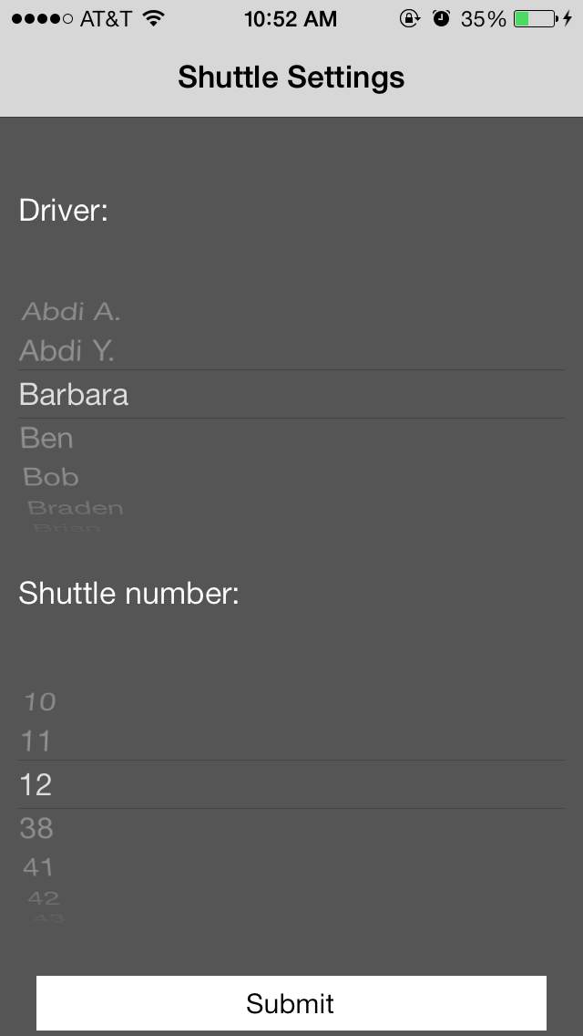

1. Press submit, and the detail screen will appear. You should start seeing the number of updates (written “Updates to server”) increase.

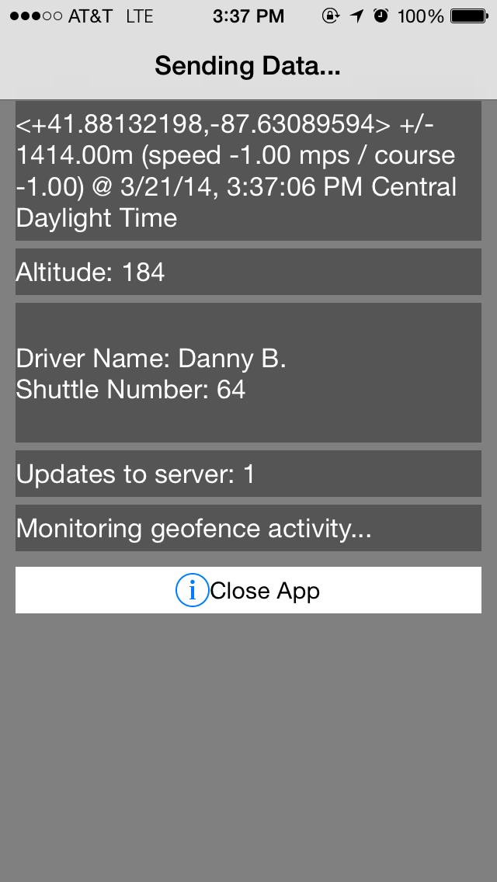

At this point, the app is transmitting data to the server, and you should now turn the phone’s screen off by pressing the lock button at the top of the phone. With the screen off, the app will still run.

To make the app stop transmitting, press “Close App”.

While the app is running, place it on the shuttle to relay the movements of the shuttle to the gps server.