Ultrasonic Ear with Transmitter

Paul Noel

**Abstract**

The Ultrasonic Ear detects and makes audible ultrasonic frequencies through the use of a heterodyne circuit that mixes a detected acoustic signal with a stable local oscillator that is subsequently filtered and made audible with an ordinary speaker. Similar circuits are often referred to as a bat detectors, though here we have adapted it to a lab investigating the speed of sound through the phenomenon of the doppler effect in a swinging pendulum.

**Construction of Apparatus**

While the Ultrasonic Ear can in principle detect any ultrasonic signal near it, we also provide a simple transmitter that can be attached to any number of objects or apparatus. It consists of a 555 timer in a simple astable configuration driving a 10mm 40 kHz transducer. A trim pot is used to locate the transducer’s particular resonance so as to provide the largest possible output. To tune the transmitter, look at the signal going to the transducer on an oscilloscope and adjust the trim pot until a maximum amplitude is displayed on the scope.

**PCB Transmitter Construction and assembly**

The transmitter is driven by and mounted on a custom designed circuitboard in the shape of a bat (of course).The emitting transducer is secured to the circuitboard by a screw terminal which allows the transducer to be at 90 degrees to the board surface. As with all PCB circuits, start soldering small parts like resistors first, then move on to the larger parts (double check polarity). The transmitter is designed to have two anchor points to connect easily to a meter stick (or any other object) with a bolt or zip tie. When mounted on a pendulum, you should use a meter stick with predrilled hole in the end so it can be hung on a horizontally mounted pin or screw so it can swing freely. A schematic is shown in the appendix, and the PCB board files are on github (<https://github.com/penoel/Bat-Detector>).

**PCB Heterodyne Receiver Operation**

The heterodyne receiver consists of 7 modules: pre-amp, op amp, diode mixer, local oscillator, low pass filter, audio amplifier, and speaker (see Fig. 1).

* The preamp amplifies the signal and using the popular 2n3904 transistor in a common emitter configuration.
* The Op-amp further amplifies the signal using the LM358 which can operate from a single supply and is commonly available.
* The local oscillator module again uses the 555-timer in astable mode. The tuning pot on the local oscillator allows the user to adjust the ultimate output frequency of the speaker.
* The diode mixer takes the local oscillator signal and adds it to the amplified input signal. It is an unbalanced mixer that does not require a special diode, only a standard 1N4007.
* The low-pass filter eliminates everything except the beat frequency (the difference between the local oscillator and received signal frequencies.
* The audio amplifier (LM386) amplifies this signal so it can drive a speaker without the need for a push-pull amplifier.
* The speaker outputs the beat frequency which will fluctuate based on the fluctuations in the received signal.

As with the transmitter, take care in soldering in the components. The schematic is in the appendix, and the board files are on the github site.

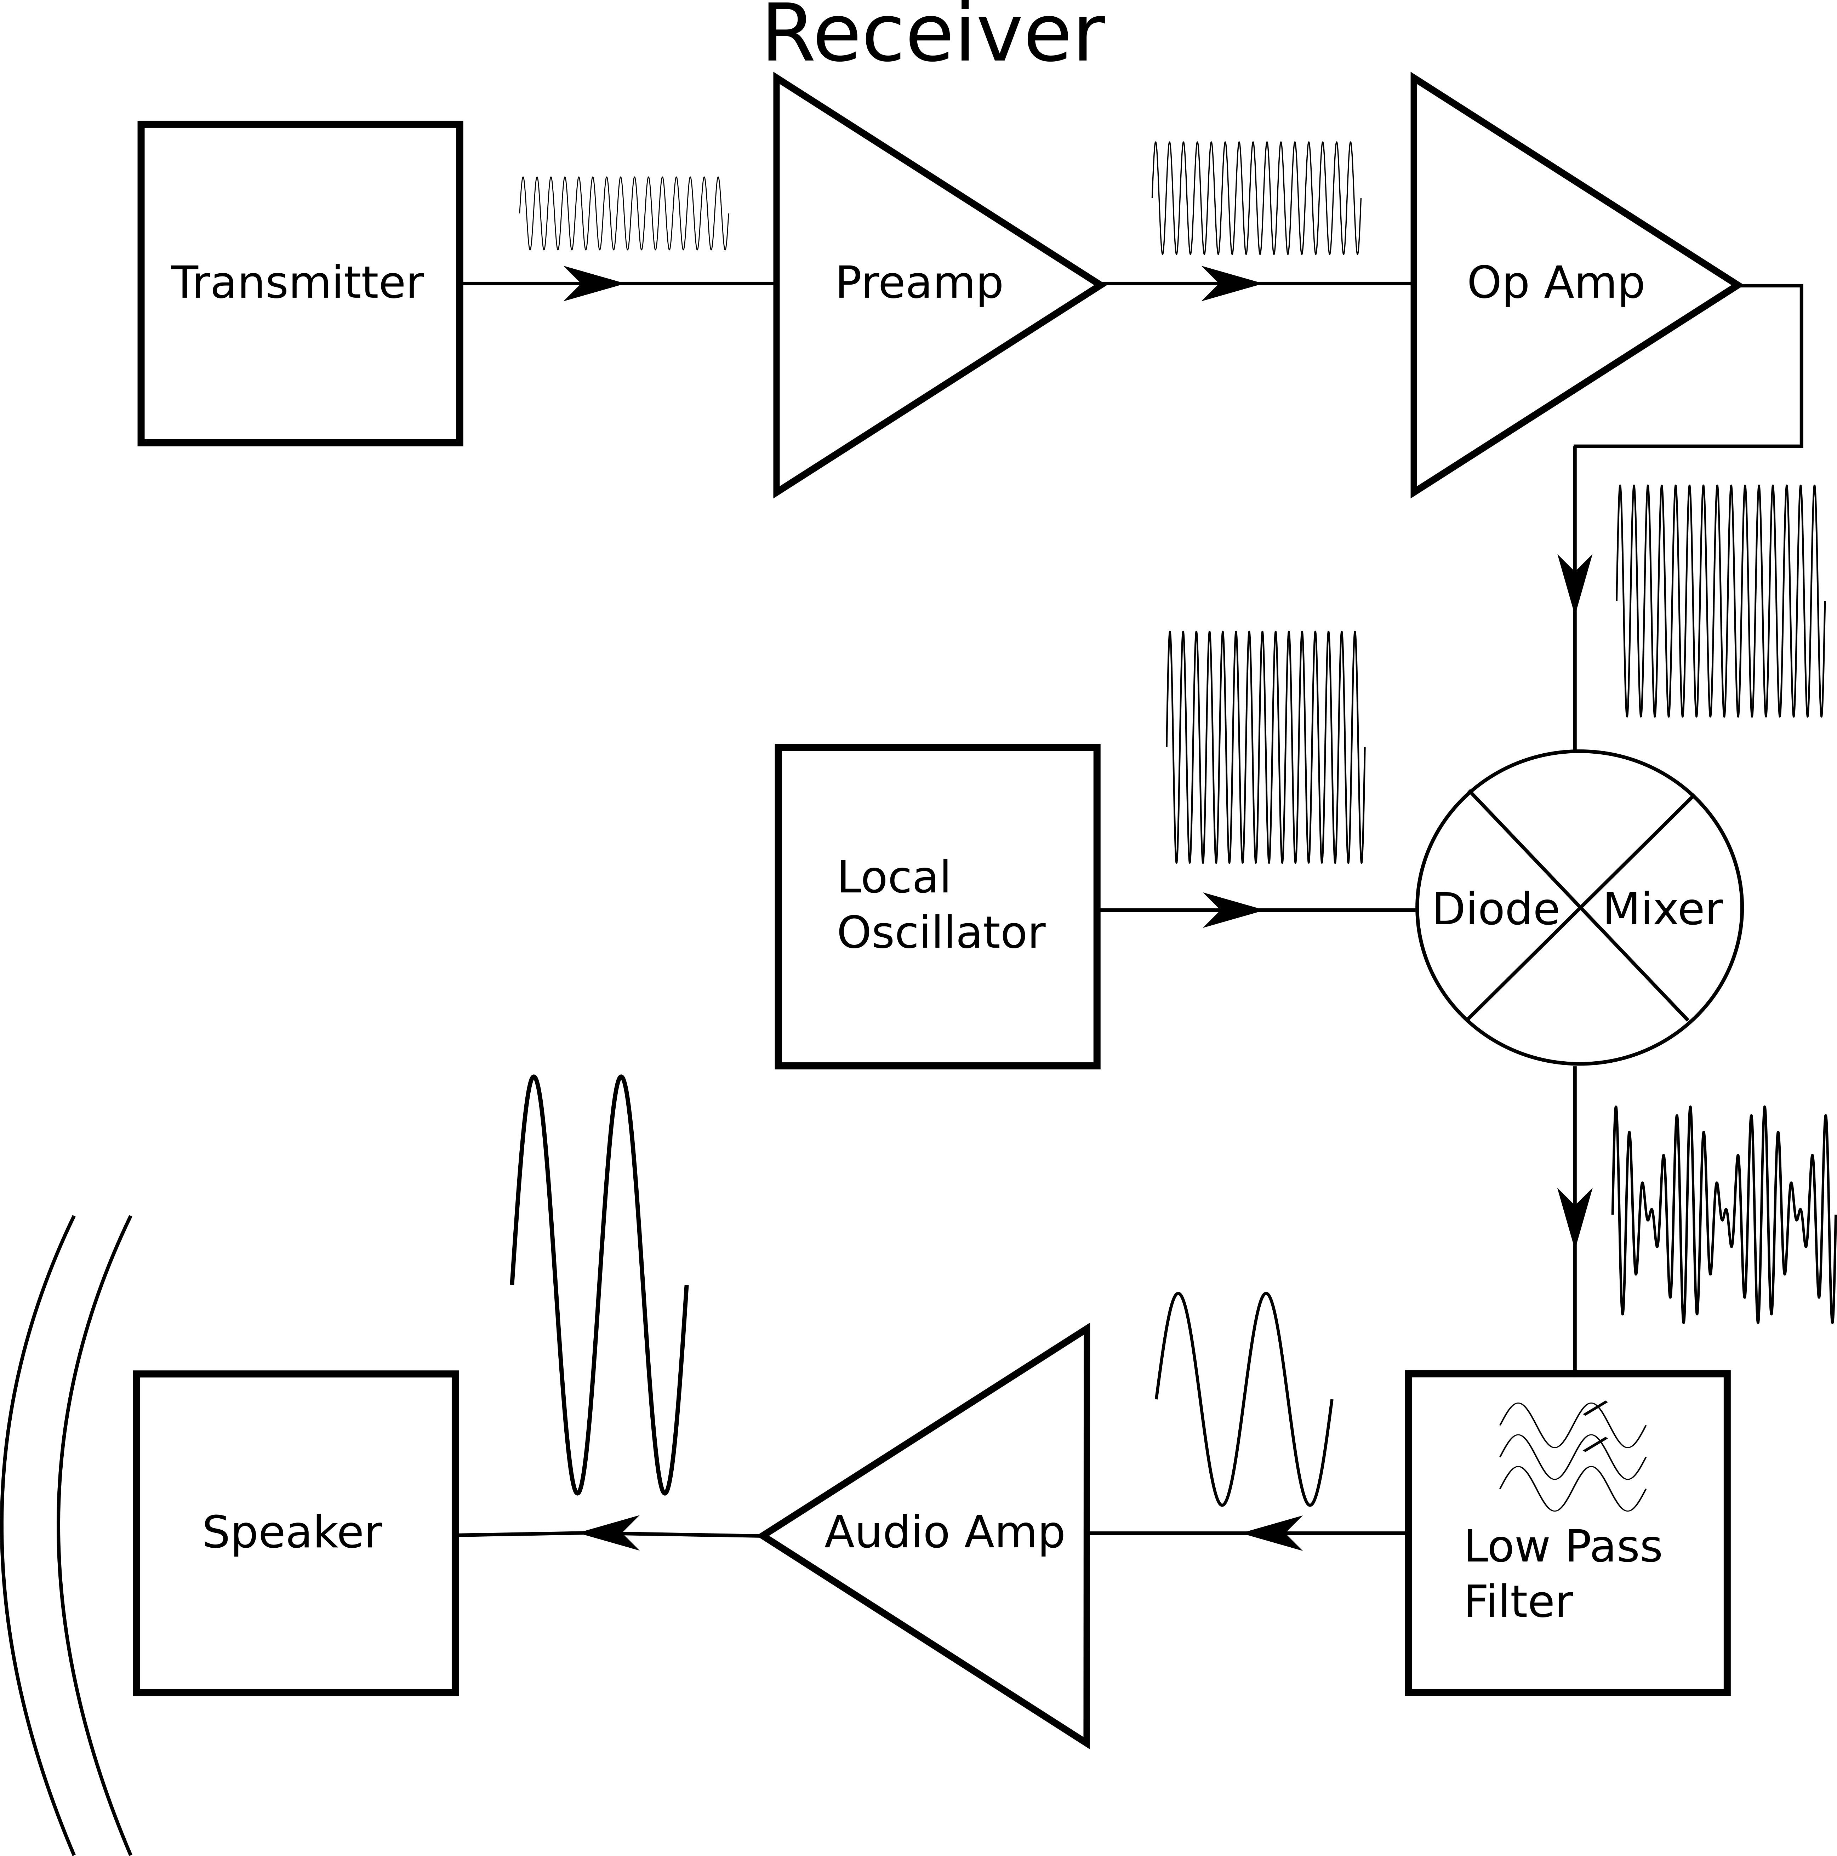

Figure. 1 Block diagram of the bat detector receiver

**Uses**

**Student Physics Laboratory** – At our institution, we have a speed of sound lab in which students use an ultrasonic transmitter on a pendulum to measure the Doppler shift with an arbitrary waveform generator. From these data they calculate the speed of sound. The Ultrasonic Ear allows students to hear the doppler effect as well.

**Demonstration** – This is a powerful alternative illustration of the Doppler effect. In contrast to the ubiquitous (and annoying) spinning buzzer. The Ultrasonic Ear and Transmitter can be used to very clearly (and pleasantly) shows how the frequency shifts up when the source and receiver are moving toward each other and downward when they are moving away. If one mounts the transmitter at the end of a pendulum (of varying length) and places the receiver facing it (as shown in Fig. 2), students can measure the period audibly, allowing visually impaired students to investigate the frequency dependence of the pendulum on amplitude, length and mass.

**Bat Detector** – With some adjustments to the gain of the Preamp, the Ultrasonic Ear can be turned into a bat detector. Taken outside, in the presence of flying bats you will be able to hear their echolocating chirps as they hunt for food. While you won’t be hearing the actual frequencies they are emitting, you will hear the fluctuations in their calls which vary by species and prey type.

**Warning:** Many modern buildings now have ultrasonic sensors that control lighting. This detector will sense this signal and may interfere with your experiment.

**Basic Doppler Theory**

As the source and receiver move relative to each other, frequency shift is given by:

where ***f0*** is the transmitter frequency, ***c*** is the speed of sound, ***vr*** is the velocity of the receiver, and ***vs*** is the velocity of the source (transmitter). The **±** addresses motion toward each other (+) and away from each other (-). In the case of a 1 m pendulum with a reasonable amplitude the doppler shift will be a maximum of about 200Hz. While this is small compared to the transducer frequency (about a 1% shift), when mixed with the local oscillator frequency down to audible ranges, such a shift is easily noticeable.

As the theory demonstrates, when the pendulum approaches the receiver, the wavelength is compressed and the frequency upshift will be a maximum as it passes through the lowest point. At the top of the swing, the velocity is 0 so no shift occurs. As it travels away from the receiver, the wavelength is stretched but the frequency downshifts and is a maximum at the lowest point, see Fig.2.

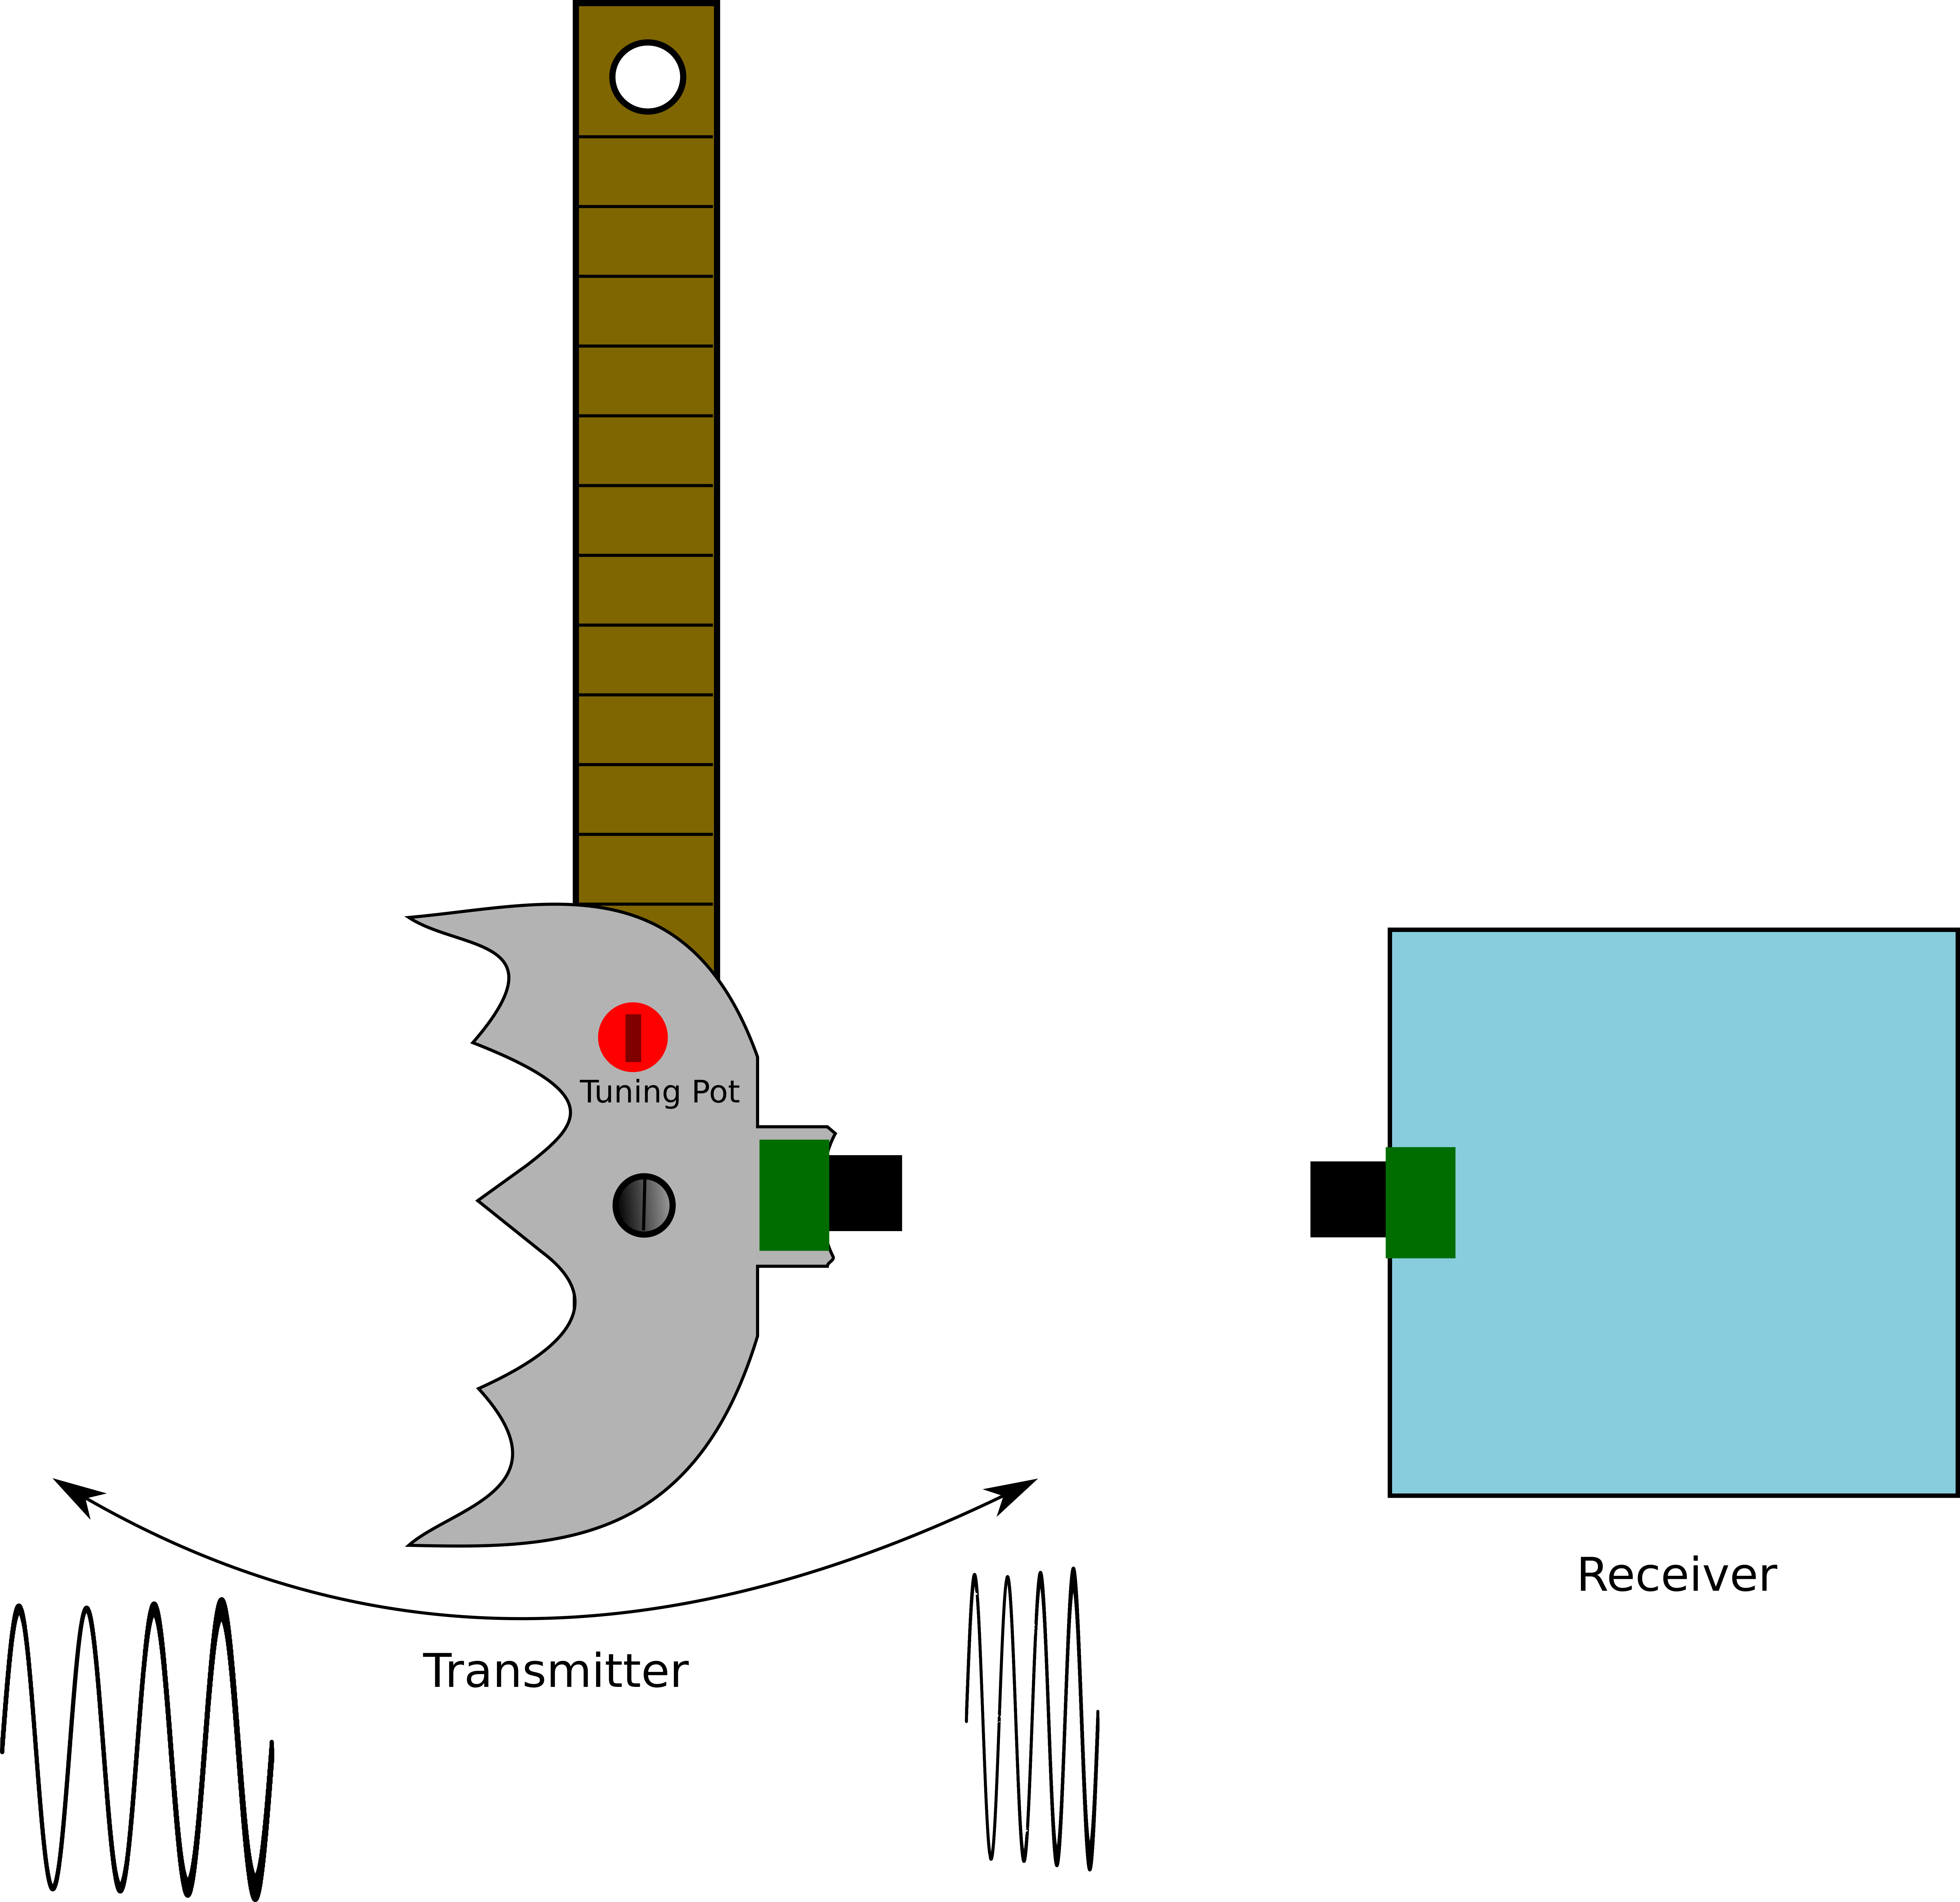

Figure. 2 The transmitter in motion

**Basic Operations**:

* Connect the transmitter to the meter stick and the meter stick to the lab stand.
* Place the receiver in front of the pendulum so that the transducers are aligned (ultrasonic transducers are fairly focused)
* Turn both on
* Adjust the local oscillator on the receiver to a pleasant frequency
* Start the pendulum swinging

Note: If it doesn’t make a sound, adjust the pots on the mixer. These pots are to make sure the signal the diode sees is around turn on. About 90 percent of the motion of these pots will work.

**Conclusion:**

The Ultrasonic Ear and Transmitter makes for a fun way to illustrate the Doppler effect and offers an introduction to ultrasonic sound and how it can be manipulated to make detectable signals that our ordinary senses cannot discern. The electronics that make the ultrasonics audible are a good introduction to several important electronic devices (amplifiers, mixers, filters, oscillators).

**Appendix:**

|  |  |  |  |  |  |
| --- | --- | --- | --- | --- | --- |
| Vendor | Part Number | Description | Unit Price $ | Quantity | Price $ |
| Digikey | 732-5008-ND | LED GRN DIFF 3MM ROUND T/H | 0.15 | 2 | 0.3 |
| Digikey | 609-3927-ND | TERM BLOCK 2POS 5.00MM PCB HORIZ | 0.8 | 2 | 1.6 |
| Digikey | EG1903-ND | SWITCH SLIDE SPDT 200MA 30V | 0.58 | 2 | 1.16 |
| Digikey | BH9V-PC-ND | HOLDER BATTERY 9V PC MOUNT | 1.65 | 1 | 1.65 |
| Digikey | 296-1411-5-ND | IC OSC SINGLE TIMER 100KHZ 8-DIP | 0.45 | 2 | 0.9 |
| Digikey | CF14JT22R0CT-ND | RES 22 OHM 1/4W 5% AXIAL | 0.1 | 1 | 0.1 |
| Digikey | CF14JT330RCT-ND | RES 330 OHM 1/4W 5% AXIAL | 0.1 | 2 | 0.2 |
| Digikey | 732-8823-1-ND | CAP ALUM 47UF 20% 25V RADIAL | 0.1 | 1 | 0.1 |
| Digikey | BC2662CT-ND | CAP CER 10000PF 50V X7R RADIAL | 0.17 | 4 | 0.68 |
| Digikey | BC2659CT-ND | CAP CER 1000PF 50V X7R RADIAL | 0.17 | 3 | 0.51 |
| Digikey | CF18JT470RCT-ND | RES 470 OHM 1/8W 5% CF AXIAL | 0.1 | 1 | 0.1 |
| Digikey | 17.4KXBK-ND | RES 17.4K OHM 1/4W 1% AXIAL | 0.1 | 1 | 0.1 |
| Digikey | 262UR252B-ND | TRIMMER 2.5K OHM 0.15W TH | 0.57 | 1 | 0.57 |
| Digikey | BC2686CT-ND | CAP CER 0.047UF 50V X7R RADIAL | 0.19 | 2 | 0.38 |
| Digikey | 732-8593-1-ND | CAP 10 UF 20% 16 V | 0.1 | 3 | 0.3 |
| Digikey | 732-8854-1-ND | CAP ALUM 4.7UF 20% 50V RADIAL | 0.1 | 3 | 0.3 |
| Digikey | 732-8911-1-ND | CAP ALUM 220UF 20% 10V RADIAL | 0.13 | 2 | 0.26 |
| Digikey | 36-232-ND | STRAP BATT ECON 9V I STYLE 4"LD | 0.6 | 1 | 0.6 |
| Digikey | 1N4007-TPMSCT | DIODE GEN PURP 1KV 1A DO41 | 0.11 | 1 | 0.11 |
| Digikey | 296-1395-5-ND | IC OPAMP GP 700KHZ 8DIP | 0.45 | 1 | 0.45 |
| Digikey | 296-43960-5-ND | IC AMP AUDIO PWR 1W MONO AB 8DIP | 1.01 | 1 | 1.01 |
| Digikey | 1528-2435-ND | SPEAKER - 3 DIAMETER - 4 OHM | 1.95 | 1 | 1.95 |
| Digikey | 2N3904-APCT | TRANS NPN 40V 0.2A TO92 | 0.19 | 1 | 0.19 |
| Digikey | 3306P-502-ND | TRIMMER 5K OHM 0.2W PC PIN | 0.43 | 2 | 0.86 |
| Digikey | 3306P-104-ND | TRIMMER 100K OHM 0.2W PC PIN | 0.43 | 1 | 0.43 |
| Digikey | CF14JT10K0CT-ND | RES 10K OHM 1/4W 5% AXIAL | 0.04 | 10 | 0.4 |
| Digikey | CF14JT1K00CT-ND | RES 1K OHM 1/4W 5% AXIAL | 0.1 | 2 | 0.2 |
| Digikey | CF14JT100KCT-ND | RES 100K OHM 1/4W 5% AXIAL | 0.1 | 1 | 0.1 |
| Digikey | S20KQCT-ND | RES 20K OHM 1/4W 5% CF MINI | 0.1 | 2 | 0.2 |
| Digikey | CF14JT22K0CT | RES 22K OHM 1/4W 5% AXIAL | 0.1 | 1 | 0.1 |
| Digikey | CF14JT1K50CT-ND | RES 1.5K OHM 1/4W 5% AXIAL | 0.1 | 1 | 0.1 |
| Digikey | 1.2KQBK-ND | RES 1.2K OHM 1/4W 5% AXIAL | 0.1 | 1 | 0.1 |
| Digikey | CF14JT560RCT-ND | RES 560 OHM 1/4W 5% AXIAL | 0.1 | 1 | 0.1 |
| Digikey | CF14JT10R0CT-ND | RES 10 OHM 1/4W 5% AXIAL | 0.1 | 1 | 0.1 |
| Digikey | S47QCT-ND | RES 47 OHM 1/4W 5% CF MINI | 0.1 | 1 | 0.1 |
| Digikey | CF14JT4K70CT-ND | RES 4.7K OHM 1/4W 5% AXIAL | 0.1 | 1 | 0.1 |
| Digikey | CF14JT15K0CT-ND | RES 15K OHM 1/4W 5% AXIAL | 0.1 | 1 | 0.1 |
| Digikey | CF14JT220RCT-ND | RES 220 OHM 1/4W 5% AXIAL | 0.1 | 1 | 0.1 |
| Dollar Store |  | 9V Battery | 1 | 2 | 2 |
| PCB Way |  | Custom pcb* | 0.5 | 2 | 1 |
| Alibaba |  | 10mm 40kHz transducer | 0.8 | 2 | 1.6 |
| Arbor | P1-7072 | Meter stick | 3 | 1 | 3 |
| Arbor | 66-4220 | Lab stand | 17 | 1 | 17 |
| Arbor | 66-8290 | 90 degree clamp | 5.5 | 1 | 5.5 |
| McMaster | 90272A287 | 4-40 x 3’’ bolt** | .17 | 1 | .17 |
|  |  |  |  |  | 46.88 |

*Boards have to be ordered in a quantity of 10

**Bolts have to be ordered in a quantity of 50

Transmitter Schematic

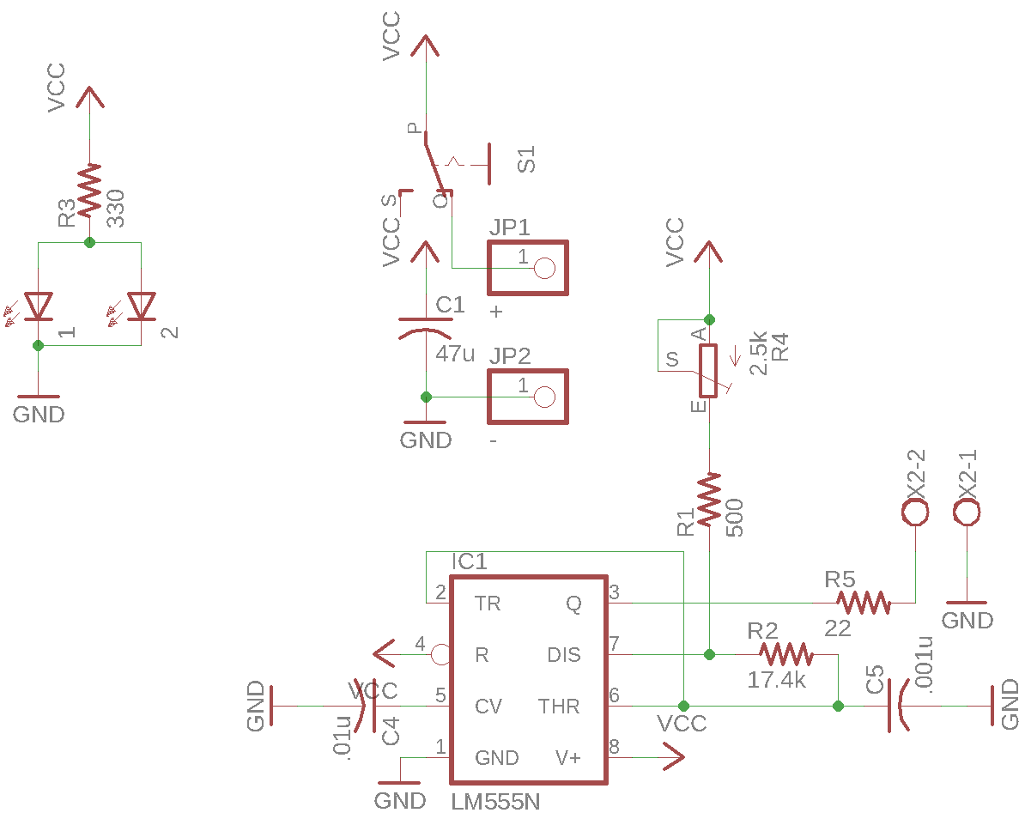

Receiver Schematic

