**Pendulum Wave**



Design by Tom Senior  
Parts cut by Paul Noel

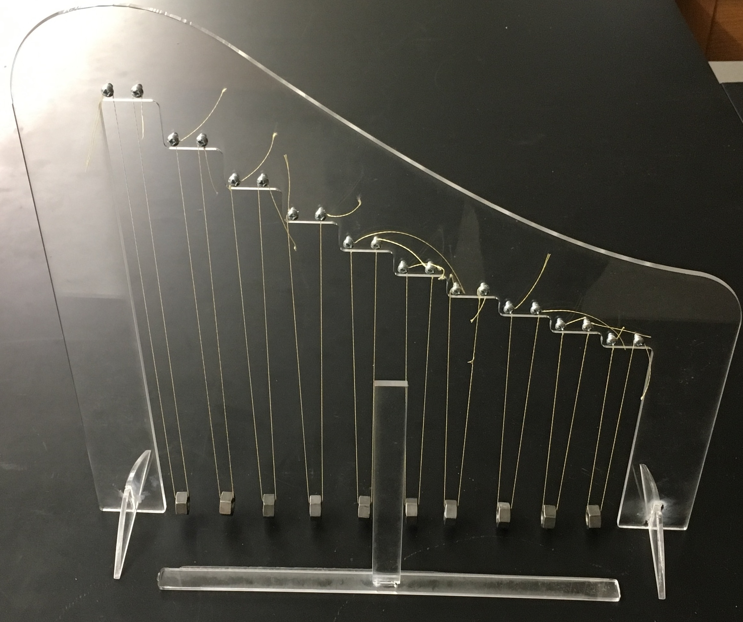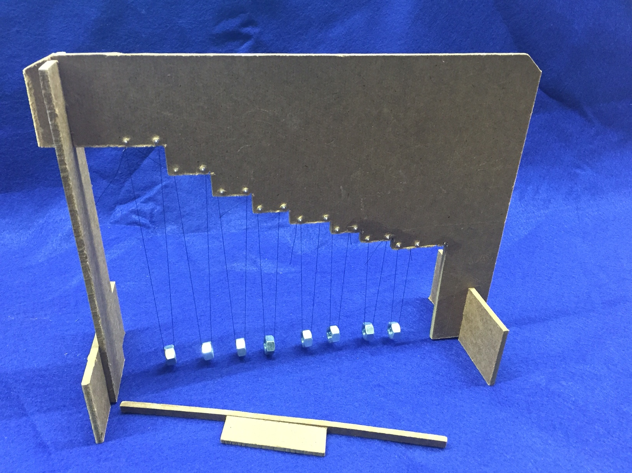

The pendulum is frequently used as an example of sinusoidal motion (for small angles) where the period of oscillation is dependent only on the length (as long as gravity is constant!). This property is used most famously to adjust the time of clocks.

Pendulums can also be used to demonstrate the effect of coupling, where the motion of one pendulum affects the motion of another through a weak interaction between them. This effect can lead to phase-locking where the pendulums adjust their motion to match phases, as well as beats where the pendulums exchange energy, leading to a periodic fluctuation in their amplitudes.

The pendulum wave is not an example of either of these phenomena. Rather, it is an example of recurrence where a set of pendulums have lengths that are set so that each pendulum’s period differs from its neighbor’s by an integer number. The effect this has is that if all are set in motion together, the pendulum’s phases will eventually all be the same again after a certain number of oscillations and hence they will all swing together again.

To calculate the lengths of the pendulums, start with the longest time period, *T0*. Decide how many cycles of this pendulum you would want before all the pendulums are back in phase, usually 12 to 20 cycles.  For example, let us use 16 cycles. This means that the time period (*T1*) of the next pendulum needs to be such that it takes 17 cycles to get back in phase with the first, the next will take 18 cycles, the next 19, etc... This leads to the relationships:

, ,  … 

To calculate the lengths, solve each relation for each pendulum’s period *Tn*and then substitute for the period using:



You should discover that (for a wave with a recurrence of 16 cycles) the length of each pendulum Ln is given by

,

where *L0* is the length of the length of the longest pendulum. When you decide how long you want the longest pendulum to be, the lengths of the others can be calculated easily. (Spreadsheets are great for this!).

We have cut the pieces to the stand for you, but if you want to build your own of a different size, you will need to choose a longest pendulum length, and a recurrence cycle and then calculate the lengths for each pendulum.  To build the stand, the difference in lengths between adjacent pendulums, will form the steps on the stand so the swinging bobs hang to the same level. The method of attachment is up to the builder, but the string supporting each pendulum needs to be pinched to make a definite length. The bob support string should also be bifilar, or two stringed, one on each side of the bob. This ensures the pendulums will swing in a plane. The top ends of the bifilar support strings need to be separated by enough distance to assure stability. The ability to make fine adjustments to the length is also necessary so the pendulums come back into phase after two or even three full cycles. It can also be laser cut using the dxf provided on the flash drive.

* 1 – Upright pendulum support
* 2 – Feet
* 1 – String
* 10 – Nuts
* 20 – Self tapping Screws
* 1 – Push bar
* 1 – Push bar handle
* Place the feet in the grooves in the upright pendulum support. Glue it in place with acrylic bonder or super glue.
* Place the push bar in between the feet.
* Start screwing the screw in the small hole at the top. Be sure to back it out every ½ turn.
  + Before it is tight place the string around the screw to hold it there.
* Put a nut through the other side of the string. Start screwing the second screw in the paired set.
  + Place the string around the screw just like before, but make sure that the nut is just barely touching the push bar.
  + Cut the extra string.
* Repeat for each pendulum.
* Push the push bar handle in the push bar.